May 2022

SCHOOL OF COMPUTING AND MATHEMATICAL SCIENCES, UNIVERSITY OF LEICESter

CO3201 Computer Science Project: Dissertation

LEGO: SET CHECKLIST CREATOR

DAN Booth

# Declaration



# Abstract

Ever since I was young, I have always loved building and playing with Lego Sets, over time I disassembled these Sets, leading to Lego Pieces for different Sets becoming muddled up making them difficult to rebuild. This could be solved however with the use of a digital checklist for pieces in a Lego Set where pieces can be checked off when they have been found.

I looked into similar Lego websites and their features but none contained this checklist functionality, however, I found after a questionnaire that it is something Lego enthusiasts would find useful.

I created an adaptable website for both PC/Laptop and mobile devices, to retrieve data on Lego Set (using the Reebirckable API [1]) that users searched and view all the pieces in the Set in a checklist, that meets the needs of Lego enthusiasts. Users can also login to this website and save their checklist progress to their account.

I evaluated the usability of my website with 5 participants, using a Questionnaire and Interview. From this, I learned that I had successfully achieved my aim of a simple and consistent cross-platform website, but that it could still be improved to work better with mobile devices.

If I learned that my project planning could be improved as I under and overestimated the length of several tasks and I have planned to create a dedicated mobile application to improve mobile device usability.

# contents

The purpose of this project

# Glossary

|  |  |
| --- | --- |
| Abbreviation | Meaning |
| API | Application Programming Interface |
| CSS | Cascading Style Sheets |
| HTML | HyperText Markup Language |
| HTTP | HyperText Transfer Protocol |
| HTTPS | HyperText Transfer Protocol Secure |
| JPA | Java Persistence API |
| JSP | Java Server Page |
| JSTL | JSP Standard Tag Library |
| MVC | Model-View-Controller |
| SQL | Structured Query Language |
| UI | User Interface |

## Introduction

Ever since I was young, I have always loved building and playing with Lego, getting Lego Sets regularly for Christmas and birthdays. Over time as I got more Lego Sets, I had to take some older sets apart to make room for newer ones. The Lego pieces from these sets would be stored in separate containers so that if I wanted to rebuild a set, I could simply get that certain container. However, as I got more Lego sets these pieces became muddled so that it was no longer as simple as picking a container. This can be done using the list of pieces in the back of the Lego set’s instruction booklet and as I find the pieces tick them off this page. This can work when rebuilding the set for the first few times but after a while, it can become very difficult because there are ticks all over the page. Therefore, having a digital checklist for pieces in a Lego Set would help fix this issue as once you have built the set, the next time you go to rebuild it the checklist will be blank, and you can start all over again.

For example, if you have a Lego set that you have taken apart and put all the pieces in a box along with other Lego pieces, and you would like to rebuild the set, you could do this easily using a digital checklist.

The target users for this project are 18+ Lego builders, enthusiasts, and collectors (referred to as ‘Lego enthusiasts’ from now on for briefness) who are looking to build or rebuild a Lego set they own.

### Aim

The key aim of this project was to create a digital checklist for pieces in a Lego Set. Users can find and then select a Lego Set they would like to see the pieces for. They can then view all the pieces in this Lego set (like in the back of the instruction book), and they can check they have all the pieces when they are building the set again.

### Objectives

1. Write a program to connect to a Lego Set API and retrieve data
2. Learn how to turn JSON files into a class
3. Build an application using the Spring Model-View-Controller (MVC) framework
4. Design a cross-platform website (view) from which users can use the system
5. Implement a cross-platform website (view) from which users can use the system
6. Design a way for users to save progress on a checklist
7. Implement a way for users to save progress on a checklist

## Survey of Literature/Information Sources

### Preliminary Research

To begin with, I looked up the Rebrickable API [1] that contains data on Lego sets, that I am going to use, that can search through to find a Lego set and the pieces within this set. I also read the documentation for the API [2], finding out that it's a RESTful API (meaning I can use HTTP requests to access data) and to access the data I need an API key that is freely available with an account. Using the API you can request a Lego set directly using the Lego set unique number, or search using “A search term”, filter using “theme_id (a number associated with a Lego theme e.g. Star Wars, that can be retrieved also using API), min_year, max_year, min_parts, max_parts” and order by a certain “field” (“set_num”, “name”, “year”, “theme_id”, “num_parts”). Data is returned from the API in the form of JSON files, and a set returns “set_num”, “name”, “year”, “theme_id”, “num_parts” and “set_img_url”, but to retrieve a JSON of all the pieces in a Lego set another call to the API needs to be performed. This returns a list containing each part however this cannot be ordered using the API.

### Questionnaire Introduction

I then performed some data collection on what my target users would like from a digital checklist for pieces in a Lego Set, via an online questionnaire (see **Appendix A**). Using this I could identify their key requirements and features for the system, for example where they would like to use the system, how they currently check they have all the pieces for a Lego set, other tools they use for research, how important certain features would be to them and if they have any other ideas for features.

### Questionnaire Results and Further Research

My questionnaire received a reasonable number of responses (20 responses) and from the results of this questionnaire, I was able to decide on certain features and requirements for my project. (For full results of the questionnaire see **Appendix B**).

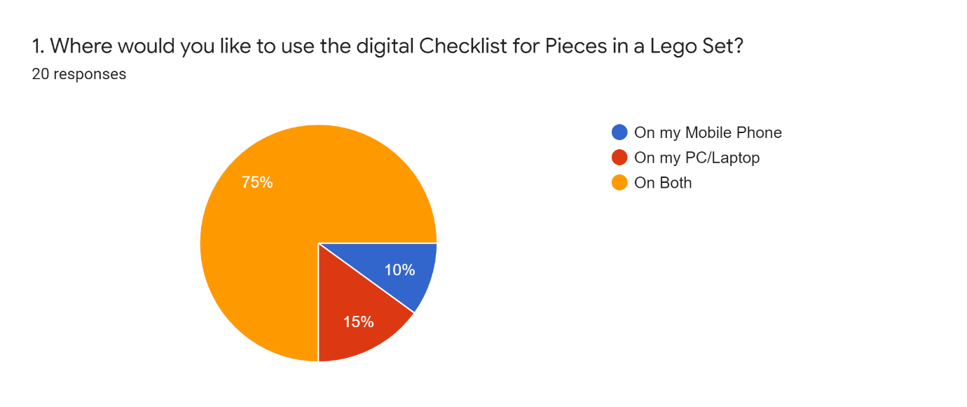

Figure 1 – Question 1 Results

Question 1 showed me that most users (75% see Figure 1) would like to use the digital checklist on both PC/Laptop and mobile devices, which helped inform me that my digital checklist for pieces in a Lego Set should run on both these types of systems.

I also learnt from questions answers to 2 and 3 that Lego enthusiasts who use a digital tool use the website Bricklink [3]. I found that on Bricklink users can add pieces from a Lego set to a “wanted list” and from there tick off parts you have. This shows the user how many pieces they need and how many they currently have found. However, this number easily be changed by accident which could cause issues. For example, users could believe they have all the pieces for a Set but they accidentally decreased how many pieces they needed so are missing one, or the opposite where they increase the number they need but have all of them. Users can’t filter pieces by colour or type making it difficult to find pieces, also when pieces are fully found they are not hidden from the list. Any pieces missing can easily show a list of possible locations to buy them. Most of these issues appear because the purpose of the tool is to buy pieces for a Lego set.

The answers to question 3 also show some people currently use the Rebrickable website [4]. On Rebrickable, which also provides the API I am going to use, users can find a Lego set by typing in the set number or searching by a text search (i.e. Set Name) and filter by a range of year released, range of the number of parts and also filter by themes. On the page of a Set (e.g. this Lego Set [5]) users can see a list of all parts, the instructions, pictures of the Lego set, the year released, the number of parts etc. Here if the user has an account, they can add the set parts to a List. On the list, the user added parts too, users can filter by piece colour, type (Category) and sort by colour, Hue, part, type (category) and price to buy the Lego piece. Users can see how many each piece is required as well as the colour and price to buy it but to check a piece off the list, the user must delete it from the list meaning you can’t undo the change, also users can change the number of certain pieces needed but not see the original number (like BrickLink see above). This is primarily due to the fact the tool is meant to help users buy Lego pieces for a set, also the same as Bricklink, but can be used as a makeshift checklist.

Overall, the results of questions 2 and 3 have helped me find and research similar software and helped give me ideas on what would be useful to use from these.

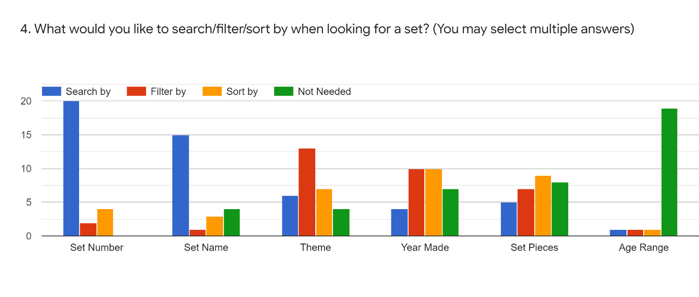

Figure 2 – Question 4 Results

The results of question 4 (see Figure 2) provided lots of useful information about how users would like to search for a Lego set. Some of the answers were very conclusion for example 19 people said that searching by ‘Age Range’ for a Lego Set was not needed showing me that there is no demand for this search parameter. Likewise, all 20 respondents stated they would like to be able to search by ‘Set Number’.

The answers to the ‘Set Pieces’ section of question 4 are quite varied, with 8 responses saying it was ‘not needed’, which was one more than the ‘Filter by’ (7 responses) and one less than ‘Sort by’ (9 responses). This shows filter and sort for ‘Set Pieces’ only just make up most responses showing that maybe this is not a key requirement when searching for a set but would still be useful.

Overall conclusions that I can draw from question 4 are that overall users would like to search by ‘set number’ and ‘set name’ when trying to locate a Lego Set. They would also like to filter by the ‘year made’, ‘theme’ and ‘Set Pieces’ as well as sorting by ‘Theme’, ‘Year Made’ and ‘Set Pieces’.

The results of Question 5 show that most people find it important or very important that a digital checklist the Lego pieces can be sorted by colour and type of piece, showing this should be a key feature of my digital checklist. However, being able to filter by Lego pieces type and colour is shown to be not as important and therefore are not as key to people. Finally, having a link to buy a missing Lego piece and being able to scan Lego pieces in a set to see if they are there and then check them off, have very mixed answers showing they should be nothing more than optional for the checklist.

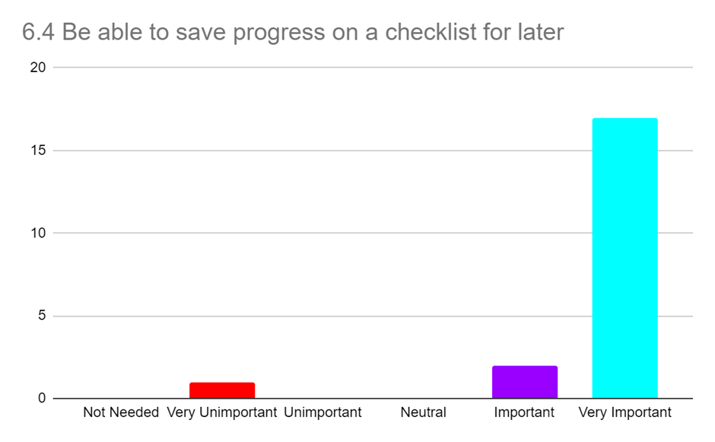

Figure 3 – Question 6 part 4 (Be able to save progress on a checklist for later) Results

Question 6 results show that it is very important to most people (17/20 see Figure 3) to be able to save progress on a checklist making this a key requirement for the system. Being to view and download instructions is also important to most users, as is being able to save Lego Sets they own to a list meaning this is also key. The responses to having a favourites list for Lego sets are very mixed but mostly positive showing that it would be nice to have but not key.

From the responses to question 6 I went and found the Brickset API [7] that requires a free API key, and I can use it to retrieve Lego set instructions (as the current Rebrickable API cannot do this). These are returned as a list of instruction PDF links, in a JSON file. This API also allows users to search for Lego Sets, but I will only use this API for retrieving instructions as it does not contain data on pieces within a Lego set, which is a vital part of the project.

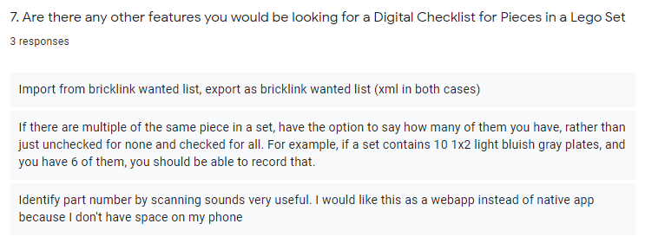

Figure 4 – Question 7 Results

Finally, the results of question 7 (see Figure 4) where users are allowed to add any ideas for any other features gave some useful ideas. For example, being able to also scan bricks with a webcam as well as a mobile for PC/Laptop users. As well as if there are multiple Lego pieces of the same type and colour on the checklist being able to record the specific number of these found. Finally, another feature suggested was to import and export XML files like a Bricklink [3] wanted list. I took these suggestions into account when designing my requirements.

## Requirements

### Key Features

* The system must be usable as a website on both mobile and PC/laptops
* The system must display a list of all Lego sets stored in Rebrickable API [1]
* The system must have a search feature that allows users to search a list of Lego sets. Can search by set number and text search (e.g. set name), and filter and sort by year made and set theme.
* Users must be able to ‘check’ piece off the checklist, showing how many more of that piece are remaining
* The system must show on the checklist (for Lego pieces in a set) a picture of the piece, with the correct colour, as well as an alternative text description including the piece name and colour
* Users must be able to sort a checklist by colour and type of a Lego piece
* The system must be usable with and without a user account
* Users must be able to save progress on a checklist

### Nice to Have Features

* The system may have an additional search parameter to sort and filter by the number of pieces in a Lego set
* The system may have an additional search parameter to sort alphabetically by Set Name
* The system may have a consistent and simple UI
* Users may be able to view instructions for a Lego set
* Users may be able to download instructions for a Lego set
* Users may be able to filter a checklist by the colour of a piece
* Users may be able to filter a checklist by type of a piece
* The system may have a link to buy a missing piece from a Lego Set
* Users may be able to create an account
* Users with an account may be able to save sets they own to a ‘Sets Owned List’, so they can easily find them later

### Optional Features

* Users with an account could create lists for Lego sets and save sets to them, so they can easily find them later (Sets can be in multiple lists)
* Users could search their ‘Sets Owned List’ and other lists for Lego sets, like the main search feature
* The system could save a user's progress on a checklist in the database
* The system could also be a mobile application
* Users could scan Lego pieces with a phone camera or webcam to check if the piece is in a Lego list
  + If it is in the set (and not already enough of them), there is an option to check pieces off the Digital Checklist
  + If in the set but already have all that type of piece needed, it will inform the user of this
  + If not in the set it will inform the user of this
* Users could import and export a checklist as an XML file in the Bricklink [3] wanted list format

## Design

### A High-level overview of the architecture of the system

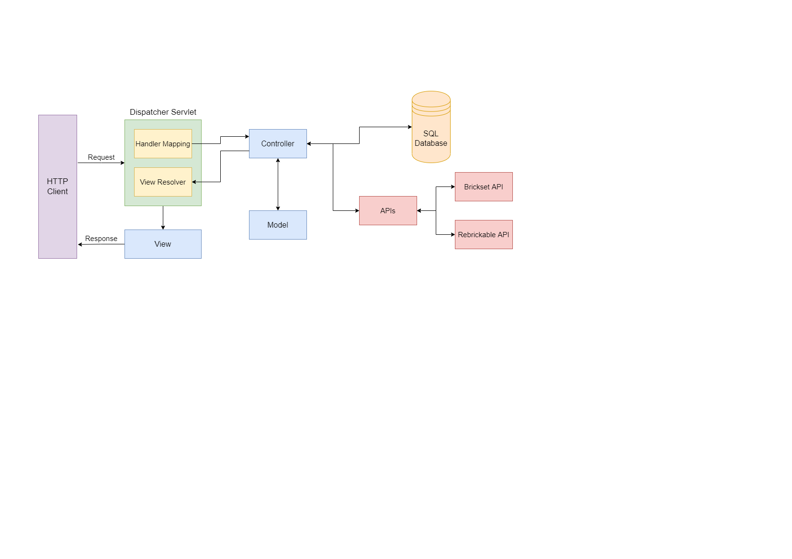

Figure 5 – High-Level Overview

Figure 5 above shows a high-level view of the Spring MVC [8] architecture that my website uses. Where the view is a JSP (Java Server Page) that is displayed to the users on the HTTP client (their web browser). When the user interacts with the View, via the web browser, a request is sent to the Dispatcher Servlet. Here the Dispatcher Servlet will use the Handler Mapping to match the request URL to the correct Controller. The controller will then call APIs or interact with the SQL database to collect and edit information as needed, it will then update attributes in the Model, before returning the name of the next View to the View Resolver. View Resolver, which locates the correct View add adds in the Model attributes. This View is then sent back to the HTTP client as a response.

### APIs

#### Rebrickable API

The Rebrickable API [1] (as mentioned above see 2 Survey of Literature/Information Sources) stores all the data about all Lego sets and the Lego pieces in these sets, as well as all the Lego themes and which sets are in them. This API will be used to search for Lego sets and retrieve all the Lego pieces in a Lego Set.

#### Brickset API

The Brickset API [7] (as mentioned above, see 2 Survey of Literature/Information Sources) will be used to obtain PDF instructions for a Lego set so users can view and download these for a Lego set.

### Database Design

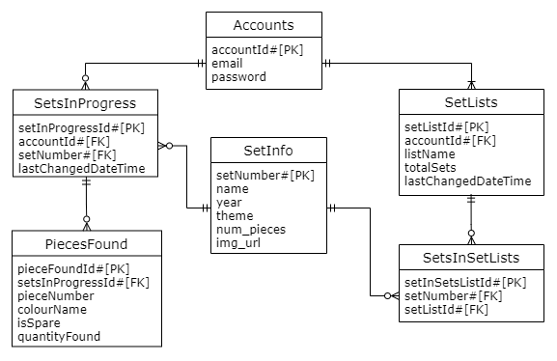

Figure 6 – ER Class Diagram

I have used SQL for my database, and Figure 6 above shows an ER class diagram for this database, that may change depending on the requirements completed. The database has several tables called Accounts, SetsInProgress, PiecesFound, SetLists, SetsInSetsList and SetInfo. These database tables are generated using hibernate [9] and JPA [10] in the classes described in the 4.4 Class Diagram.

The Accounts table is used to store user accounts, with ‘accountId’ as the primary key, ‘email’ which is a unique attribute as an email can only belong to one account, and a ‘password’ that is encrypted using a hash and salt.

The SetsInProgress table stores the set numbers of sets (‘setNumber’) that a user currently has a checklist in progress for, the information for these sets is stored in the ‘SetInfo’ table explained below. ‘setInProgressId’ is the primary key, with the user’s ‘accountId’ as the foreign key so it's easy to find which user it belongs to. Finally, ‘lastChangedDateTime’ which stores the last time the set in progress was saved to the database, this is used so that the last 3 used sets in progress can be displayed to the user on the home page.

The PiecesFound table is used to store pieces for a ‘SetInProgress’ and contains attributes ‘pieceFoundId’ is the primary key, ‘setInProgressId’ is a foreign key so it's easy to identify which setInProgress the pieceFound belongs to. The ‘pieceNumber’, the ‘colourName’ is the colour of the piece, ‘isSpare’ shows if this is a spare provided piece with the Lego Set but not required to build the set and ‘quantityFound’ is the quantity of the particular piece that has currently been found (if 0 pieces have been found these won’t be saved to save database storage).

SetLists table stores lists the user has created, that contain Lego sets (called setlists). The table stores the name of the list (‘listName’), a primary key (‘setListId’) (used to find the sets that belong to the list in the SetsInSetsList table explained below), the total number of sets in the list (‘totalSets’), with the user’s ‘accountId’ as the foreign key so it's easy to find which user it belongs to. Finally, ‘lastChangedDateTime’ which stores the last time the setlist was saved to the database, is used so that the last 3 used setlists can be displayed to the user on the home page.

SetsInSetsList stores the set numbers of sets (‘setNumber’) saved to a setlist in the database, the information for these sets is stored in the ‘SetInfo’ table explained below. It has a primary key ‘setInSetListId’, ‘setListId’ is a foreign key so it's easy to identify which setlist this belongs to and the ‘setNumber’ for the set, which can only appear once in a setlist.

The SetInfo table holds information about sets stored in either the SetsInProgress or SetsInSetLists tables. ‘setNumber’ is the primary key that is used to link to this table in the other tables, the set’s ‘name’, ‘year’ released, ‘theme’, number of pieces in the set ‘num_pieces’ and a URL for an image of the set (‘img_url’).

### Class Diagram

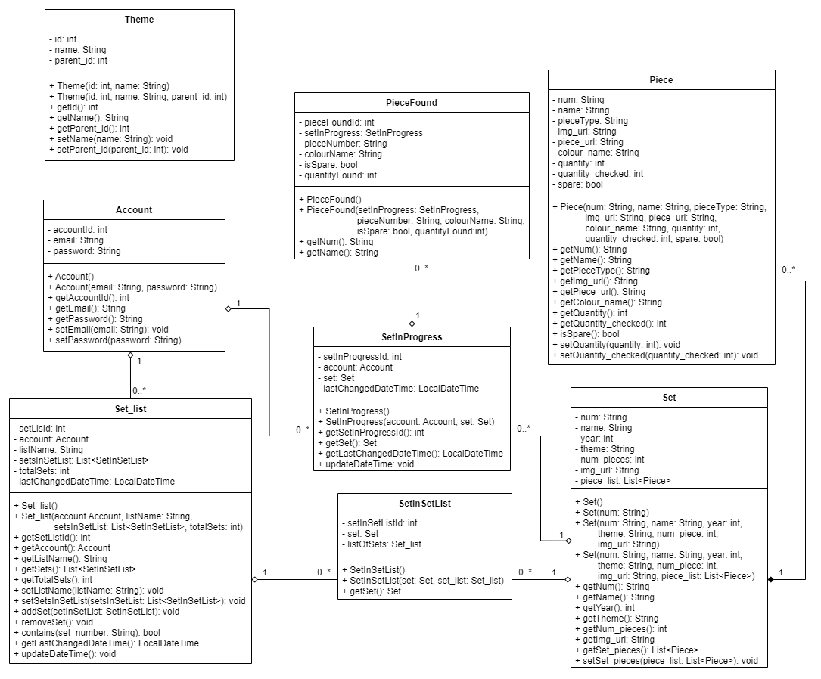

Figure 7 – Class Diagram

Figure 7 above is a class diagram for my system, with several classes Set, Piece, SetInSetList, Set_list, SetInProgress, PieceFound, Account and Theme.

The Set class is used to store Lego Set data read from a JSON file received from the Rebrickable API [1]. This data includes the Lego Set’s Number (‘num’) which is a unique number that identifies the Lego Set, and this is a string because all set numbers contain a '-' that is followed by a version number that donates different versions of certain sets, with the standard being '-1'. It also contains the ‘name’ of the Set, the ‘year’ released, the ‘theme’ the set belongs to, the number of Lego pieces (‘num_pieces’) in the set, a URL for an image of the set (‘img_url’). Finally, there is an attribute called ‘piece_list’ which is a list of the Piece class and is used to store a list of all Lego pieces in a Lego set.

The Piece class is used to store information about a Lego piece read from a JSON file received from the Rebrickable API [1]. This contains a piece number (‘num’) as these sometimes contain letters this is a string, ‘name’ of the piece, a ‘pieceType’ which is the type of Lego piece the piece is, a URL for an image of the piece (‘img_url’) and another URL (‘piece_url’) to the piece’s page on the Rebrickable website where the user can view a list of websites to buy the Lego Piece [6]. A ‘colour_name’ that’s the colour of the piece, ‘quantity’ which is the number of these pieces that are required to build the Lego Set, ‘quantity_checked’ which is the quantity the user has checked off these pieces and finally ‘spare’ which denotes if this piece is a spare provided with the Lego Set but not required to build the set.

The SetInSetList class is used to link the Set_list and Set classes and is used for the database (using Hibernate [9] and JPA annotations [10]) so that information on a Lego set does not have to be duplicated if in several setlists, and can just save a table that links to the set via the set’s number. It contains a unique auto-generated id (‘setInSetListId’) used as the primary key for the table in the database, ‘listOfSets’ is the setlist the set is in and ‘set’ is the set that is in the setlist.

The Set_list class is used to store a list of the class SetInSetList which is created by the user or retrieved from a user’s setlist of Lego sets from the database, and as explained above SetInSetList links to the Set Class, which stores the information on Lego sets that part of a setlist. This class is also used to create the database using Hibernate [9] and JPA annotations [10]. It contains the name of a list (‘listName’), the user ‘account’ the list belongs to, ‘setListId’ is a unique auto-generated id used as the primary key in the database, the number of sets in the list (‘totalSets’), ‘lastChangedDateTime’ which holds the last date and time the class was changed and is used so that the last 3 used setlists can be displayed to the user on the home page and so that the last accessed list is at the top of the selector when selecting a setlist to add a Lego set to. Finally, there is a List of type SetInSetList (‘setsInSetList’), that is used to store all the Lego sets in the list. It contains several functions with the ‘contains()’ that checks if a set is in the list, ‘updateDateTime()’ sets the ‘lastChangedDateTime()’ to the current date and time, ‘addSet()’ adds a set to the list and increases total sets by 1, and ‘removeSet()’ that decreases total sets by 1.

The SetInProgress class also uses Hibernate [9] and JPA annotations [10] to generate a table that connects a user’s account to a Lego Set checklist that they have saved to the database. Similarly, the SetInSetList class links to the Set class so that in the database set information is not saved multiple times, by having a variable ‘set’ of type Set. This also contains the user ‘account’ the set in progress belongs to, ‘lastChangedDateTime’ which holds the last date and time the class was changed (used like Set_list to display the last 3 last saved sets in progress), and ‘setInProgressId’ is a unique auto-generated id used as the primary key in the database. This also contains a ‘updateDateTime()’ which operates in the same way as in the Set_list class.

The PieceFound class is another class that is used to create the database (using Hibernate [9] and JPA annotations [10]). This class is used to store pieces from SetsInProgress, and only contains information that makes each piece unique, the ‘pieceNumber’ which is unique, the piece’s colour (‘colourName’) and if it is a spare piece (‘isSpare’) and finally how many of this particular Lego piece has been found (‘quantityFound’). It also has an auto-generated primary key ‘pieceFoundId’.

The Account class is used to create the database table (with Hibernate [9] and JPA annotations [10]) that holds an account user’s information. It has a user’s auto-generated primary key (‘accountId’), the user's ‘email’ and ‘password’ that is used by a user when logging into the website.

Finally, the Theme class holds information about Lego Set themes retrieved from the Rebrickable API [1] as a JSON file. This class is separate from the other tables and is used to store all the themes, so that each time a set is received from the Rebrickable API [1], the program does not have to call the API again with a theme number to retrieve that theme’s name. It contains a unique ‘id’ used to identify the theme, the theme’s ‘name’ and ‘parent_id’ which is the id of the theme that this theme is a sub-theme for.

### User Interface Design

Throughout the UI all buttons, links and images contain tooltips informing the user on what action is performed when clicking the button, link or image. Input boxes also have tooltips informing the user what should be inputted. All images have alternative text informing the user what the image is. Additionally, in all the initial design Figures, a blue square denotes an image.

At the top of every page, there is a black navbar containing the website's name so it’s clear to users what website they are on, which when clicked returns the user to the Home Page. At the far right of this navbar, there is a link which will appear as ‘Login/SignUp’ when the user is not logged in and ‘Logout’ when they are. ‘Login/SignUp’ opens the Login tab on the Login and Sign-Up Popup (Figure 42) and ‘Logout’ opens Figure 57: Logout Popup, these are both explained later.

In the footer of every page, there is a breadcrumb trail, that shows the current page in white text, and hyperlinks to previous pages to its left, which I added so a user can see their position on the user journey.

All popups have either a ‘Cancel’ button or an ‘X’ in the top right corner, which both dismiss the popups.

#### Find Set Feature

In the navbar of some pages, there are 2 number boxes where users can enter a Set number and variant number and a ‘Find Set’ button that will search for the Lego Set and return Figure 17 or Figure 21, these are explained in Set Page below. On the pages with this feature, I will refer to it as the Find Set Feature.

#### Home Page

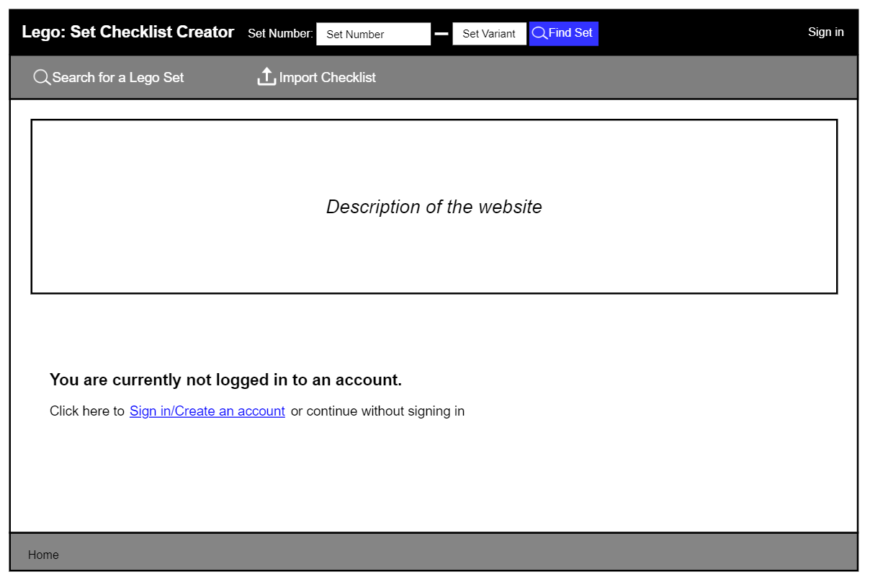

Figure 8: Initial Home Page - logged out

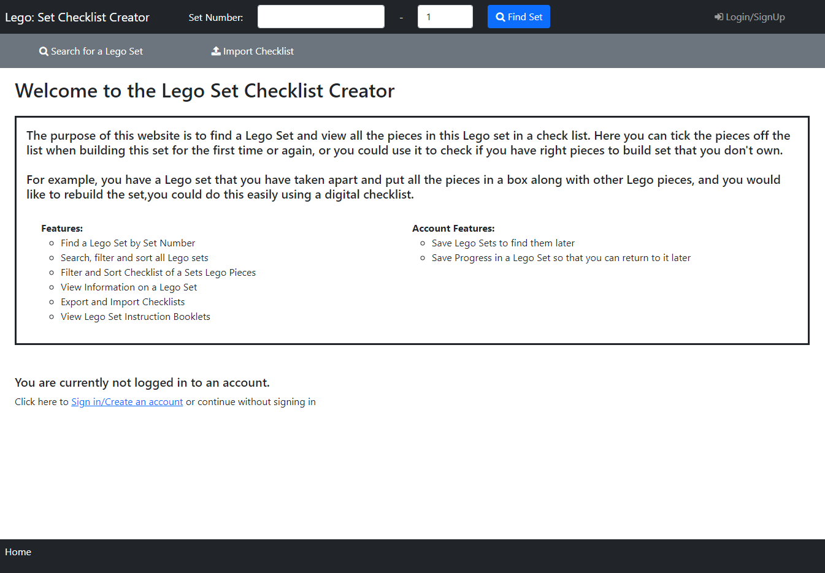

Figure 9: Home Page - logged out

The first page that appears to the user when they access the site is the home page (Figure 9). On this page, there is a welcome message with the website name which I added so it was immediately clear to users which site they are viewing. Under this users can view a description of the website and what it is used for, helping useability by making it clear what the website does. There is also some text informing the user that they are not logged in, offering users the option to ‘Sign in/Create an account’ (which is a hyperlink), but also making it clear to users that they can continue without these. When this hyperlink is clicked it opens the Login and Sign-Up Popup with the Login Tab Selected (Figure 42), explained below.

The navbar contains the Find Set Feature, and underneath is a secondary navbar with a ‘Search’ link that opens the Search Page (below) and an ‘Import Checklist’ link that opens Figure 39: Import Checklist Popup where users can import a previously exported checklist.

Compared to the initial design in Figure 8 the final design (Figure 9) is mostly the same, except the final design also includes a welcome message with the site name above the website description box (which has also now been filled in). In addition, the ‘Sign in’ link text has been replaced by ‘Login/SignUp’ in the final design.

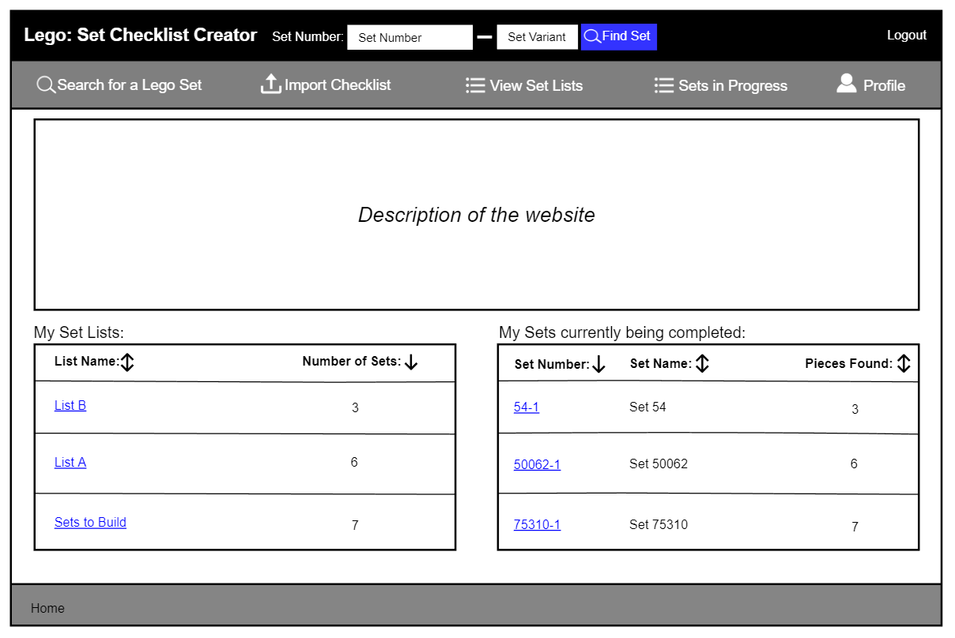

Figure 10: Initial Home Page - logged in

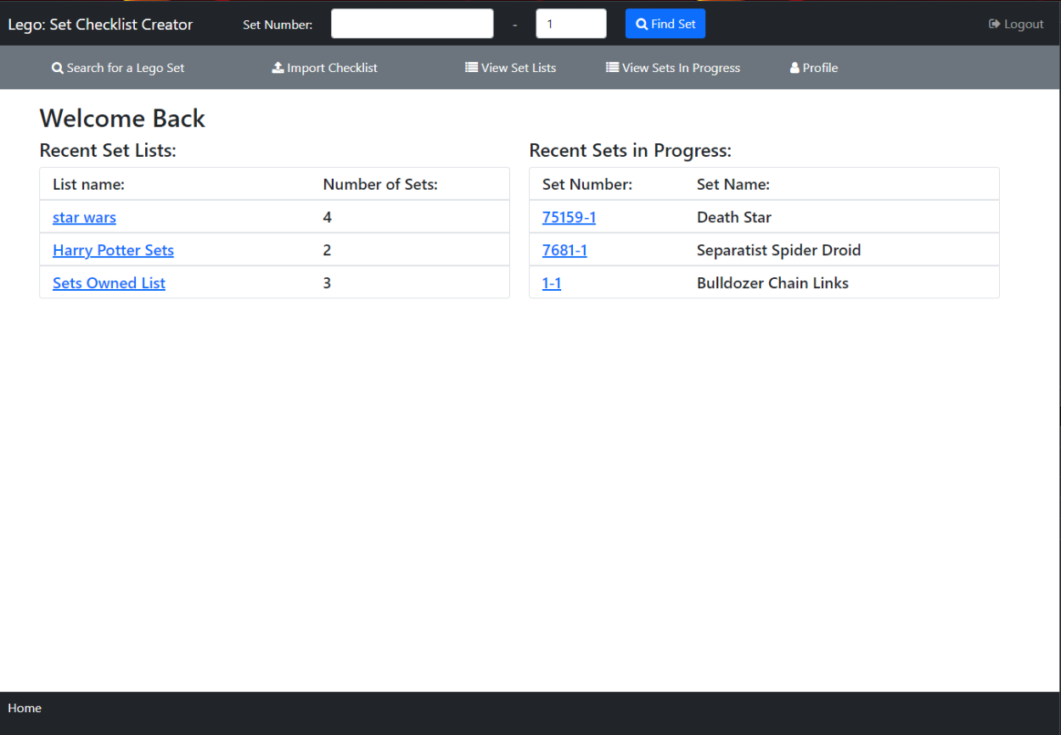

Figure 11: Home Page - logged in

The home page displayed to a logged-in user (Figure 11) is mostly the same but with a few differences. Additional links are shown ot the user in the secondary navbar, there are to view their ‘Set Lists’ (Set Lists Page below), ‘Sets In Progress’ (Sets in Progress Page below) and their account ‘Profile’ page (Profile Page below).

The not logged in message is replaced with the user's last three edited setlists, with links that can be used for quick access to view these, along with the user's last three saved sets in progress, accessed by clicking the hyperlinks for the ‘List Name’ and ‘Set Number’ respectively.

There is a difference between the initial design (Figure 10) and the final design (Figure 11). In the final design, I removed the website description as I felt if users already had an account they would not need to have the website explained to them, the final design instead includes a welcome back message to greet users back to the site.

#### Search Page

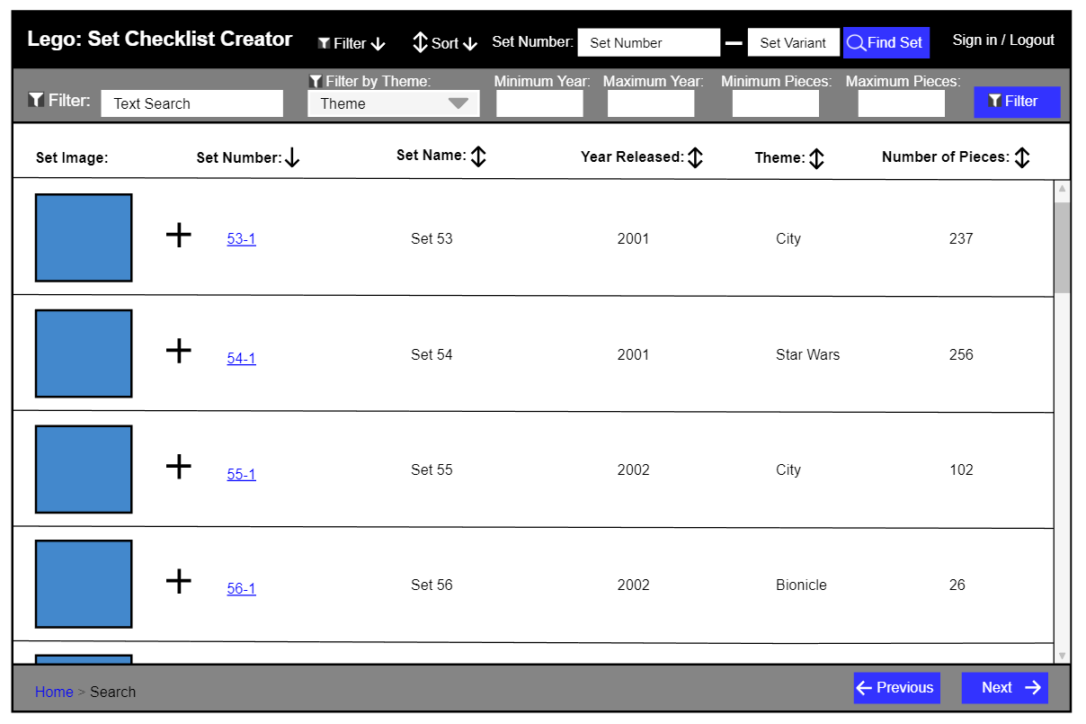

Figure 12: Initial Search Page - Filter Bar Open

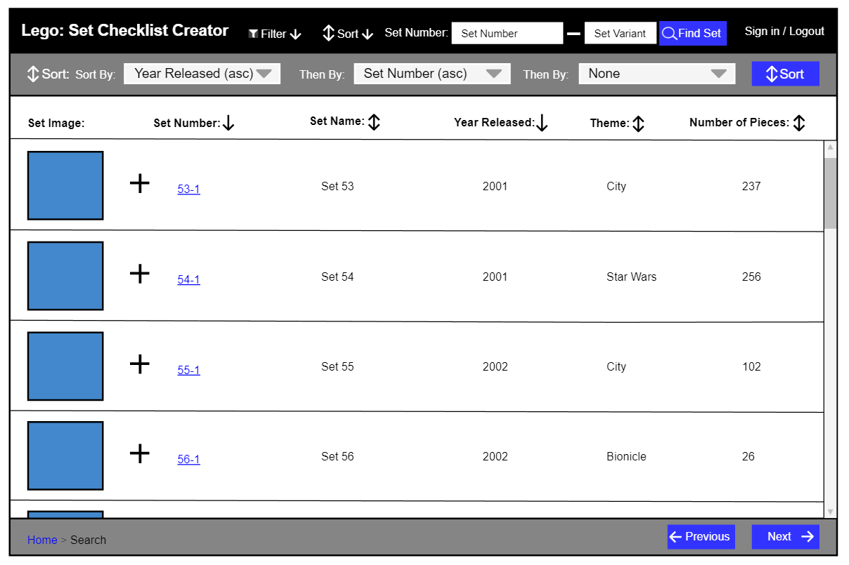

Figure 13: Initial Search Page - Sort Bar Open

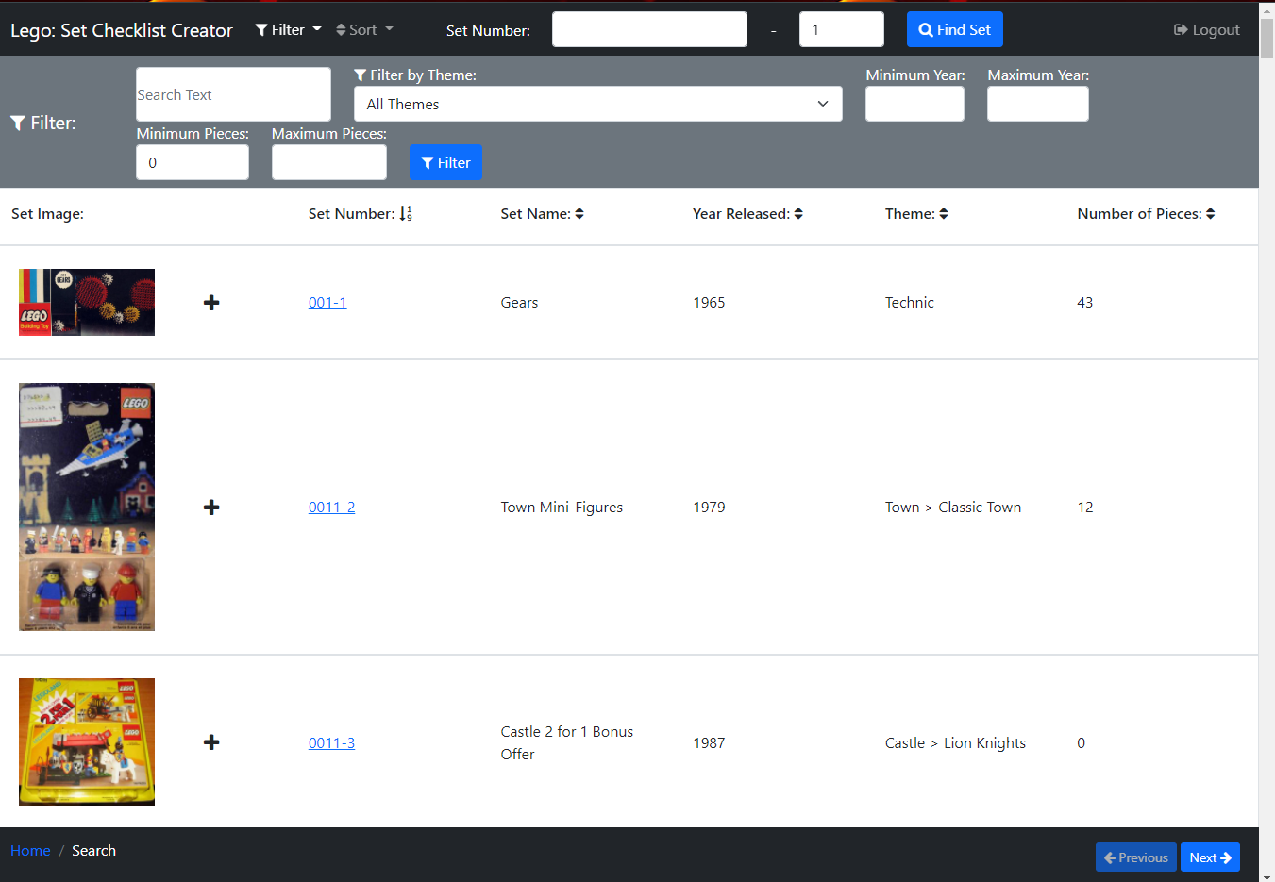

Figure 14: Search Page - Filter Bar Open

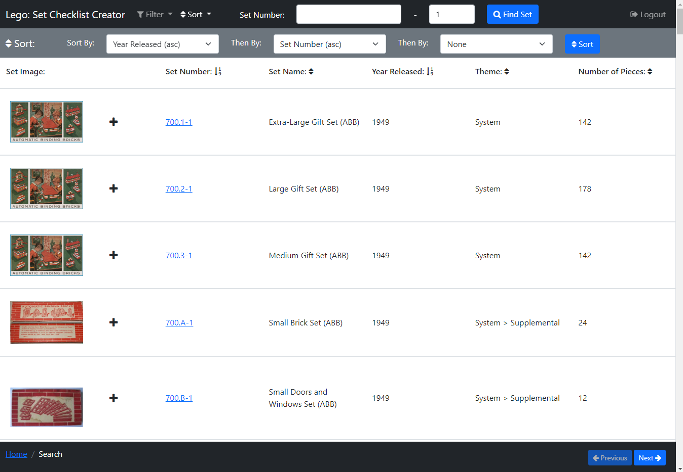

Figure 15: Search Page - Sort Bar Open

The Search Page (Figure 14 and Figure 15) can be accessed by clicking the ‘Search’ link on the secondary navbar on the Home Page (above), or the ‘BACK TO SEARCH’ button on the Set Page (below) or breadcrumb links on other pages. On this page users can search for a Lego Set they would like to view.

In the centre of the page, a list of Lego sets is displayed in rows, with columns displaying different bits of information on Lego sets. There is an image of each Lego Set in each row, that when clicked will open Figure 37 to view the image enlarged (see more detail below). There is a ‘plus’ icon button that only appears to signed-in users, that when clicked opens a popup (Figure 75) to add a set to a setlist.

Above the list of sets is a header that has the name for each column, so it is clear to the user what each of these columns contains. Each of these column names (excluding ‘Set Image’), has an arrow next to it, these show if the sets are being sorted by that column, with a down arrow showing the list is being sorted ascending in that column, an up arrow shows descending and an up-down arrow shows the sets are not being sorted by that column. For example, in Figure 14 the sets are being sorted by ‘Set Number’ ascending and not by any other column.

Clicking one of these arrows will sort the sets in the column the arrow is adjacent to. If a down arrow is clicked the sets will be sorted descending and the arrow will change to an up arrow, if it’s an up arrow they will be sorted ascending, and the arrow will change to a down arrow. If an up-down arrow is clicked the sets will be sorted ascending, and this arrow will change to a down arrow and any other arrows that are not up-down arrows will change to up-down as those columns are no longer being filtered. Clicking on an arrow to sort a list will remove any other sorts currently active including a multi-sort selected via the sort bar, which is explained below.

There is a scroll bar down the side of the page so users can scroll through this list of Lego Sets, and in the footer, at the bottom of the page there are two buttons ‘Previous’ and ‘Next’, which go to the previous page of sets or the next page of sets, these are disabled if it is the first list of sets or last list of sets respectively.

If the user clicks a Set’s set number, which is a hyperlink, Figure 17: Lego Set Information Page will open displaying the selected set.

In the navbar there is a link ‘Filter’ which opens a filter bar underneath the navbar (shown open in Figure 14), closing the sort bar (shown open in Figure 15) if it is open. Likewise, the ‘Sort’ link opens a sort bar underneath the navbar shown open in Figure 15, closing the filter bar if it is open. Then there is the Find Set Feature.

The filter bar (Figure 14) contains filters the user can use to filter the Lego Sets, there is a text box to search by text (e.g. ‘Clone’), a select box to filter by Lego Set Theme (e.g. Star Wars, Lego City, Batman), ‘Minimum Year’ and ‘Maximum Year’ number boxes that filter between these years, ‘Minimum Pieces’ and ‘Maximum Pieces’ number boxes that filters the sets by the minimum and the maximum number of Lego Pieces in the set and the ‘Filter’ button then applies these filters to all Lego Sets.

The sort bar (Figure 15) contains three select boxes so a user can perform a multi-sort, containing all the columns sorts ascending and descending with also the option of none. The first select must always be selected, and by default, the sets are sorted by ‘Set Number’. This is used by selecting a column to sort by and then the preceding column to sort by, up to a maximum of three columns, this means where the first column values of sets match then they are compared by the second column value instead e.t.c. There is then a ‘Sort’ button that when pressed applies this sort to the list. For example, in Figure 15 the sets are first being filtered by ‘Year Released’ ascending and then by ‘Set Number’ ascending, so the ‘Extra-Large Gift Set (ABB)’ and ‘Large Gift Set (ABB)’ both have ‘Year Released’ of ‘1949’ so they are then compared by ‘Set Number’ and as ‘Extra-Large Gift Set (ABB)’ has a set number of ’700.1-1’ and ‘Large Gift Set (ABB)’ has a set number of ’700.2-1’ therefore ‘Extra-Large Gift Set (ABB)’ appears first.

There are no differences between the initial design (Figure 12 and Figure 13) and the final design (Figure 14 and Figure 15) on this page, however, in the final design the ‘Sign in’ link has changed to ‘Login/SignUp’.

#### Set Page

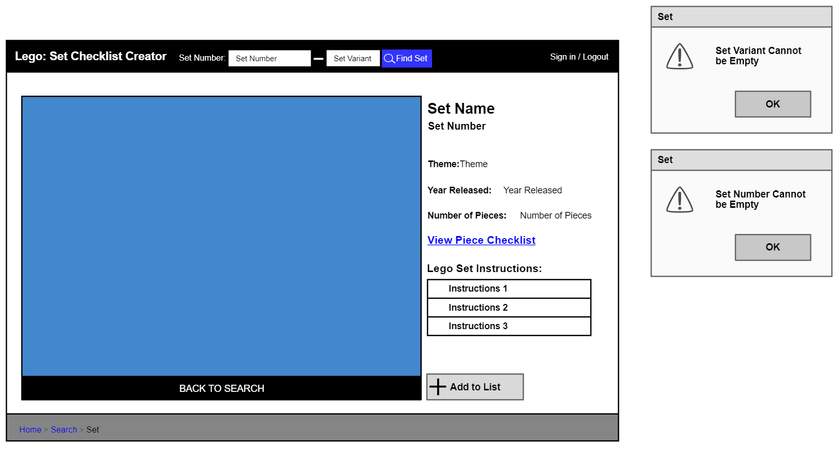

Figure 16: Initial Lego Set Information Page

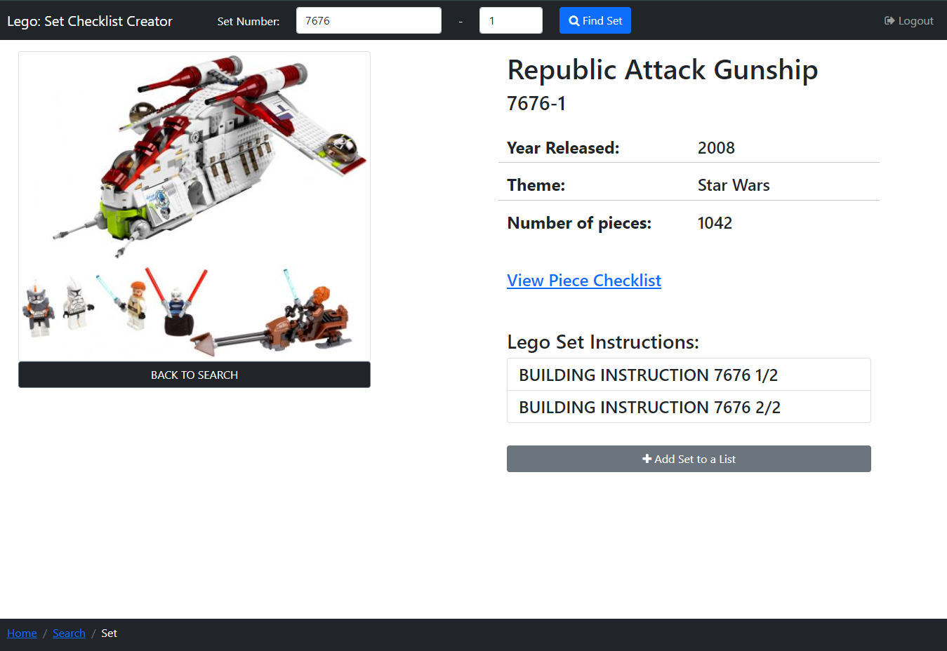

Figure 17: Lego Set Information Page

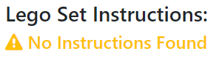

Figure 18: Lego Set - No Instructions

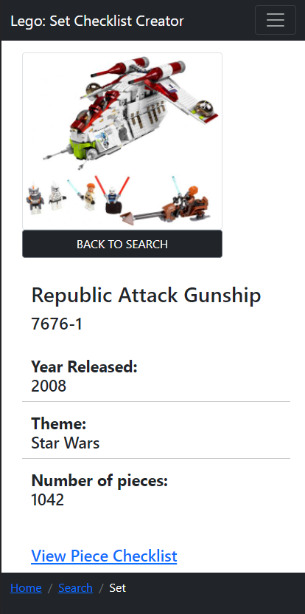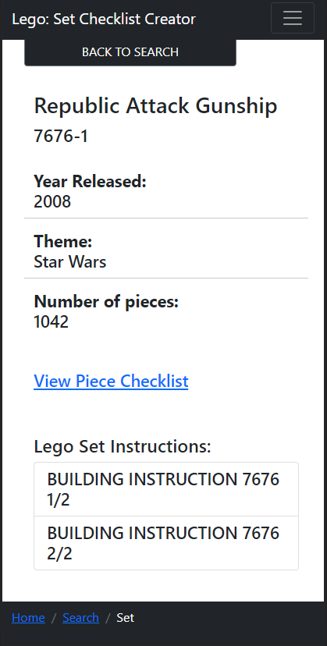

Figure 19: Set Information Page - Small Screen One Column

The Set Page (Figure 17) can be accessed by entering a Set Number and Variant in the Find Set Feature in the navbar on certain pages, it can also be accessed by clicking a Set’s ‘Set Number’ hyperlink on the Search Page (above), the Sets in Progress Page (below) and the Set List Page (below), or via the breadcrumb link on Piece Checklist Page (below).

On this page, users can view information on a Lego Set, view the Set’s building instructions, access the Set’s pieces in a checklist and signed in users can add the set to a setlist, this example Set ‘Republic Attack Gunship’ is being shown.

In the centre of the page, there is an image of a Lego Set that when clicked will open Figure 37 to view the image enlarged (see more detail below). Below this image is a ‘BACK TO SEARCH’ button which returns users to the Search Page with the previous Filters and Sorts applied. On the right of the image, information on the Lego Set is displayed.

Under this is the ‘View Piece Checklist’ hyperlink, which when clicked opens Figure 27: Piece Checklist Page, which displays a checklist of the Lego sets pieces (explained in more detail below).

There is some text ‘Lego Set Instructions’ beneath which, there are some boxes containing the names of Lego Set building instruction booklets, which when clicked opens the selected instruction booklet in a new tab on the browser being used where the user can view these. If there are no instruction booklets available for the Lego Set a yellow symbol and text appears instead (Figure 18), informing the user there are no instructions found. I added this text and made it yellow so it would draw a user’s attention and they could easily see that no instructions were found.

There is a ‘Add to List’ button that only appears to signed-in users, which when clicked opens a popup (Figure 75) to add a set to a setlist.

In the navbar, there is the Find Set Feature, that on this page, has the set number and set variant boxes pre-filled with this Set’s information, e.g. ‘7676’ and ‘1’, which I have added here because if the user has found the Set using the Find Set Feature, they the entered ‘Set Number’ and ‘Variant’ are still displayed.

When this page is viewed on a smaller screen the two columns are combined into one column that is the full width of the screen, which is shown in Figure 19. I did this so on a smaller screen it is still easy for users to see.

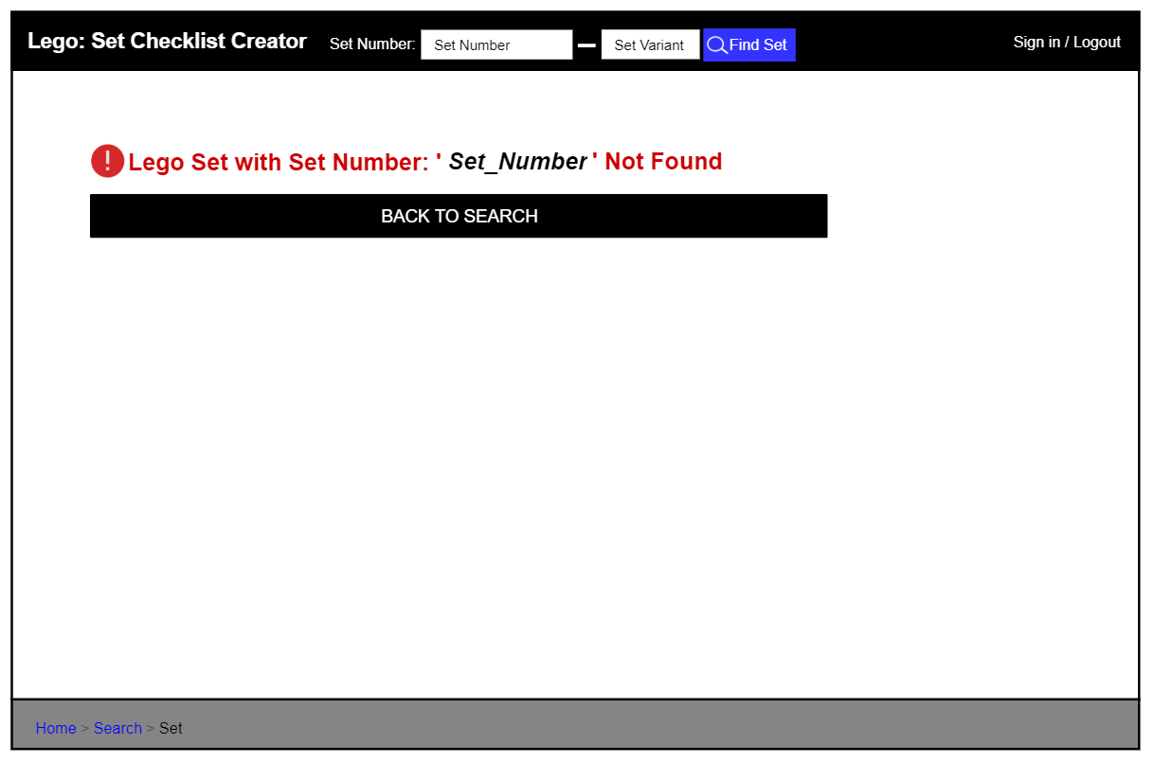

Figure 20: Initial Lego Set Not Found Page

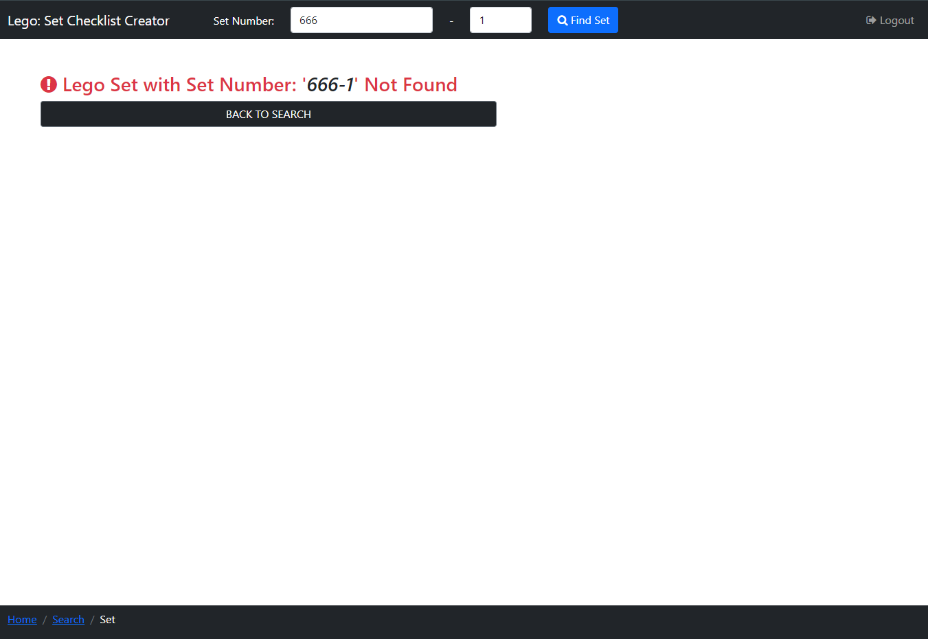

Figure 21: Lego Set Not Found Page

If the page is accessed by entering in a Set Number and this Set Number is not found, Figure 21 is displayed, this is mostly the same as Figure 17 (Lego Set Information Page) but the main body is replaced with a message informing the user that the set number (in this case ‘666-1’) entered was not found and with the same ‘BACK TO SEARCH’ button. I have put this message in red text with a recognised error logo so it draws the user's attention and is clear to users why a set has not been displayed.

The initial design for this page is shown in Figure 16 and Figure 20, and there are no differences between these and the final design (Figure 17 and Figure 21), apart from the ‘Sign in’ link which has changed to ‘Login/SignUp’ in the final design, and I also added Figure 18 to display if there were no instructions for the Lego Set, as before there was no information informing the user of this.

#### Set Number and Variant Find Set Feature - Errors



Figure 22: Initial Set Number Search Missing Number Error Popups



Figure 23: Set Number Search - Missing Set Number



Figure 24: Set Number Search - Missing Set Variant



Figure 25: Set Number Search - Missing Both Set Number and Variant

If a user clicks the ‘Find Set’ button in the navbar on the Home Page, Search Page and Set Page, but either the Set Number box or Set Variant box is empty, the set number is not searched for. If the Set Number box is empty it is highlighted red (Figure 23), or if the Set Variant box is empty it is highlighted red (Figure 24), and if both boxes are empty, they are both highlighted red (Figure 25). I have highlighted these empty boxes in red to show there is an error, as this is a recognised colour for errors. In Figure 23 and Figure 24 the Set Variant box and the Set Number Box are highlighted in green (respectfully) to make it clear to users these boxes are not the problem.

I had initially planned to use popups to display to the user if a number was missing (see Figure 22), but I decided to highlight the boxes in red as this makes it clear to the user that an error has occurred without the user having to spend time closing an alert popup breaking up their flow.

#### Piece Checklist Page

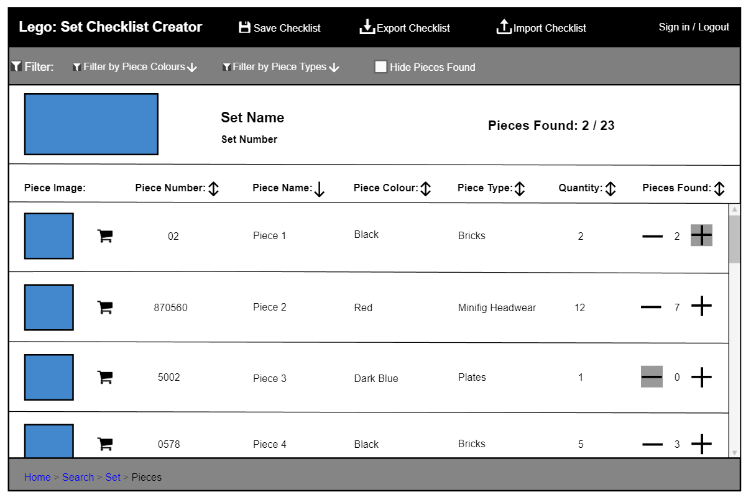

Figure 26: Initial Piece Checklist Page

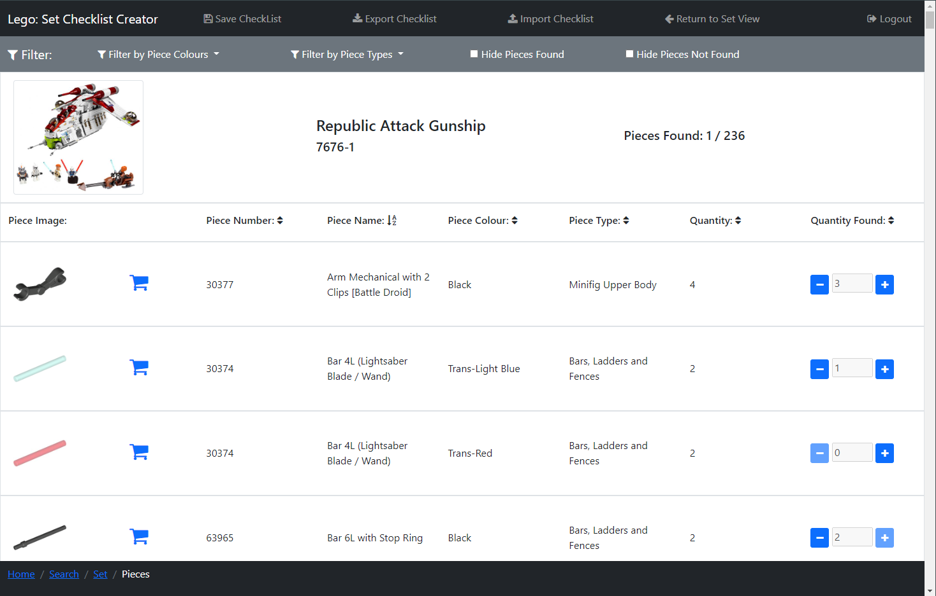

Figure 27: Piece Checklist Page

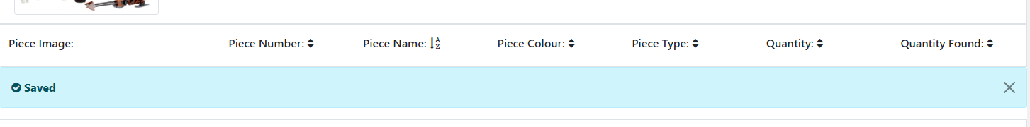

Figure 28: Piece Checklist Save Alert

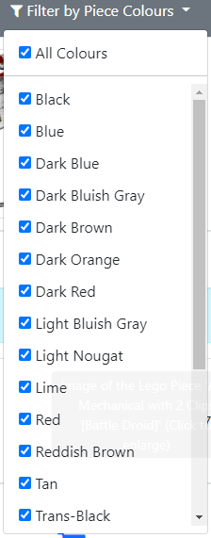

Figure 29: Piece Checklist Filter - Piece Colour

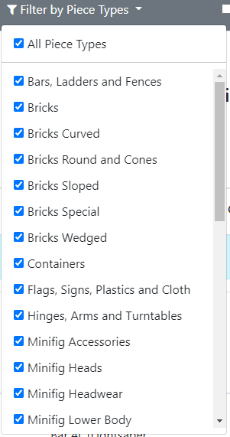

Figure 30: Piece Checklist Filter - Piece Type

The Piece Checklist Page (Figure 27) can be accessed by clicking the ‘View Piece Checklist’ link on the Set Page (Figure 17). On this page, users can view all Lego pieces in a set in a checklist and can check pieces off when they have been found, so the user can build said set.

In the centre of the page, the list of Lego pieces in the set are displayed in rows, with columns displaying different bits of information on Lego pieces. There is an image of each Lego Piece, that is the same colour as the piece, in each row, that when clicked will open Figure 36 to view the image enlarged (see more detail below). There is a ‘shopping cart’ icon button that when clicked opens the Lego pieces page on the Rebrickable website [6] where the user can view a list of websites to buy the Lego Piece. I used, this so if a user was missing a Lego piece that is required to build a Lego Set, they could then see a list of websites where they could buy the missing piece.

Each row has the piece’s name and colour so users can easily identify by the name and if there are multiple pieces with the same name then by their colour. There is also a ‘Quantity’ field which is the number of this piece required to build the set. There is a ‘Quantity Found’ field which is how many of this piece the user has found so far. This is initially set as 0 unless the user has imported the checklist or is a logged-in user who has previously saved the checklist to the database, as in these cases the ‘Quantity Found’ would be set as the same value as the imported or saved piece’s value.

There is a button on either side of the ‘Quantity Found’ number, a ‘minus’ and ‘plus’ icon buttons, that decrease and increase the ‘Quantity Found’ respectfully, with a minimum of 0 and the maximum of the ‘Quantity’ needed. When the ‘Quantity Found’ is 0 the ‘minus’ icon box is disabled and when it is the same as the ‘Quantity’ the plus icon is disabled, this is because the user should not be able to decrease or increase the ‘Quantity Found’ past these points.

Above the list of pieces is a header that has the name for each column, so it is clear to the user what each of these columns contains. Each of the column names (excluding ‘Piece Image’), has an arrow next to it, these show if the sets are being sorted by that column, which works the same as the Search Page above.

There is a scroll bar down the side of the page so users can scroll through this list of Lego Sets.

In the navbar, there is the ‘Save Checklist’ link, which only appears to a logged-in user, which when clicked saves the user's progress on the checklist, and a light blue dismissible alert appears under the piece list header informing the user of this (Figure 28). I used an alert here so it was clear to the user that the checklist was saved, it is dismissible so the user can remove it once they have read it. There is an ‘Export Checklist’ link that exports the checklist to the user's device and an ‘Import Checklist’ link that opens Figure 39: Import Checklist Popup where users can import a previously exported checklist. There is then a link ‘Return to Set View’ which returns the user to the Set Page (Figure 17) for this piece checklist.

There is a filter bar under the navbar that, contains filters the user can use to filter the Lego pieces. There is a dropdown ‘Filter by Piece Colours’ (Figure 29) where users can filter by all piece colours in the checklist, that has tick boxes allowing users to select all colours or tick only the piece colours they would like to view. There is another dropdown ‘Filter by Piece Types’ (Figure 30) that works the same as ‘Filter by Piece Colours’ but for the type of Lego Piece. There is a checkbox ‘Hide Pieces Found’ that hides all the pieces fully found (have a ‘Quantity Found’ that matches ‘Quantity’), which I added so users can easily see which pieces they still need to find. After this, a checkbox ‘Hide Pieces Not Found’ is the opposite of the last checkbox, and shows only those pieces fully found, which I added so if users wanted to decrease a piece’s ‘Quantity Found’ that is maxed, they could just view all pieces with a maxed out ‘Quantity Found’ to find it quicker.

Under the filter bar is a white row that has the image of the Lego Set the checklist is for, which when clicked will open Figure 37 to view the image enlarged (see more detail below). There is also the Set’s name and Set Number, which I added, so it was clear to users which set’s piece checklist they are currently viewing. Then there is ‘Pieces Found’ which to the right has how many pieces have fully been found out of the total number of different types and colours of pieces in the checklist.

I made some changes from the initial design of this page (Figure 26) and the final design (Figure 27). I added the ‘Return to Set View’ link, as apart from the breadcrumb link there was no other way to easily return to this Piece checklist’s Lego Set information page (Figure 17). I also added the checkbox ‘Hide Pieces Not Found’ as, as mentioned above, if users wanted to decrease a ‘Quantity Found’ of a fully found piece, they could just view the pieces that had been fully found to find it quicker. I also added the Save Alert (Figure 28) in the final design, so it was clear to users the checklist was successfully saved.

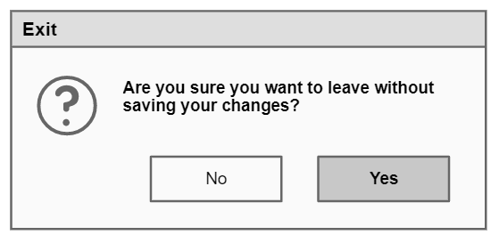

Figure 31: Initial Exit Checklist without Saving Popup

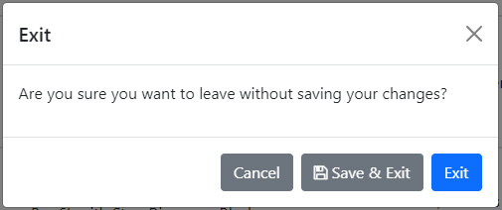

Figure 32: Exit Checklist without Saving Popup

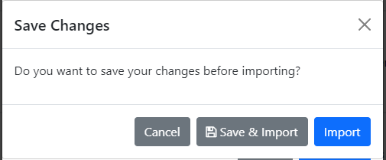

Figure 33: Import Checklist without Saving Current Checklist Popup

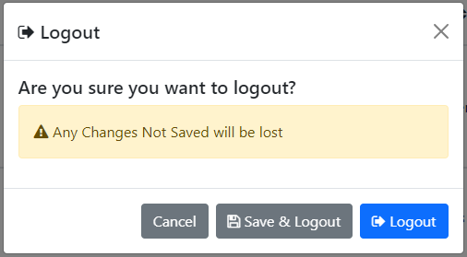

Figure 34: Logout without Saving Checklist Popup

When a logged-in user tries to exit this page after making changes to the piece quantities without saving, a popup (Figure 32) appears asking the user if they want to leave without saving their changes. There is a ‘Save & Exit’ button that saves the checklist progress before letting the user exit the page and an ‘Exit’ button which closes the popup and allows the user to leave the page.

If the user is trying to import a checklist using Figure 39 (explained below) and clicks the ‘Import’ button without saving changes to the checklist, a second popup (Figure 33) opens over the top of this popup. The second popup informs the user the checklist is not saved, with a ‘Save & Import’ button that saves the checklist before attempting the import and an ‘Import’ button which attempts the import.

If the user tries to logout after making changes to the checklist a popup Figure 34 appears instead of Figure 57. This popup is the same as Figure 57 (see below) but with the addition of a yellow alert (which is yellow to draw the user's attention so they read it), informing the user their changes won’t be saved and a ‘Save & Logout’ button that will save the checklist before continuing the Logout process (for more detail see below).

Compared to the initial design (Figure 31), in the final design (Figure 32, Figure 33 and Figure 34) I have added the option to save and continue on the popup, as this makes it easier to save and leave, as well as making more specific popups to leave without saving (Figure 33 and Figure 34).

#### Image Popups

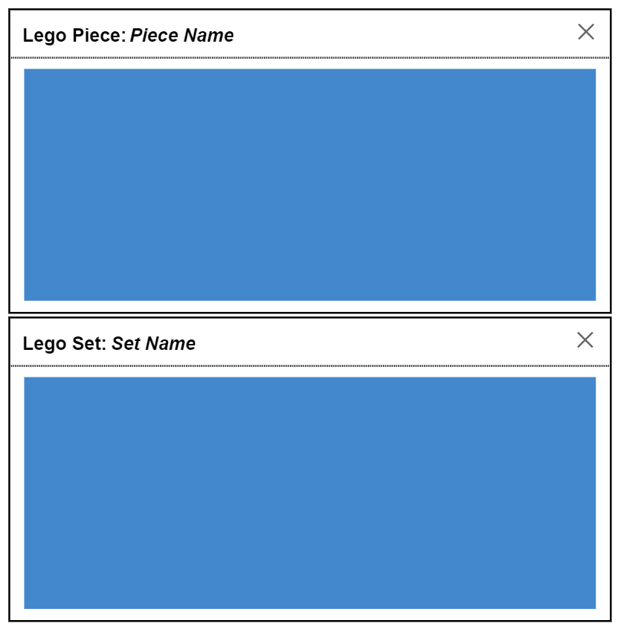

Figure 35: Initial Popups for Piece Images and Set Images

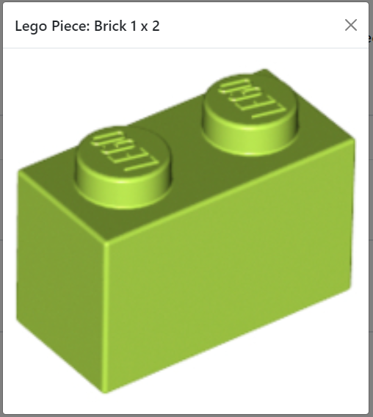

Figure 36: Popup for Piece Image

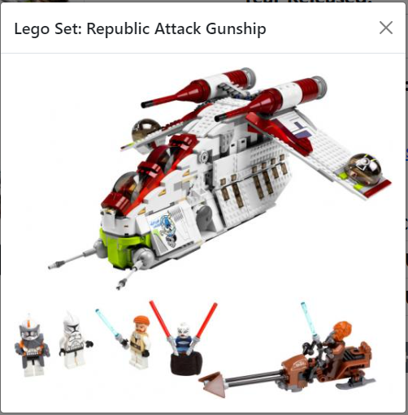

Figure 37: Popup for Set Image

Figure 36 and Figure 37 are two popups both of which display images. Figure 36 displays the image of a Lego Piece (in this case ‘Brick 1 x 2’) and Figure 37 displays the image of a Lego Set (in this case ‘Republic Attack Gunship’). These popups are opened when a picture of a Lego Piece or Lego Set is clicked on. These popups are used so that if the image on the page is small, users can expand it so they can see it easier. The ‘X’ in the top right corner of both popups dismisses them.

Figure 35 shows the initial design of both popups which are the same as the final design.

#### Import Checklist Popup

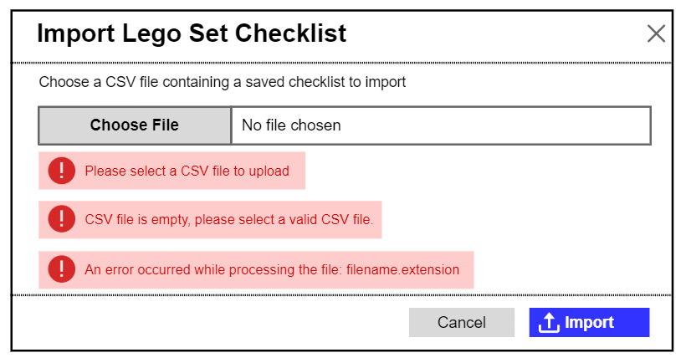

Figure 38: Initial Import Checklist Popup

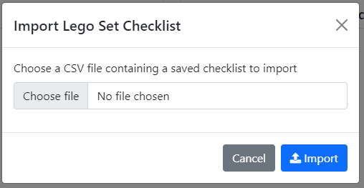

Figure 39: Import Checklist Popup

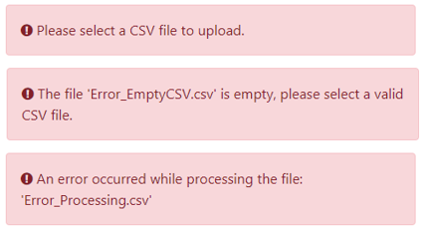

Figure 40: Import Checklist Error Alert Boxes

The import checklist popup (Figure 39) is used to import a Lego Set Piece checklist CSV file that has been previously exported and is opened via clicking the ‘Import Checklist’ link in the navbar on the Home Page or the Piece Checklist Page (Figure 27). Clicking the ‘Choose File’ button will open the file browser on the system the user is viewing the website on, they can then select a file to upload to the website. The name of this file will then replace the ‘No file chosen’ text.

The ‘Import’ button when clicked will try to import the selected file, if the file is valid (in the right format and a CSV file) the pieces stored will be imported and the user will be redirected to Figure 17: Lego Set Information Page. If they then click the ‘View Piece Checklist’ link on that page, Figure 27: Piece Checklist Page will be opened showing the pieces of the imported set, with the piece quantities found matching those from the imported CSV file.

There are also three error alerts in Figure 40 in red boxes, these are displayed when the user clicks the ‘Import’ button but there is an error while importing. These alert boxes appear beneath the ‘Choose File’ button and the ‘Choose File’ button and the box adjacent are both highlighted red to show there is an error. The top error alert is displayed if a file is not selected, the second alert is displayed if the CSV file is empty (where ‘Error_EmptyCSV.csv’ is the file the user tried to import), and the third alert is displayed if the file is not a CSV file or not correctly formatted so cannot be read (where ‘Error_Processing.csv’ is the file the user tried to import). Here I have used these alerts in the popup instead of a separate alert popup, as this makes it clear to the user that an error has occurred, without the user having to spend time closing an alert popup breaking up their flow. The name of the file that could not be imported is displayed in the popups so users can see which file they tried to import.

The initial design for this popup (Figure 38) is the same as the final design (Figure 39 and Figure 40), apart from some rewording of alert boxes text (Figure 40).

#### Login and Sign-Up Popup

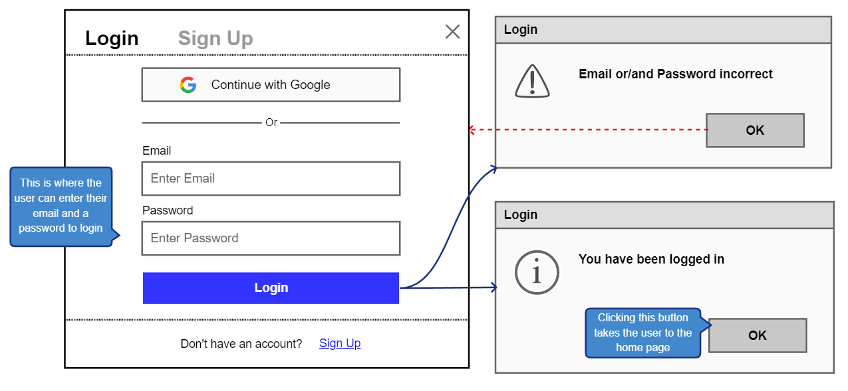

Figure 41: Initial Login and Sign Up Popup – Login Tab Selected

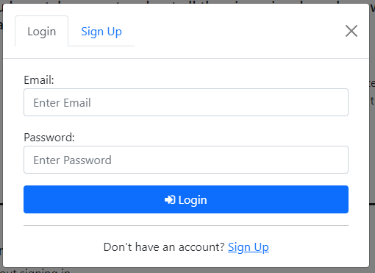

Figure 42: Login and Sign-Up Popup – Login Tab Selected

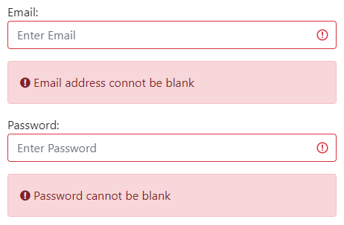

Figure 43: Login/Sign Up Error – Email Blank



Figure 44: Login Error – Password Blank

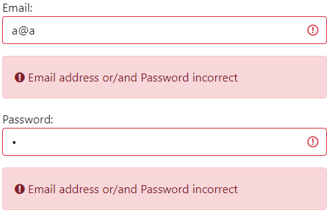

Figure 45: Login Error – Email or Password incorrect

When the ‘Login/SignUp’ link is clicked in the black navbar on the Home Page, the Search Page, the Set Page or the Piece Checklist Page, a popup (Figure 42) appears where users can Login or create an account.

There are two tabs at the top of the popup, in Figure 42 there is a ‘Login’ tab (which is selected), and there is a ‘Sign Up’ tab adjacent, which when clicked opens the Sign-Up tab in the popup (Figure 47). As the ‘Login’ tab is selected in the main body of the popup there are input boxes where user can enter their details to login to their account. At the bottom of the popup is some text and a hyperlink ‘Sign Up’ which also opens the Sign-Up tab in the popup (Figure 47).

There is an ‘Email’ input box where the user must enter the email address connected to their account and a ‘Password’ input box where the user must enter their account’s password. If the entered email is not valid the corresponding Invalid Alert will be displayed (see Entered Email Invalid Alerts below for more details). There is a ‘Login’ button that checks the user’s entered email and password. If the ‘Email’ or ‘Password’ input boxes are blank, they are highlighted red and the red alert boxes in Figure 43 and Figure 44 are shown respectfully.

If the entered email address does not belong to an account, or if it does belong to an account but the entered password is incorrect, then error alert boxes will appear (Figure 45) informing the user the ‘Email’ or ‘Password’ is incorrect and highlighting the ‘Email’ and ‘Password’ input boxes in red. Here I decided to use an ambiguous message if the email or password were wrong, as this way an attacker could not trial and error their way into logging into an account as they would not know if the entered email address belongs to an account or not.

Error alerts and input boxes are highlighted red for errors so users can easily see this is an error.

If the entered email belongs to an account and the password entered matches the account's stored password, then the user is logged into their account. After this, the popup is closed, and the logged-in Home Page is shown (Figure 11).

In the initial design for the ‘Login’ tab (Figure 41) I had planned to use popups to inform the user the entered Email or Password was incorrect, however, in the final design (Figure 45) I chose to use error alert boxes to inform the user of this, I made this decision so the user wouldn’t have to spend time closing alert popups breaking up their flow. I also removed the logged in alert popup in the final design, as I felt it was obvious to the user they had logged in as the Home Page displayed (Figure 11) is different to the logged-out Home Page (Figure 9).

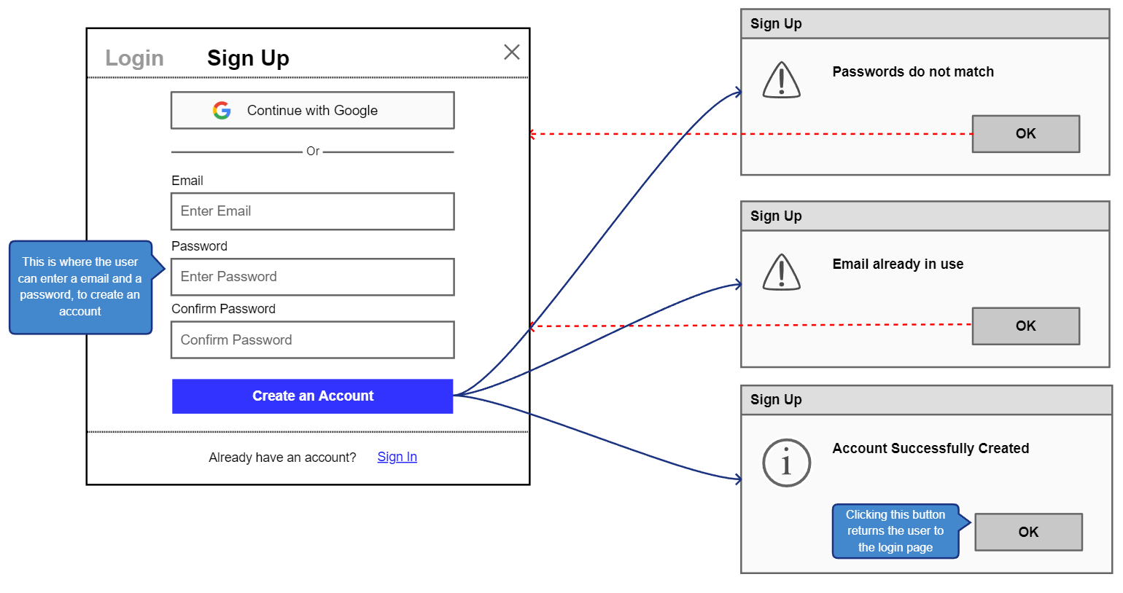

Figure 46: Initial Login and Sign-Up Popup – Sign Up Tab Selected

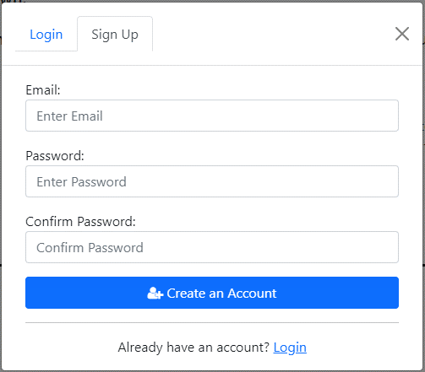

Figure 47: Login and Sign-Up Popup – Sign Up Tab Selected

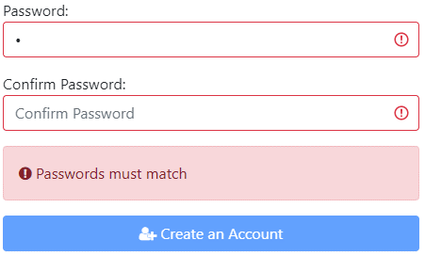

Figure 48: Sign Up Error – Passwords Must Match

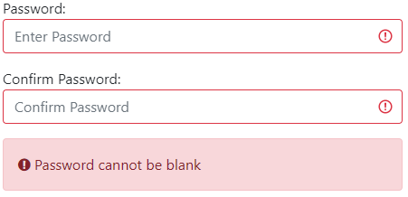

Figure 49: Sign Up Error – Password Blank

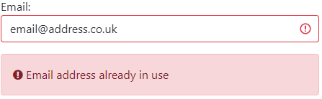

Figure 50: Sign Up Error – Email Not Unique

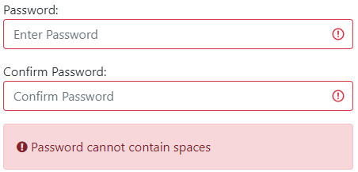

Figure 51: Sign Up Error – Password Cannot Contains Spaces

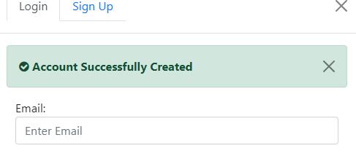

Figure 52: Account Created Alert

The ‘Sign Up’ tab (Figure 47) in the Login and Sign-Up Popup is opened by selecting the ‘Sign Up’ tab at the top of the popup, or the ‘Sign Up’ link at the bottom of the Login tab body (Figure 42).

At the top of the popup, in Figure 47 the ‘Sign Up’ tab is selected, and the ‘Login’ tab when clicked opens the Login tab in the popup (Figure 42). As the ‘Sign Up’ tab is selected in the main body of this popup there are input boxes where user can enter their details to create an account. At the bottom of the popup is some text and a hyperlink ‘Login’ which also opens the Login tab in the popup (Figure 42).

There is an ‘Email’ input box where the user must enter the email address they would like to use for their account. If the entered email is not valid the corresponding Invalid Alert will be displayed (see Entered Email Invalid Alerts below for more details).

There is a ‘Password’ input box where they can input a password for their account, and a ‘Confirm Password’ input box, that checks the user entered the password they meant, as text is hidden in these input boxes. If the text enter in the ‘Password’ and ‘Confirm Password’ input boxes do not match they are highlighted red and a red error alert box will appear (Figure 48) informing the user that they don’t match and disabling the ‘Create Account’ button.

The ‘Create Account’ button checks both the user’s entered email address and password when clicked.

If the ‘Email’ or ‘Password’ and ‘Confirm Password’ input boxes are blank, they are highlighted red and the red alert boxes in Figure 43 and Figure 49 are shown respectfully. If the email entered belongs to another account, then an error alert box will appear (Figure 50) informing the user of this and highlighting the ‘Email’ input box in red. If the new password contains spaces, the ‘Password’ and ‘Confirm Password’ input boxes are highlighted red and the red alert boxes in Figure 51 are shown. Error alerts and input boxes are highlighted red for errors so users can easily see this is an error.

If the entered email address is valid and not in use and the ‘Password’ is not blank and does not contain spaces, then a new account is created for the user using this email and password. Then the ‘Login’ tab (Figure 42) is displayed in the popup, with a light green dismissible alert (Figure 52) opening under the popup header, informing the user that they have successfully created an account. I chose to direct users to the ‘Login’ tab as if a user is creating an account it's likely afterwards, they would like to use it.

In the initial design for the ‘Sign Up’ tab (Figure 46) I had planned to use popups to inform the user that the ‘Password’ and ‘Confirm Password’ did not match, the email was already in use, and their account was created. However, in the final design (Figure 48, Figure 50 and Figure 52) I chose to use error alert boxes for non-matching passwords, email not unique, and a dismissible alert when an account was created. I made this decision so the user wouldn’t have to spend time closing alert popups breaking up their flow.

In the initial design of the whole popup (Figure 41 and Figure 46) there is a button ‘Continue with Google’ in both the ‘Sign Up’ and ‘Login’ tabs, that when clicked would allow users to sign-up and login with a Google account, but I removed this in the final design (Figure 42 and Figure 47), as this feature was not essential to the website as there is already another way to sign-up and login, and so I felt that my time would be better spent on implementing other features.

#### Entered Email Invalid Alerts

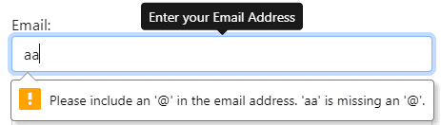

Figure 53: Login/SignUp Error Email should contain '@'

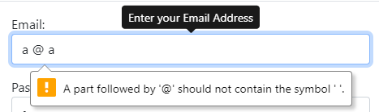

Figure 54: Login/SignUp Error Email Should not contain spaces

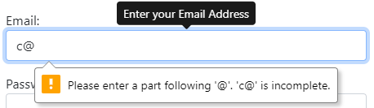

Figure 55: Login/SignUp Error Email not complete

If the user enters an email address in the input boxes in the Login and Sign-Up Popup (Figure 42 and Figure 47) or the Change Email Popup (Figure 95), and this entered email is invalid a popup appears under the input box informing the user of this.

If the email is missing an ‘@’ symbol Figure 53 informs the user of this, if it contains spaces Figure 54 informs the user, and if there is no text following the ‘@’ symbol Figure 55 informs the user.

#### Logout Popup

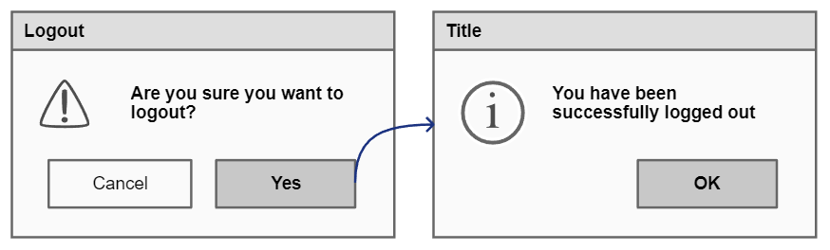

Figure 56: Initial Logout Popup

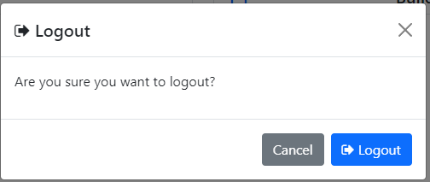

Figure 57: Logout Popup

The Logout Popup (Figure 57) appears when a user clicks the ‘Logout’ link in the navbar on all pages (only visible when logged in), this is used to confirm they want to logout and stops users from logging out by misclicking. The ‘Logout’ button logs out the user and returns them to the Home Page (Figure 9).

In the initial design (Figure 56) I had planned to have a logged out confirmation popup informing users they have been logged out, however, I choose to not use this because I felt it was clear to users as they are sent to the logged-out home page (Figure 9).

#### Sets in Progress Page

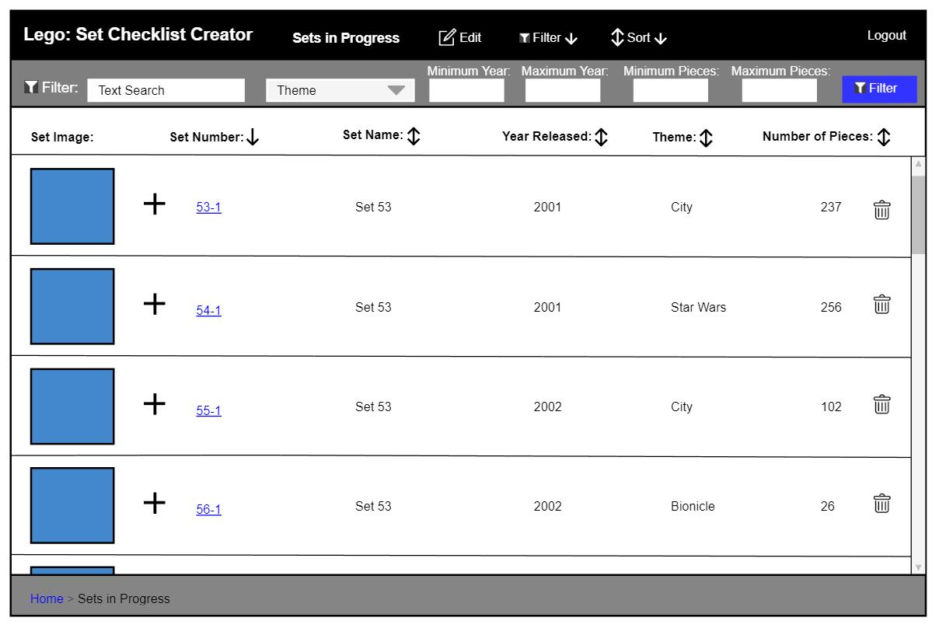

Figure 58: Initial Sets in Progress - Filter Bar Open

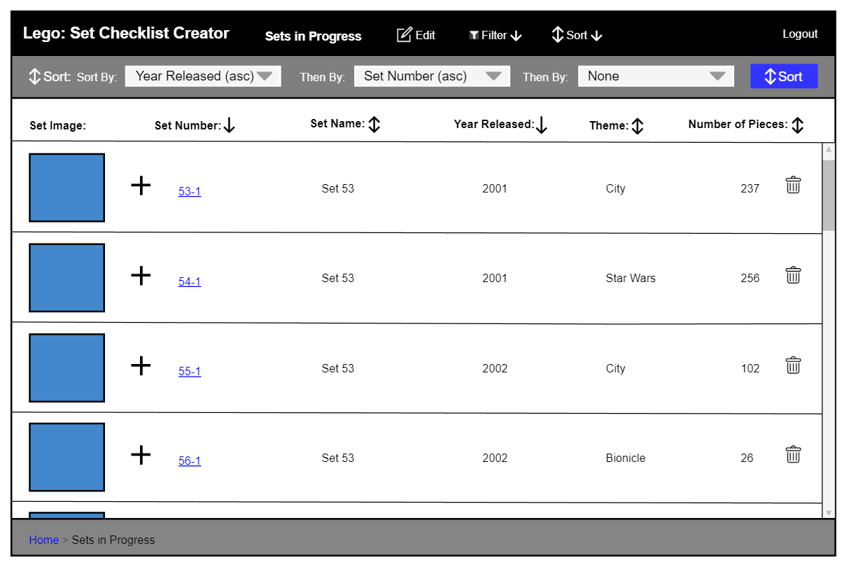

Figure 59: Initial Sets in Progress - Sort Bar Open

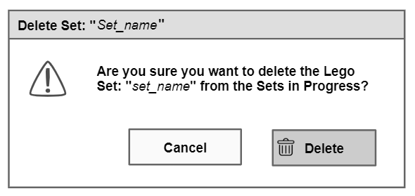

Figure 60: Initial Delete Set from Sets in Progress Popup

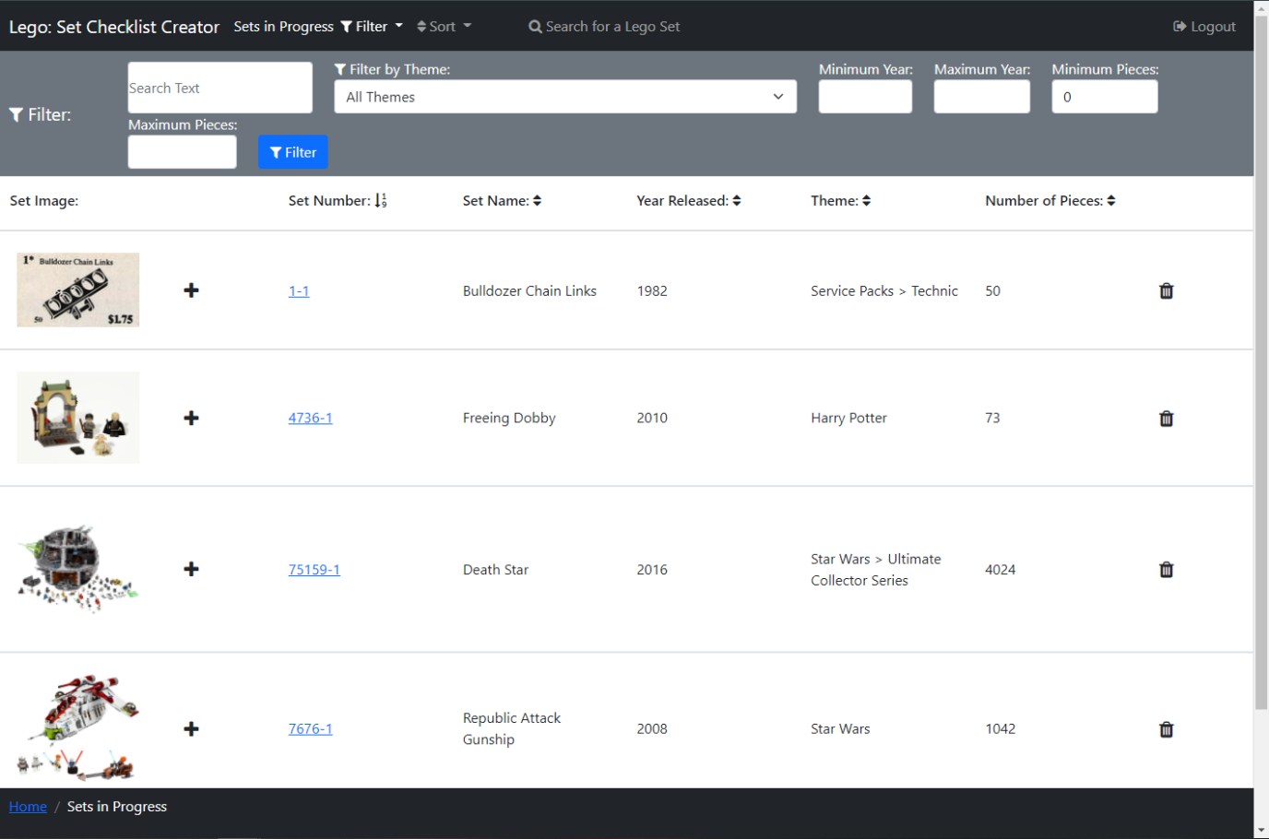

Figure 61: Sets in Progress - Filter Bar Open

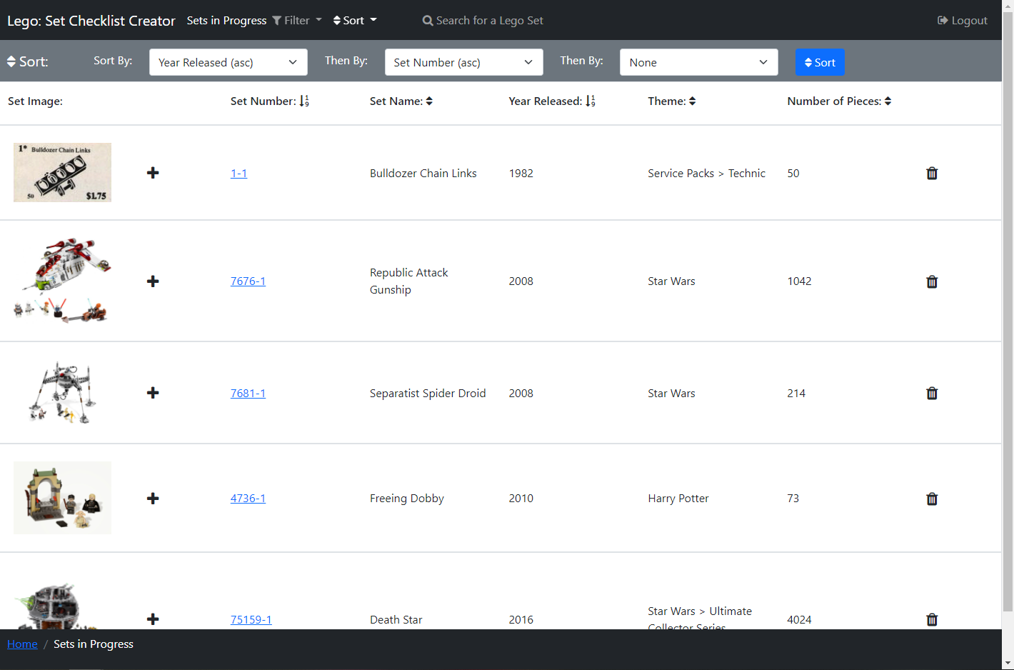

Figure 62: Sets in Progress - Sort Bar Open

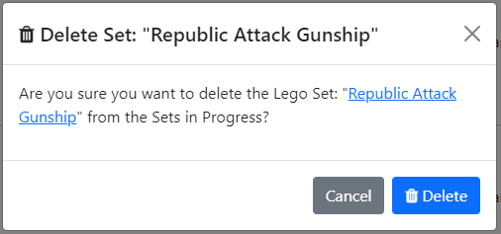

Figure 63: Delete Set from Sets in Progress Popup



Figure 64: Deleted Set from Sets in Progress Alert

The Sets in Progress Page (Figure 61 and Figure 62) can be accessed by a user, who is logged in, by clicking the ‘Sets in Progress’ link in the secondary navbar on the Home Page (Figure 11). On this page, users can search their Sets in Progress to find a Set they wish to continue a checklist for.

Similar to the Search Page, in the centre of the page, a list of Lego sets is displayed in rows, with columns displaying different bits of information on Lego sets. There is an image of each Lego Set in each row, that when clicked will open Figure 37 to view the image enlarged (see more detail above). There is a ‘plus’ icon button that when clicked opens a popup (Figure 75) to add a set to a setlist.

There is a ‘bin’ icon in each set row, that when clicked a popup (Figure 63) appears asking the user if they want to delete the selected set from their sets in progress, this is used so that users don’t accidentally delete a set from Sets in Progress by misclicking. The text ‘Republic Attack Gunship’ is replaced with the name of the set that will be deleted, and the second set name is a hyperlink to the Set Page (Figure 17) so users can check the set they are going to delete before they delete it. There is a ‘Delete’ button that will delete the selected set from the Sets in Progress, and a light blue dismissible alert (Figure 64) appears under the list of sets header informing the user of this, with the set name (in this case ‘Republic Attack Gunship’) a hyperlink to the deleted Sets page (Figure 17).

Above the list of sets is a header that has the name for each column, so it is clear to the user what each of these columns contains. Each of the column names (excluding ‘Set Image’), has an arrow next to it, these show if the sets are being sorted by that column, which works the same as the Search Page above.

There is a scroll bar down the side of the page so users can scroll through this list of Lego Sets.

If the user clicks a Set’s set number, which is a hyperlink, Figure 17: Lego Set Information Page will open displaying the selected set. If they then click the ‘View Piece Checklist’ link on that page Figure 27: Piece Checklist Page will be opened showing the saved progress of the Set, with the piece quantities found matching those saved previously.

In the navbar, there is text informing the user they are viewing their Sets in Progress, a link ‘Filter’ which opens a filter bar underneath the navbar (shown open in Figure 61), closing the sort bar (shown open in Figure 62) if it is open. Likewise, the ‘Sort’ link opens a sort bar underneath the navbar shown open in Figure 62, closing the filter bar if it is open. Then there is a link ‘Search for a Lego Set’ which opens the Search Page (above).

The filter bar (Figure 61) contains filters the user can use to filter the Lego Sets and functions the same as on the Search Page but filtering a user’s Sets in Progress instead of sets from the Rebrickable API [1].

The sort bar (Figure 62) contains three select boxes so a user can perform a multi-sort, which functions the same as on the Search Page but sorts a user’s Sets in Progress instead.

There are not many differences between the initial design (Figure 58 and Figure 59) and the final design (Figure 61 and Figure 62), however, there is a link ‘Edit’ in the initial design which is removed because there is nothing a user needs to edit in the Sets in Progress, instead, I added the ‘Search for a Lego Set’ link so users could go and find another set to complete straight from this page. I added a hyperlink to the set number in the final delete popup design (Figure 63) for the reasons explained above, whereas it is not in the initial design (Figure 60). I also added the Deleted Set Alert (Figure 64) in the final design, so it was clear to users the set was successfully deleted from the Sets in Progress.

#### Set Lists Page

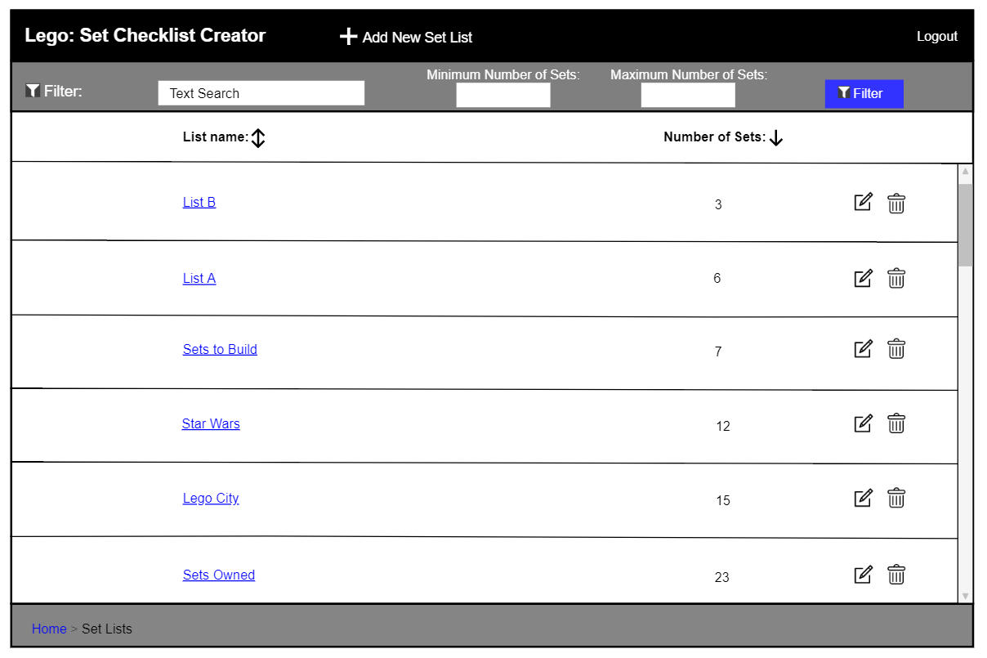

Figure 65: Initial Set Lists Page

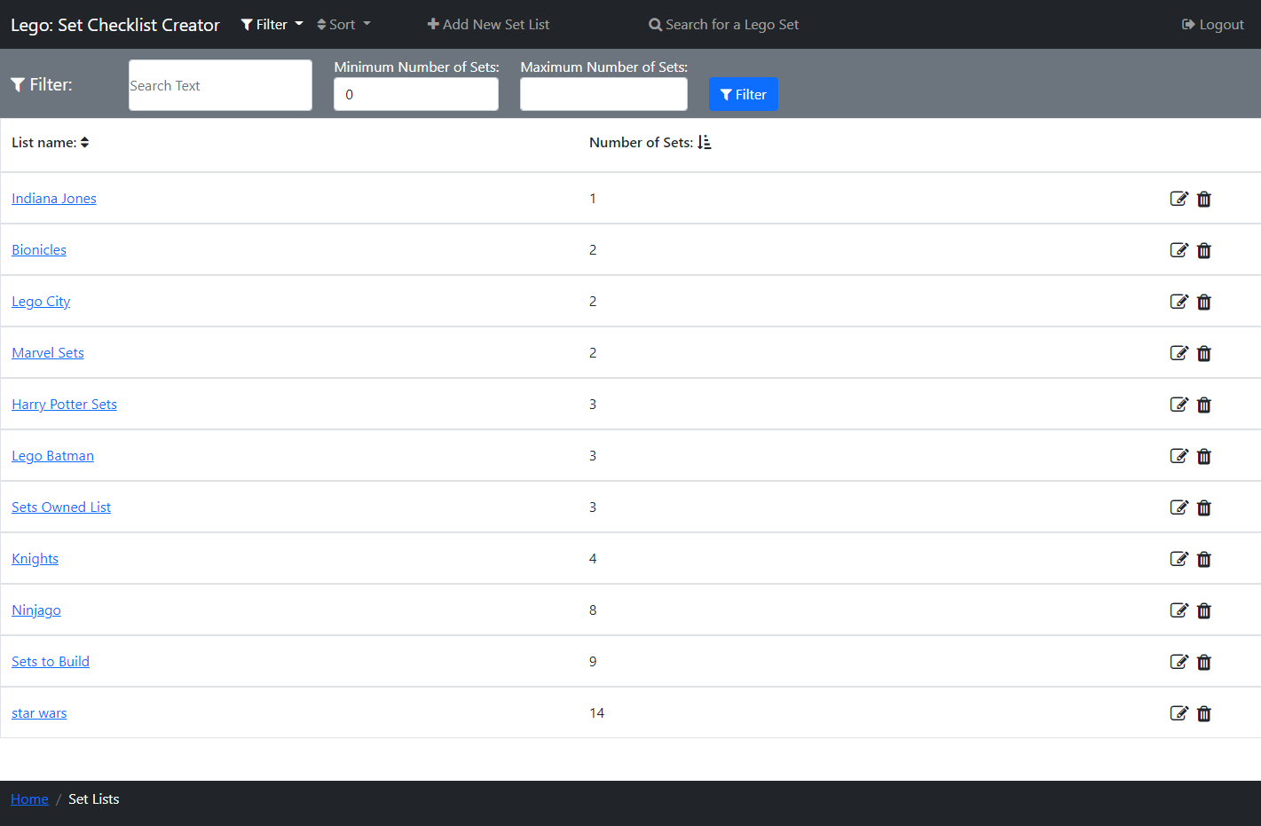

Figure 66: Set Lists Page - Filter Bar Open

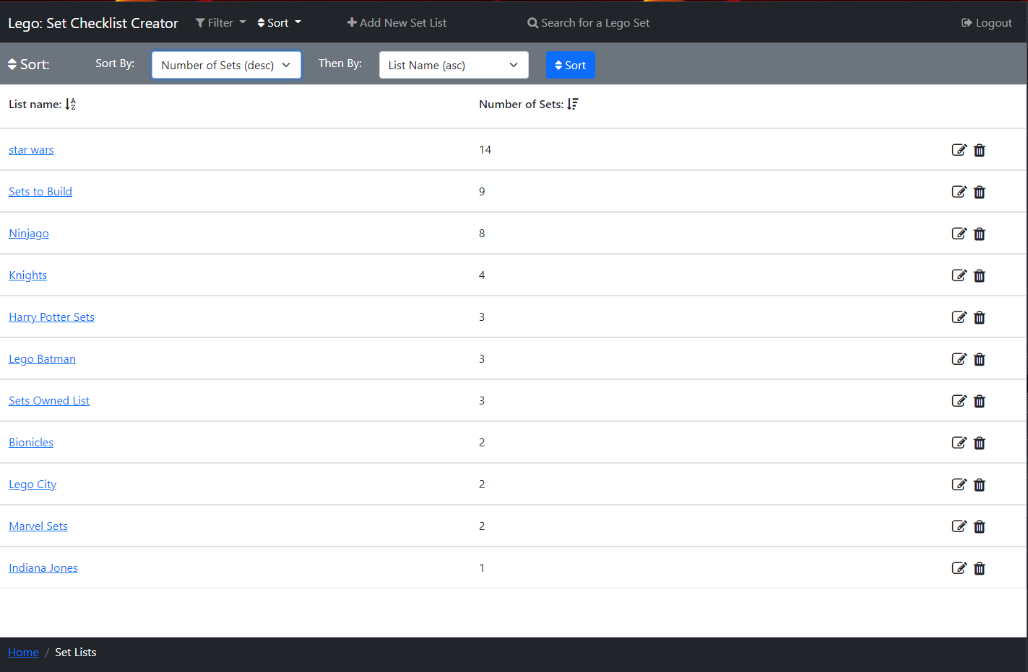

Figure 67: Set Lists Page - Sort Bar Open

The Set Lists Page (Figure 66 and Figure 67) can be accessed by a user, who is logged in, by clicking the ‘View Set lists’ link in the secondary navbar on the Home Page (Figure 11), or via the breadcrumb link on the Set List Page. On this page, users can view their Setlists saved to the database.

Similar to the Search Page, in the centre of the page, a list of the user's setlists is displayed in rows, with columns and a header displaying the ‘List Name’ and ‘Number of Sets’ in the setlist. If the user clicks a Setlist’s ‘List Name’ hyperlink, the Set Lists Page (above) will open displaying the selected setlist.

There is an ‘edit’ icon in each setlist row, that when clicked opens a popup (Figure 85) that allows the user to change the name of the selected Setlist, and also a ‘bin’ icon, that when clicked opens a popup (Figure 89) that allows users to delete the selected Setlist.

The list of setlists header has the name for both columns, so it is clear to the user what each of these columns contains. Both column names have an arrow next to them, that shows if the setlists are being sorted by that column, which works the same as the Search Page above.

There is a scroll bar down the side of the page so users can scroll through this list of Lego Sets.

In the navbar, there is a link ‘Filter’ which opens a filter bar underneath the navbar (shown open in Figure 66), closing the sort bar (shown open in Figure 67) if it is open. Likewise, the ‘Sort’ link opens a sort bar underneath the navbar shown open in (Figure 67), closing the filter bar if it is open. Next to this, there is a link ‘Add New Set List’ that when clicked, opens the Create New Set List Popup (Figure 70) where users can create a new setlist to add the set too, then there is a link ‘Search for a Lego Set’ which opens the Search Page (above).

The filter bar (Figure 66) contains filters the user can use to filter the Setlists, there is a text box to search by text in the list name (e.g. ‘City’), ‘Minimum Number of Sets’ and ‘Maximum Number of Sets' number boxes that filter between these number of sets and the ‘Filter’ button then applies these filters to the Setlists.

The sort bar (Figure 67) contains two select boxes so a user can perform a multi-sort, containing all the columns sorts ascending and descending, with also the option of none. The first select must always be selected, and by default, the sets are sorted by ‘List name’. This is used by selecting a column to sort by and then the preceding column to sort by, this means where the first column values of sets match then they are compared by the second column value instead. There is then a ‘Sort’ button that when pressed applies this sort to the list. For example, in Figure 67 the sets are first being filtered by ‘Number of Sets’ descending and then by ‘List name’ ascending, so the ‘Harry Potter Sets’ and ‘Lego Batman’ setlists both have a ‘Number of Sets’ of ‘3’ so they are then compared by ‘List Name’ and as alphabetically ‘Harry Potter Sets’ is above ’Lego Batman’ therefore ‘Harry Potter Sets’ appears first.

There are a few differences between the initial design (Figure 65) and the final design (Figure 66 and Figure 67). I added the ‘Search for a Lego Set’ link so users could go and find another set to add to a setlist straight from this page. I also added the sort bar (see open in Figure 67) in the final design, as I felt users would benefit from being able to perform a multi-sort on their setlists.

#### Create New Set List Popup

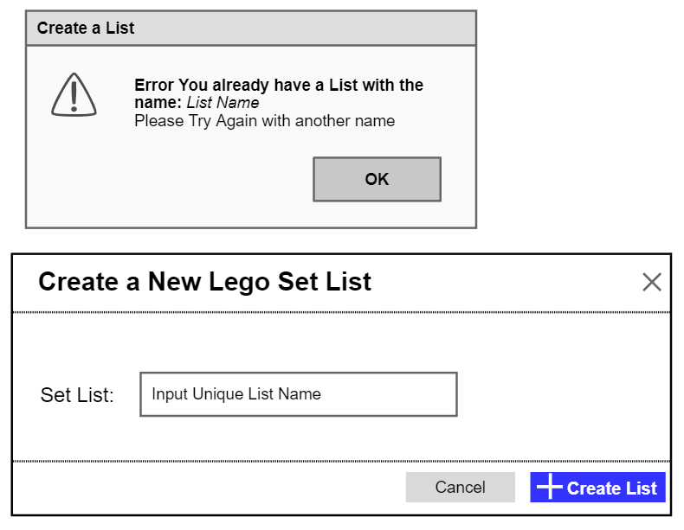

Figure 68: Initial Create New Set List Popup



Figure 69: Initial Create Set List Error – Name Not Unique

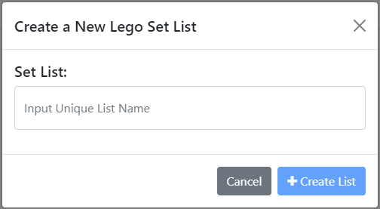

Figure 70: Create New Set List Popup

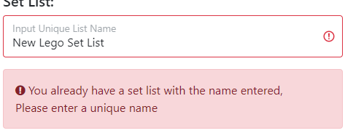

Figure 71: Create Set List Error – Name Not Unique



Figure 72: Created New Set List Alert

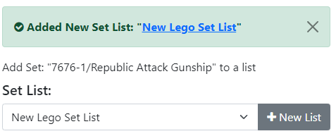

Figure 73: Small Created New Set List Alert on Add Set to a List Popup

The Create New Set List Popup (Figure 70) is displayed when a logged-in user clicks the ‘Add New Set List’ button on the Set Lists Page (above) or clicks the ‘New List’ button on the Add Set to Set List Popup (Figure 75 below). Using this popup users can create a new Set List by entering the name they would like the setlist to have in the text box, where ‘Input Unique List Name’ is a placeholder.

If the setlist name entered matches one of the user's saved setlist names then an error alert box will appear (Figure 71) informing the user the name must be unique and highlighting the input box in red so users can easily see this is the error, also while the name matches the ‘Create List’ button is disabled.

There is a tick box which has to be ticked to activate the ‘Create List’ button that, when clicked, will create a new setlist with the entered name and then close the popup. If the user opened the popup from the Set Lists Page a light green dismissible alert (Figure 72) appears under the navbar and filter or sort bar on that page, or if they opened the popup using the Add Set to a Set List Popup a light green dismissible alert (Figure 73) appears underneath the Add Set to a Set List Popup header, with the new setlist selected in the selector. Both these popups inform the user a setlist has been created, where ‘New Lego Set List’ is the name of the user’s setlist, which is a hyperlink to the that Set’s Set List Page (below). I made this a hyperlink so that users could easily access their new setlist instantly.

There are a few differences between the initial design (Figure 68) and the final design (Figure 70). I had initially planned to use a popup to display to the user if the setlist name entered was not unique (Figure 69), but I decided to highlight the textbox in red with a red alert box (Figure 71) this makes it clear to the user that an error has occurred, without the user having to spend time closing an alert popup breaking up their flow. Finally, I added the Created Set List Alert in the final design (Figure 72 and Figure 73), so it was clear to users the setlist name was successfully changed.

#### Add Set to a Set List Popup

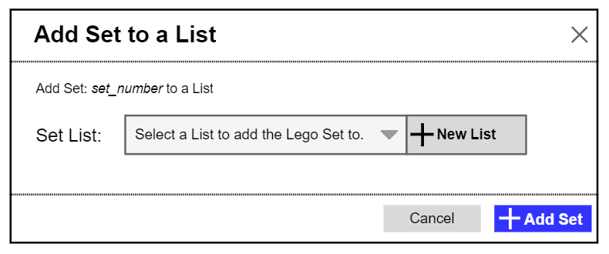

Figure 74: Initial Add Set to Set List Popup

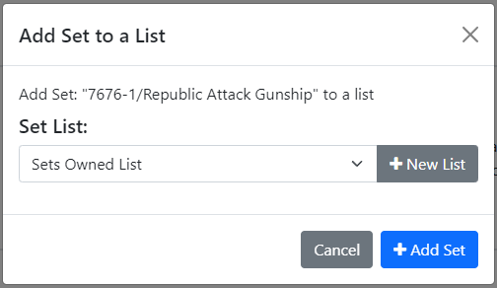

Figure 75: Add Set to Set List Popup



Figure 76: Added Set to Set List Alert

The Add Set to a Set List Popup (Figure 75) is displayed when a logged-in user clicks the ‘plus’ icon button on the Search Page, Sets in Progress Page, Set List Page or clicks the ‘Add Set to List’ button on the Set Page. Using this popup users can add a Lego Set to one of their setlists. The text ‘7676-1/Republic Attack Gunship’ is replaced with the set number of the set that the user wants to add to a list, followed by a ‘/’ and then this set’s name.

Using the select dropdown, the user can select which of their setlists to add the set too, where ‘Sets Owned List’ is the name of a setlist. The ‘Add Set’ button adds the set to the selected list and a light green dismissible alert (Figure 76) appears under the navbars and headers informing the user the set has been added to a setlist, where ‘7676-1’ is the Set’s set number and ‘Sets Owned List’ is the selected setlist. These are both hyperlinks to the set and setlist, respectfully, so that users can quickly access these pages after adding the set to a setlist.

The ‘New List’ button opens the Create New Set List Popup (Figure 70) over the top of this popup, where users can create a new setlist to add the set to.

There are a few small differences between the initial design (Figure 74) and the final design (Figure 75). In the initial design, there was text ‘set_number’ which I changed to the set number ‘/’ set name in the final design, I did this so the user could easily see the set they were adding to the setlist by both its number and name. I also added the added Set to a Setlist Alert (Figure 76) in the final design, so it was clear to users that a set was added to a setlist and which set and setlist these were.

#### Set List Page

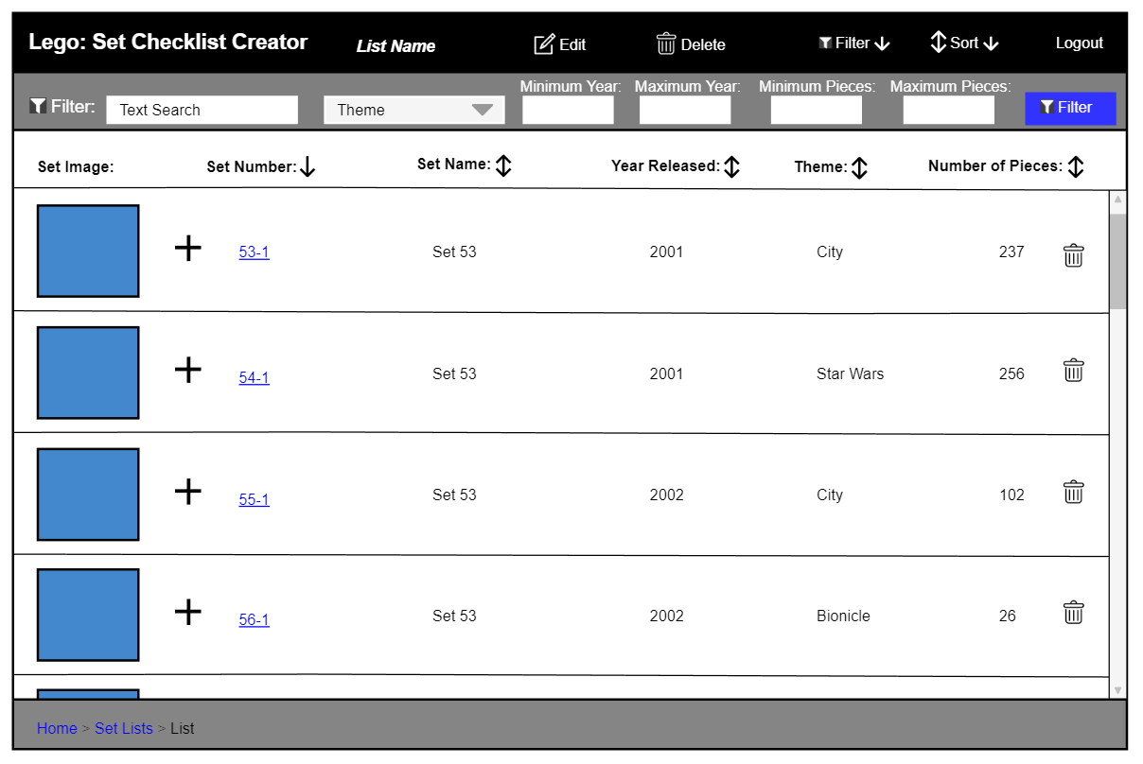

Figure 77: Initial Set List - Filter Bar Open

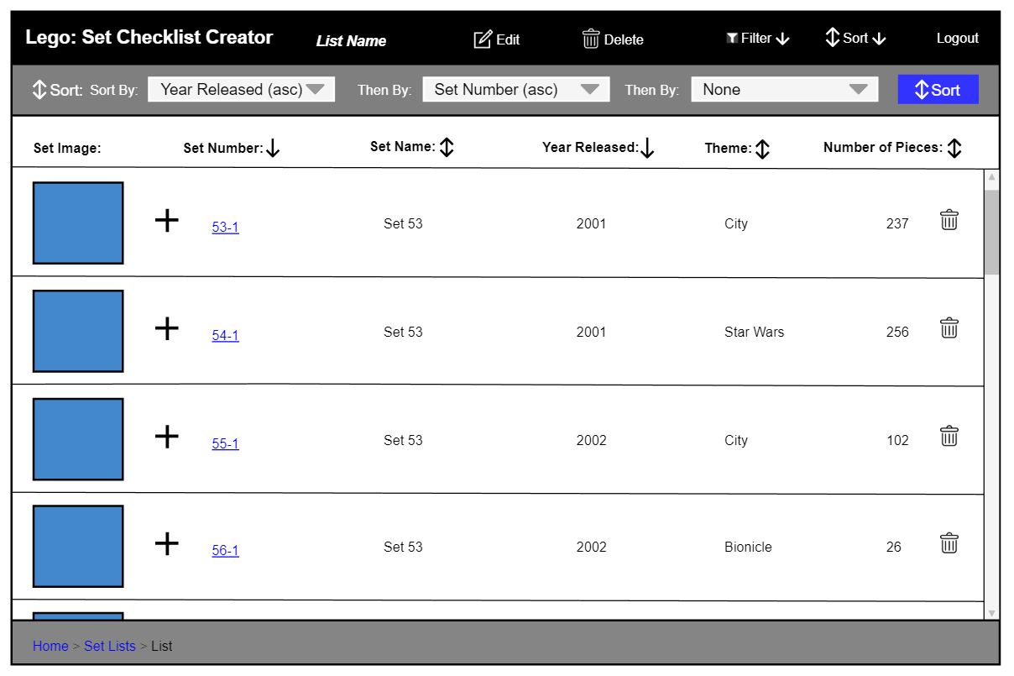

Figure 78: Initial Set List - Sort Bar Open

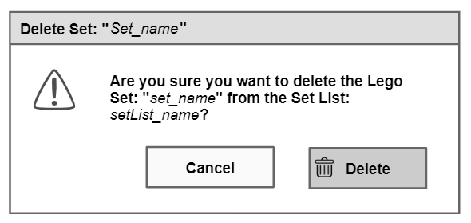

Figure 79: Initial Delete Set from Set List Popup

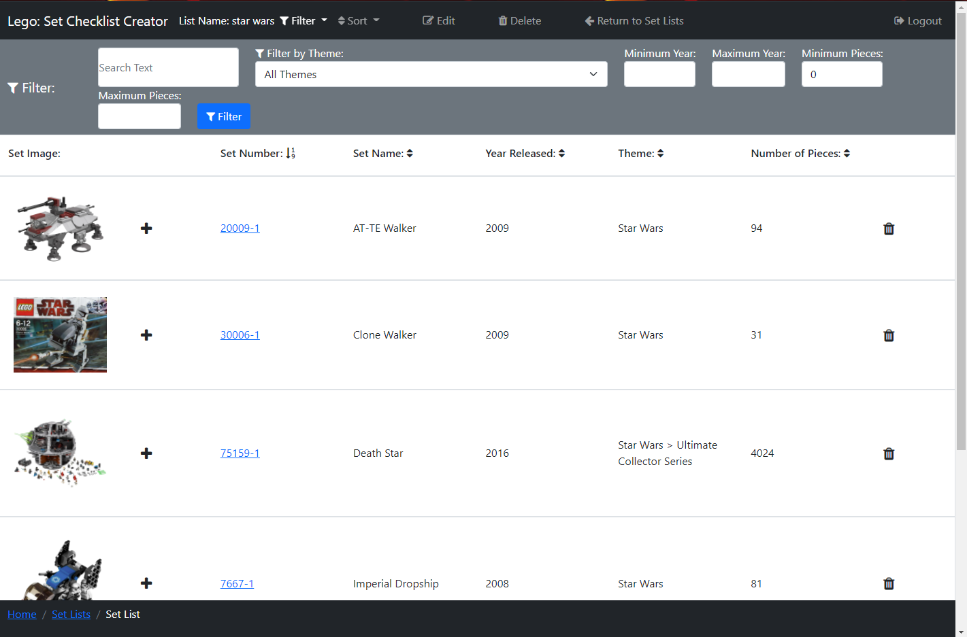

Figure 80: Set List - Filter Bar Open

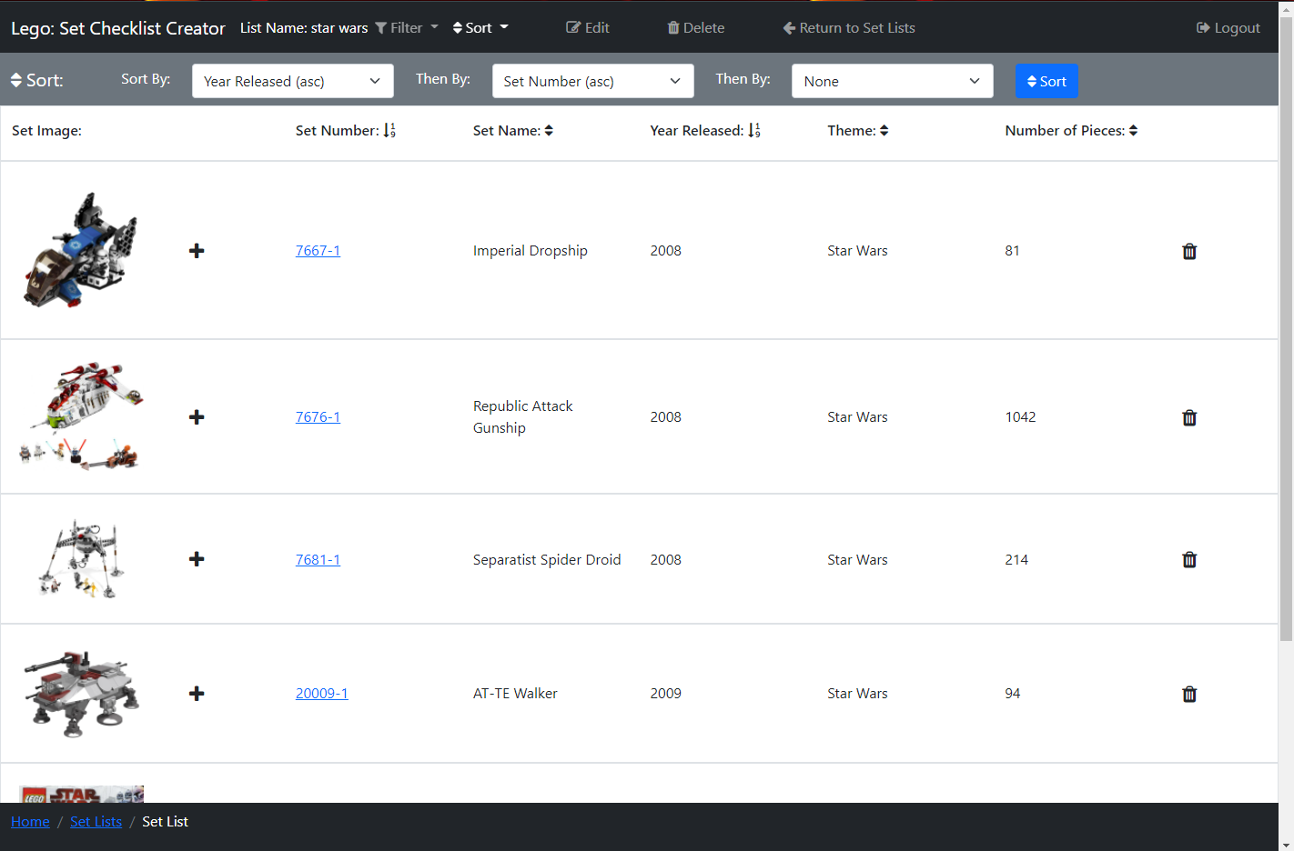

Figure 81: Set List - Sort Bar Open

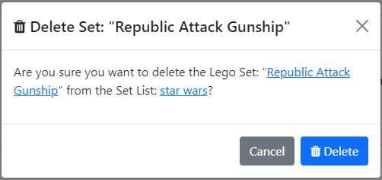

Figure 82: Delete Set from Set List Popup



Figure 83: Deleted Set from Set List Alert

The Set List Page (Figure 80 and Figure 81) can be accessed by a user, who is logged in, by clicking the ‘List Name’ hyperlink on the Home Page (Figure 11) from the last 3 edited setlists, or via the Set Lists Page (Figure 65: Initial Set Lists Page). On this page, users can search the sets that they have added to the Setlist, to find a Set they wish to view.

Similar to the Search Page, in the centre of the page, a list of Lego sets is displayed in rows, with columns displaying different bits of information on Lego sets. There is an image of each Lego Set in each row, that when clicked will open Figure 37 to view the image enlarged (see more detail above). If the user clicks a Set’s set number, which is a hyperlink, Figure 17: Lego Set Information Page will open displaying the selected set.

There is a ‘plus’ icon button that when clicked opens a popup (Figure 75) to add a set to a setlist. There is also a ‘bin’ icon in each set row, that when clicked, a popup (Figure 82) appears asking the user if they want to delete the selected set from the setlist, this is used so that users don’t accidentally delete a set from a list by misclicking. The text ‘Republic Attack Gunship’ is replaced with the name of the set that will be deleted and ‘star wars’ with the setlist name. The second set name is a hyperlink to the Set Page (Figure 17), and the setlist name is a hyperlink to the Set List Page, I added these so users can check the Lego Set before they delete it from the setlist. There is a ‘Delete’ button that will delete the selected set from the setlist and a light blue dismissible alert (Figure 83) appears under the list of sets header, informing the user of this with the set name (in this case ‘Republic Attack Gunship’) a hyperlink to the deleted Sets page (Figure 17).

Above the list of sets is a header that has the name for each column, so it is clear to the user what each of these columns contains. Each of the column names (excluding ‘Set Image’), has an arrow next to it, these show if the sets are being sorted by that column, which works the same as the Search Page above.

There is a scroll bar down the side of the page so users can scroll through the Lego Sets in the setlist.

In the navbar there is the name of the setlist the user is viewing, I added this, so it was clear to users which setlist they are viewing. There is a link ‘Filter’ which opens a filter bar underneath the navbar (shown open in Figure 80), closing the sort bar (shown open in Figure 81) if it is open. Likewise, the ‘Sort’ link opens a sort bar underneath the navbar shown open in Figure 81, closing the filter bar if it is open. Then there is a link ‘Edit’ that opens a popup (Figure 85) that allows the user to change the name of the Setlist, and a ‘Delete’ link that opens a popup (Figure 88 initial) to allow users to delete the Setlist. There is then a link ‘Return to Set Lists’ which returns the user to the Set Lists Page (see above).

The filter bar (Figure 80) contains filters the user can use to filter the Lego Sets and functions the same as on the Search Page but filtering a user’s setlist instead of sets from the Rebrickable API [1].

The sort bar (Figure 81) contains three select boxes so a user can perform a multi-sort, which functions the same as on the Search Page but sorts a user’s setlist instead.

There are not many differences between the initial design (Figure 77 and Figure 78) and the final design (Figure 80 and Figure 81), however, I added the ‘Return to Set Lists’ link, as apart from the breadcrumb link there was no other way to easily return to the user’s Set Lists Page (see above). I added a hyperlink to the set number in the final delete popup design (Figure 82) for the reasons explained above, whereas it is not in the initial design (Figure 79). I also added the Deleted Set Alert (Figure 83) in the final design, so it was clear to users the set was successfully deleted from the Sets in Progress.

#### Edit Set List Popup

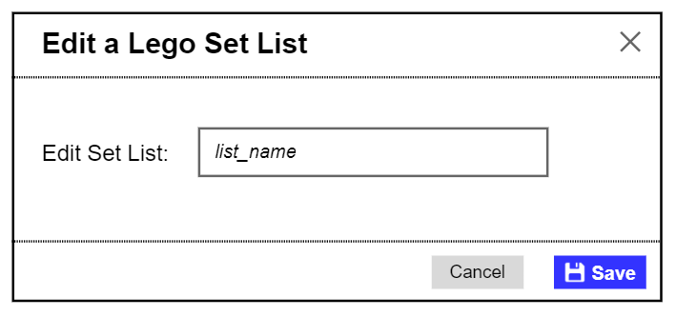

Figure 84: Initial Edit Set List Popup

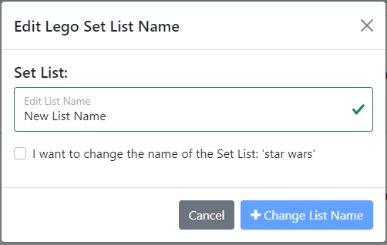

Figure 85: Edit Set List Popup

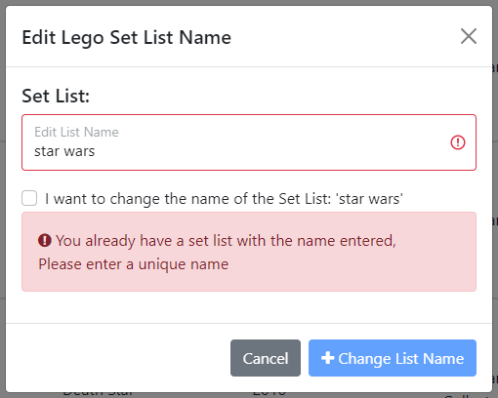

Figure 86: Edit Set List Error - Name Not Unique



Figure 87: Set List Edited Alert

When the ‘edit’ icon is clicked on a setlist row on the Set Lists Page or the ‘edit’ link in the navbar on the Set List Page (see above) is clicked, a popup (Figure 85) appears where a user can enter a new name for their setlist. The text ‘New List Name’ is replaced with the new name for the setlist that the user has entered, and ‘star wars’ is the old name of the setlist. If the new list name entered matches one of this user's saved setlist names, then an error alert box will appear (Figure 86) informing the user the name must be unique and highlighting the input box red so users can easily see this is the error, also while the name matches the ‘Change List Name’ button is disabled.

There is a tick box which has to be ticked to activate the ‘Change List Name’ button that, when clicked, will update the selected setlist with the new name, and a light green dismissible alert (Figure 87) appears under the navbars and headers informing the user the setlist’s name has been changed, where ‘New List Name’ is the new name of the user’s setlist.

There are a few differences between the initial design (Figure 84) and the final design (Figure 85). In the initial design, there is a button with the text ‘Save’ which I changed to ‘Change List Name’ in the final design as I felt this better described what the button does. I also added the tick box in the final design so that the user had to confirm the new name of the setlist. In the final design, I also added the red alert box (Figure 86), as in the initial design there was no way of informing the user if the setlist name was already in use. Finally, I added the Set List Name changed Alert (Figure 87) in the final design, so it was clear to users the setlist name was successfully changed.

#### Delete Set List Popup

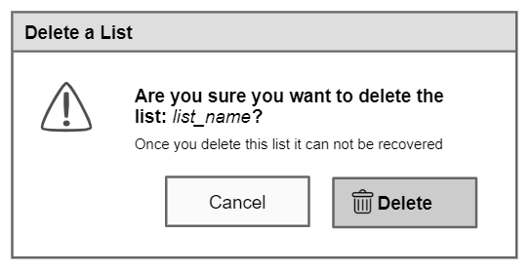

Figure 88: Initial Delete Set List Popup

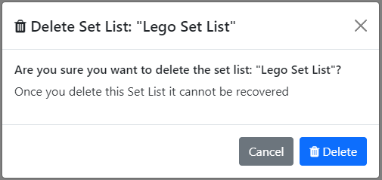

Figure 89: Delete Set List Popup



Figure 90: Deleted Set List Alert

When the ‘bin’ icon is clicked on a setlist row on Set Lists Page (above) or the ‘delete’ link in the navbar on the Set List Page (above) is clicked, a popup (Figure 89) appears asking the user if they want to delete the selected setlist, this is used so that users don’t accidentally delete a list by misclicking. The text ‘Lego Set List’ is replaced with the name of the setlist that will be deleted. There is a ‘Delete’ button that will delete the selected setlist, sending the user to the Set Lists Page, with a light blue dismissible alert (Figure 90) open under the navbar and sort or filter bar, informing the user the setlist has been deleted with ‘Lego Set List’ the name of the setlist that has been deleted.

There are no differences between the initial design (Figure 88) and the final design (Figure 89), however, I added the Deleted Set List Alert (Figure 90) in the final design, so it was clear to users the setlist was successfully deleted.

#### Profile Page

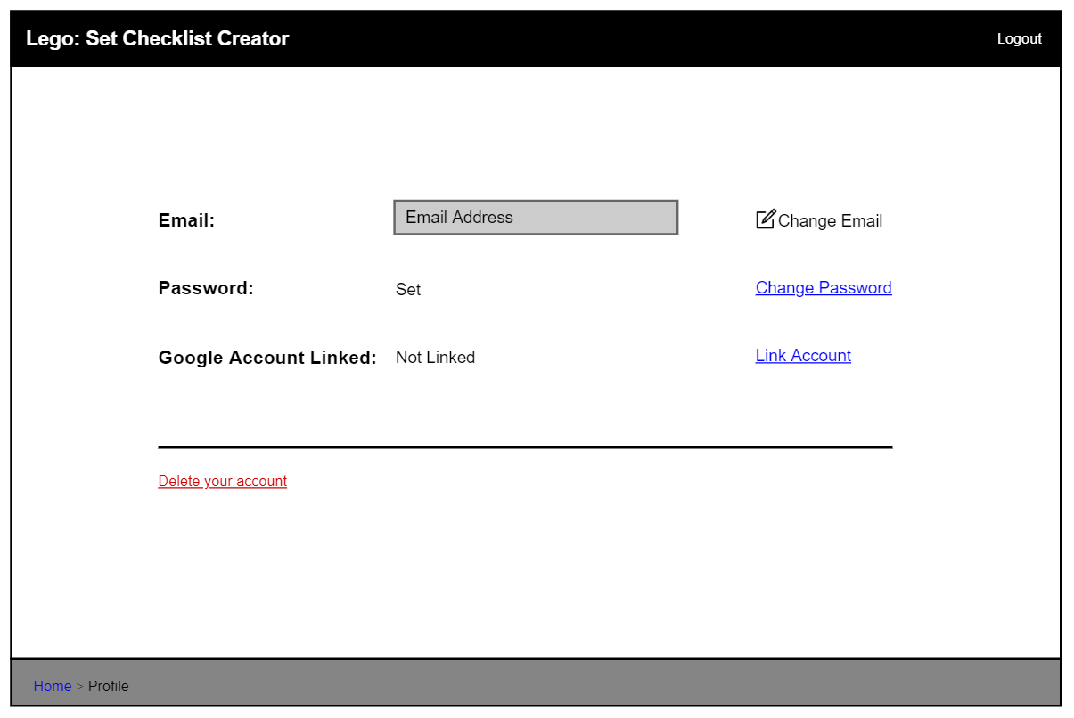

Figure 91: Initial Profile Page - Password Set, Google Account Not Linked

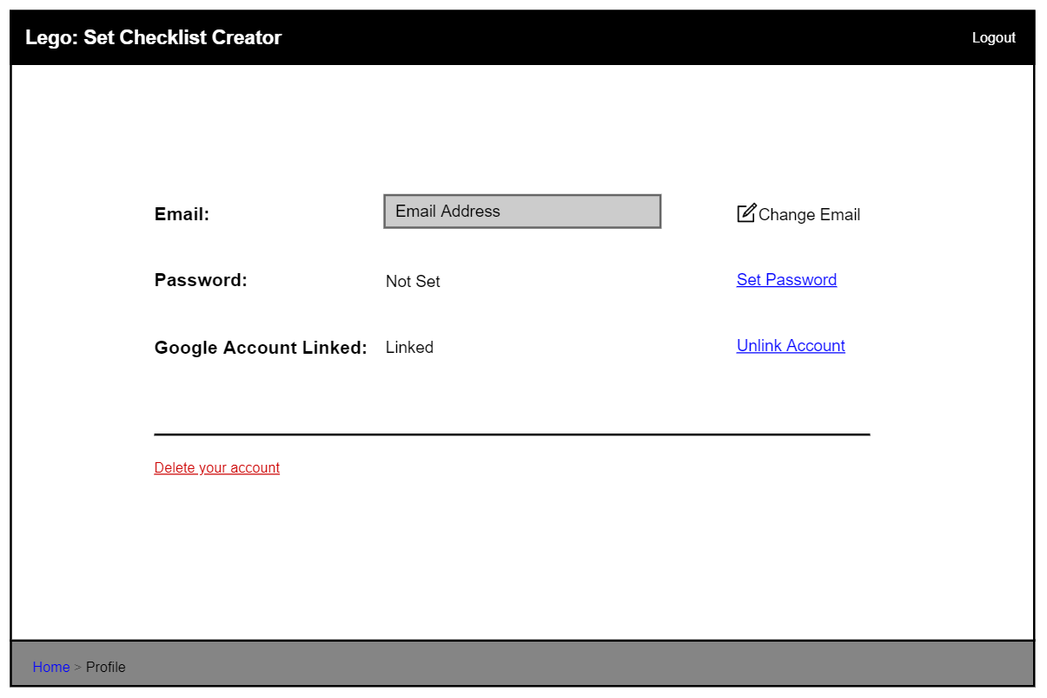

Figure 92: Initial Profile Page - Password Not Set, Google Account Linked

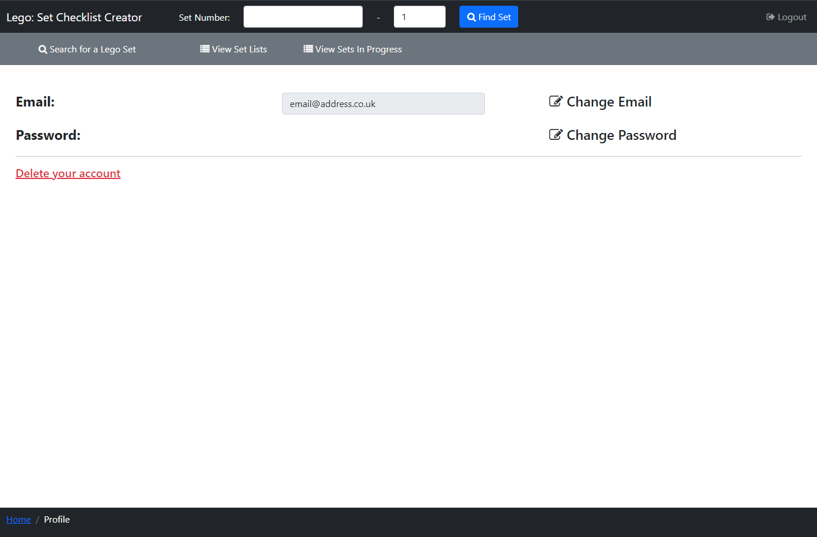

Figure 93: Profile Page

The Profile Page (Figure 93) can be accessed by a user, who is logged in, by clicking the ‘Profile’ link in the secondary navbar on the Home Page (Figure 11). On this page, users can view their account Email address, and can change their email and password, as well as the option to delete their account.

There is an ‘Email’ disabled text box, where users can view their current Email Address, which I added so users can check what email is on their account. Adjacent to this is a link ‘Change Email’ which opens a popup (Figure 95) where the user can change their email address. Additionally, the link ‘Change Password’ opens a popup (Figure 102) where the user can change their password.

There is a red link ‘Delete your account’ which opens a popup where a user can then delete their account. I decided to make this link red so it was easily visible to users and users were warned what would happen when it was clicked.

In the navbar, there is the Find Set Feature, and under this is a secondary navbar with a ‘Search’ link that opens the Search Page (above), a link so users can view their ‘Set Lists’ (Set Lists Page above) and their ‘Sets In Progress’ (Sets in Progress Page above).

In the initial design (Figure 91 and Figure 92) there is text informing on whether the user has a linked ‘Google Account’ or not. However, in the final design (Figure 93) I removed this text as I decided against using a ‘Google Account’ to SignUp and Login to an account, which I explained above in the Login and Sign-Up Popup section. Also, as I removed the option of linking a ‘Google Account’, the user must have a password set to login, and therefore in the final design, I removed the text which informed the user if their password was set. I additionally added the set number search and second navbar in the final design so users have more accessibility to access other pages without having to return to the Home Page (Figure 11).

#### Change Email Popup

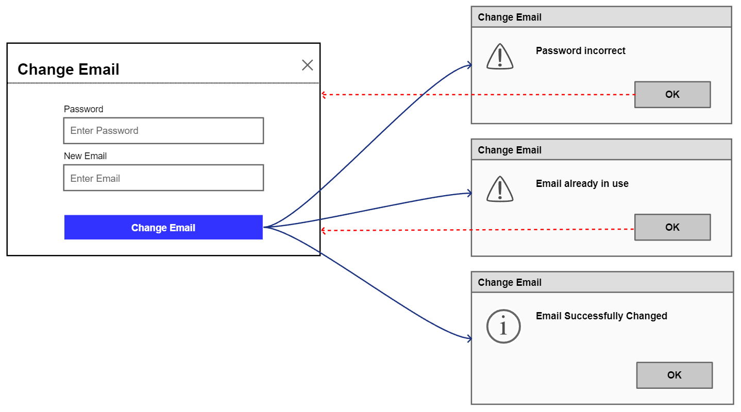

Figure 94: Initial Change Email Popup

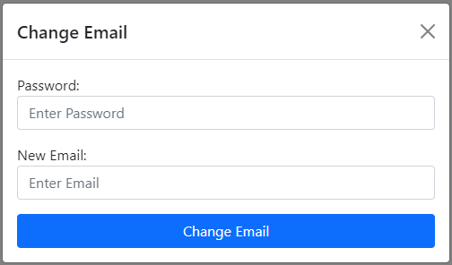

Figure 95: Change Email Popup

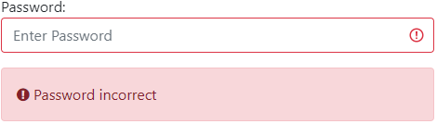

Figure 96: Change Email Error - Password Incorrect

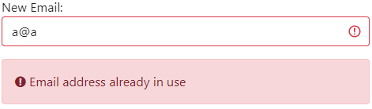

Figure 97: Change Email Error - New Email Not Unique

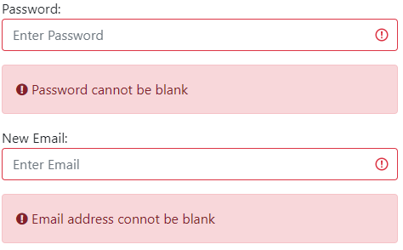

Figure 98: Change Email Error - Password Blank



Figure 99: Change Email Error - Email Blank



Figure 100: Email Address Changed Alert

When the ‘Change Email’ link is clicked on the Profile Page, a popup (Figure 95) appears where the user can change their email address. There is a ‘Password’ input box where the user must enter their password to be able to change their email and a ‘New Email’ input box where they can input a new email address, and if the entered email is not valid the corresponding Invalid Alert will be displayed (see Entered Email Invalid Alerts above for more details). There is a ‘Change Email’ button, that when clicked will check both the user’s entered password and new email address.

If the password entered is incorrect then an error alert box will appear (Figure 96) informing the user that the entered password is incorrect and highlighting the ‘Password’ input box in red. If the email entered belongs to another account, then an error alert box will appear (Figure 97) informing the user of this and highlighting the ‘New Email’ input box in red. If the ‘Password’ or ‘New Email’ input boxes are blank, they are highlighted red and the red alert boxes in Figure 98 and Figure 99 are shown respectfully. Red alerts and input boxes are highlighted red for errors so users can easily see this is an error.

If the password entered is correct and the email address is valid and not in use, then the user’s email address is changed. After this, the popup is closed, and the Profile Page (Figure 93) is shown with the email input box displaying the user's new email, and with a light green dismissible alert (Figure 100) open under the secondary navbar, informing the user that their email address was successfully changed.

In the initial design (Figure 94) I had planned to use popups to inform the user the entered Password was incorrect, the email was in use and their email was changed. However, in the final design (Figure 96, Figure 97 and Figure 100) I chose to use error alert boxes for an incorrect password and an email being in use, and a dismissible alert when an email was changed. I made this decision so the user wouldn’t have to spend time closing alert popups breaking up their flow.

#### Change Password Popup

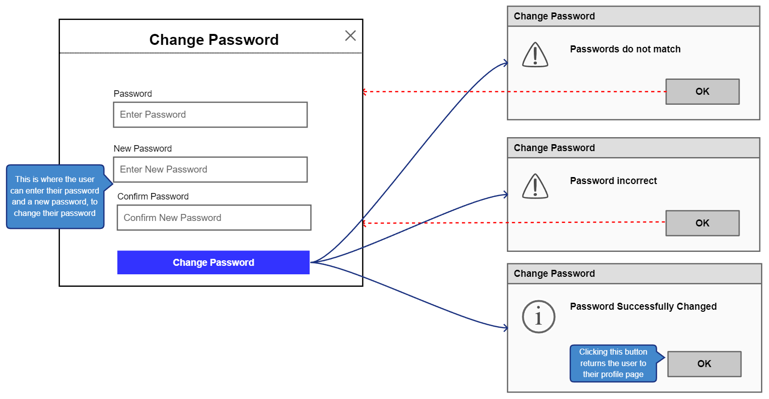

Figure 101: Initial Change Password Popup

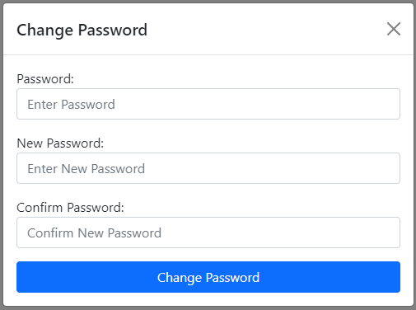

Figure 102: Change Password Popup

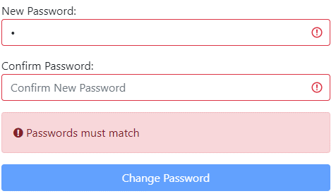

Figure 103: Change Password Error - Passwords Must Match

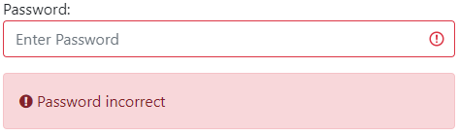

Figure 104: Change Password Error - Password Incorrect



Figure 105: Change Password Error - Password Blank

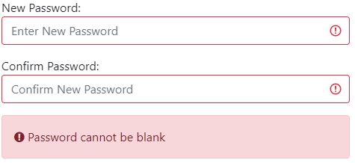

Figure 106: Change Password Error - New Password Blank

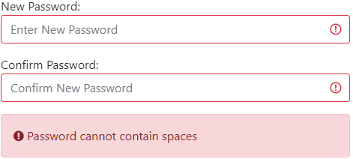

Figure 107: Change Password Error - Password Cannot Contain Spaces



Figure 108: Password Changed Alert

When the ‘Change Password’ link is clicked on the Profile Page, a popup (Figure 102) appears where the user can change their password. There is a ‘Password’ input box where the user must enter their current password, to be able to change their password, a ‘New Password’ input box where they can input a new password, and a ‘Confirm Password’ input box, that checks the user entered the password they meant, as text is hidden in these input boxes.

If the text entered in the ‘New Password’ and ‘Confirm Password’ input boxes do not match they are highlighted red and a red error alert box will appear (Figure 103) informing the user that they don’t match and disabling the ‘Change Password’ button. There is a ‘Change Password’ button, that when clicked will check both the user’s entered current password and new password.

If the ‘Password’ entered is incorrect then an error alert box will appear (Figure 104) informing the user the entered password is incorrect and highlighting the ‘Password’ input box in red. If the ‘Password’ or ‘New Password’ and ‘Current Password’ input boxes are blank, they are highlighted red and the red alert boxes in Figure 105 and Figure 106 are shown respectfully. If the new password contains spaces, the ‘New Password’ and ‘Current Password’ input boxes are highlighted red and the red alert boxes in Figure 107 are shown. Red alerts and input boxes are highlighted red for errors so users can easily see this is an error.

If the ‘Password’ entered is correct and the ‘New Password’ is not blank and does not contain spaces, then the user’s password is changed. After this, the popup is closed, and the Profile Page (Figure 93) is shown with a light green dismissible alert (Figure 108) open under the secondary navbar, informing the user their email address was successfully changed.

In the initial design (Figure 101) I had planned to use popups to inform the user that the ‘New’ and ‘Confirm’ passwords did not match, the current password was incorrect, and their password was changed. However, in the final design (Figure 103, Figure 104 and Figure 108) I chose to use error alert boxes for non-matching passwords, an incorrect password, and a dismissible alert when a password was changed. I made this decision so the user wouldn’t have to spend time closing alert popups breaking up their flow.

#### Delete Account Popup

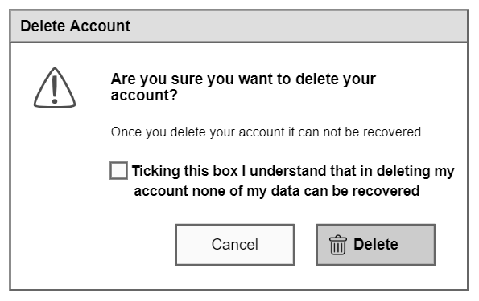

Figure 109: Initial Delete Account Popup

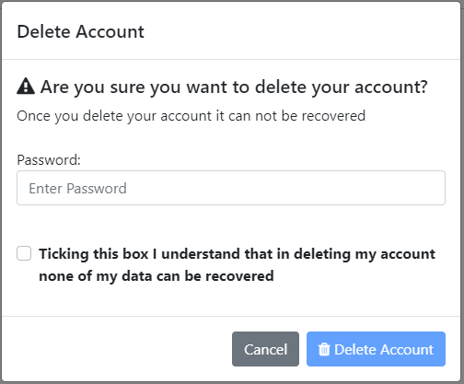

Figure 110: Delete Account Popup

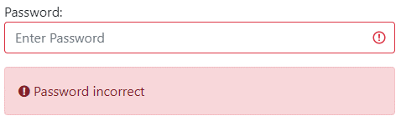

Figure 111: Delete Account Error Password Incorrect

When the ‘Delete your account’ link is clicked on the Profile Page, a popup (Figure 110) appears asking the user if they are sure they want to delete their account, with a ‘Password’ input box where the user must enter their password to be able to delete their account. There is also a tick box that must be ticked to activate the ‘Delete’ button so the user can click that button to delete their account. When the ‘Delete’ button is clicked, if the password entered is correct the user's account is deleted and they are sent to the Home Page (Figure 9). If the password entered is incorrect then an error alert box will appear (Figure 111) informing the user the entered password is incorrect and highlighting the input box red so users can easily see this is the error.

This popup is used so that users don’t accidentally delete their account by misclicking and the tick box ensures the user understands they are deleting their account.

In the initial design (Figure 109) users only had to click a tick box to delete their account, however, I felt this was insecure and so I added the ‘Password’ tickbox in the final design (Figure 110) so that if a user left their account logged in someone could not then delete their account.

#### Access Denied Page

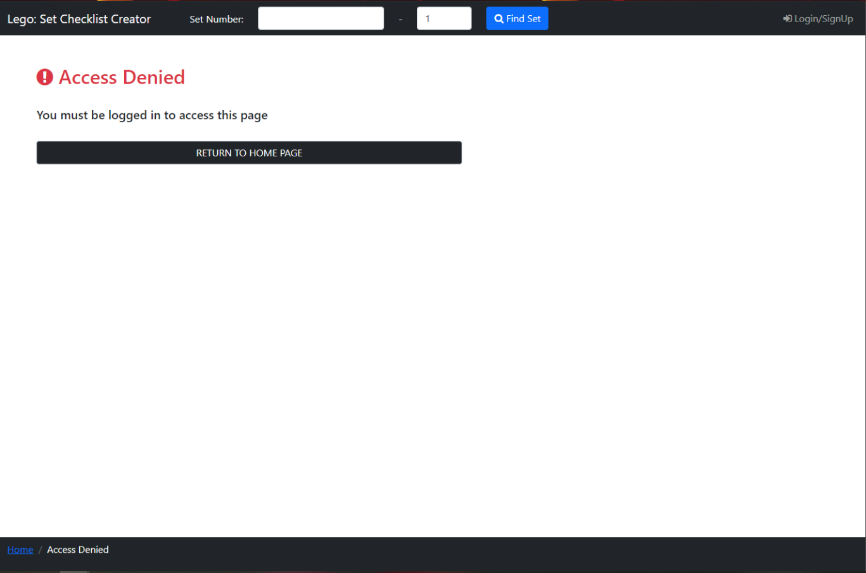

Figure 112: Access Denied Page

If a logged-out user tries to access a page meant only for logged-in users, then they are sent to the Access Denied Page (Figure 112). This page informs the user they need an account to access the requested page, with the word ‘this’ replaced with the name of the page in question. There is a button ‘RETURN TO HOME PAGE’, which returns users to the Home Page (Figure 9), so users can quickly return to a page they have access to.

In the navbar, there is the Find Set Feature, which I added here so a user could easily find a set and go back to a valid page.

#### Popup for Page Loading

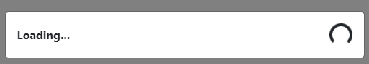

Figure 113: Loading Popup

The loading popup (Figure 113) is displayed when the user clicks on a page link or imports a checklist informing the user that the page or checklist is being loaded. I added this so it was clear to users the website was loading and so they didn’t think it was not functioning.

## Implementation

### Retrieving and Reading Data from the APIs

To retrieve information on Lego Sets from the Rebrickable API [1], the system must perform an HTTP request with a URI. The URI contains the API’s URL, information on what data to retrieve and an API key. The information on what data to retrieve is written using the Rebrickable API documentation [2] or the Brickset API documentation [7].

The RestTemplate class [11] is used to perform an HTTP request to an API using the created URI. This is achieved using ‘String set_JSON = restTemplate.getForObject(set_uri, String.class);’, where the method ‘getForObject’ returns a JSON tree with the requested data, which is saved as a String. I use this to retrieve Lego Set and Piece information from the Rebrickable API [1] and when retrieving Lego Set instruction booklets from the Brickset API [7].

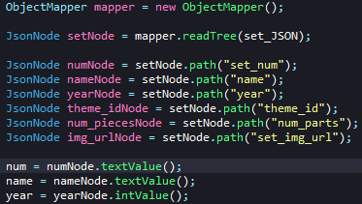

Figure : Reading Json String Code

To read the String that contains the JSON tree with the API data, I used Jackson-core [12] and Jackson-databind [13] libraries. Using the ‘ObjectMapper’ class and its method ‘readTree’ with the JSON String as a parameter (Figure 114), it retrieves a ‘JsonNode’ which is the root node in the JSON tree. Then using the ‘path’ method on a ‘JsonNode’ with a String parameter returns a ‘JsonNode’ that is a child of the root node, where its name matches the String parameter, for example, ‘set_num’.

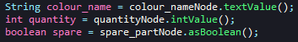

Figure : JsonNode to DataType Code

If a ‘JsonNode’ has no child then it can be transformed into a datatype (Figure 115) which means information received from an API can be read, like a Lego Set’s number, name and year released etc.

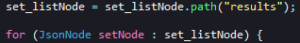

Figure : JsonNode Tree Iteration Code

A ‘JsonNode’ can also be an array of JSON trees, and to retrieve data from each tree the ‘JsonNode’ is iterated by every ‘JsonNode’ it contains. For example, when searching for a Lego Set using the Rebrickable API [1] the list of Lego sets is returned as a JSON array and is iterated through to get all data in this array.

If data received, now stored in variables, is from the Rebrickable API [1] then this information is added to an instance of the relevant class the data is for ‘Set’, ‘Piece’, ‘PieceType’ or ‘Theme’, which are explained above in the Class Diagram in the Design section and their implementation in the Classes section below.

If the data received is for Instruction Booklets for a Lego Set, retrieved from the Brickset API [7], then the data from each ‘JsonNode’ in the JSON array is stored as a list of String Arrays that contain the URL to the PDF instruction booklet and a description for the instructions. This list is then displayed to a user as the list of Lego set instructions on the Set Page (Figure 17 above).

### Classes

I have implemented the following Classes in Java so that they match their design explained in the 4.4 Class Diagram section above.

I added Hibernate [9] and JPA [10] annotations to the Set, SetInSetList, Set_list, SetInProgress, PieceFound and Account Classes to generate their corresponding database table, explained 5.6.2 Database Table Generation.

#### Set Class

The Set Class constructors create each an instance of the Set class with only the values inputted (see Figure 7) to the constructors initialised. The getter and setter functions in this class are basic and only set and retrieve values.

#### Piece Class

The Piece Class constructors each create an instance of the Piece class with only the values inputted (see Figure 7) to the constructors initialised. The getter and setter functions in this class are basic and only set and retrieve values.

#### SetInSetList Class

The SetInSetList Class constructors each create an instance of the SetInSetList class with only the values inputted (see Figure 7) to the constructors initialised. The getter function in this class is basic and only retrieves the instance of the Set Class this class contains. The ‘setInSetListId’ variable in this class is auto-generated, see 5.6.2 below.

#### Set_list Class

The Set_list Class constructors each create an instance of the Set_list class with only the values inputted (see Figure 7) to the constructors initialised, apart from the ‘lastChangedDateTime’ which is set as the current date and time this class is initialised. The getter and setter functions in this class are basic and only set and retrieve values. The ‘updateDateTime()’ function updates the ‘lastChangedDateTime’ to the current date and time. The ‘addSet()’ function adds an instance of the SetInSetList Class to the list ‘setsInSetList’, and increases ‘totalSets’ by 1, and ‘removeSet()’ decreases ‘totalSets’ by 1. The ‘contains()’ function takes a String ‘set_number’ as input, and iterates through all the SetInSetLists in the list ‘setsInSetList’, checking if any of these have the same Set Number, and thus the Setlist contains that Lego Set. The ‘setListId’ variable in this class is auto-generated, see 5.6.2 below.

#### SetInProgress Class

The SetInProgress Class constructors each create an instance of the SetInProgress class with only the values inputted (see Figure 7) to the constructors initialised, apart from the ‘lastChangedDateTime’ which is set as the current date and time this class is initialised. The getter and setter functions in this class are basic and only set and retrieve values. The ‘updateDateTime()’ function updates the ‘lastChangedDateTime’ to the current date and time. The ‘setInProgressId’ variable in this class is auto-generated, see 5.6.2 below.

#### PieceFound Class

The PieceFound Class constructors each create an instance of the PieceFound class with only the values inputted (see Figure 7) to the constructors initialised. The getter setter functions in this class are basic and only retrieve values. The ‘pieceFoundId’ variable in this class is auto-generated, see 5.6.2 below.

#### Account Class

The Account Class constructors each create an instance of the Account class with only the values inputted (see Figure 7) to the constructors initialised. The getter and setter functions in this class are basic and only set and retrieve values. The ‘accountId’ variable in this class is auto-generated, see 5.6.2 below.

#### Theme Class

The Theme Class constructors each create an instance of the Theme class with only the values inputted (see Figure 7) to the constructors initialised. The getter and setter functions in this class are basic and only set and retrieve values.

### Controllers

Controllers contain methods which handle URL requests to load the JSPs that display website pages to users and update the database. Controllers can send variables containing data to a JSP, which are added as Model Attributes [8], and can be accessed by JSPs, explained in 5.5.4 Accessing Model Attributes.

Controller methods can send URL requests for other methods, which works the same as when a page does this. This is called a redirect and data can be added to the JSP the Redirected Controller calls using Redirect Attributes, which work similarly to Model Attributes except they are applied before the Redirect.

Controllers are classes with the annotation ‘@Controller’ [8] so that Spring knows that this is a controller.

#### Main Controller

This loads the Home Page, and if a user is logged in adds their 3 last changed setlists and 3 last saved Sets in Progress as Model Attributes so they can be viewed on this page.

The ‘onStartUp’ method, is run every time the system starts and calls the Theme Controller and the Piece Type Controller to create Hash Maps for all Themes and Piece Types respectfully.

#### Set Controller

The Set Controller handles views that involve Lego Sets and the retrieval of Set information.

It interacts with the Rebrickable API [1] to retrieve Set information using a Set’s ‘Set Number’, and then reads the data returned. This data is added to a Set Class instance, then this controller interacts with the Piece Controller (below) to retrieve a list of type Piece Class which are added to this Set Class. This Set is then added to the Set Page (Figure 17) JSP as a Session Attribute, where it can be displayed.

It can also retrieve a list of Sets from the API, the request sent to the API to retrieve the list of sets can have parameters to sort and filter the returned sets, which the user can set on the Search Page (Figure 14 and Figure 15). Each Set is stored as a Set Class instance in a list of the same type. This list and a Hash Map of all Themes (see Theme Controller below) are added to the Search Page JSP as Model Attributes. The list of sets is added so they can then be displayed, and the Theme Hash Map so a user can select one of these themes to filter the Sets by.

This controller can additionally retrieve Lego Set instructions from the Brickset API [7], so that these can be added to the Set Page (Figure 17) JSP as Model Attributes, so a user can access these instructions on this page.

The controller also handles importing a Lego Set Checklist, explained below in 5.4.2 Import CSV.

This Controller has a method for displaying logged-in users' Setlists on the Set List Page (Figure 66 and Figure 67). A list of all the user's setlists ‘set_lists’ is added as a Session Attribute when a user logs into their account (see Database Controller below), which can be displayed to the user on the page, however, they are accessed here to obtain the number of setlists to add as a Model Attribute, to be used when iterating through the setlists to filtering them in the JSP, see 5.5.5 Filtering of Lists. This method also sorts the setlists if the user has selected a sort on the Set List Page, which is parsed into this method. The setlists are sorted by the parsed sort and as ‘set_lists’ is a Session Attribute it auto updates and does not have to be readded. Filters applied to the setlists when a sort is initiated are parsed into the method, and once a sort is completed, they are added as Model Attributes so can then be reapplied to the setlists.

#### Piece Controller

The Piece Controller handles the retrieval of Lego Pieces and controls URLs for the Piece Checklist Page.

This controller retrieves information from the Rebrickable API [1] on Pieces needed to build a Lego Set and its Minifigures using its ‘Set Number’, and then reads the data returned. Each piece’s information is added to a Piece Class instance and then added to a list of the same type. This Piece List is returned to the Set Controller (above) where it is added to a Set Class instance that contains information on the Lego Set.

A method that handles requests for the Piece Checklist Page (Figure 27), and as Set is a Session Attribute the pieces can already be accessed on the page JSP.

It adds two Java lists of Strings as Model Attributes, and they contain all Piece Colours and Piece types in the Set. These lists are created by iterating through all pieces and if they are not in the respective list adding their colour and piece type to the lists. These are added so thatPiece Checklist Page a user can filter the pieces by colour and piece type on this page, explained in 5.5 User Interface Implementation.

This method also sorts for the Piece List using a parsed in sort selected by a user on the Piece Checklist Page. The list is sorted by the parsed sort and then is then re-added to the Session Attribute Set, and as it is a Session Attribute it does not have to be re-added and the pieces can now be displayed in the sorted order.

Filters applied to the checklist when a sort is initiated are parsed into the method, and once a sort is completed, they are added as Model Attributes so can then be reapplied to the checklist.

A comma-separated list of each Piece’s ‘Quantity Found’ is also parsed during a sort, in the same order the piece list is in, and before the sort, each Piece’s ‘quantity_checked’ field is updated to match these. This is done so ‘Quantity Founds’ are the same after a sort.

This Controller also handles exporting a checklist, explained in 5.4.1 Exporting CSV.

#### Theme Controller

The Theme Controller is run on start-up via the ‘onStartUp’ method in the Main Controller and connects to the Rebrickable API [1] to get all the Lego Set Themes. Each theme’s unique ‘id’, ‘name’ and ‘parent_id’ which is the parent theme that this theme is a child of (e.g. Lego City is the parent of Police) and adds these to a Theme Class instance (see Theme Class above). The Theme is then added to a Hash Map with ‘id’ as the identifier.

Once all the themes are added to the Hash Map the controller goes through each of them and checks if the ‘parent_id’ is 0, meaning there is no parent theme. If ‘parent_id’ is not 0 the parent theme ‘name’ is added ahead of the child theme name with a ‘>’ identifying where each theme name is separated (e.g. Lego City > Police), the parent theme is then checked to so if it has a parent and if so that theme name is added. This continues until the ‘parent_id’ is 0, which means the full name of the original theme has now been set and its ‘parent_id’ can be set to 0. This is then repeated for all the Themes.

This hash map is created so that when Lego Sets are received from the Rebrickable API [1], the API does not have to be called again with each set’s ‘theme_id’ to retrieve the theme name, but can instead use this hash map which speeds up the program and stops the Rebrickable API Server from timing-out as there are too many requests.

#### Piece Type Controller

This Piece Type Controller is run on start-up via the ‘onStartUp’ method in the Main Controller and connects to the Rebrickable API [1] to get all the different types of Lego Pieces. Each piece’s unique ‘id’ and ‘name’ are added to a Hash Map containing will contain all the Piece Types. The ‘id’ is used as the Hash Map unique identifier with ‘name’ as the data.

This hash map is created so that when Lego Pieces are received from the Rebrickable API [1], the API does not have to be called again with each piece’s ‘pieceType_id’ to retrieve the piece type name, but can instead use this hash map which speeds up the program and stops the Rebrickable API Server from timing-out as there are too many requests.

#### Database Controller

This controller handles database functionality between views and the database and handles requests for logged-in pages.

When creating an account, this controller uses the ‘Account Validator’ to check the email and the password entered are valid, which checks there is no account with the entered email, the password contains no spaces and both are not blank. If any of these are false these errors are to the Controller, which redirects the user back to the Home Page (Figure 9). These errors are added as Redirect Attributes, along with another that informs the page’s JSP there was a sign-up error so that it knows to open the Sign-Up tab in Login and Sign-Up Popup (Figure 47), so the errors can be viewed. If there are no errors, an account is created and saved to the database with the password hashed and salted (5.7 Password Hashing and Salt). Additionally, a new setlist is created for this account, named ‘Sets Owned List’ and saved to the database. The user is then redirected to the Home Page with a Redirect Attribute used to inform the JSP an account was created, so it knows to open the Login tab in the Login and Sign-Up Popup (Figure 41) with an account created alert bar (Figure 52).

The ‘Account Validator’ is also used to check an email entered belongs to an account and the password matches the saved password when a user tries to login. It checks if the entered email and password entered are blank and if the email belongs to an account, if it does that account’s password is retrieved and compared with entered password (which is hashed and salted). If the email does not belong to an account, the password is incorrect or both are blank, these errors are returned to the Controller, which redirects the user to the Home Page (Figure 9). These errors are added as Redirect Attributes, along with another that informs the page’s JSP there was a login error so that it knows to open the Login tab in Login and Sign-Up Popup (Figure 41), so the errors can be viewed. If there are no errors, the account email is added as the Session Attribute ‘accountLoggedIn’ so JSPs and controllers know the user is logged in to this account. The account’s setlists are retrieved from the database as a list of the SetInSetList Class and added as the Session Attribute ‘set_lists’ so that they don’t have to be retrieved every time the user needs to select one to add a Set to a Setlist (Figure 75). Finally, the user is redirected to the logged-in Home Page (Figure 11).

The logout method removes the Session Attributes ‘accountLoggedIn’ and ‘set_lists’ so that the system knows that there is no account logged in and the previously logged-in user's setlists cannot be accessed. It then redirects the user to the logged-out Home Page (Figure 9).

To delete an account or change an email or password the ‘Account Validator’ is used to check that the user’s current password entered is correct, along with checking other entered details. The validator checks the email entered is unique when changing an email, and when changing a password checks the entered new password is valid. If there are any errors the user is redirected to the Profile Page (Figure 93), with Redirect Attributes containing these errors. When changing an email or password if the current password entered is correct and the new email or password is valid, then the user’s account’s email or password is changed, their account is resaved to the database, and they are redirected to the Profile Page, with a Redirect Attribute informing the JSP one of these was changed so the appropriate alert bar can be displayed (Figure 100 or Figure 108). When deleting an account, if the password entered is correct the user’s account is deleted from the database with other data related to their account deleted from other tables, the user is redirected to the Logout method so the account’s Session Attributes can be removed before being returned to logged-out the Home Page (Figure 9).

This controller retrieves information on Lego sets in setlists from the database, as a list of the Set Class, adding this as a Model Attribute so the sets can be displayed on the Set List Page (Figure 80 and Figure 81). The controller can add and remove Sets from a setlist and update the database to show this, furthermore, it can add and delete setlists from the database and change their names.

This controller can retrieve a user’s Sets in Progress from the database, as a list of the SetInProgress Class, adding this as a Model Attribute so they can be displayed on the Sets in Progress Page (Figure 61 and Figure 62). A Set in Progress can be saved to and removed from the database by the Controller too.

This controller displays the Access Denied Page (Figure 112) when a logged-out user tries to access any page only available to logged-in users. Each method, that handles these pages, checks if the Session Attribute ‘accountLoggedIn’ exists, and if it does not then the Access Denied Page is displayed.

### Exporting and Importing CSV Files

One of my key requirements for my project (3.1), was that users could save progress on a checklist, even without an account. To do this I decided that any user could export and import their Lego Set Piece Checklist. I found a website [14] that explains how to read and write to a CSV file using ‘OpenCSV’ which is added as an ‘implementation’ to the ‘build.grade’ file so that it can be used in my program.

#### Exporting CSV

To export a Lego Set Piece Checklist as a CSV file, the program retrieves all the ‘Quantity Checked’ values for each piece from the Piece Checklist Page (Figure 27). I combined code from two website articles [14] and [15] to create and then export the CSV file to the client's machine, and I borrowed code from these websites as this feature is not vital to the main function of the program.

The website article [15] explains how to export data in a CSV file in Spring Boot, in the form of a download on the client's device via their browser. I used code from this article inside a method in the Piece Controller which after the method ends exports the file to the client’s device. This code sets the method’s ‘HTTPServletResponse’ content type to a CSV file and sets then sets the name of this CSV file, which is the Lego Set’s name followed by ‘_Checklist.csv’ so that once the files have been exported the user knows what the checklist is for.

The other website article [14] as mentioned above explains how to read and write to a CSV file, and I used this article to help me create the code used to write data to the CSV file. The data is written to the CSV file as follows, first the Lego Set’s ‘Set Number’ is written to the first line of the CSV file. Then there is a line added for each Lego Piece that has a ‘Quantity Found’ above 0, as there is no need to store these as during the CSV import (explained below) pieces missing in the CSV file have their ‘Quantity Found’ set as 0. Each piece line contains unique identifying information for that piece, this is the piece’s number, colour name, if it is a spare piece and its ‘Quantity Found’.

#### Import CSV

To import a CSV file the user selects a file to upload in the Import Checklist Popup (Figure 39), and this file is uploaded using code from a website article [16] that explains how to upload a file from the clients and device and parse it to the server in Spring Boot.

To read the now imported CSV file, the system uses code from the online article [14] that explains how to read and write data to CSV files in Java. The system first reads the first line to get the ‘Set Number’ of the Lego Set that this checklist is for. It then reads the rest of the lines in the CSV file getting the information on each Lego Piece stored in it as a String Array, and adding each piece’s String Array to a list.

The system then retrieves the information for this Lego Set along with its pieces from the Rebrickable API [1], using the ‘Set Number’ from the CSV file. This data is retrieved via the method explained above in Retrieving and Reading Data from the APIs. The system then iterates through each Lego Piece in the Lego Set, add checks if the piece’s unique identifying data (this is the piece’s number, the name of the piece's colour and if it is a spare) matches the unique identifying data of any of the pieces in the list of String Arrays. If these pieces are matched to their corresponding imported piece, the piece stored in the Lego Set’s list of Pieces is updated so its ‘Quantity Found’ matches the imported piece’s ‘Quantity Found’.

Once the system has finished reading the file and updating the Lego set pieces, the user is sent to the Lego Set’s Set Page (Figure 17), and if they go to this set’s piece checklist they will see that every piece’s ‘Quantity Found’ matches that of the imported checklist CSV file.

### User Interface Implementation

To implement the design explained above in the 4.5 User Interface Design section, I’ve used JSPs with HTML and JavaScript along with Bootstrap [17] and some additional inline CSS. Along with Font Awesome [18] icons used for buttons and links.

#### Bootstrap

Bootstrap [17] is a CSS and JavaScript framework, used for page styling which helped me make my UI stay constant and simple throughout the website. Furthermore, it is useful for creating interactive pages that resize for different screen sizes, through the use of bootstrap classes in HTML tags which are designed to adapt to different screen sizes, and these can also be used to make an HTML item fill the percentage of the screen. It additionally has padding and margin classes with numbered sizes which each adapt to take up more or less space depending on the screen size.

I also used bootstrap templates to create interactive popups and dismissible alerts for my user interface.

#### Viewport

To allow my website to be adaptable to different screen sizes, I have set the Viewport for every page of my website so that the size changes depending on the device width and browser window width. I have set this using information from W3Schools [19] to create the following line: ‘<meta id="viewport" name="viewport" content="width=device-width, initial-scale=1"> ’. Where ‘initial-scale’ is the initial zoom level when the page is loaded and the width of the device minus the page width.



Figure : Viewport Adapting Example

Using JavaScript in the JSPs for the Sets in Progress Page (Figure 61 and Figure 62), Set Lists Page (Figure 66 and Figure 67), Set List Page (Figure 80 and Figure 81), Search Page (Figure 14 and Figure 15) and Piece Checklist Page (Figure 27). In Figure 117, I have set a minimum viewport width so that if the screen width is less than this number the viewport width stays as this minimum width but the initial zoom level changes to ‘0.5’ so that all the columns on these pages are adjacently displayed and the pages are zoomed out so users can see all the columns.

On the Home Page, Profile Page and Access Denied Page I have also used JavaScript to set a minimum viewport width, but these pages' initial zoom level does not need to change.

On the Set Page if the browser window is above a certain width JavaScript makes the page be displayed with 2 columns like in Figure 17, otherwise if it is less than this width the 2 columns are combined one on top of the other and made to fit the page width, like in Figure 19.

#### Font Awesome

To help keep my UI consistent and improve user recognition I used Font Awesome [18] to add icons to buttons and links so users could understand at a glance what action these performed.

#### Accessing Model Attributes

To access data sent to a JSP as a Model Attribute from a controller, the name of the model attribute is placed between ‘${‘ and ‘}’ and it calls the public getter method in the class of this variable to retrieve a value. For example, ‘${set_number}’, where ‘set_number’ is a String variable, would return a String ‘7676-1’.

If the program is accessing a class I have created, e.g. the Set Class, to access a variable in this class a ‘.’ would be added after the model attribute name followed by the class variable, e.g. ‘${set.name}’. This would return the value of this variable in the instance of the class if the variable has a public getter in the class, in this case, it would return the name of a Lego Set.

I have also used JSTL core [20] with this inputted data. I have used the ‘c:if’ tag to check a bool condition involving a model attribute, that if the condition is true runs the code in between the start and end tags. For example ‘<c:if test="${not empty accountLoggedIn}">’ checks if the model attribute ‘accountLoggedIn’ is not an empty string and if this is true then the code between this tag and the end tag is run.

I have used the ‘c:when’ and ‘c:otherwise’ tags (surrounded by the c:choose tag) to create an if and else statement, where if a bool condition is true in the ‘c:when’ tag the code inside is run, and if it’s false the code in between the ‘c:otherwise’ tags is run instead. For example, in Figure 118 the ‘c:when’ tag checks if two model attributes (‘theme.id’ and ‘theme_id’) are equal. If they are equal then the first option tag within the ‘c:when’ tags is used, and if they are not equal the second option tag within the ‘c:otherwise’ tags is used.

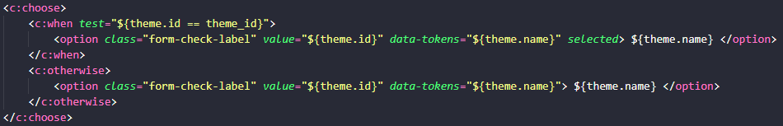

Figure 118: JSTL core choose, when and otherwise example

Finally, I have used the c:forEach tag to iterate through a list added as a model attribute. For example ‘<c:forEach items="${sets}" var="set" varStatus="loop">’ iterates through the model attribute ‘sets’ which is a list of the Set Class, ‘set’ is the name of the variable for each iteration and ‘loop’ is the name of the variable for the status of the iteration and can be used to retrieve the iteration number by adding ‘.index’, e.g. ‘${loop.index}’. I have added the ‘loop.index’ to the ids on HTML tags within the c:forEach tags, so that the JSP can identify each unique container from each iteration, which is useful when filtering lists on the Set Lists Page, Set List Page, Sets in Progress Page and Piece Checklist Page. In this example ‘set’ is an instance of the Set Class and using this variable data can be retrieved as I have explained above, e.g. ‘${set.name}’.

#### Filtering of Lists

I used JavaScript to filter the list of pieces on the Piece Checklist Page (Figure 27), setlists on the Set Lists Page (Figure 66 and Figure 67), and Lego Sets on the Sets in Progress Page (Figure 61 and Figure 62) and Set List Page (Figure 80 and Figure 81). This is done by iterating through the size of the list containing these starting at 0, it then retrieves the column containing data on each item in the list (e.g. a Lego Set) by the id in each of their HTML tags which has a ‘loop.index’ explained above (5.5.4 Accessing Model Attributes), which matches the index of this loop. If the values of the items (e.g. name, theme, year released of a Lego Set) do not fulfil a user's selected filter requirements that they have set on the page, then that row of data is hidden.

#### Controller Requests

The JSPs call controllers to request a certain page using HTML links and also via JavaScript page redirects.

### Database Implementation

To generate the database explained above in the Database Design section, I have used Hibernate [9] and the JPA [10].

#### Database Creation SQL

I generated the database that contains the database tables for the system using the following SQL statement ‘create database lego_set_checklist_db;’.

#### Database Table Generation

The tables for the database are generated on the system start-up if the tables do not already exist in the database via ‘spring.jpa.hibernate.ddl-auto=update’ in the ‘application.properties’ file.

The tables are generated using Java classes which are distinguished using the ‘@Entity’ annotation and named using the ‘@Table’ annotation.

The Set, SetInSetList, Set_list, SetInProgress, PieceFound and Account Classes generate the following tables respectfully ‘SetInfo’, ‘SetsInSetList’, ‘SetLists’, ‘SetsInProgress’, ‘PiecesFound’ and ‘Accounts’.

Variables in each class, which can have Hibernate [9] and JPA [10] annotations, denote a column in a database table.

Annotation ‘@Id’ identifies the primary key column and when combined with the ‘@GeneratedValue’ shows it is a number auto-generated by Hibernate.

Annotation ‘@Column’ is used to ‘name’ a column and inform the database if it can be empty (‘nullable’). Annotation ‘@Transient’ informs Hibernate and JPA to not add a column for the variable in a table.

Annotations are used to identify foreign key attributes and the relationship between the tables. For example, ‘@ManyToOne’ produces a many-to-one relationship between tables.

Annotation ‘@JoinColumn’ on a foreign key informs the system of the column name in the related table that’s value should be used. For example, in Figure 119 the Set Class is being linked to a table, with the ‘name’ being the column name in this table, ‘nullable’ showing it cannot be empty and ‘referencedColumnName’ being the column name in the Set Class to be used as this tables foreign key.



Figure 119: @JoinColumn annotation example

Annotation ‘@OnDelete’ is used on foreign keys to specify if the related table row will be deleted when deleting a row from this table.

#### Repositories

Each database table class has a corresponding repository which are Java classes which are used to perform query requests to the table in the database. These repositories have predefined methods ‘save’ and ‘delete’ to save and delete rows from a database table when used with an instance of a repositories class. For example, ‘accountRepo.save(account);’ saves an account to the ‘Accounts’ table in the database using the Account Repository (‘accountRepo’), where the account is of type Account Class, however, if this account’s id is already in the database, then its updated with the parsed account details.

In these repositories I have created query methods, used similarly to ‘save’ and ‘delete’, to retrieve a particular row or rows from the database, dependent on input. For example, ‘public Account findByEmail(String email);’ returns an Account that contains the inputted email, and ‘public List<Set_list> findByAccount(Account account);’ returns a list of setlists where the Account foreign key matches the inputted Account.

### Password Hashing and Salt

As users can create accounts that are saved to the database I decided to hash and add a random salt passwords so that they are encrypted. As hash algorithms are difficult to reverse the password cannot easily be retrieved and a salt means a hash table cannot be used to work out passwords. As this was not a key function of the system I used code from two website articles [21] and [22].

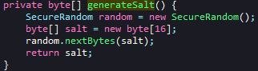

Figure : Generate Salt Code

When saving an inputted password to the database, first a random salt is generated using code from the first website [21] (Figure 120).

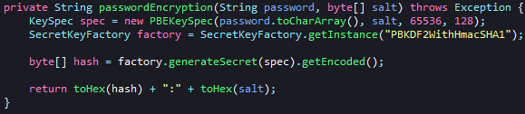

Figure : Generate Password Hash Code

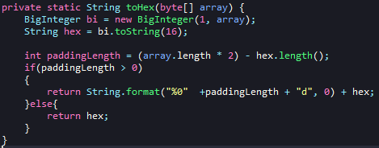

Figure : Byte Array to Hexadecimal Code

The password hash is then created using code from the first website [21], with a PBKDF2 hash with SHA1 (recommended secure hash to use) and the generated salt, which is stored as a byte array (Figure 121). Using code from the second website [22] (Figure 122) the hash is converted into hexadecimal as a byte array cannot be stored in the database. The salt is also converted into hexadecimal and added to the end of the hash after a ‘:’ symbol (Figure 121), so that the same salt can be used when comparing an entered password with a password stored in the database, and these are separated with ‘:’ as this symbol is not hexadecimal, so the hash and salt can be separated when during comparison. This password hash and salt are saved to the database with the new account id and email.

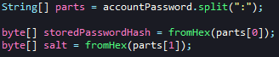

Figure : Separation of Hash and Salt Code

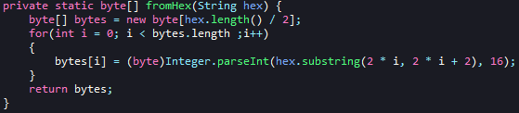

Figure : Hexadecimal to Byte Array Code

When comparing an entered password with a password stored in the database, the stored password is retrieved and using code from the second website [22] the hash and salt are extracted and converted back to byte arrays (Figure 123 and Figure 124). The entered password is then hashed using the PBKDF2 hash with SHA1 and the retrieved salt using the code explained previously (Figure 121).

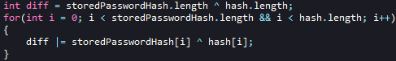

Figure : Hash Comparison Code

This new hash is then compared with the retrieved password hash to check if they match using code from the second website [22] (Figure 125).

## Results and Discussion

### Aim and Objectives Analysis

I have met the overall aim of my project, I have created a website that has a page where users can check off pieces in a checklist containing all pieces in a Lego Set, and can search for a Lego Set to view the checklist for.

I achieved my objectives as well, as my program can connect and received data from the Rebrickable API [1], I have learned how to read JSON files and add the data to a class. My program uses Spring MVC and works on both PC/Laptop and Mobile devices. I have also designed two ways for users to save a checklist's progress, with users being able to export a checklist and logged in users being able to save their progress to the database.

### Usability Questionnaire and Interview Introduction

I performed data collection on some participants about the usability of my website UI on both PC/Laptop and Mobile devices. This was achieved by participants first completing a list of tasks (see **Appendix C**) on my website on PC/Laptop and Mobile devices, followed by completing a Usability Questionnaire (see **Appendix D**) that I created using the System Usability Scale with some additional questions. I then interviewed the participants to understand their reasoning behind their questionnaire answers, and if there was anything else they think should be included.

### Usability Questionnaire and Interview Results

I had five participants undertake the study and the results from the questionnaire and interview provided valuable feedback. (see **Appendix F** forfull questionnaire results).

Answers to questions 1 and 17 showed me that most participants would use the system regularly on both devices and the interview informed me this was due to the system being well designed and containing useful features.

Questions 2 and 18 informed me that the system is not overly complex, and questions 3 and 19 showed participants thought it was easy to use on both devices, due to the ease of navigation and being well labelled. However, some users felt certain pages on the website were harder to use on a mobile device due to page adjusting for the screen size making it harder to use.

I found from questions 4 and 20 that on both devices participants would not need technical support apart from one participant stating they would require “some assistance when initially using the site”.

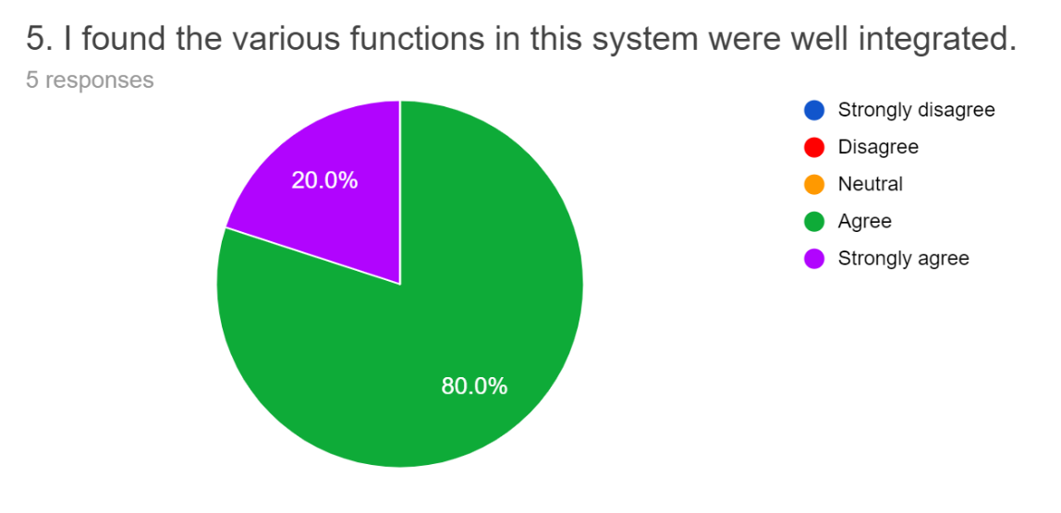

Figure 126: Usability Questionnaire - Question 5 Results

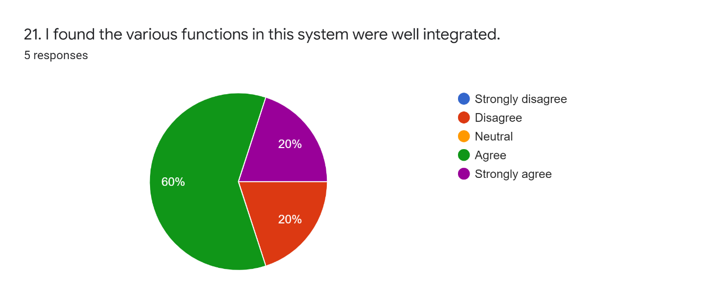

Figure 127: Usability Questionnaire - Question 21 Results

Question 5 results (Figure 126) show all participants thought the system functions were integrated well on a PC/Laptop and question 21 (Figure 127) shows similar for mobile devices, except one participant who disagreed but this was because the smaller screen made it harder to use.

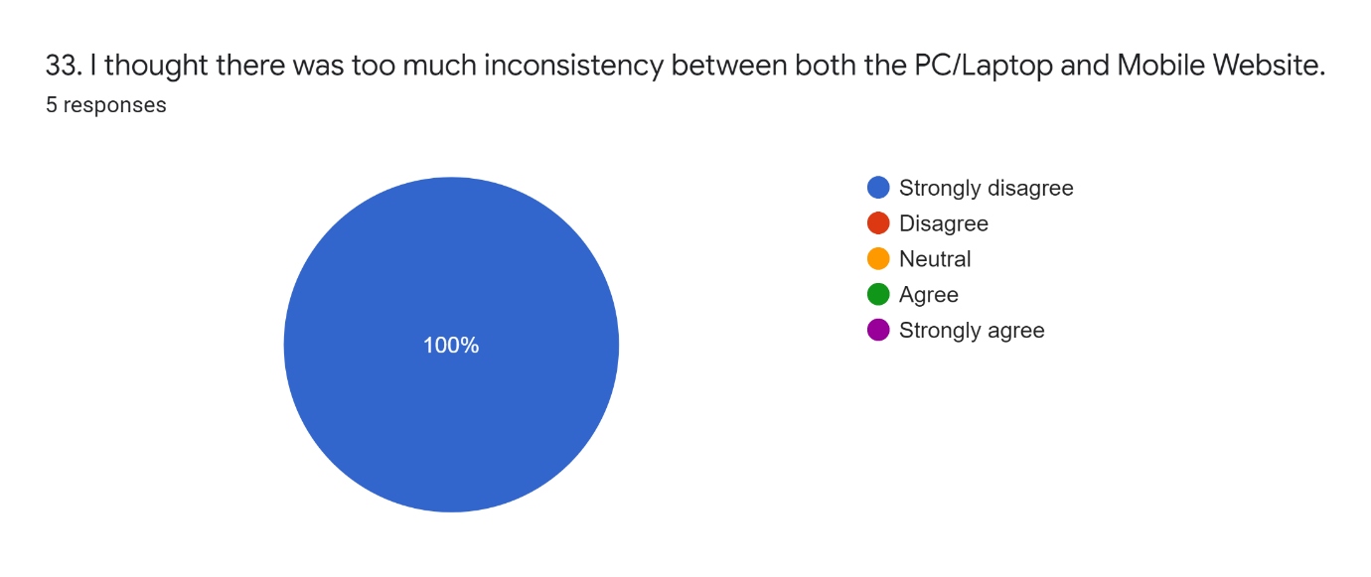

Figure 128: Usability Questionnaire - Question 33 Results

Participants felt that the system was equally consistent across both devices, as shown from the results of questions 6, 22 and 33 (Figure 128), due to style, popups and layouts being the same across multiple pages.

Questions 7 and 23 showed most participants believe the system can be learnt quickly on both devices due to being consistent and simplistic, however, the issue of screen size making this difficult was again raised.

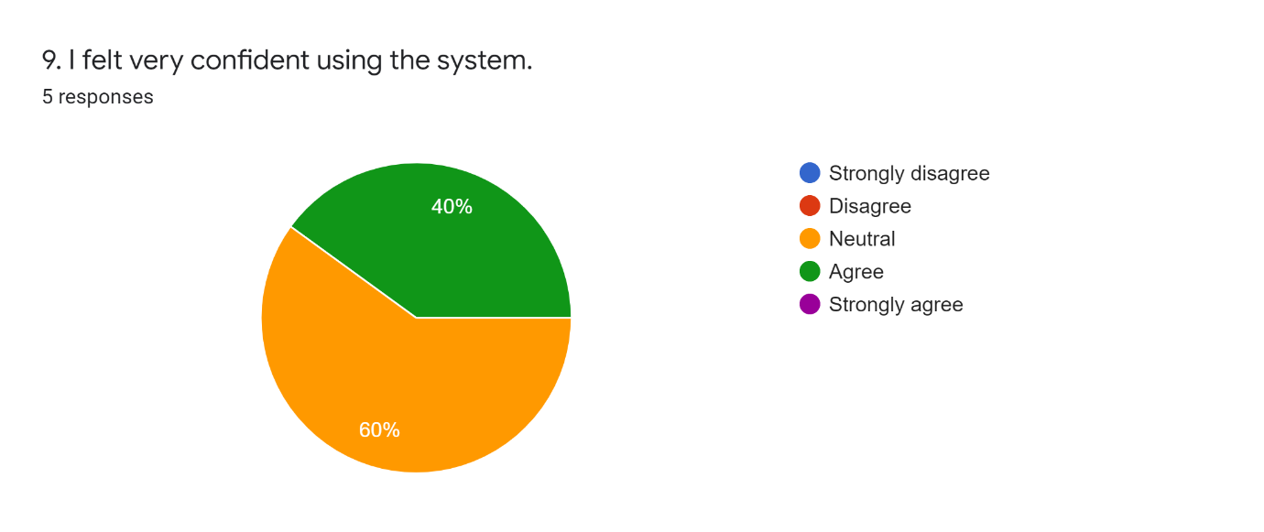

Figure 129: Usability Questionnaire - Question 9 Results

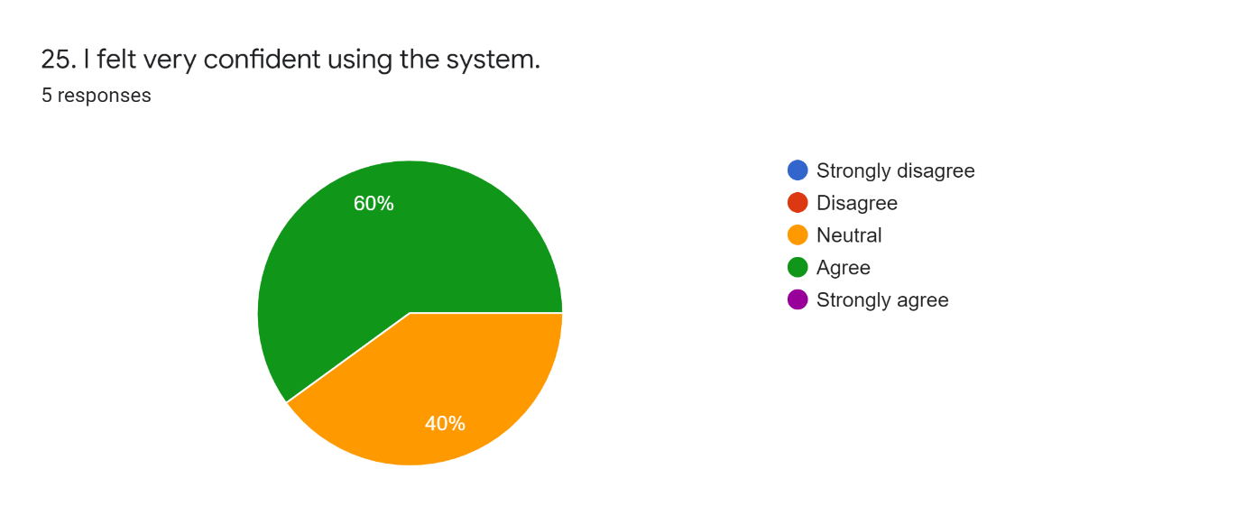

Figure 130: Usability Questionnaire - Question 25 Results

Participants did not find the website cumbersome (question 8 and 24 results) and expressed varied views on being confident using the system from questions 9 and 25 results (Figure 129 and Figure 130). As some participants felt more experience was needed to gain more confidence.

Answers from questions 10 and 26 show most believe they would not need to learn lots to use the system and questions 11 and 27 show participants can easily identify where they are in the system with the breadcrumb on pages being very informative. Some participants felt it was harder on a mobile device to identify where they were due to the screen size and suggested bigger font and a mobile application could fix this.

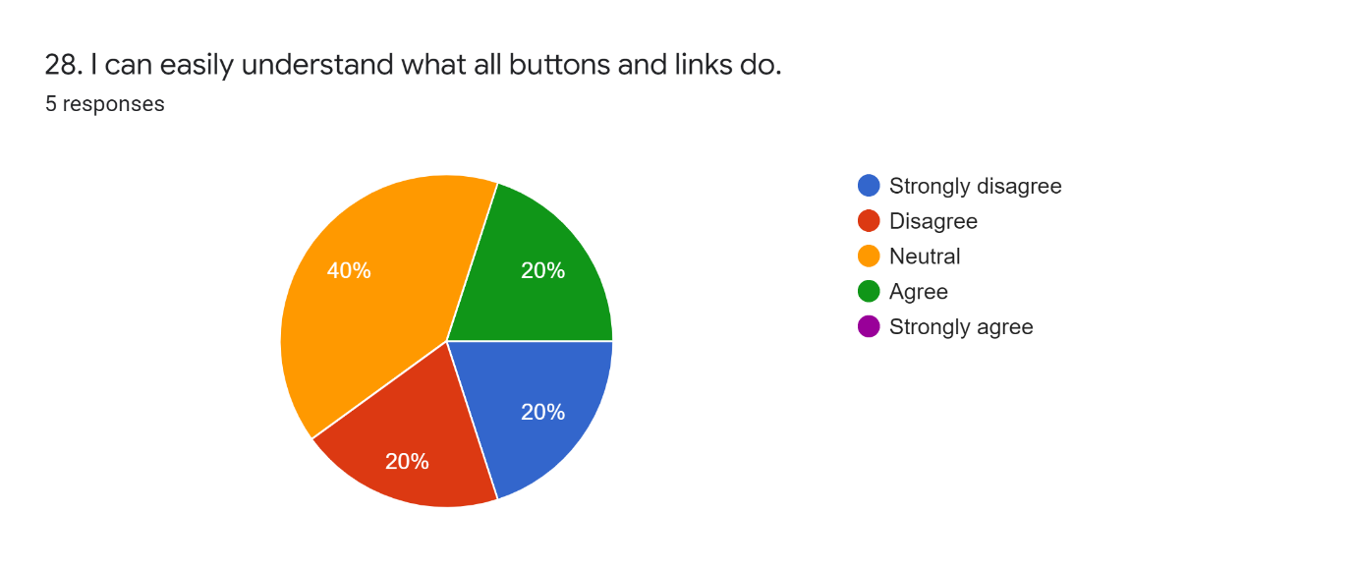

Figure 131: Usability Questionnaire - Question 28 Results

Participants mostly agreed for question 12 that it was easy to understand what buttons and links do on a PC/Laptop, due to recognisable icons, text and tooltips that describe the usage. However, on a mobile device question 28 shows more varied responses (Figure 131), with a mix of answers. Participants elaborated in interviews that although most icons and text for buttons and links were understandable, as tooltips are unusable on a mobile device this means there use is harder to determine, especially with buttons only with an icon.

Results of questions 13 and 29 show all participants felt they were not forced into completing actions, as they explained there was always an option to cancel or go back.

Across both devices, participants agreed that they were notified of any mistakes (questions 14 and 30) and errors (questions 15 and 31) made and how to fix them. They praised red highlighting on incorrect or missing input boxes and red boxes containing clear text on the mistake or error and how to resolve it. On the mobile device, a participant disagreed with error help being clear, as they felt the smaller screen size reduced the clarity.

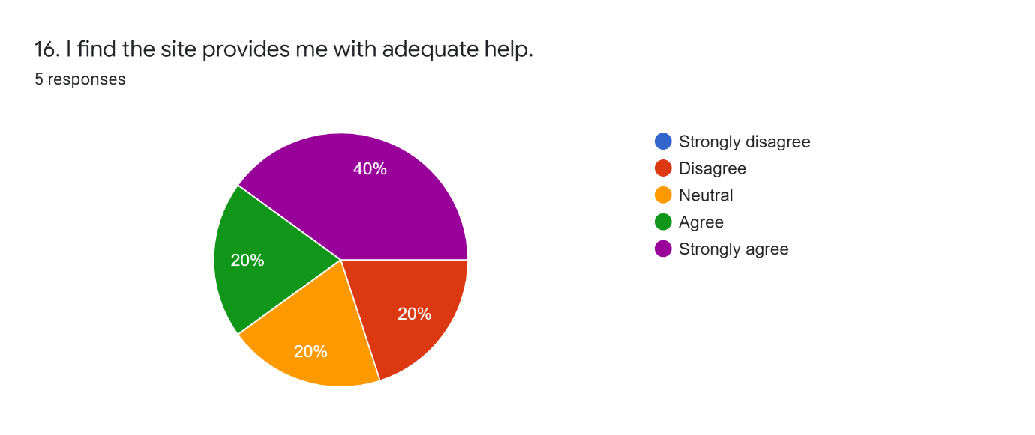

Figure 132: Usability Questionnaire - Question 16 Results

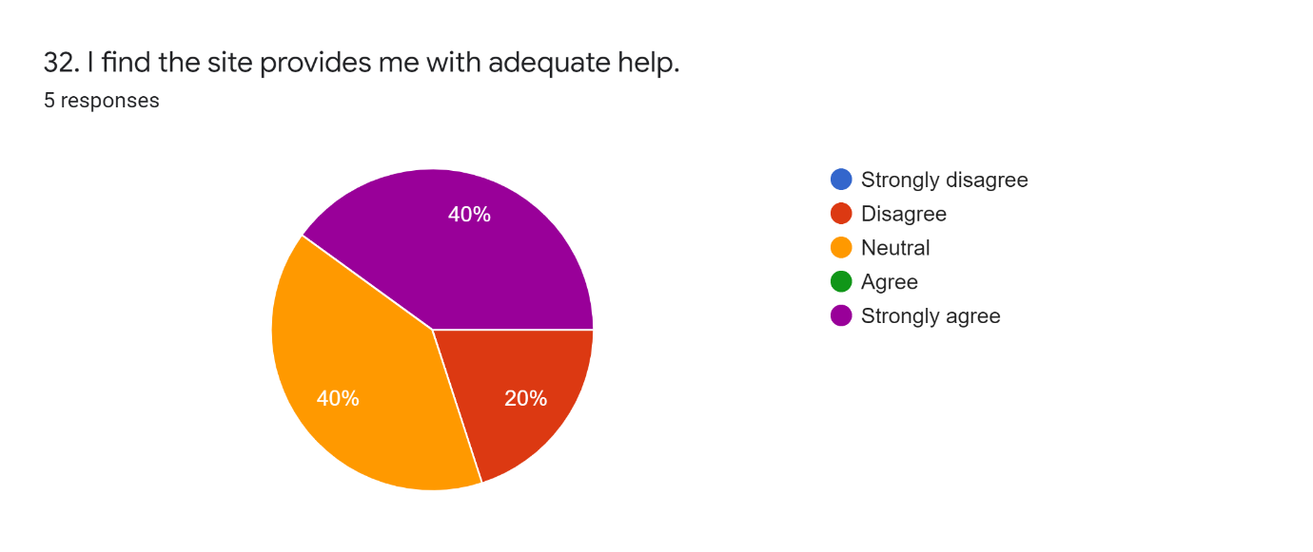

Figure 133: Usability Questionnaire - Question 32 Results

Questions 16 and 32 provided mixed responses to the help provided on the website. On a PC/Laptop (Figure 132), participants generally thought they were provided with adequate help through button and link tooltips and mistake and error alerts, but some were unsure and in disagreement, as they felt it could be improved with walkthroughs on how to complete certain tasks. On a mobile device (Figure 133), participants were mixed, with those in agreement citing the same reasons as on PC/Laptop and those in disagreement wanting similar walkthroughs with the additional reason that with lack of tooltips on mobile it is harder to understand certain buttons and links.

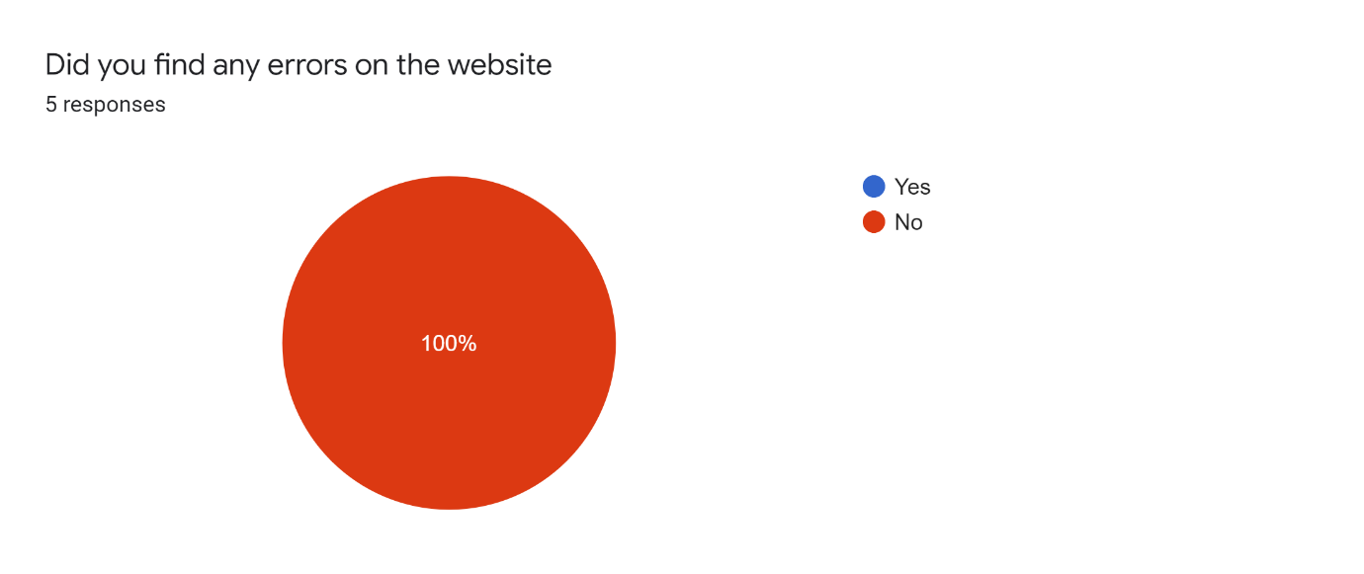

Figure 134: Interview Errors Found Result

I additionally discovered during the interviews that no errors with the system were found (Figure 134).

Participants suggested during interviews that adding a walkthrough help page on how to complete certain tasks would be a useful addition, along with the option to open saved checklists on the Piece Checklist Page and a mobile application.

### Usability Questionnaire and Interview Conclusion

I can infer from the results of the questionnaire and interview that I have successfully managed to create a simplistic, easy to use, consistent device adaptable website, that functions effectively and produces no errors.

The addition of a help/walkthrough page for certain tasks, as suggested in interviews, would improve users’ confidence and understanding of buttons, links and feature use.

I can additionally deduce, that while the website is usable on a mobile device there is scope for it to be improved and most participants felt a dedicated mobile application would address these issues.

## Critical Appraisal

### Summary and Critical Analysis

As mentioned above (6 Results and Discussion) I met the aim of my project and completed all the objects I set out to complete.

#### Requirements

When comparing my completed system to the requirements I set above (3 Requirements), I managed to complete all of my project’s Key Features. As mentioned above in the Results and Discussion section, the website works well across both PC/Laptop and mobile devices, however, on a mobile device, certain pages are harder to view and use. In hindsight I would revise these pages, so they are displayed better on mobile devices or create a mobile app as advised above in the Results and Discussion section.

When it comes to the Nice to Have Features I managed to complete all of them, however, users can not directly download instruction booklets from my website on a PC/Laptop but as they are viewed in a new tab in a PDF viewer users can download them from there. On a mobile device when users try to view instructions, it opens a new tab in the browser, where users can only choose to download instruction’s PDF file but not view them in the browser directly which is to do with the device, not my program. In hindsight, if I had more time, I would have implemented an in-page PDF viewer and added a download button next to each instruction in the list of instructions on the Set Page (Figure 17). I did add a link where a user can buy any missing Lego pieces, however, I have only used a link here as there is not an API to do this, and if I had more time, I may have been able to integrate this feature better as part of the website, instead of a link to a different page.

Out of the Optional Features I managed to add the creation of setlists and the ability to save to them for logged in users, as well as being able to search these lists of Lego Sets, and the ‘Sets Owned List’ is just the name of a setlist that is created when a user creates their account. I also managed to add the feature where users can save a Lego Set Piece Checklist in progress to the database.

However, I did not complete the Option Feature of a mobile application due to having a website useable on mobile devices and time constraints, if I was to carry on the project, I would create a mobile application to improve the user experience on these devices. I also did not add the scanning of Lego Pieces with a camera to check pieces off a checklist feature, as this is quite advanced and I instead made the decision to focus my time on the Key and Nice to have Features, as these were more vital in completing the aim of my project.

#### Planning

My planning of tasks during my project was not the best as I underestimated how long it would take to complete certain tasks. For example, the implementation of the Sign-Up and Login system involves several tasks. I did not fully consider the complexity it would take to connect the login and sign-up to the database, as first I had to create the Login and Sign-Up Popup, the account validator to check the details entered were valid and the hashing and salting of a password. I also did not factor in implementing the logout feature for users and adding a feature, so each page knows the user is logged in. I had initially allowed time of 1 day to complete this, but due to not breaking down the task it took several days longer to fully implement. I also overestimated the length of some tasks, for example, adding filtering and sorting to pages, the first time I added a filter and a sort it took the time I had planned out, but consequent filters and sorts were quicker and easier to implement as I could adapt my previous filter and sort code which I had not anticipated in my planning. However, as I had allowed 9 days to Design and Implement any other features, I had a buffer I could use as an overflow for previous tasks. See **Appendix G** for more details on my initial planning and how my final Gantt Chart that I updated during the project.

### Discussion of the social, sustainability, commercial and economic context

My project could help the target users of my project (Lego enthusiasts) check they have all the required pieces to build a Lego Set, and the PDF instruction booklet links for Sets can help users also build these Sets. Lego enthusiasts could also use this as a tool for finding out about older Lego Sets, they are interested in.

Making calls to retrieve data from APIs is very common in most programs, as many programmers make their program an API so that it can easily make its functionality available to others. The user feedback I carried out through a Questionnaire and Interview, is a commonly used way to receive usability feedback, and the System Usability Scale I used to create my interview questions is a recognised practice to retrieve reviews on a system's usability.

My website could benefit the Lego community by providing the ability to view Lego Sets, their instruction booklets and the unique selling point of allowing users to check pieces off a checklist as I could not find any other websites with this ability.

The website could be adapted to become a commercial product, as it has this unique selling point and adding a mobile application would improve this as other similar websites do not have them. Firstly, the website and database would have to be run on a server with a domain name so that users can access the website/mobile app from anywhere. Adding advertisements to the website and mobile app would help generate revenue, along with, a subscription service for user accounts with their being free and premium accounts, where users pay a subscription for a premium account to have access to additional features. Account users could also have an option to make a one-off payment to remove adverts. For this to be possible I would have to add HTTPS to make account login and sign-up more secure and help keep payments secure. Adding the option to sign-up and login using other accounts like Google and Apple would make it easier for users to sign-up, as they can use an already existing account and don’t have to enter all their details making it more appealing to have an account. Improving features such as instruction viewing and buying Lego pieces, so that they take place on the page would improve marketability, as there would be more features worth having a paid account to use. Also as mentioned by participants in my usability interviews (6.3 Usability Questionnaire and Interview Results), adding a walkthrough help page on how to complete certain tasks.

### Personal Development

I learnt how to request and retrieve data from an API using Java, which could help me when working with APIs in the future. I also learnt how to export CSV files from the server to the client's device, and import these from the client's device to the server in a Spring MVC system, which would help as a basis for importing and exporting files to a client device in the future.

I learnt how to hash and salt a password in Java which could be useful knowledge if I work with passwords in the future.

I also gained knowledge of how to create a website that adapts to different screen sizes using bootstrap [17] and setting the viewport [19], along with developing a way of filtering HTML items in a list using JavaScript. This could help me create a cross-platform website in the future as I now have a better understanding of how to implement this.

I feel that I have improved my time planning during the project, as I have now learnt to think about breakdown tasks when deciding how long they would take to implement. I have also learnt that having a planned buffer is good as then if a task takes longer than planned it will not affect the project deadline. I think this skill is useful for my future work as it would help me keep to deadlines.

I have improved my meeting skills throughout the project, as at the start I was turning up to my supervisor meetings with only a vague idea of what to discuss. As the project progressed, I started planning what to show and questions to ask to make the most of these meetings. I now realise the benefits gained from planning for meetings which can help me in the future.

## Conclusion and Future Work

Overall, I feel the project went very well as I achieved the main aim, I set out to achieve at the start of the project, along with the objectives used to ensure I met this aim. I completed all the key feature requirements by creating a simple and consistent cross-platform website that users can use to find Lego Sets and complete their piece checklists. I even managed to add some additional database features including accounts, and storage of setlists and Sets in Progress.

If I were to continue the project further, I would implement a dedicated mobile application, that would help improve the usability of a mobile device.

## References

1. "Rebrickable API | Rebrickable - Build with LEGO", *Rebrickable.com*. [Online]. Available: <https://rebrickable.com/api/>. [Accessed: 17- Nov- 2021]
2. "Rebrickable API Documentation | Rebrickable - Build with LEGO", *Rebrickable.com*, 2020. [Online]. Available: <https://rebrickable.com/api/v3/docs/?key=15b84a4cfa3259beb72eb08e7ccf55df>. [Accessed: 15- Nov- 2021]
3. "BrickLink - Buy and sell LEGO Parts, Sets and Minifigures", *Bricklink.com*. [Online]. Available: <https://www.bricklink.com/v2/main.page>. [Accessed: 17- Nov- 2021]
4. "Rebrickable | Rebrickable - Build with LEGO", *Rebrickable.com*. [Online]. Available: <https://rebrickable.com/>. [Accessed: 17- Nov- 2021]
5. "LEGO Set 75280-1 501st Legion Clone Troopers (2020 Star Wars) | Rebrickable - Build with LEGO", *Rebrickable.com*, 2021. [Online]. Available: <https://rebrickable.com/sets/75280-1/501st-legion-clone-troopers>. [Accessed: 17- Nov- 2021]
6. "LEGO PART 6134 Hinge Brick 2 x 2 Top Plate Thin | Rebrickable - Build with LEGO", *Rebrickable.com*. [Online]. Available: <https://rebrickable.com/parts/6134/hinge-brick-2-x-2-top-plate-thin/#buy_parts>. [Accessed: 24- Feb- 2022]
7. Huw, "API version 3 documentation", *Brickset.com*, 2021. [Online]. Available: <https://brickset.com/article/52664/api-version-3-documentation>. [Accessed: 17- Nov- 2021]
8. "17. Web MVC framework", *Docs.spring.io.* [Online]. Available: <https://docs.spring.io/spring-framework/docs/3.2.x/spring-framework-reference/html/mvc.html>. [Accessed: 25- Nov- 2021]
9. V. Mihalcea, S. Ebersole, A. Boriero, G. Morling, G. Badner, C. Cranford, E. Bernard, S. Grinovero, B. Meyer, H. Ferentschik, G. King, C. Bauer, M. Andersen, K. Maesen, R.Vansa and L. Jacomet, “Hibernate ORM 5.5.9.Final User Guide”, *Docs.jboss.org*. [online] Available: <https://docs.jboss.org/hibernate/orm/current/userguide/html_single/Hibernate_User_Guide.html>. [Accessed: 28- Feb- 2022].
10. O. Gierke, T. Darimont, C. Strobl, M. Paluch and J. Bryant, "Spring Data JPA - Reference Documentation", *docs.spring.io*, 2022. [Online]. Available: <https://docs.spring.io/spring-data/jpa/docs/current/reference/html/>. [Accessed: 28- Feb- 2022]
11. "RestTemplate (Spring Framework 5.3.14 API)", Docs.spring.io, 2021. [Online]. Available: <https://docs.spring.io/spring-framework/docs/current/javadoc-api/org/springframework/web/client/RestTemplate.html>. [Accessed: 02- Dec- 2021]
12. "jackson-core 2.13.1 javadoc (com.fasterxml.jackson.core)", *Javadoc.io*. [Online]. Available: <https://javadoc.io/doc/com.fasterxml.jackson.core/jackson-core/latest/index.html>. [Accessed: 05- Dec- 2021]
13. "jackson-databind 2.13.1 javadoc (com.fasterxml.jackson.core)", *Javadoc.io*. [Online]. Available: <https://javadoc.io/doc/com.fasterxml.jackson.core/jackson-databind/latest/index.html>. [Accessed: 05- Dec- 2021]
14. Atta, "Reading and writing CSV files using OpenCSV", *Atta-Ur-Rehman Shah*, 2019. [Online]. Available: <https://attacomsian.com/blog/read-write-csv-files-opencsv>. [Accessed: 03- Jan- 2022]
15. Atta, "Export & Download Data as CSV File in Spring Boot", *Atta-Ur-Rehman Shah*, 2019. [Online]. Available: <https://attacomsian.com/blog/export-download-data-csv-file-spring-boot>. [Accessed: 03- Jan- 2022]
16. Atta, "Uploading and Parsing CSV File using Spring Boot", *Atta-Ur-Rehman Shah*, 2020. [Online]. Available: <https://attacomsian.com/blog/spring-boot-upload-parse-csv-file>. [Accessed: 04- Jan- 2022]
17. "https://getbootstrap.com/docs/5.0/getting-started/introduction/", *Getbootstrap.com*. [Online]. Available: <https://getbootstrap.com/docs/5.0/>. [Accessed: 03- Feb- 2022]
18. "Font Awesome Intro", *W3schools.com*. [Online]. Available: <https://www.w3schools.com/icons/fontawesome_icons_intro.asp>. [Accessed: 04- Feb- 2022]
19. "Responsive Web Design Viewport", *W3schools.com*. [Online]. Available: <https://www.w3schools.com/css/css_rwd_viewport.asp>. [Accessed: 10- Feb- 2022]
20. "JSTL core (TLDDoc Generated Documentation)", *Docs.oracle.com*, 2003. [Online]. Available: <https://docs.oracle.com/javaee/5/jstl/1.1/docs/tlddocs/>. [Accessed: 30- Nov- 2021]
21. S. Millington, "Hashing a Password in Java", *Baeldung*, 2022. [Online]. Available: <https://www.baeldung.com/java-password-hashing>. [Accessed: 10- Apr- 2022]
22. L. Gupta, "Java - Create a Secure Password Hash - HowToDoInJava", *HowToDoInJava*, 2022. [Online]. Available: <https://howtodoinjava.com/java/java-security/how-to-generate-secure-password-hash-md5-sha-pbkdf2-bcrypt-examples/>. [Accessed: 10- Apr- 2022]
23. del

## Appendix A

Questionnaire for what user would want from a digital checklist for pieces in a Lego Set.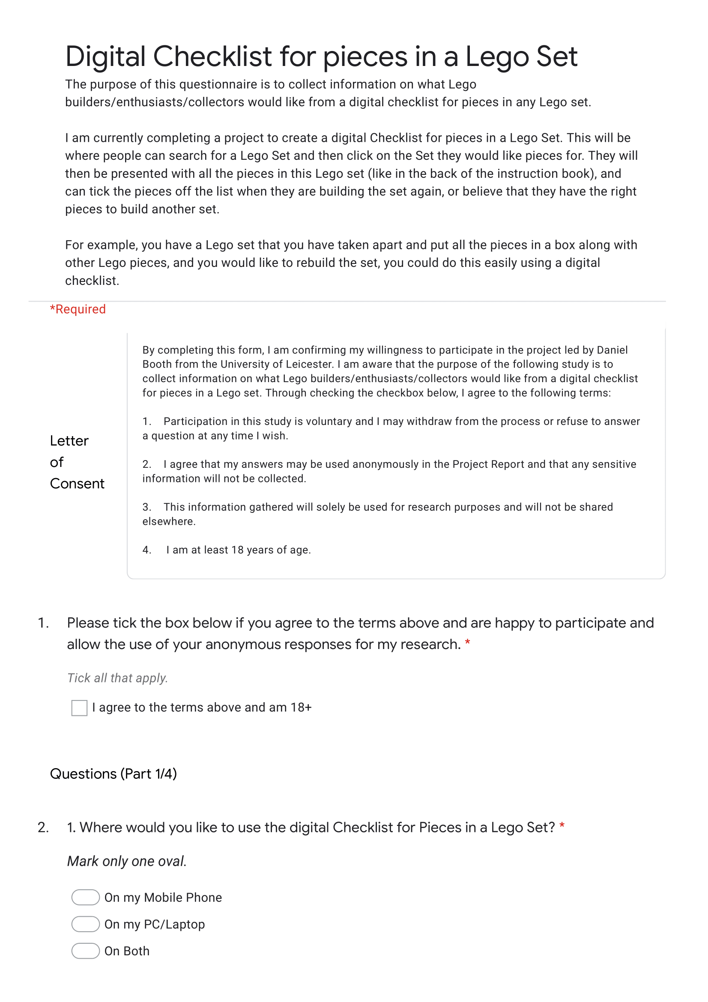

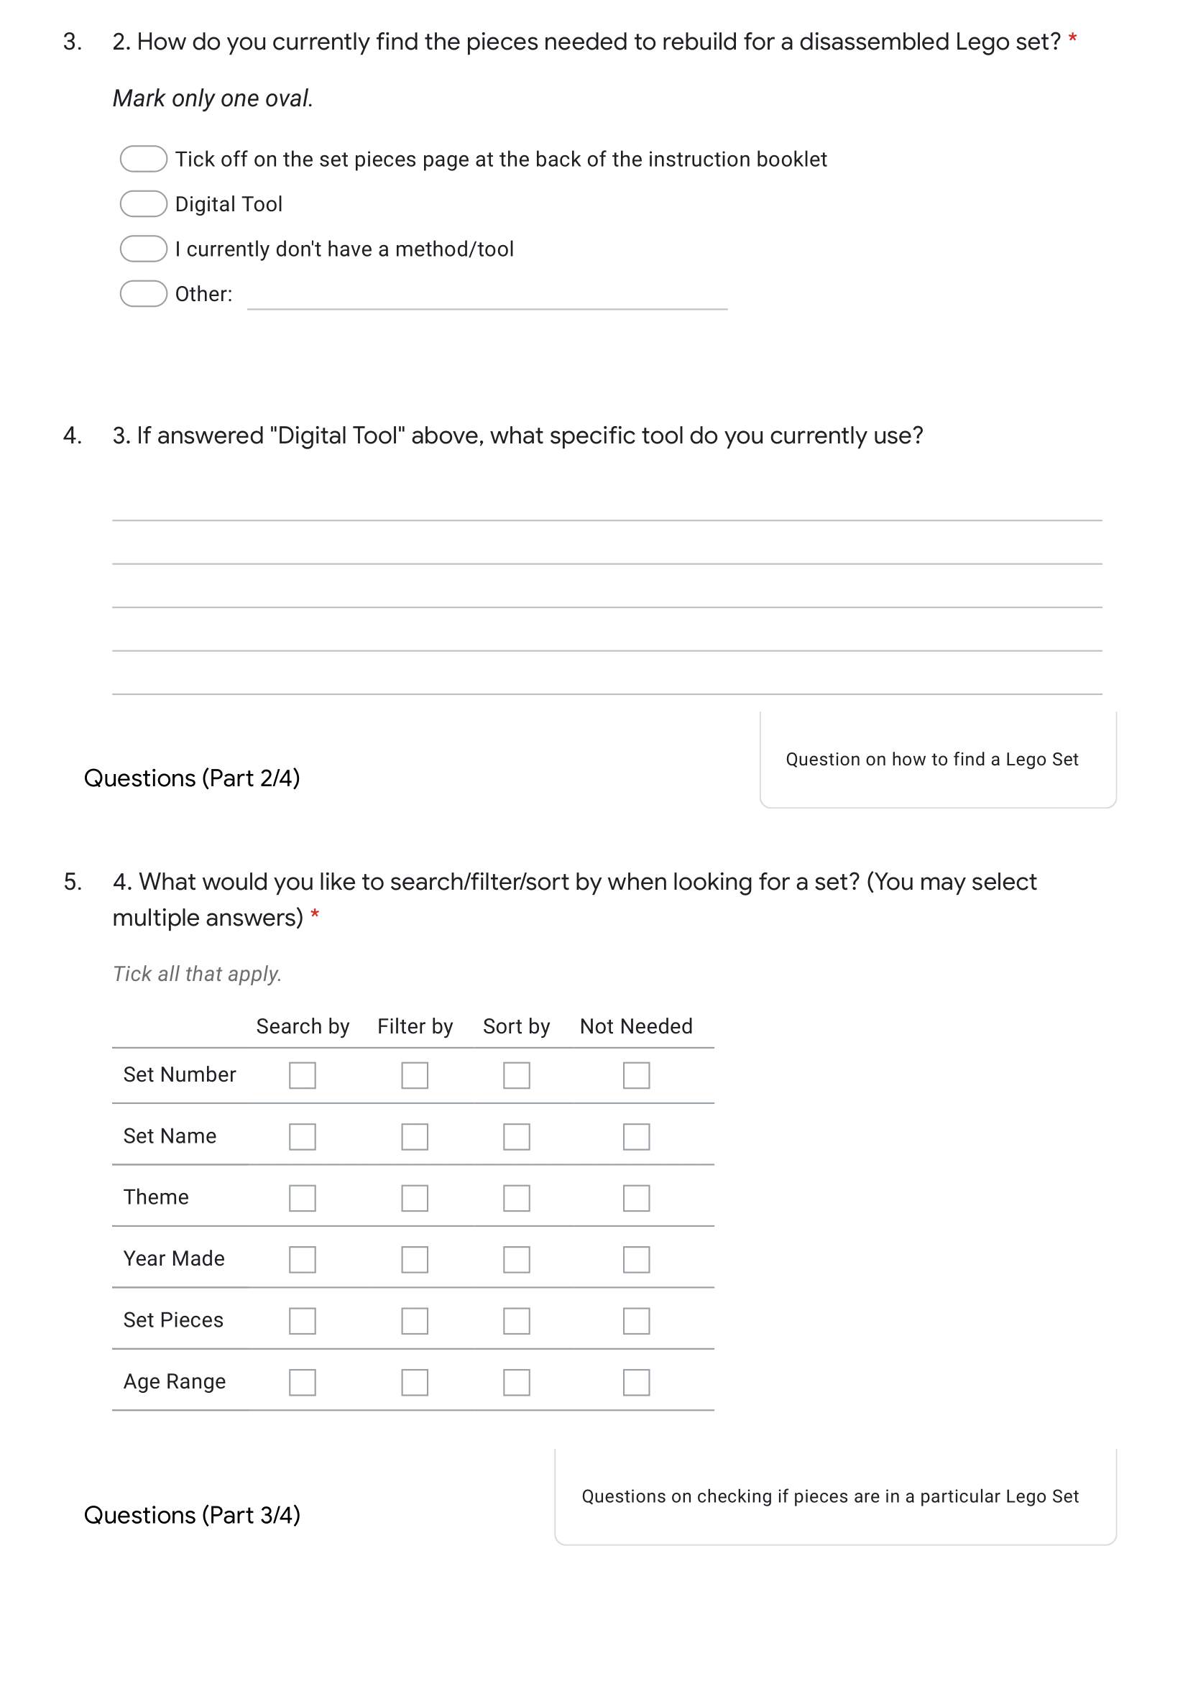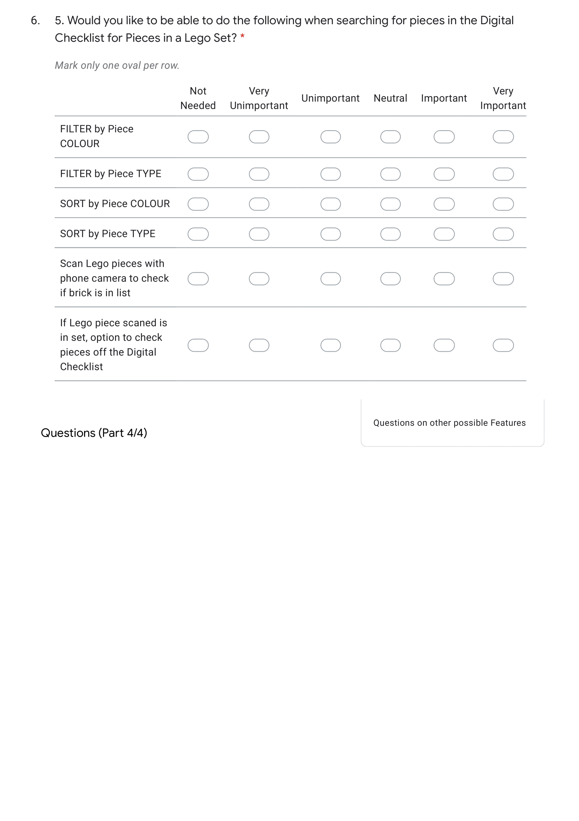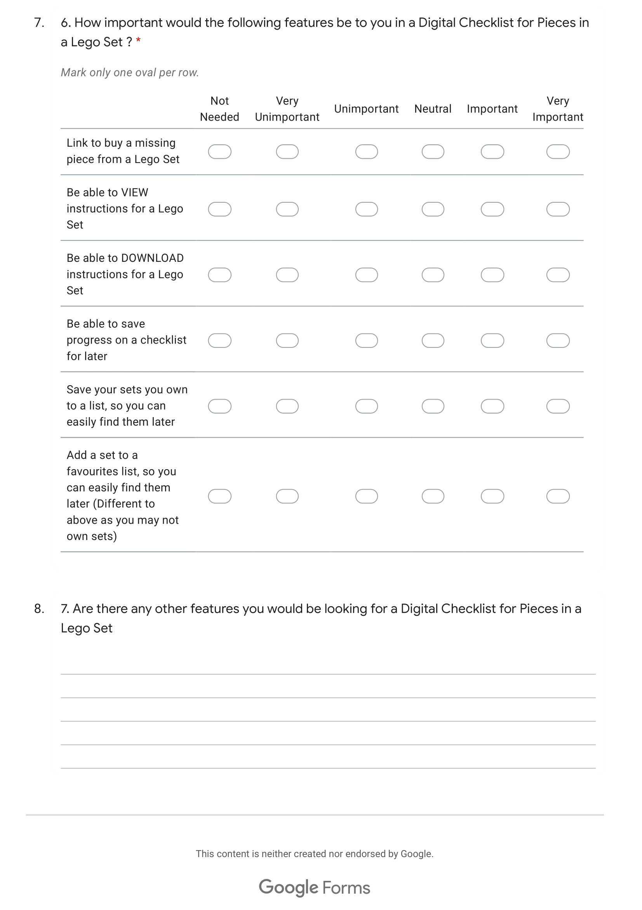

## Appendix B

Results from my questionnaire (see **Appendix A**).

Letter of Consent Result

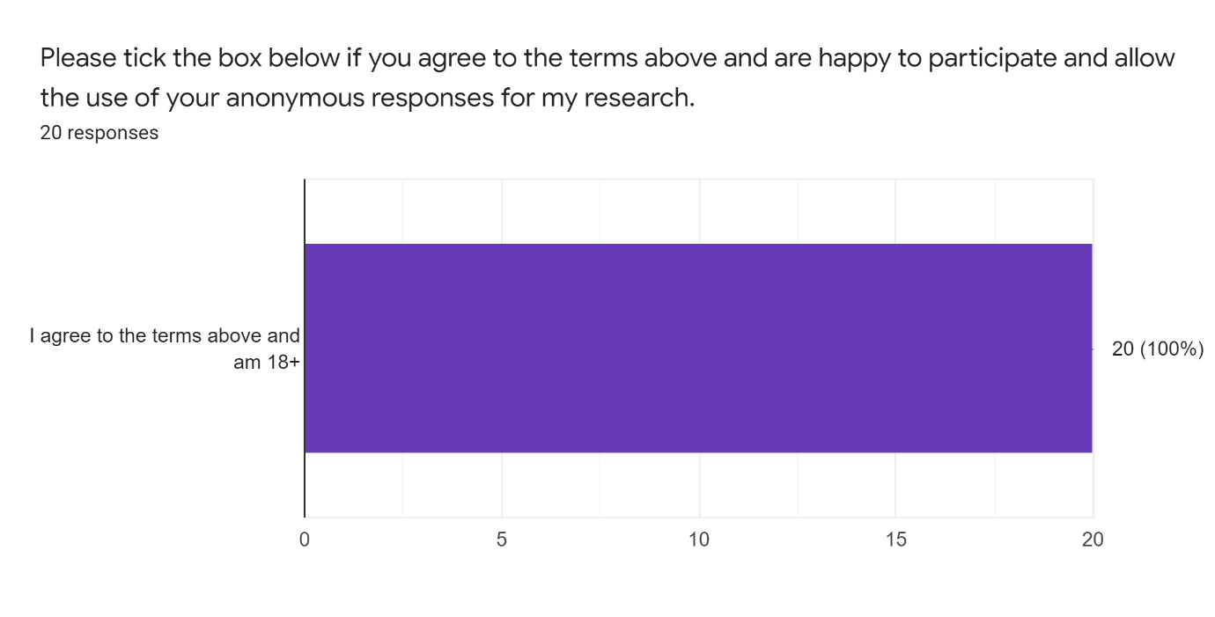



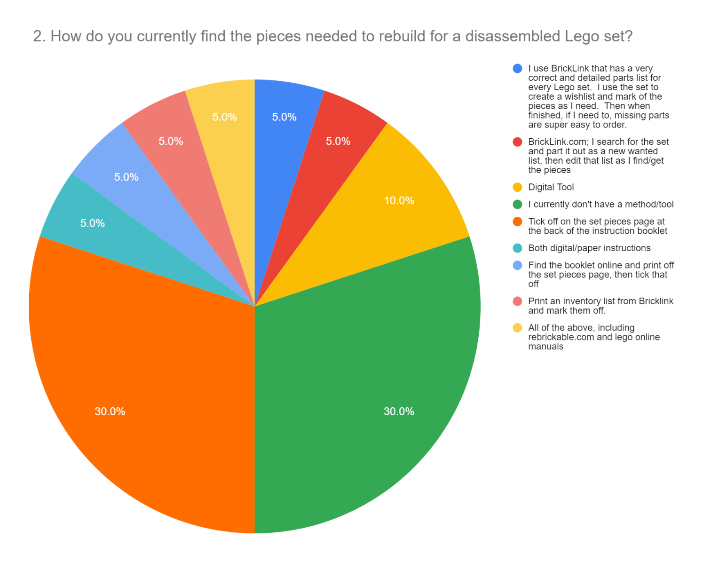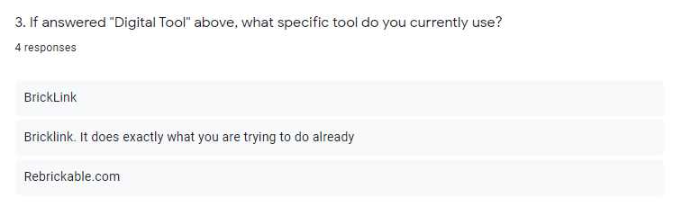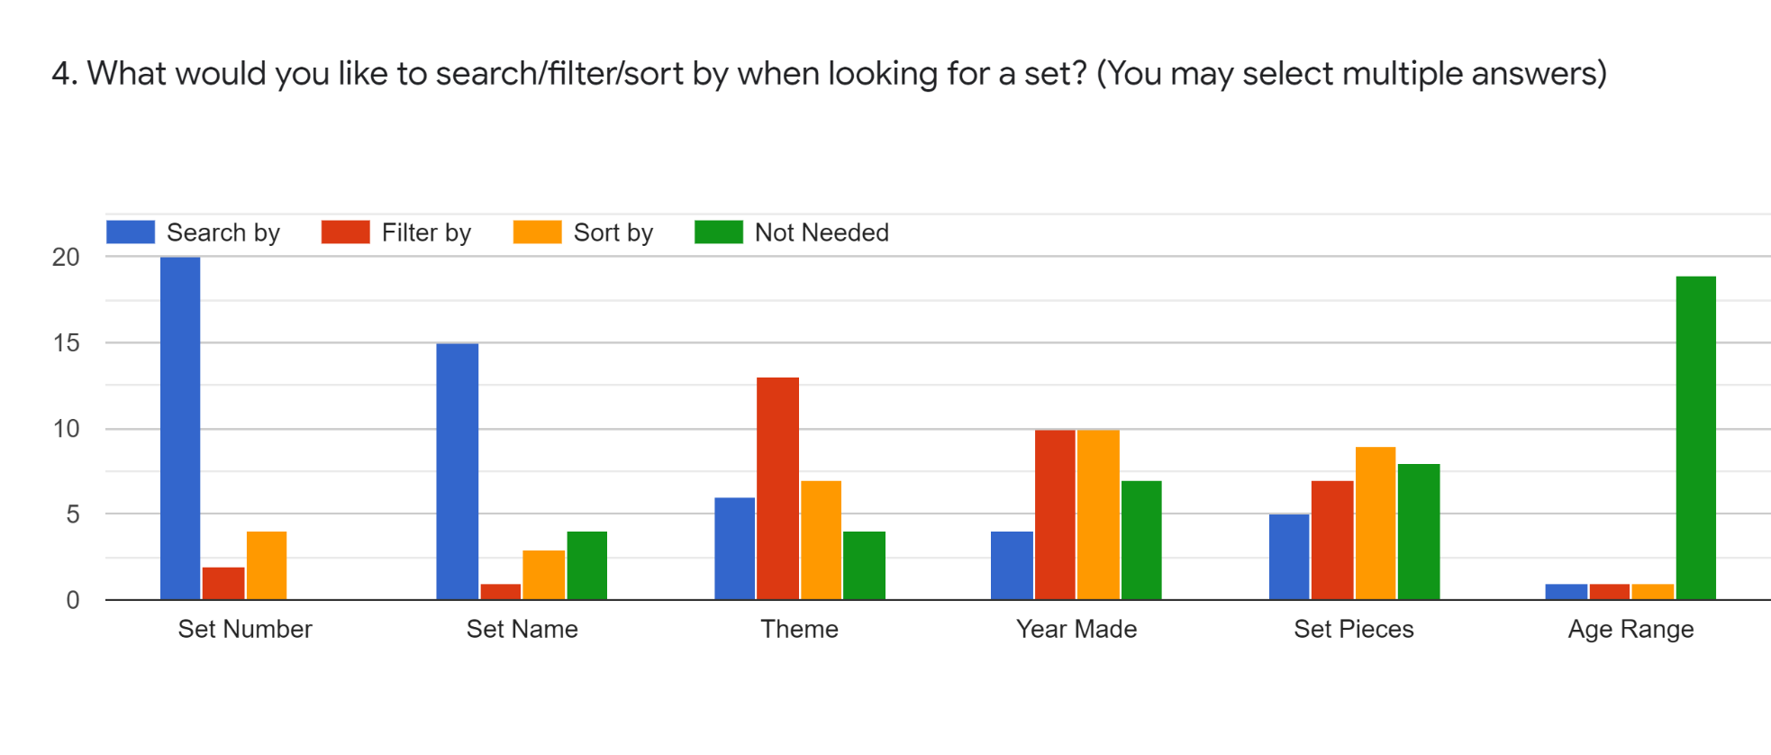

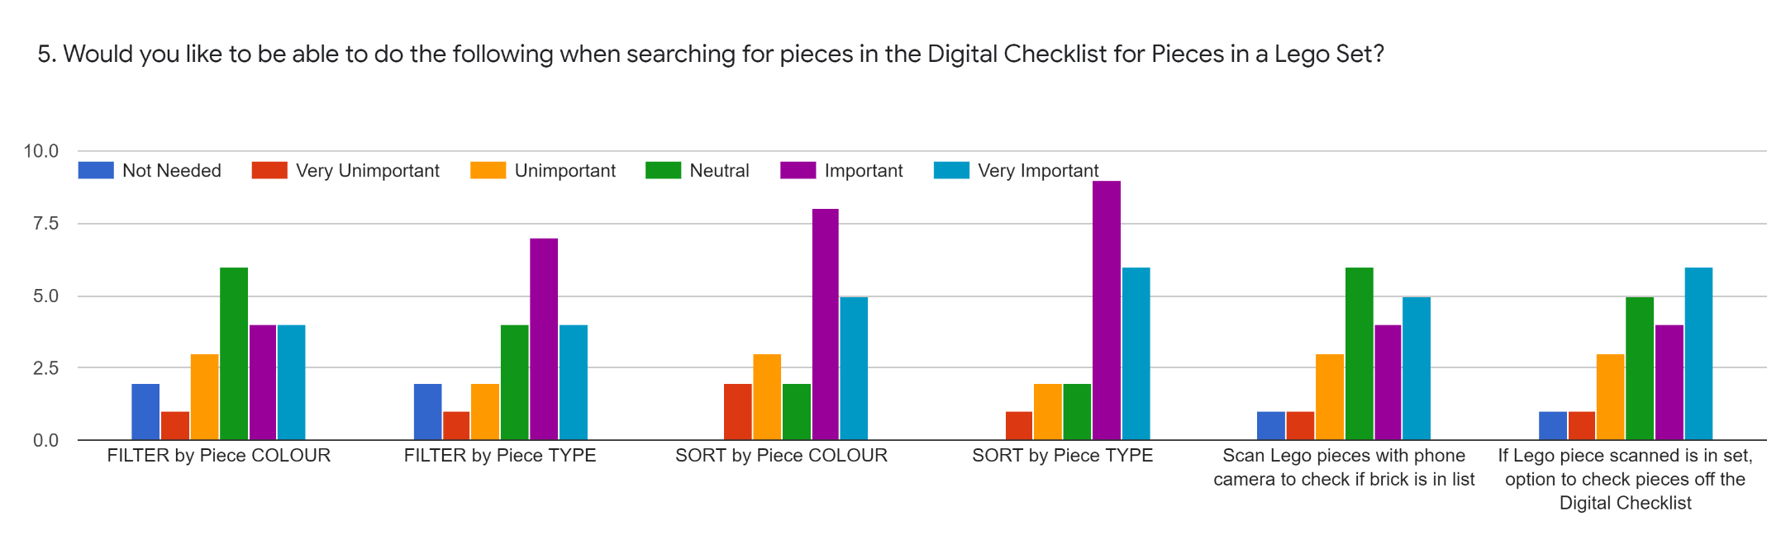

6. How important would the following features be to you in a Digital Checklist for Pieces in a Lego Set ?

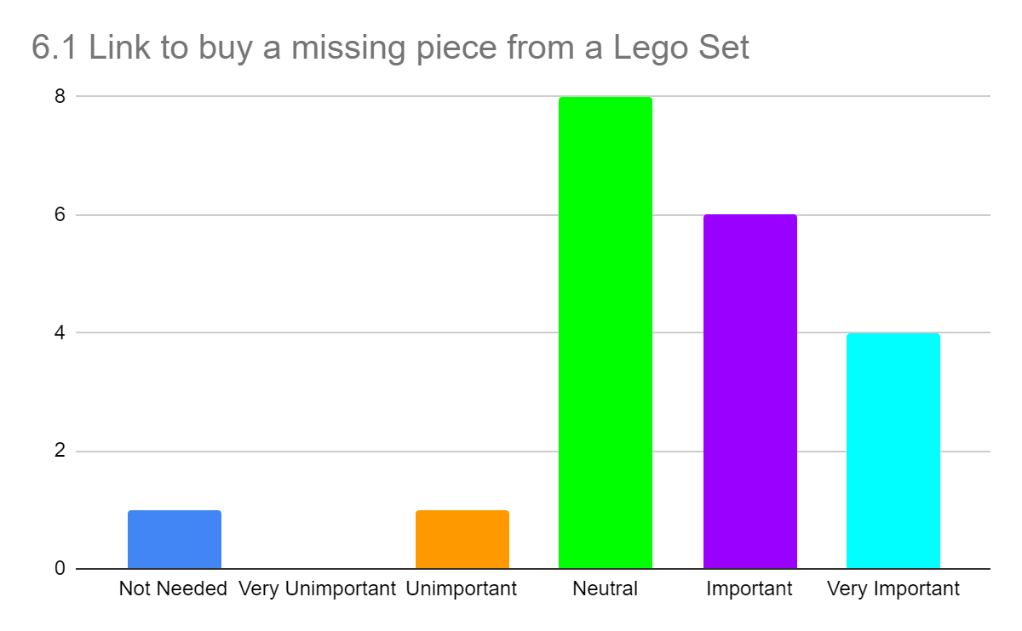

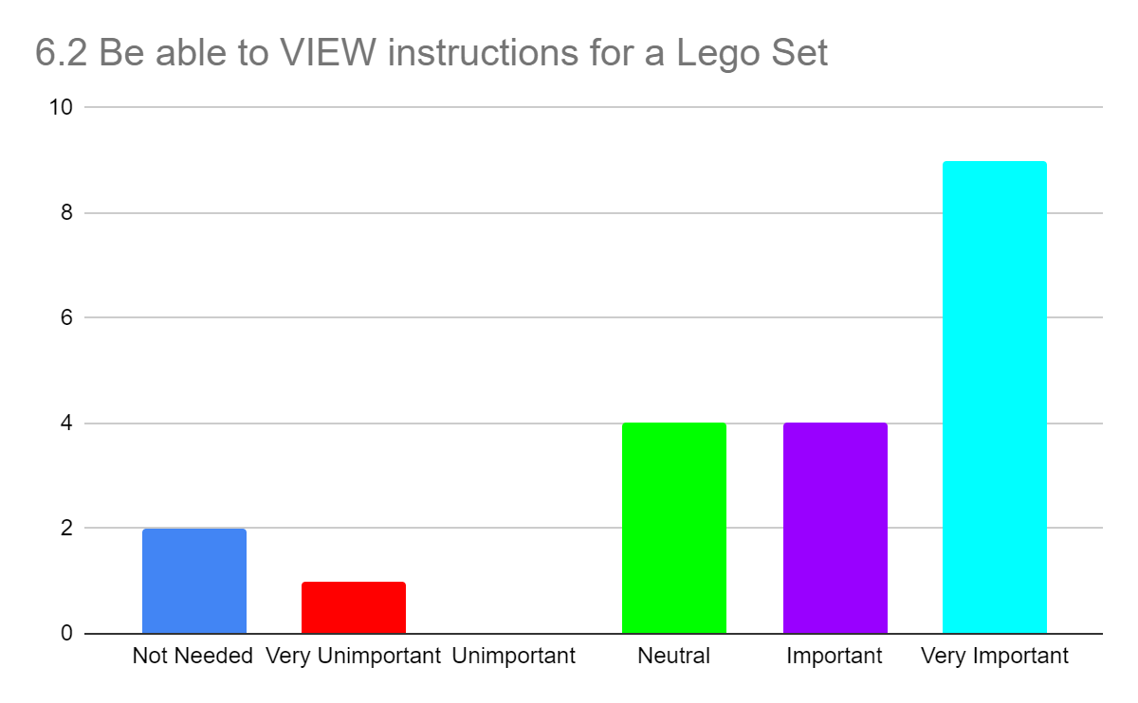

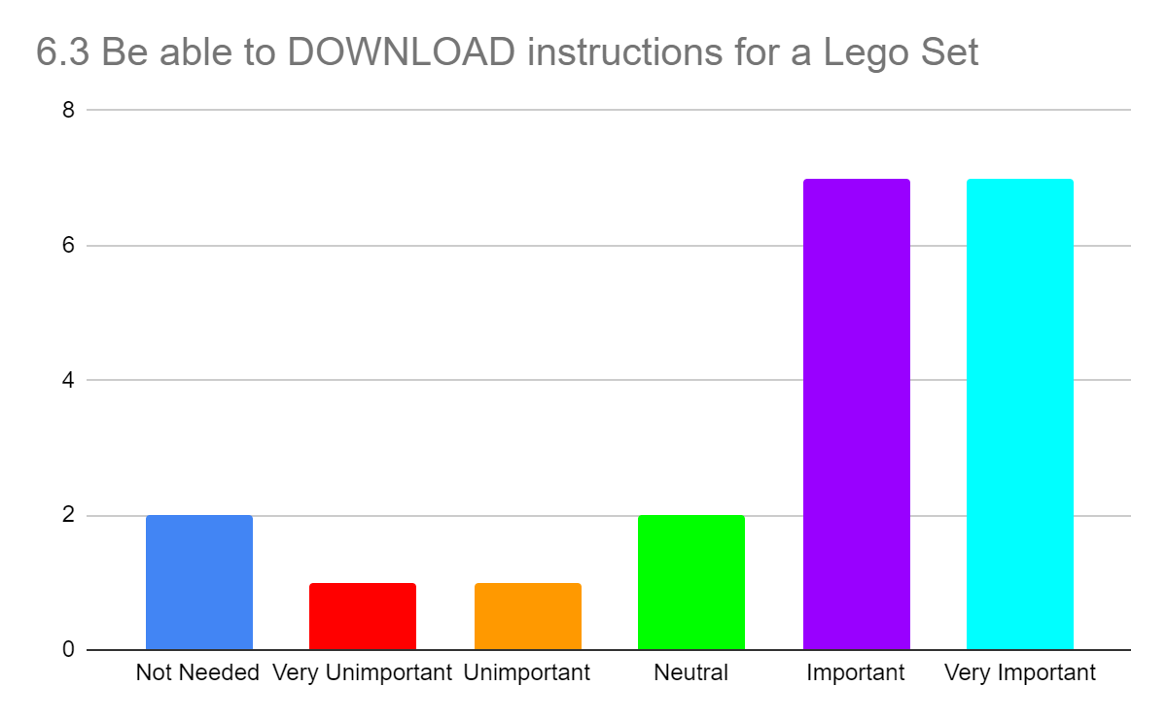

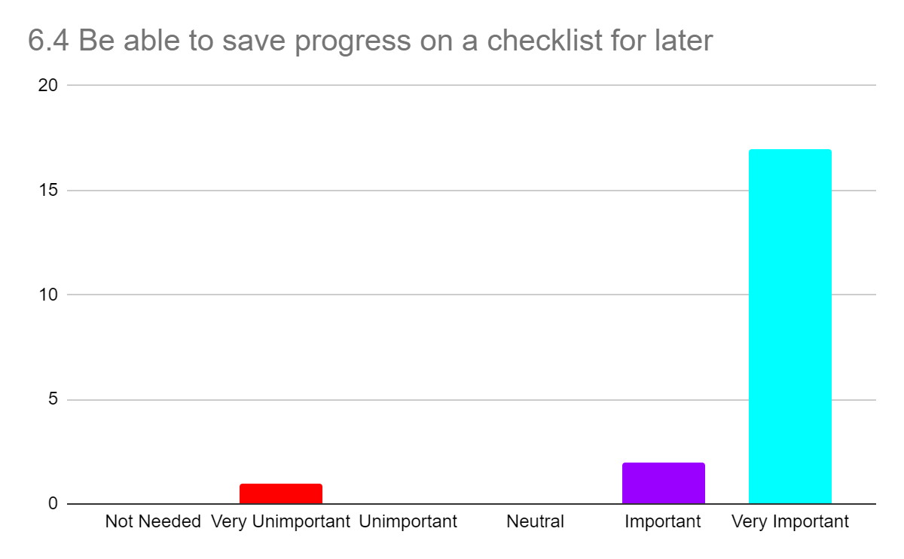

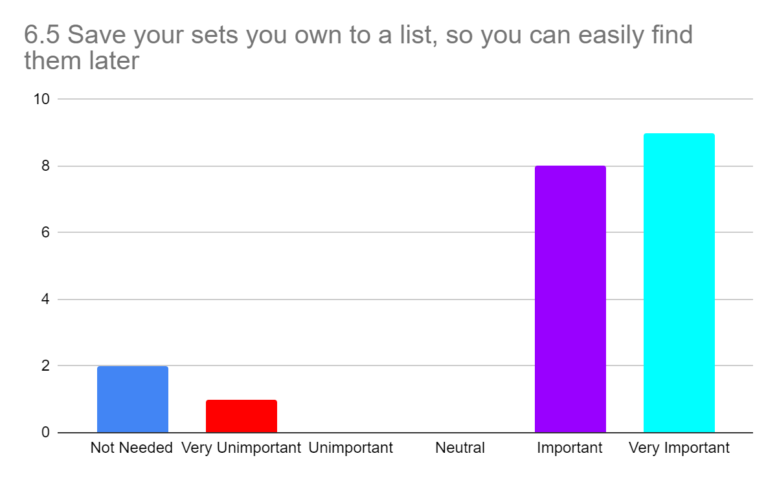

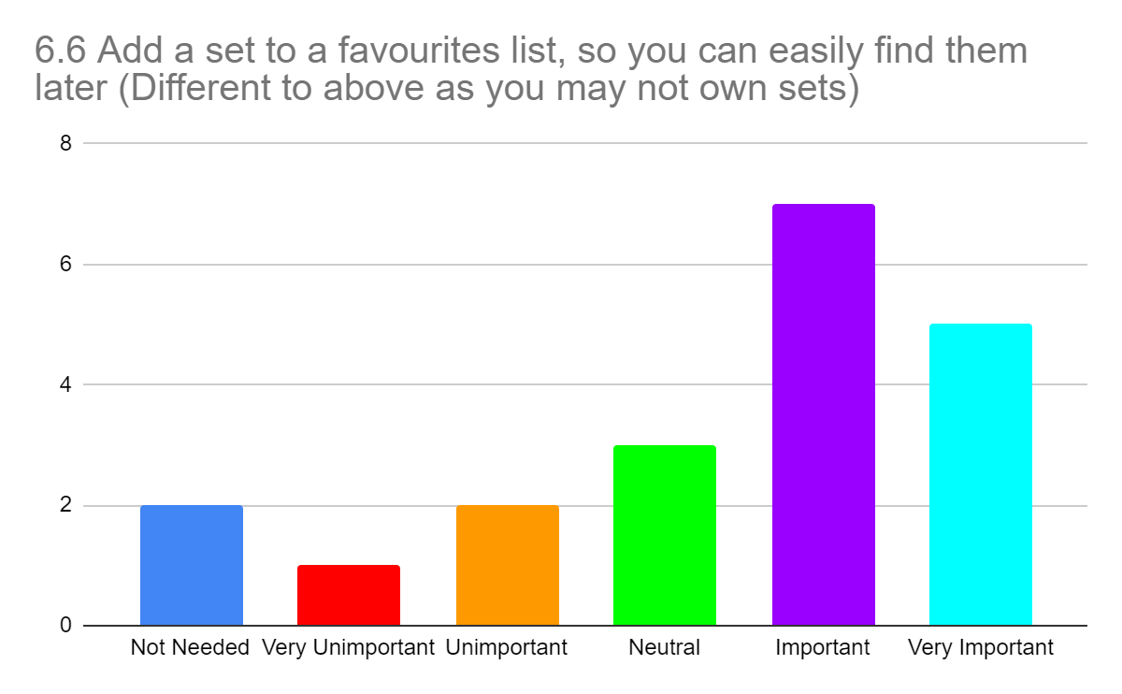



## Appendix C

List of tasks performed by each participant during the usability tests, first on a PC/Laptop and then on a mobile device.

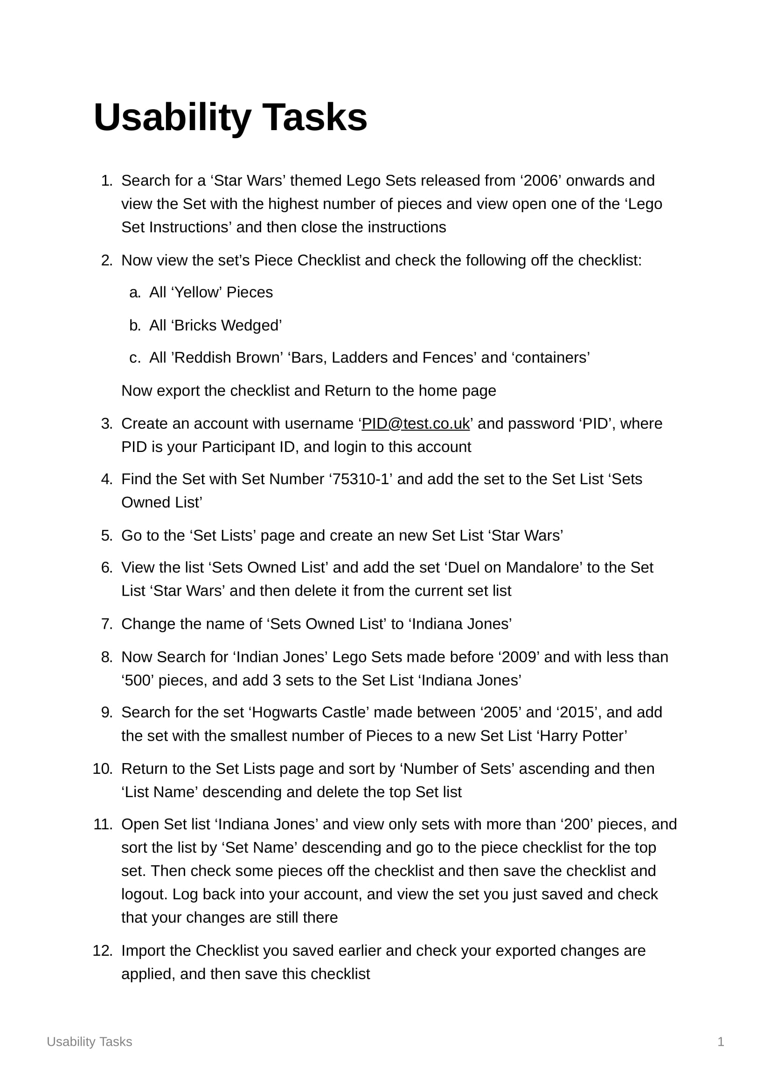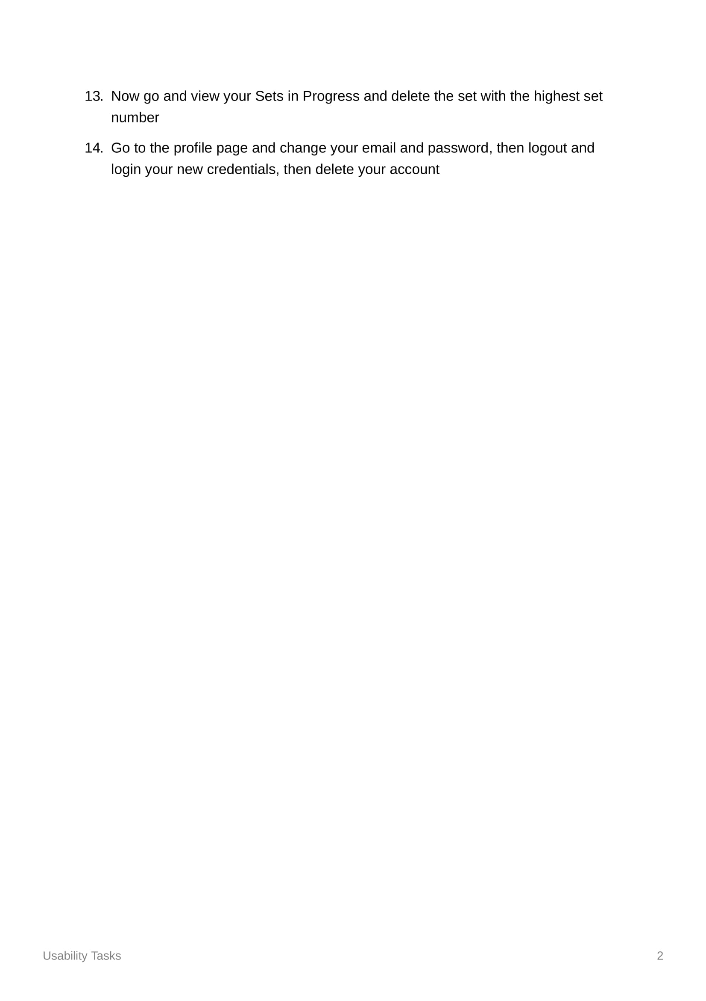

## Appendix D

Questionnaire on the Usability of my website.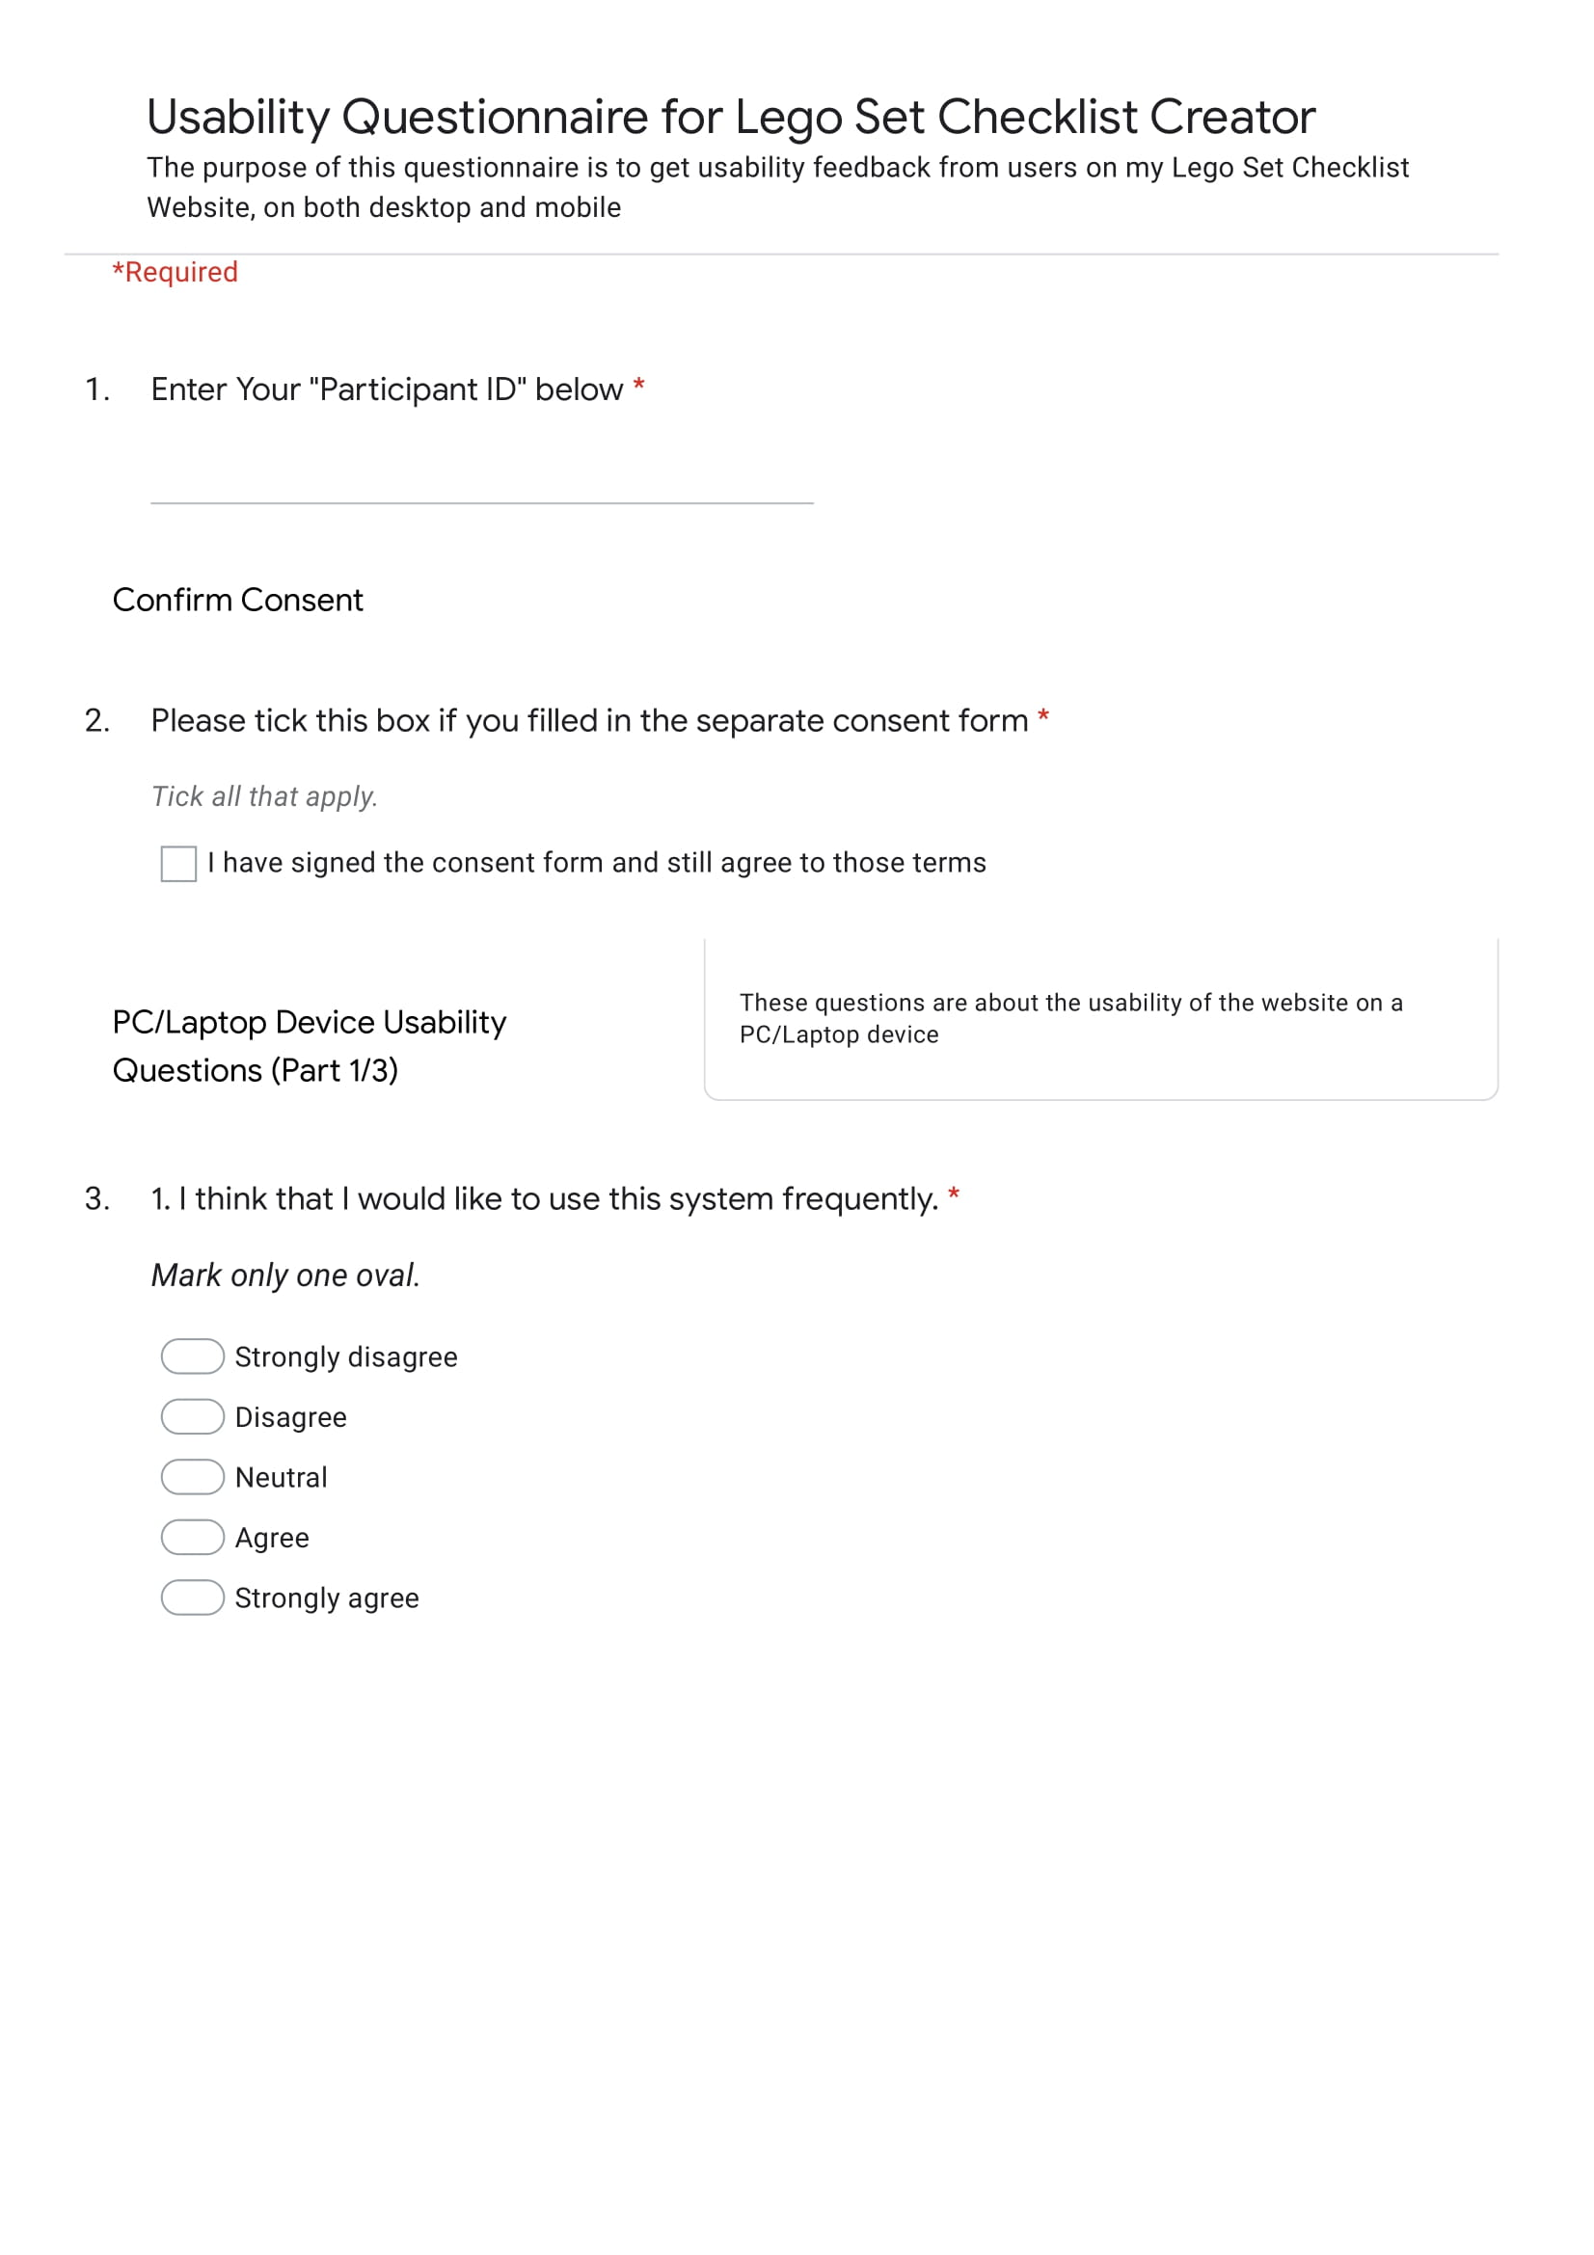 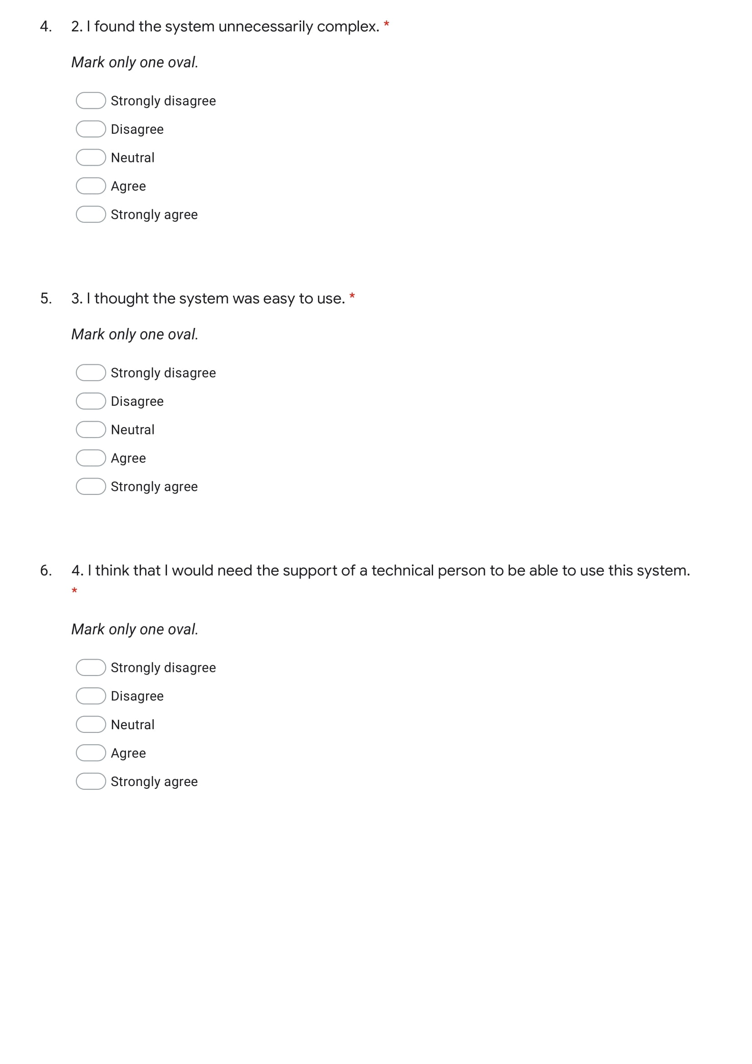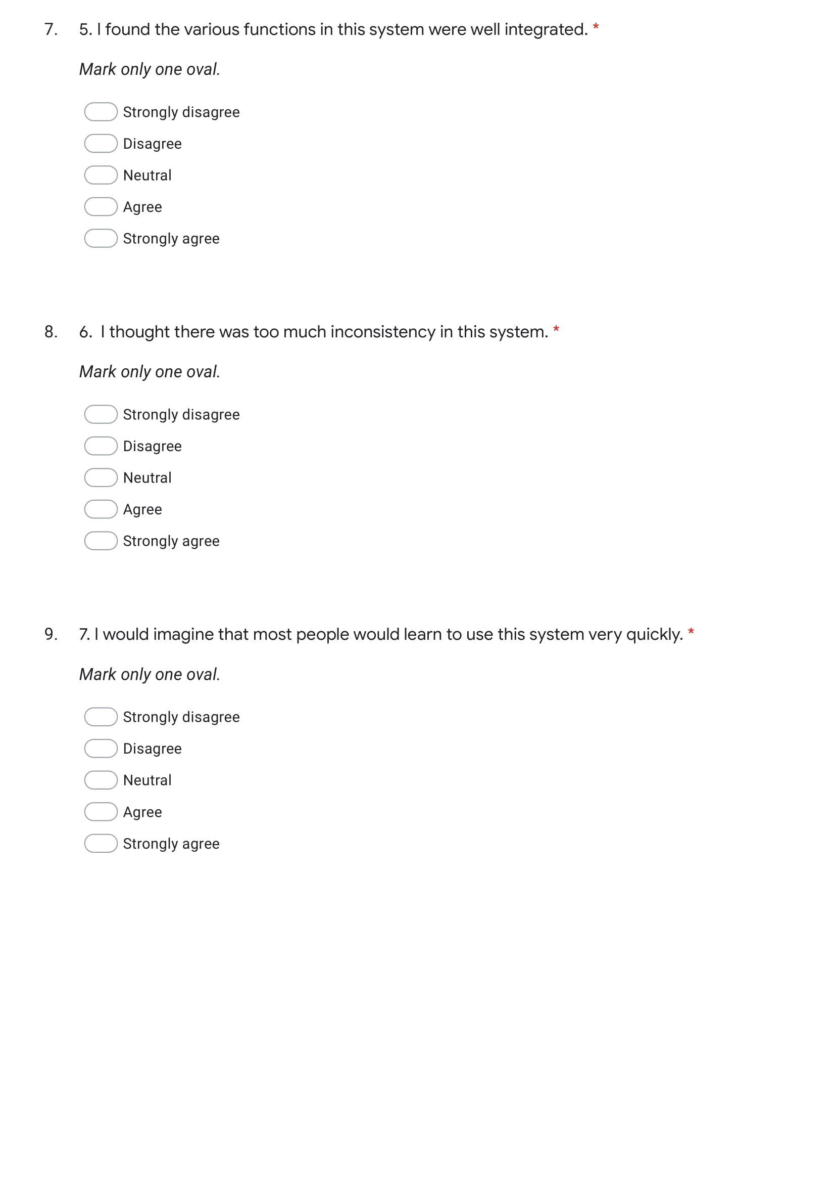

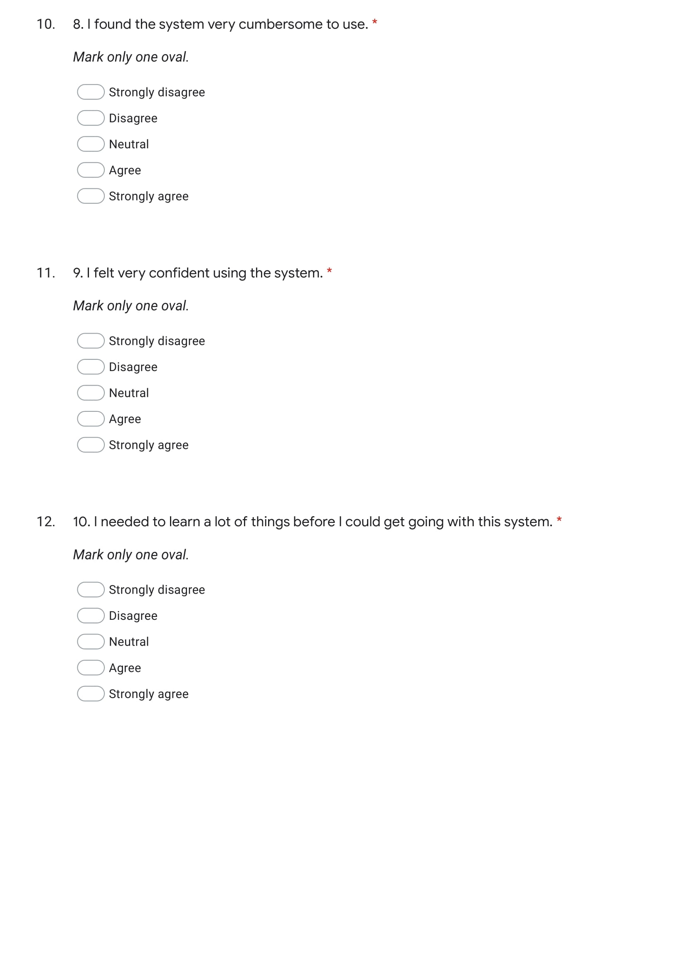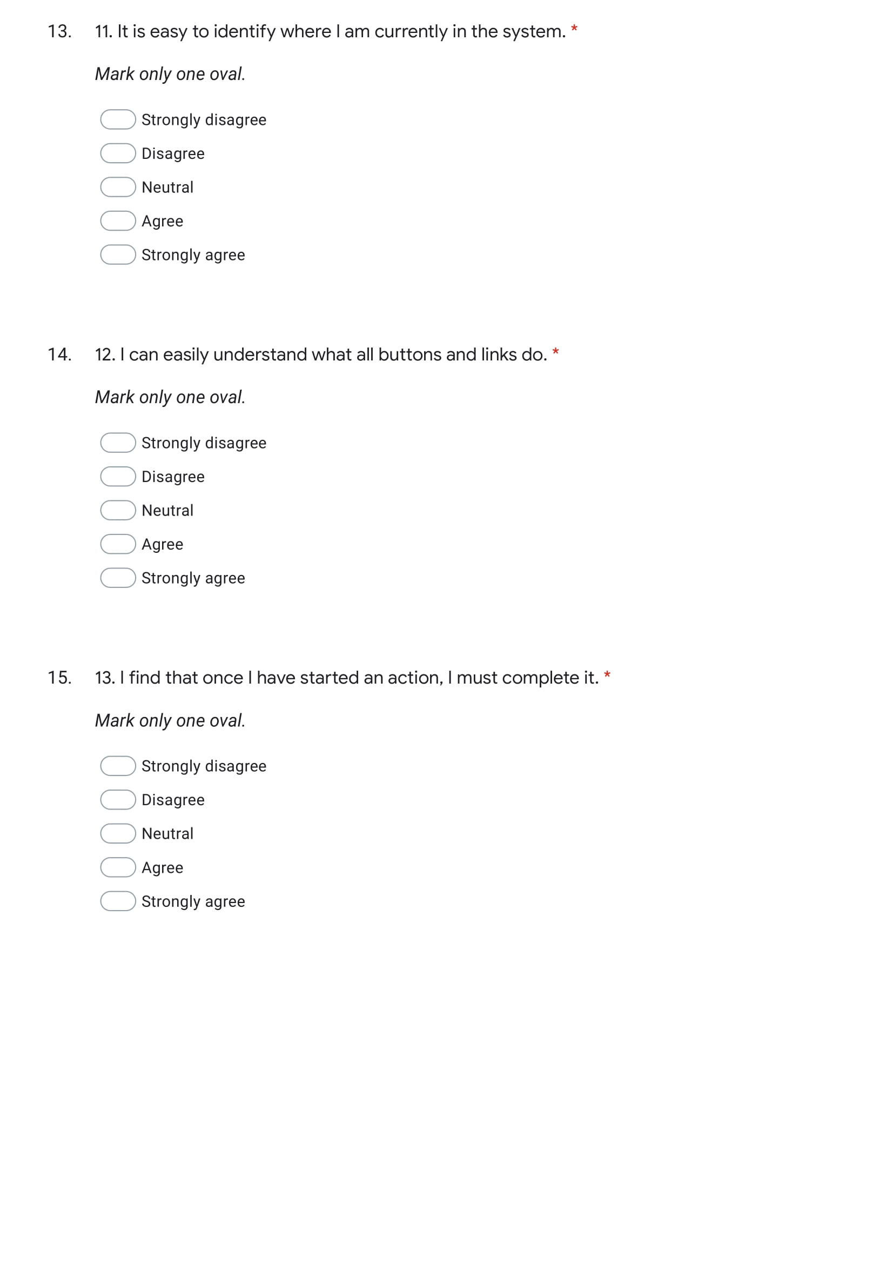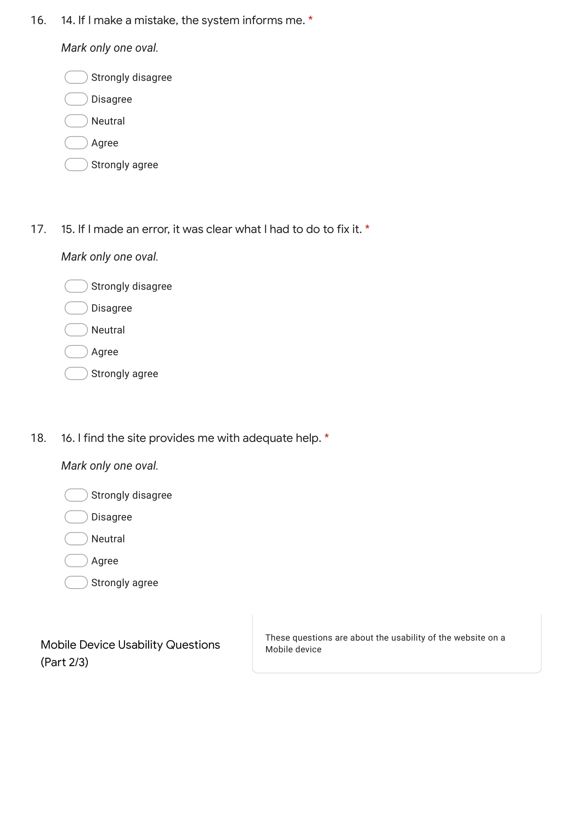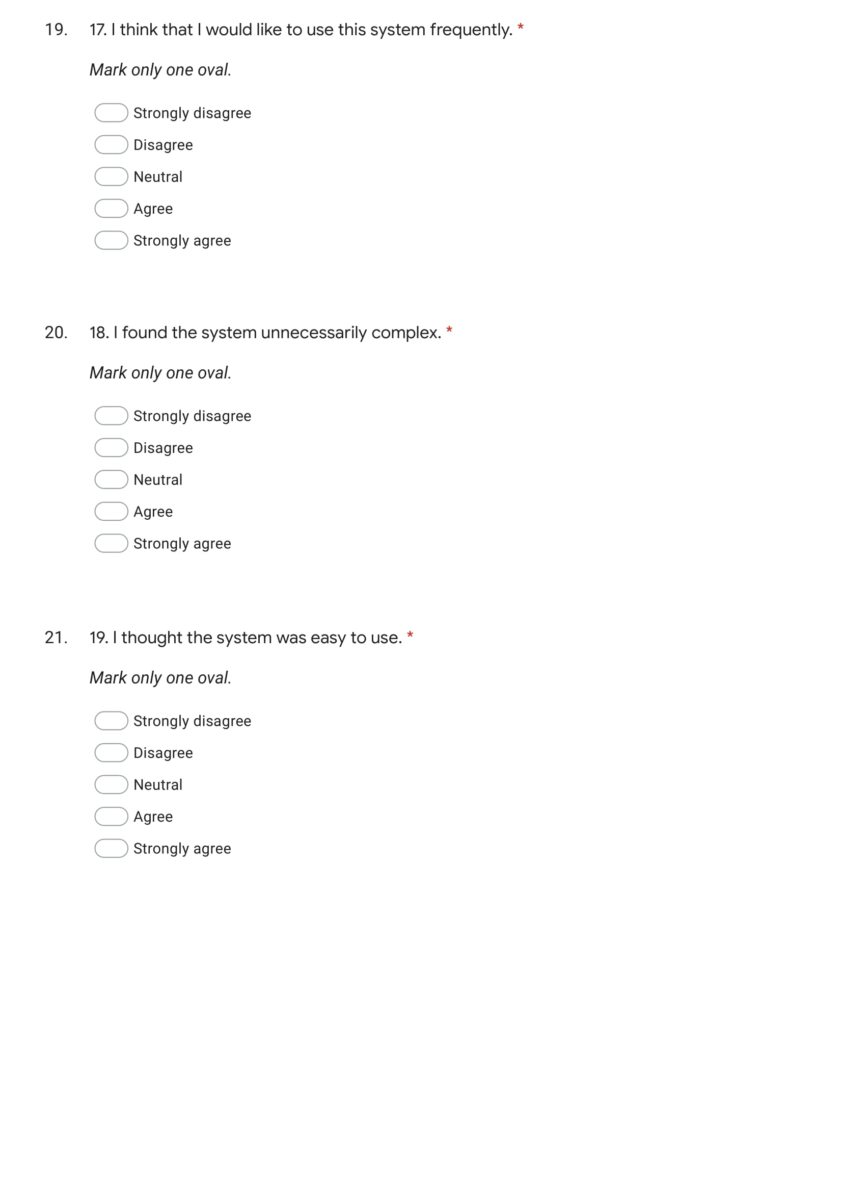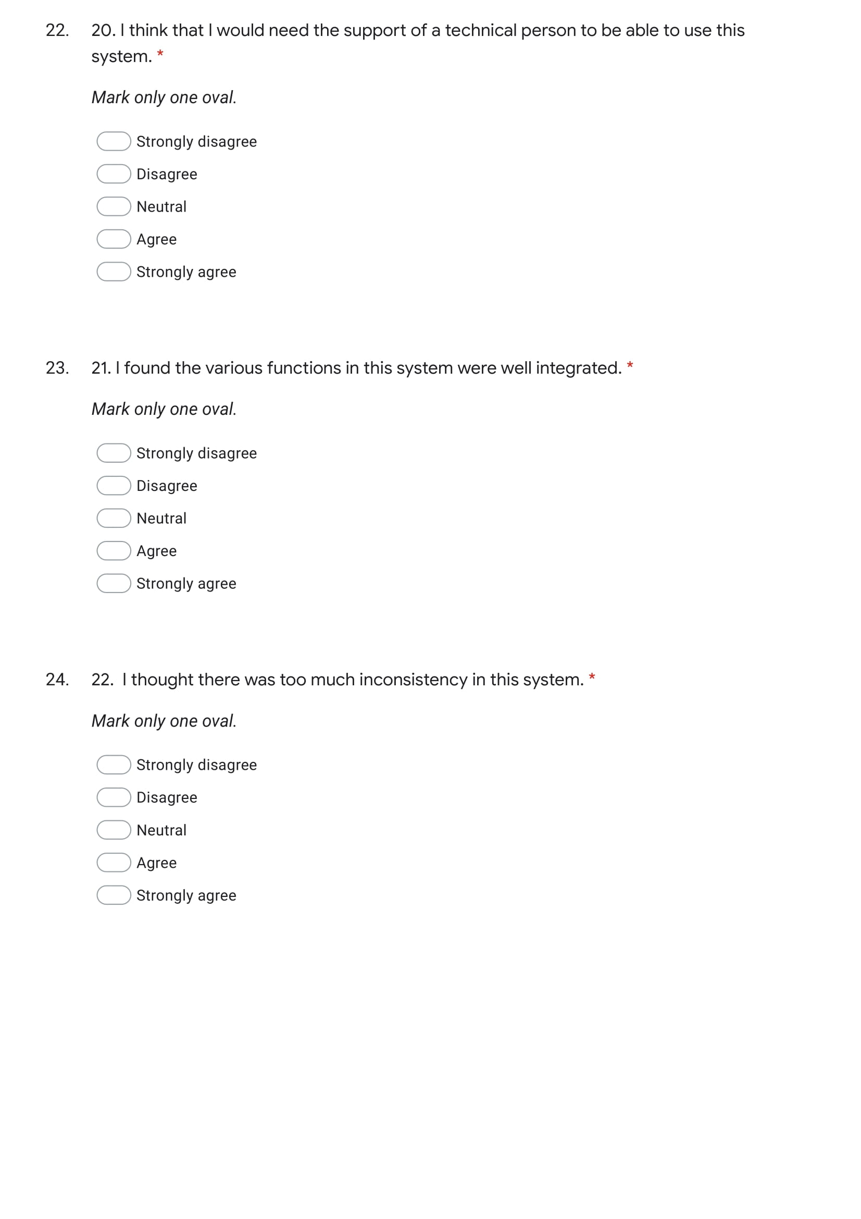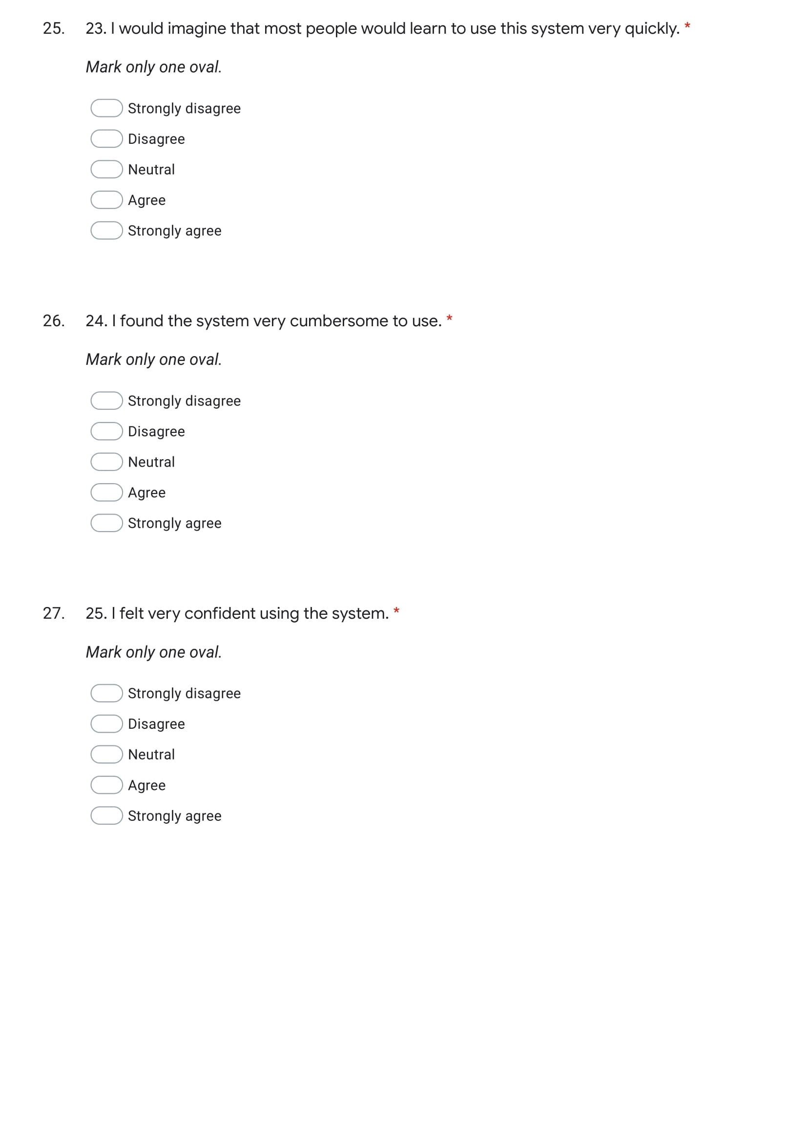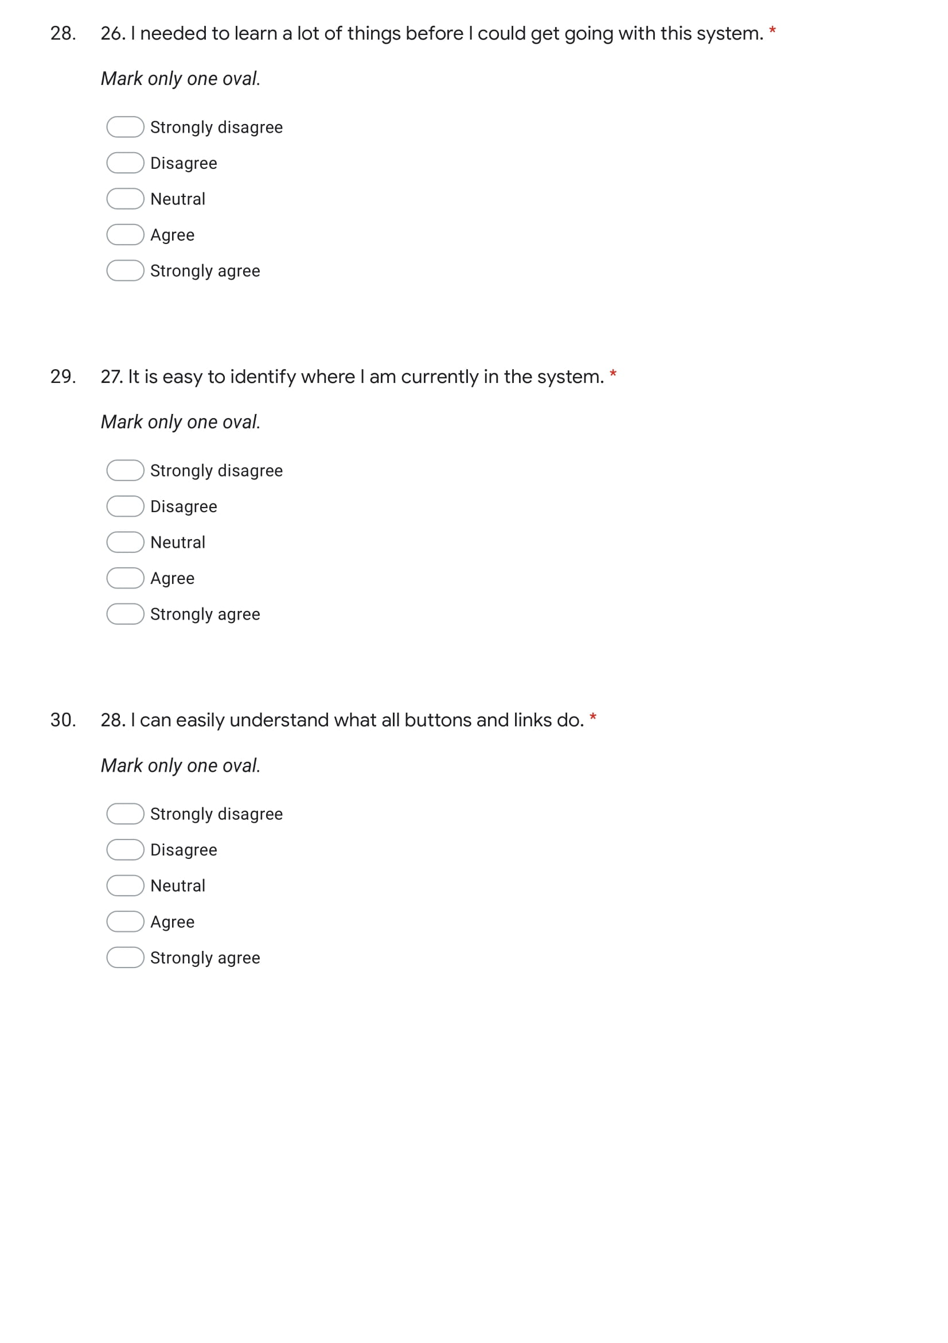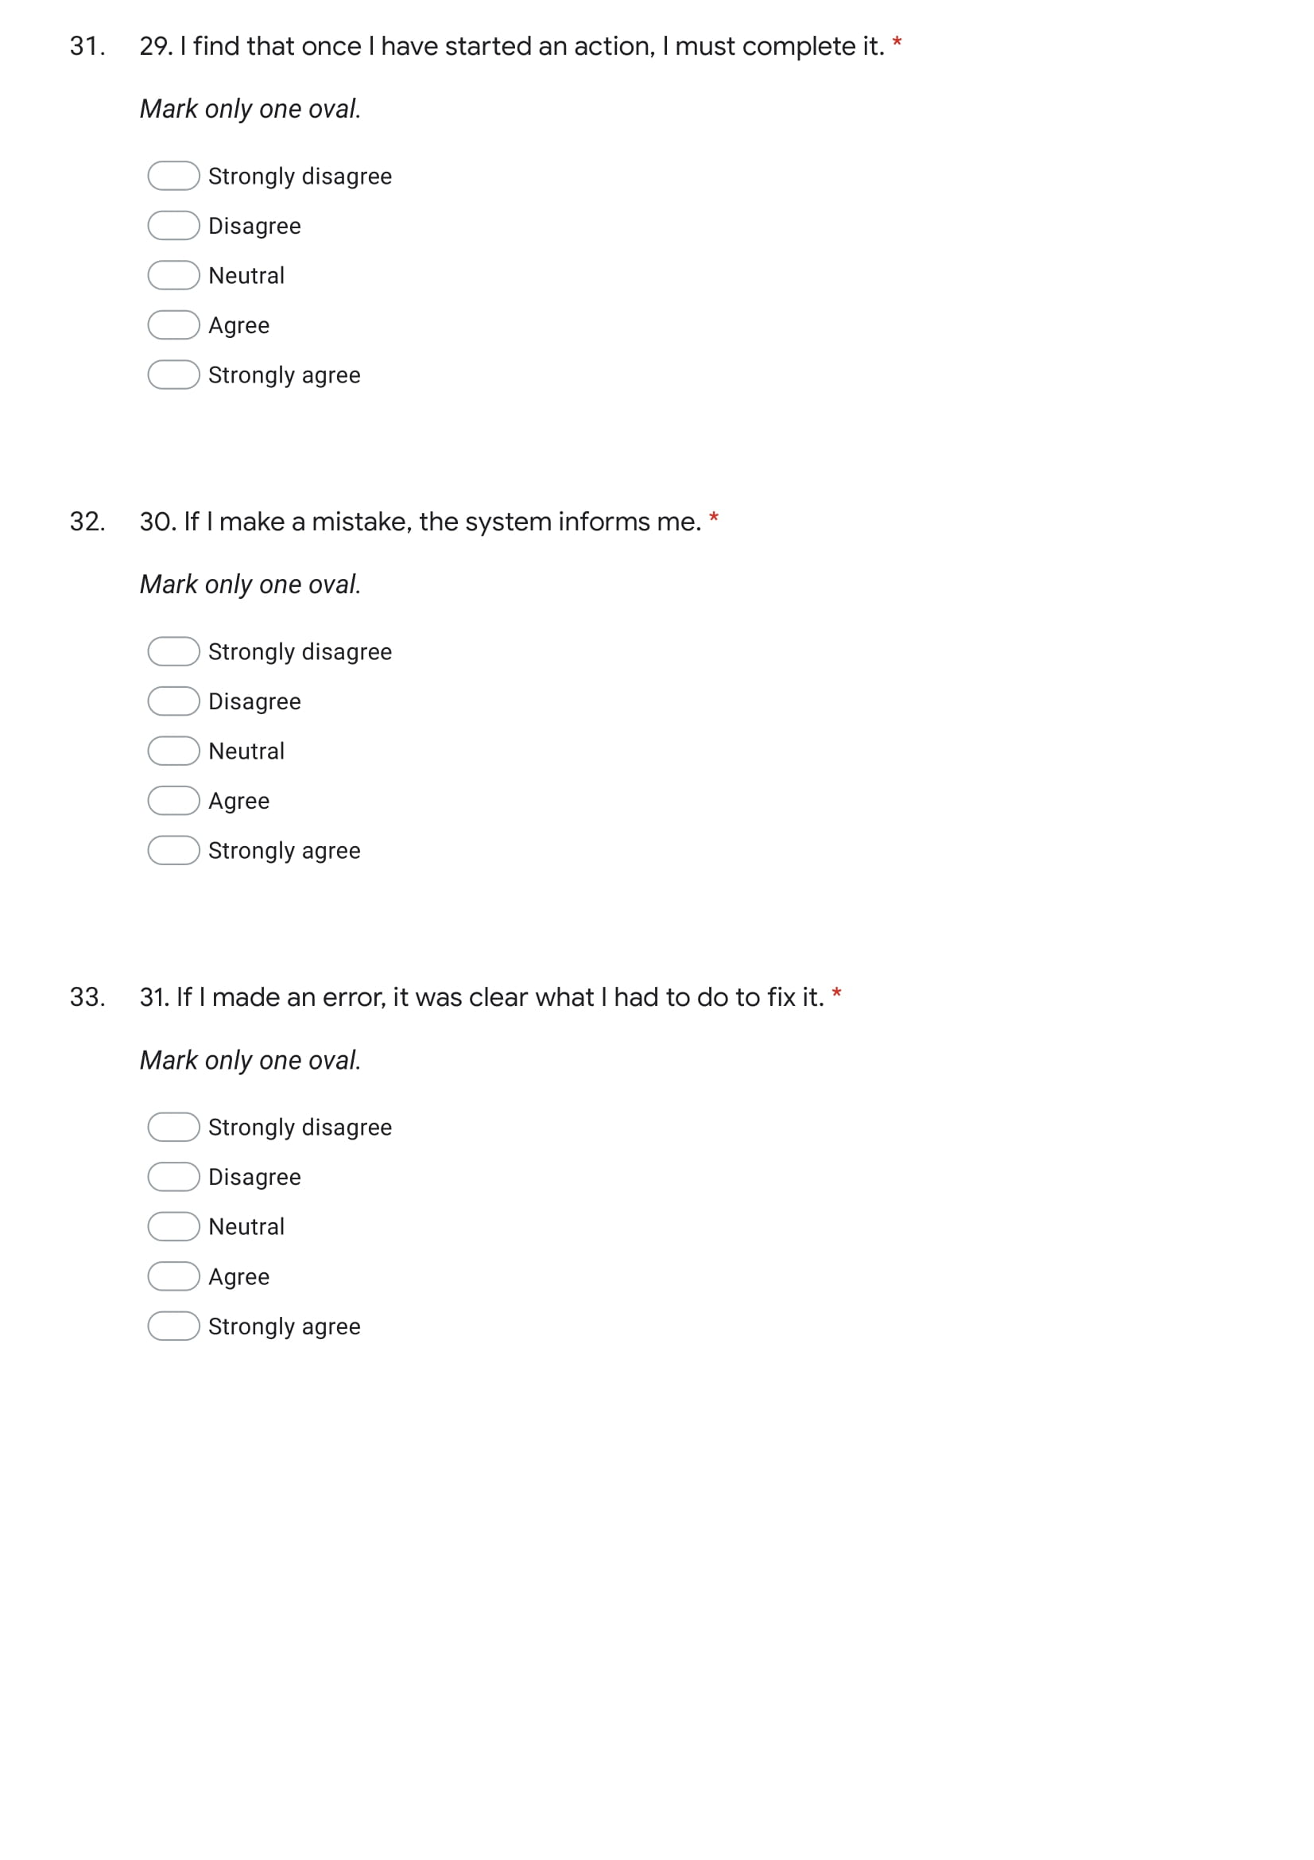

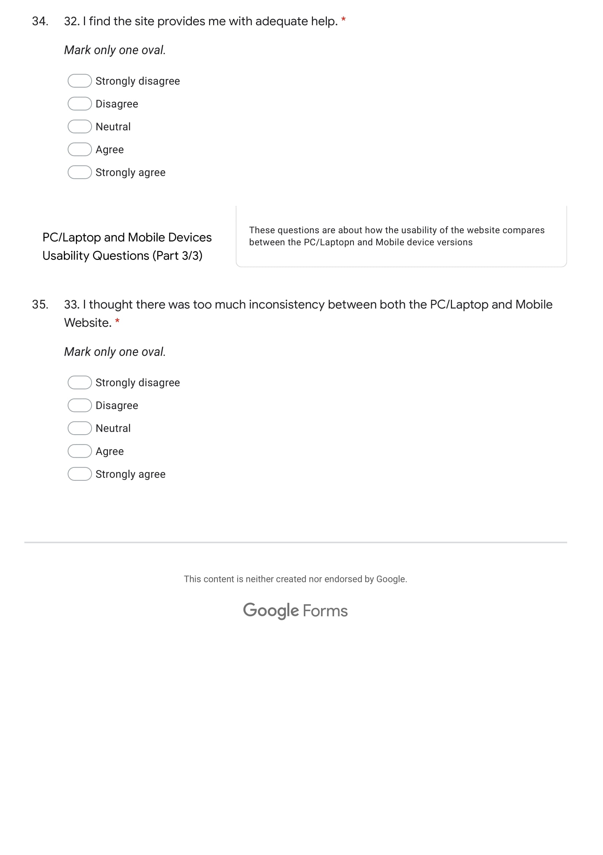



## Appendix E

Interview questions on the Usability of my website.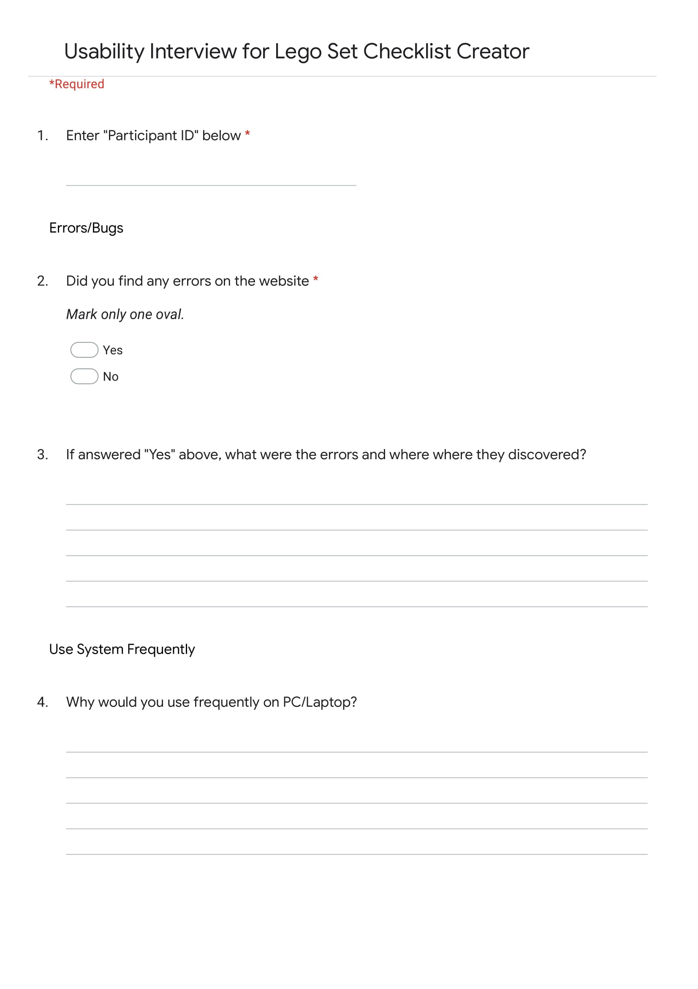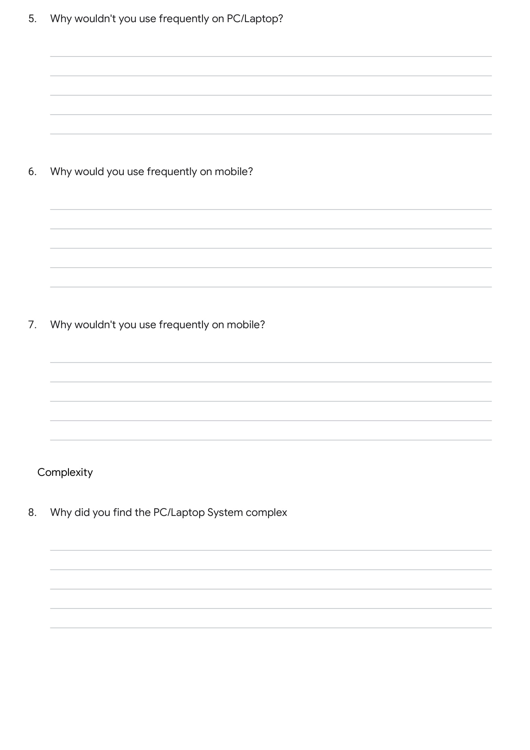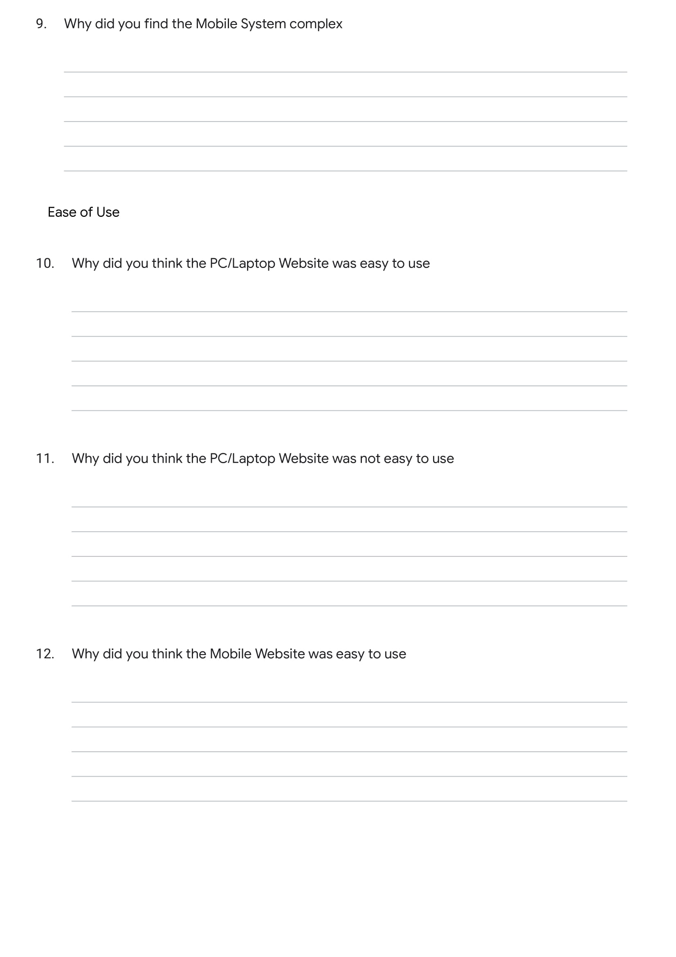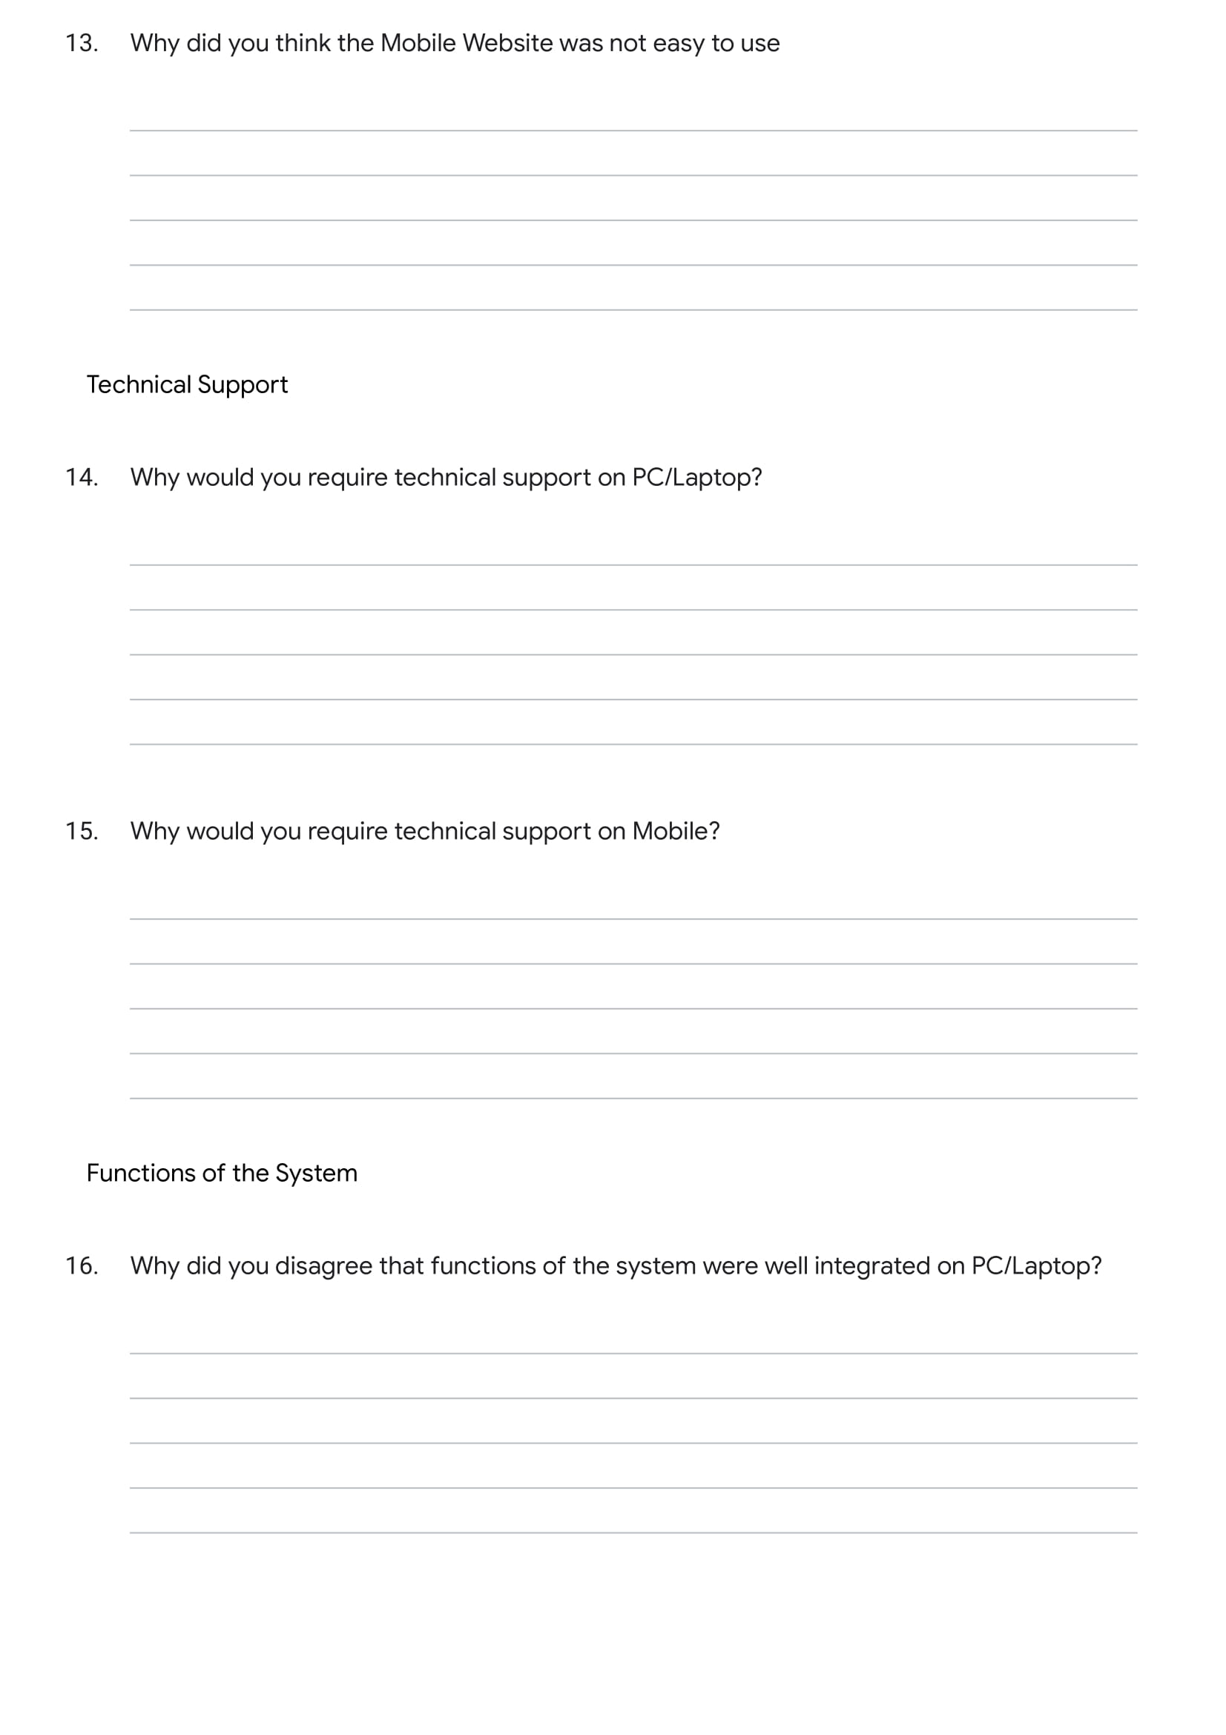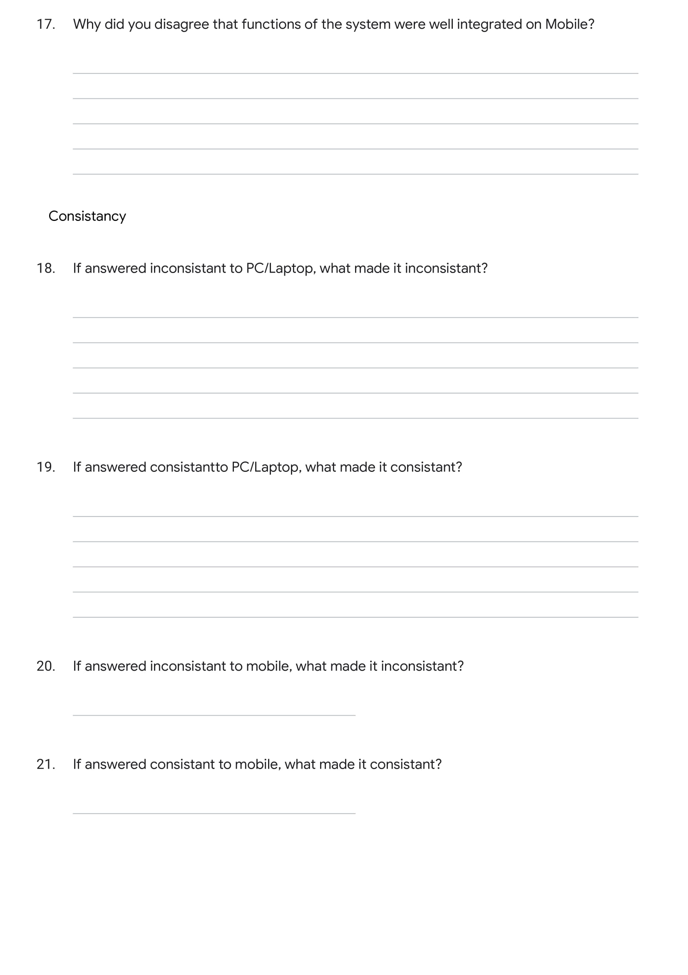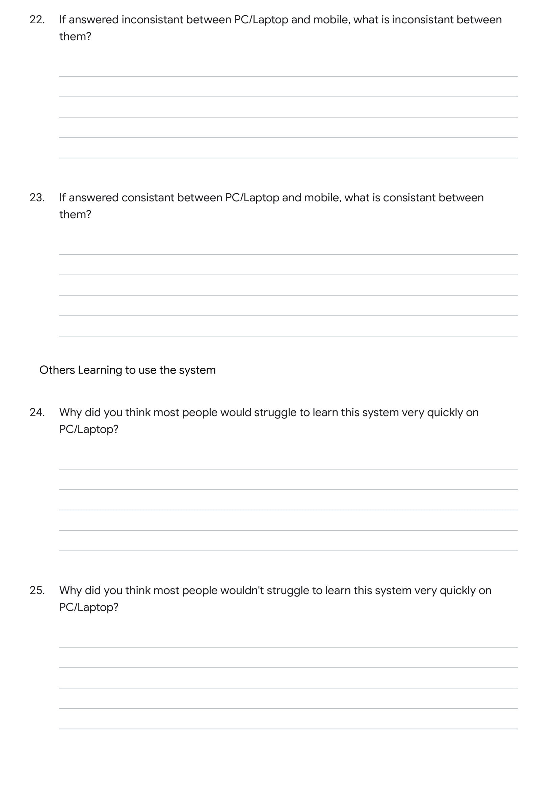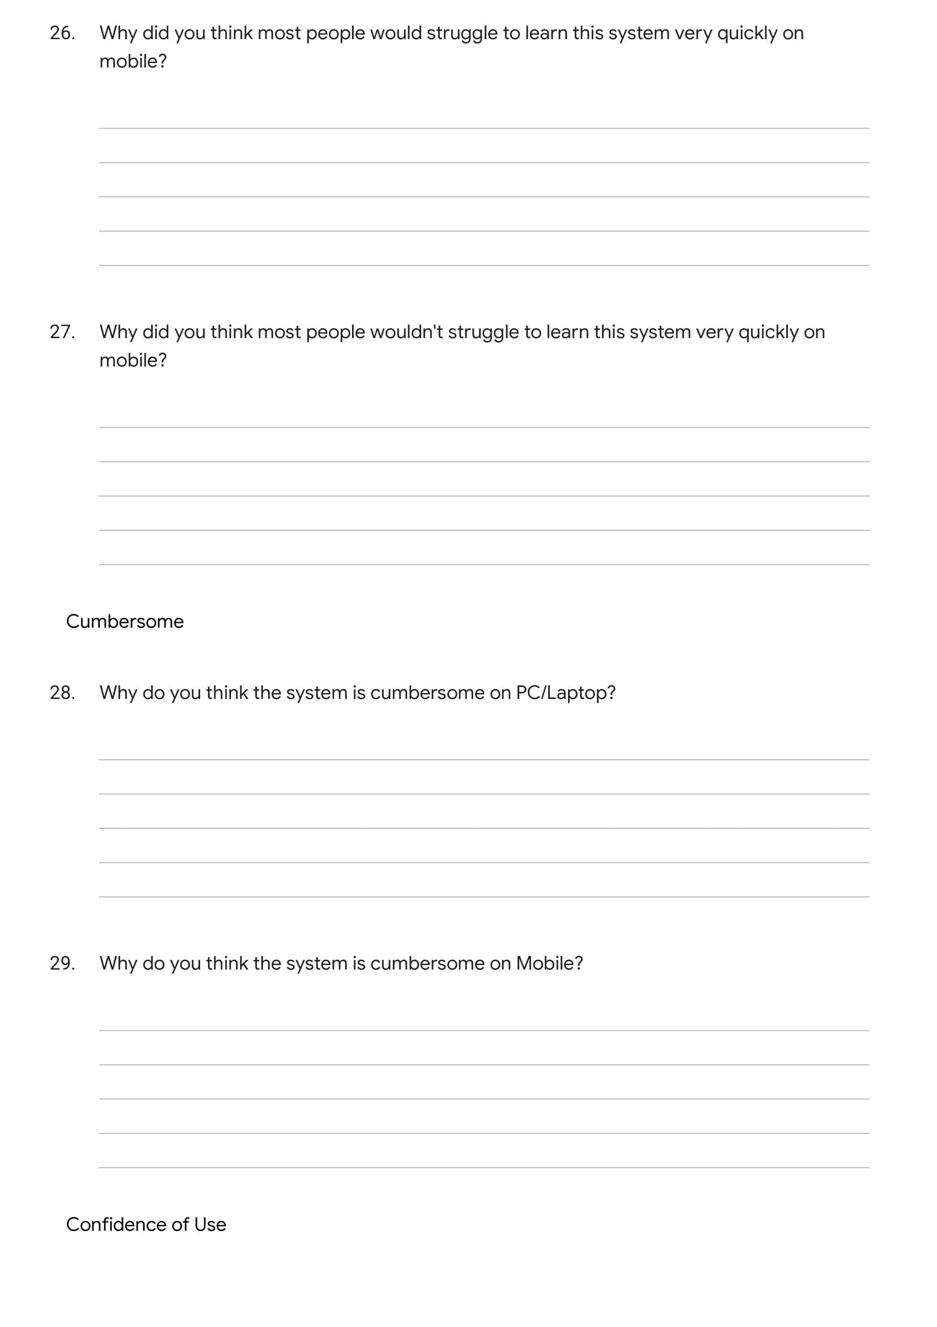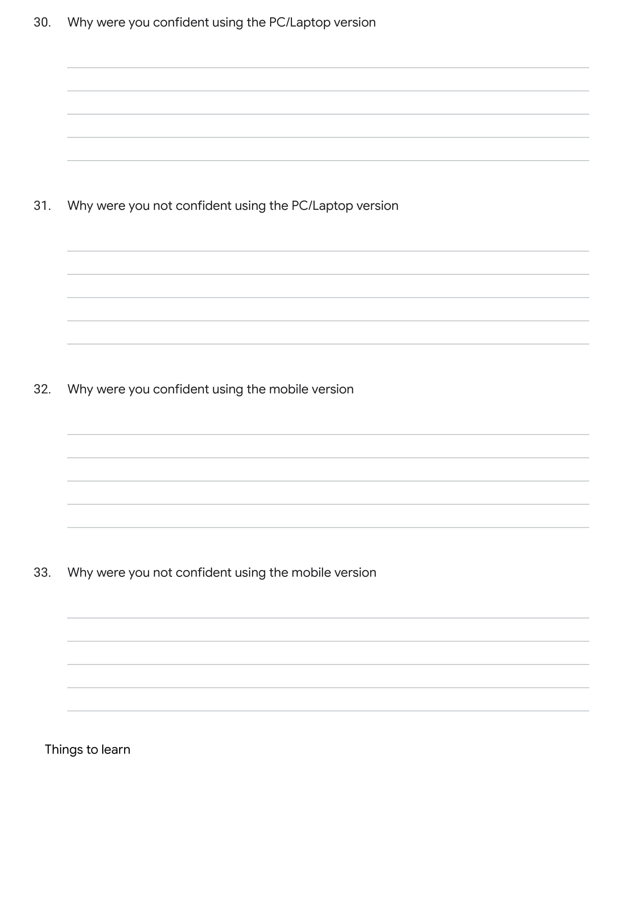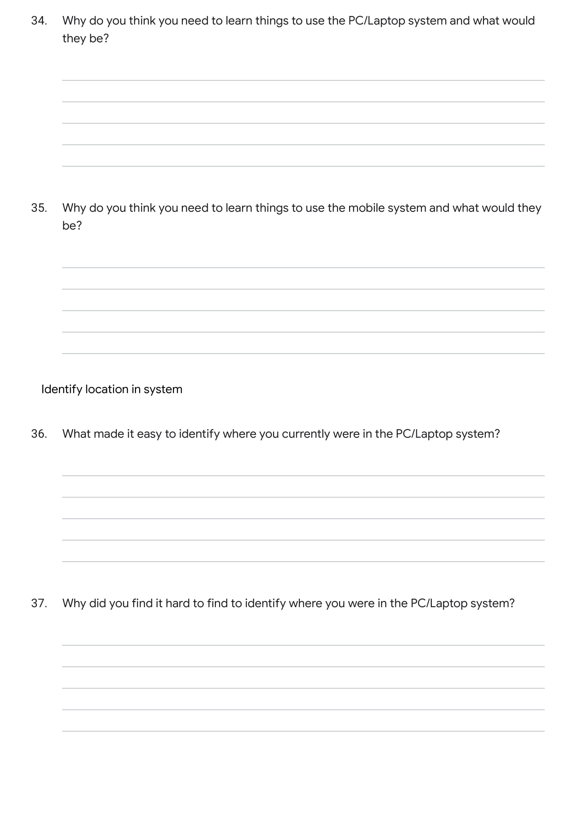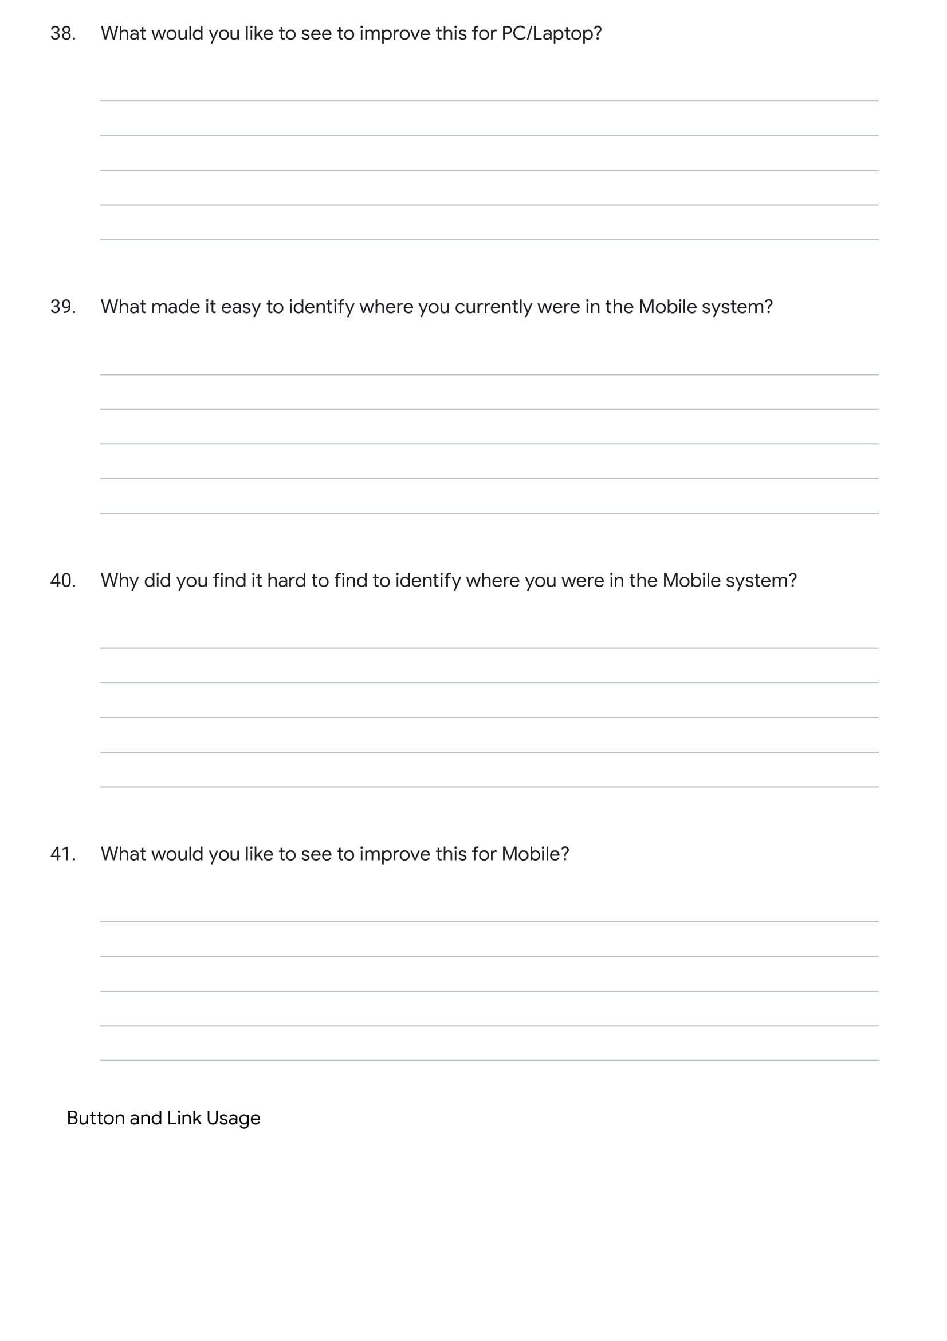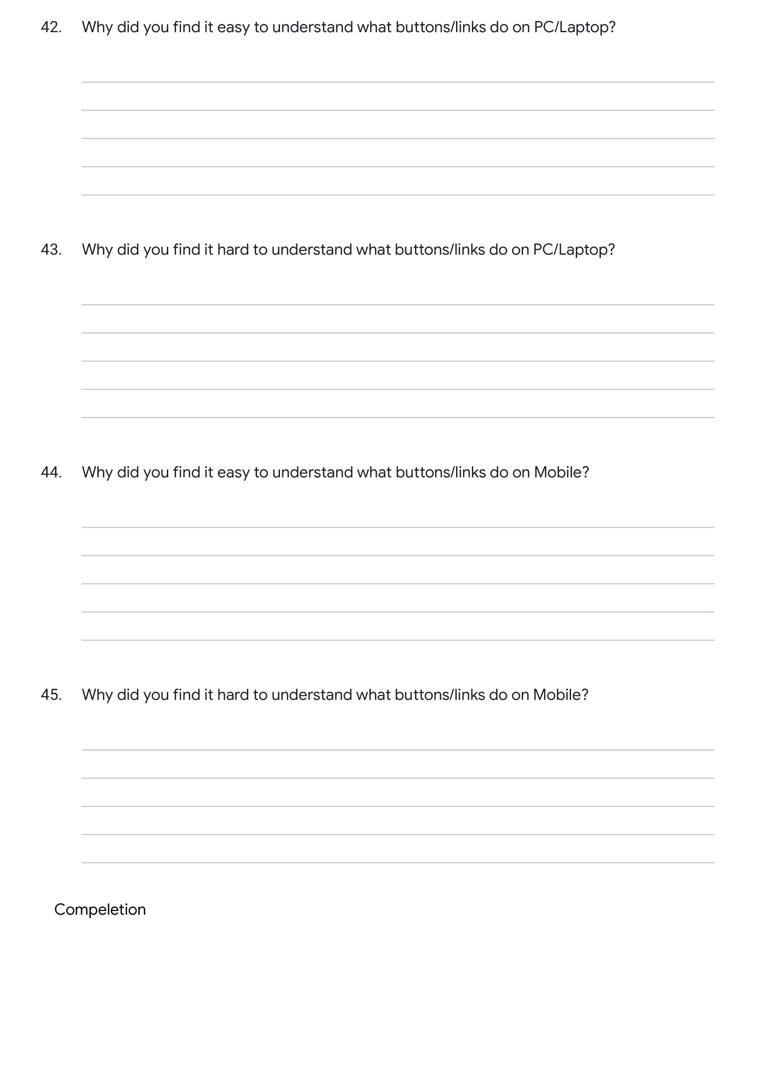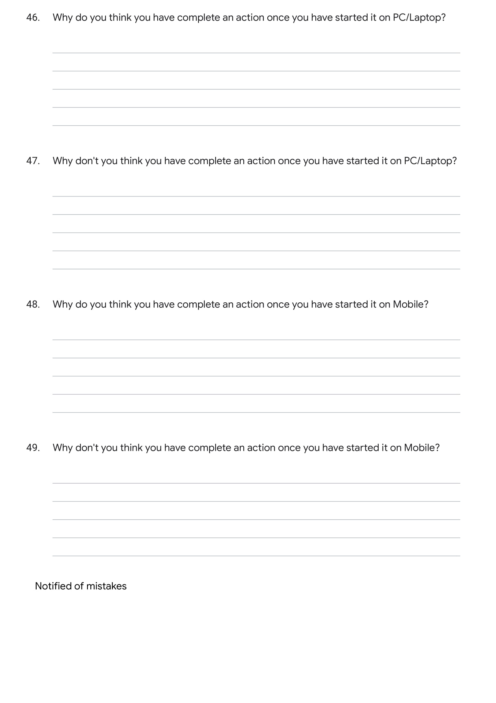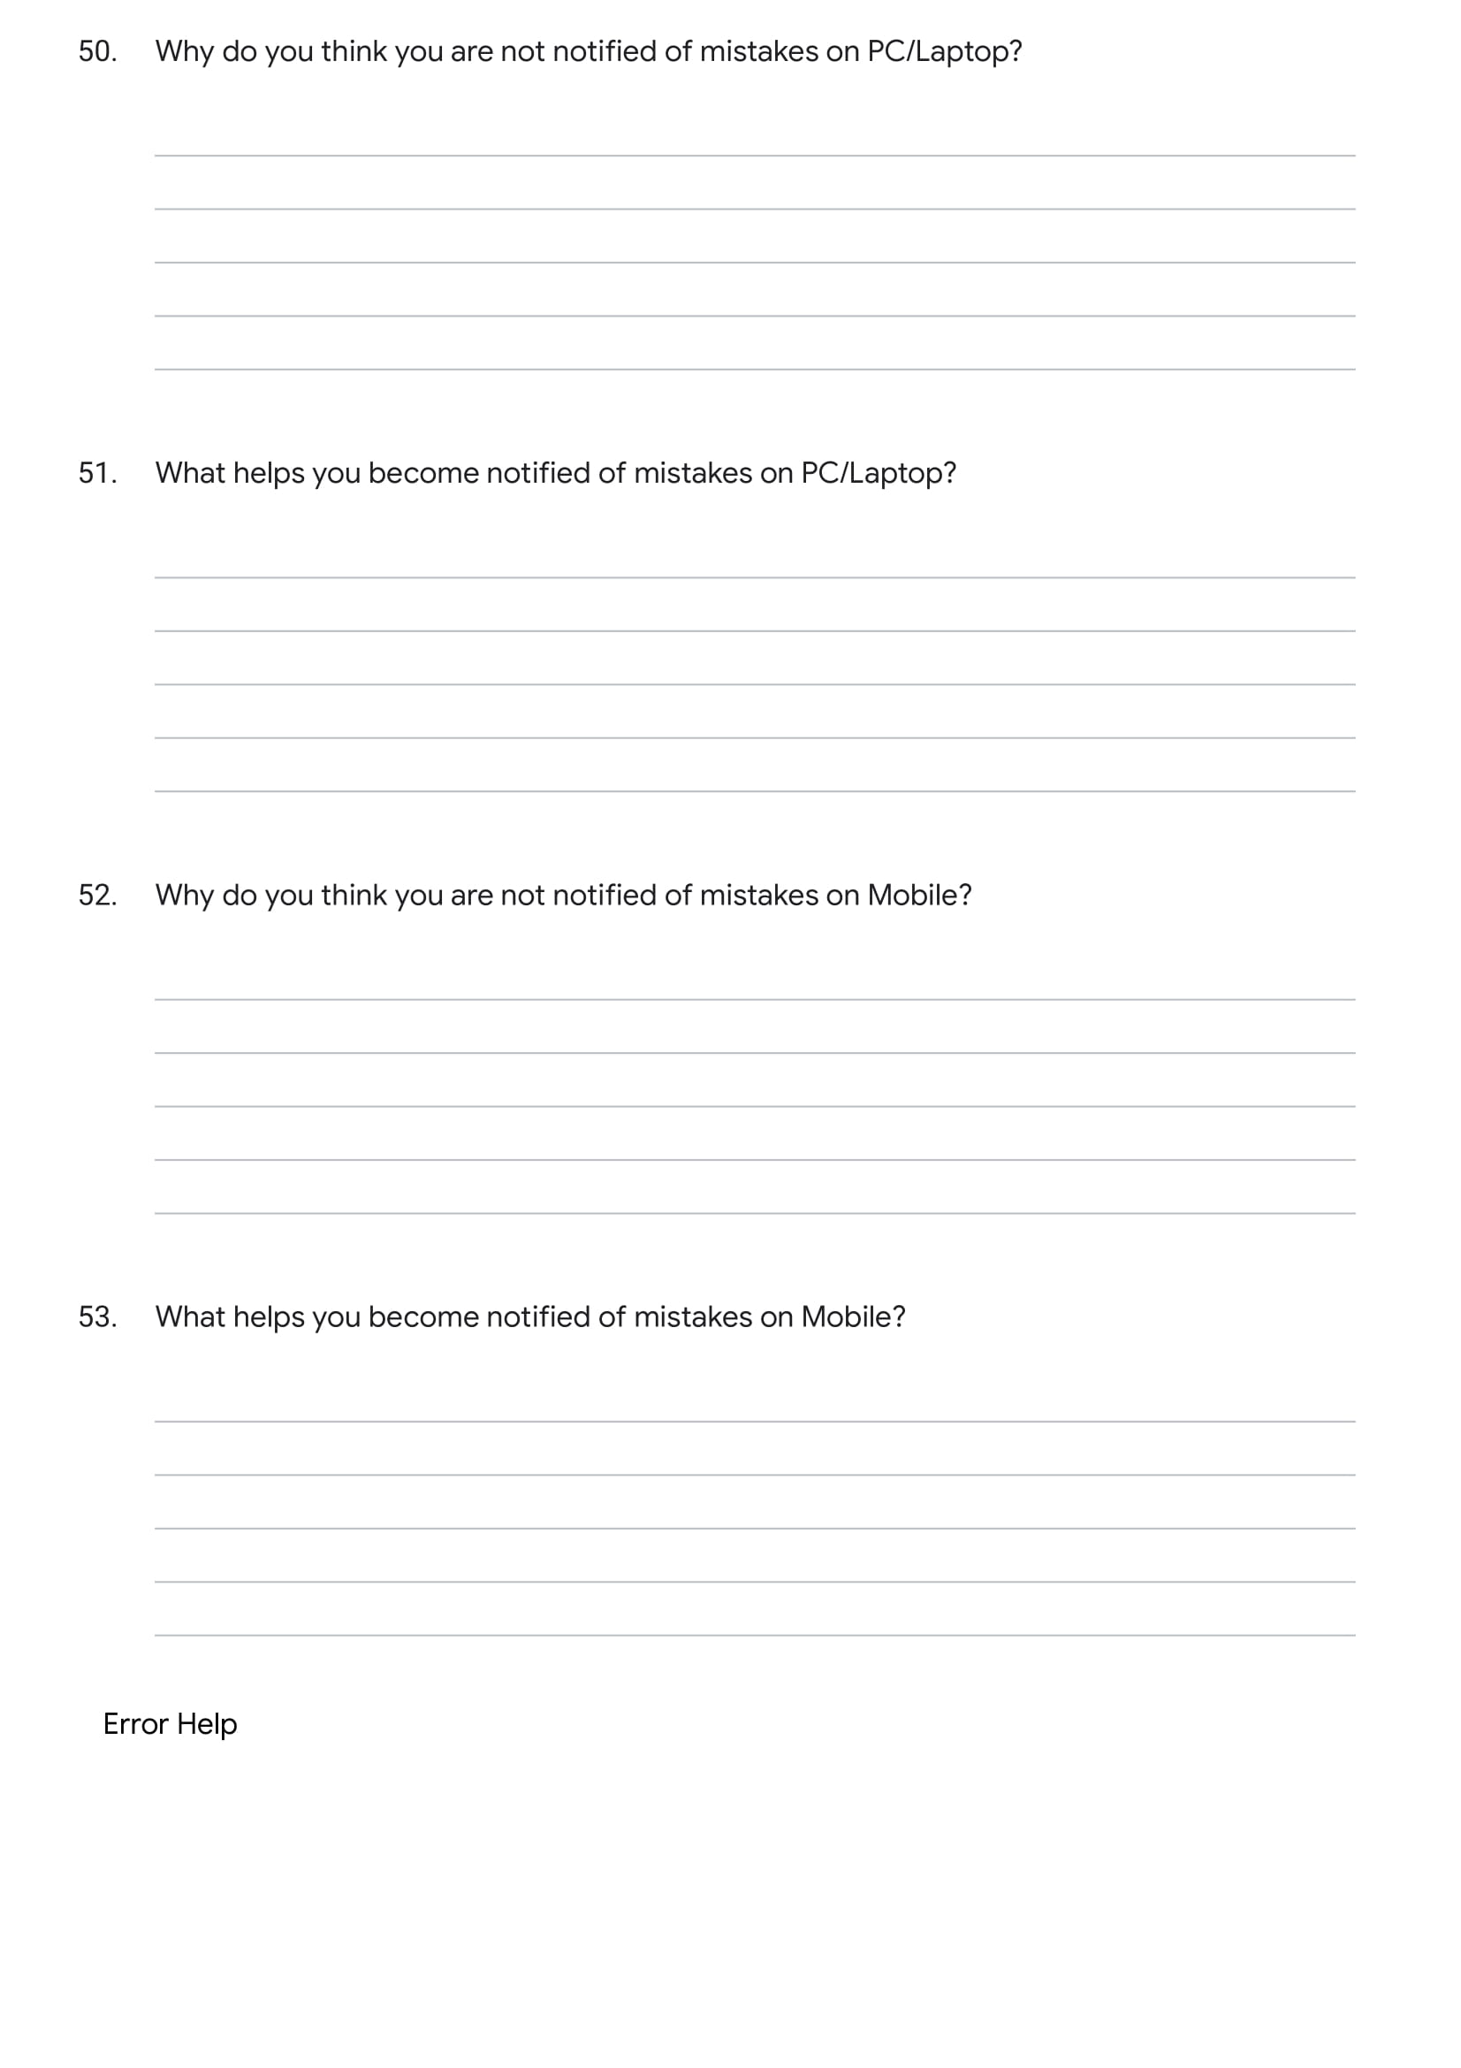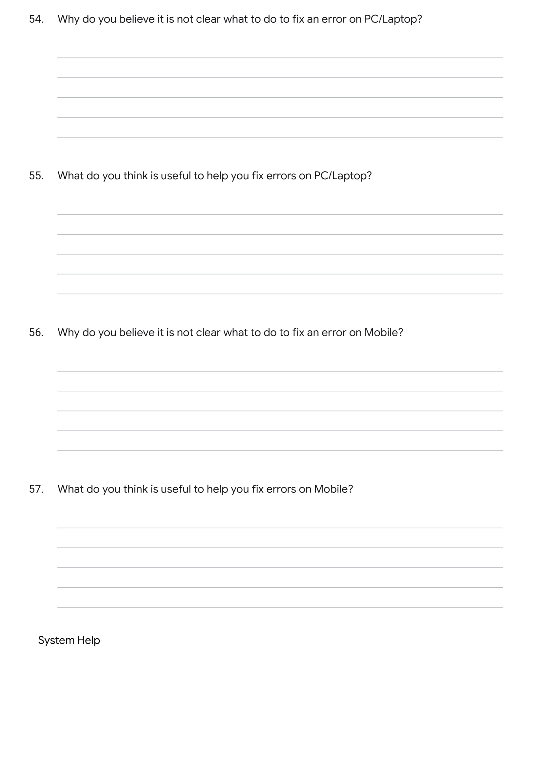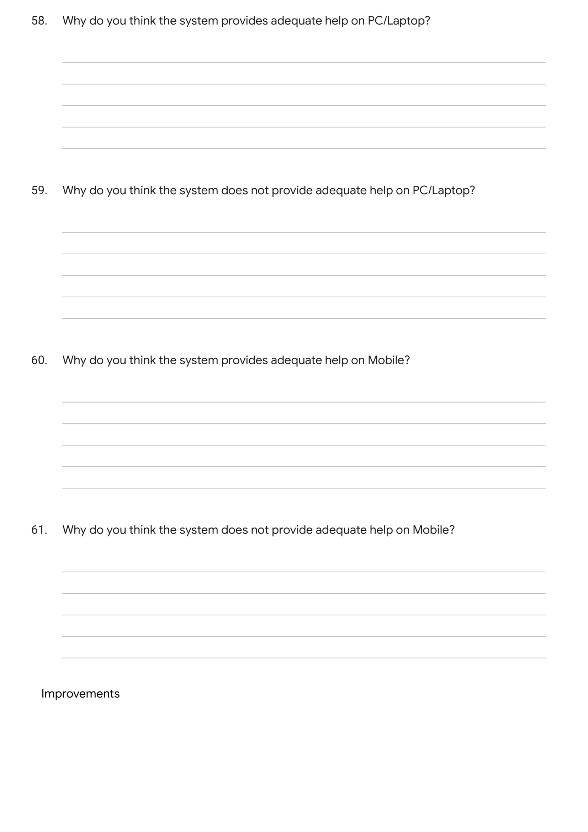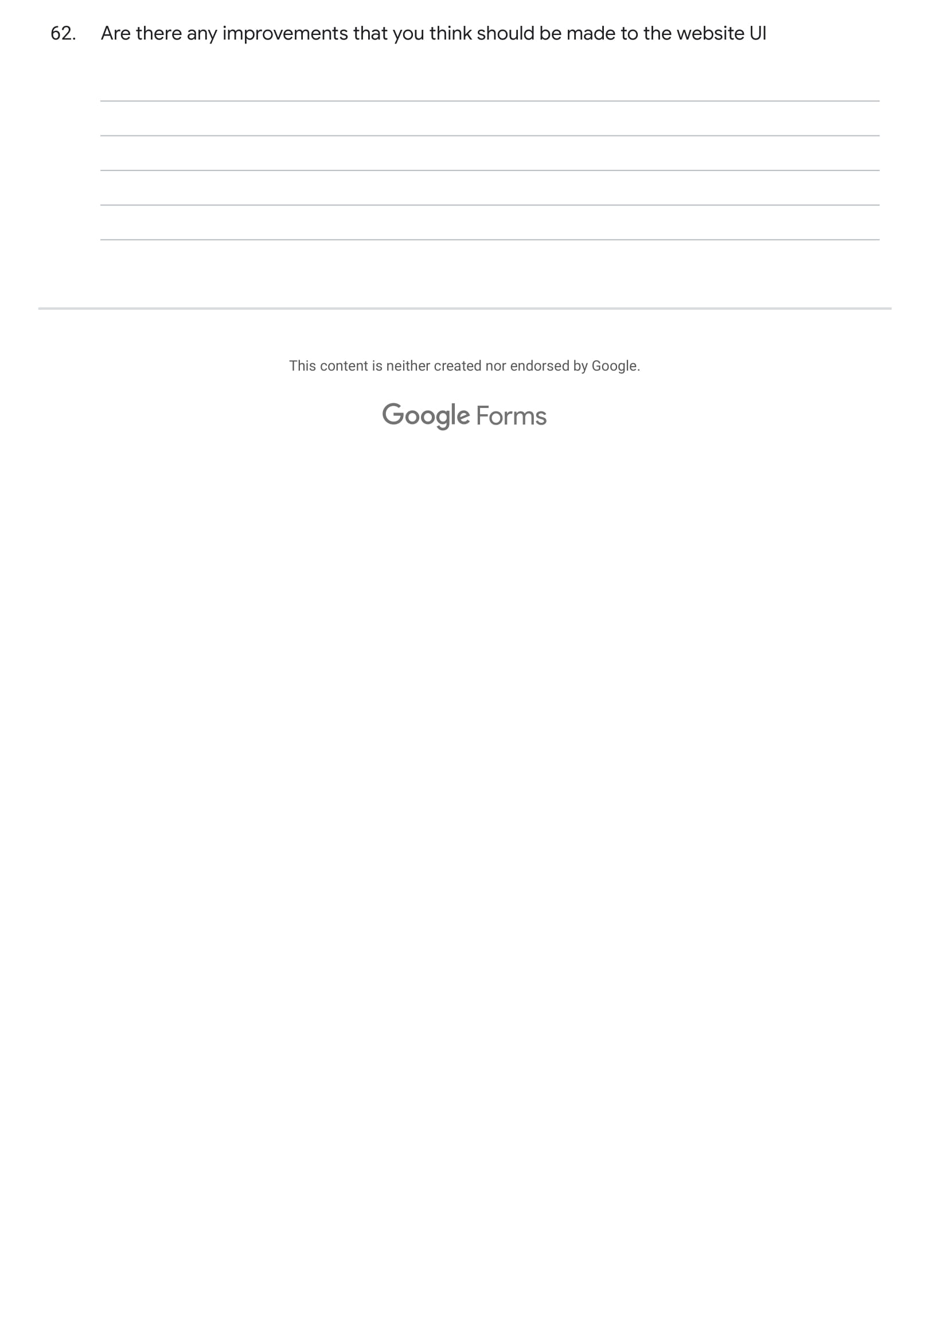

## Appendix F

Results from my Usability Questionnaire (seeAppendix D).

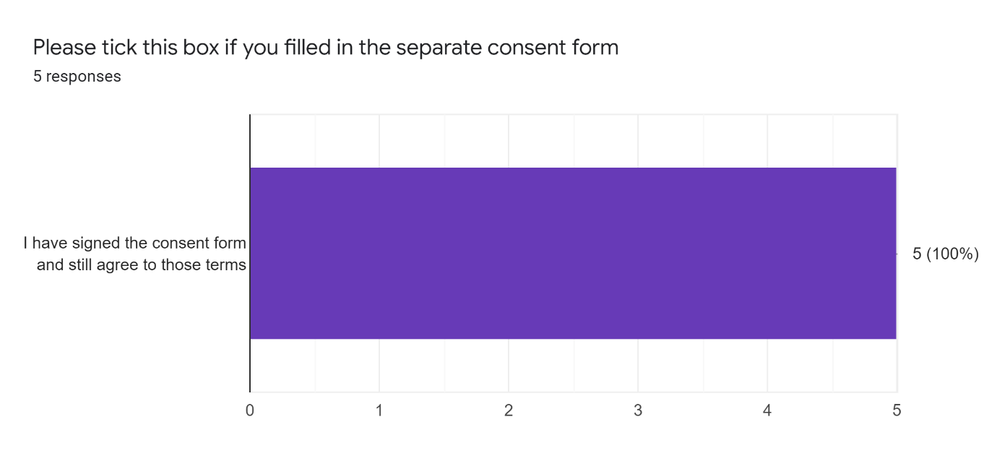

### PC/Laptop Device Usability Questions (Part 1/3)

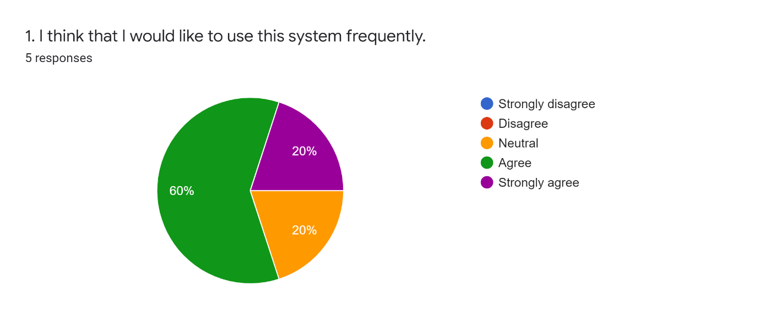

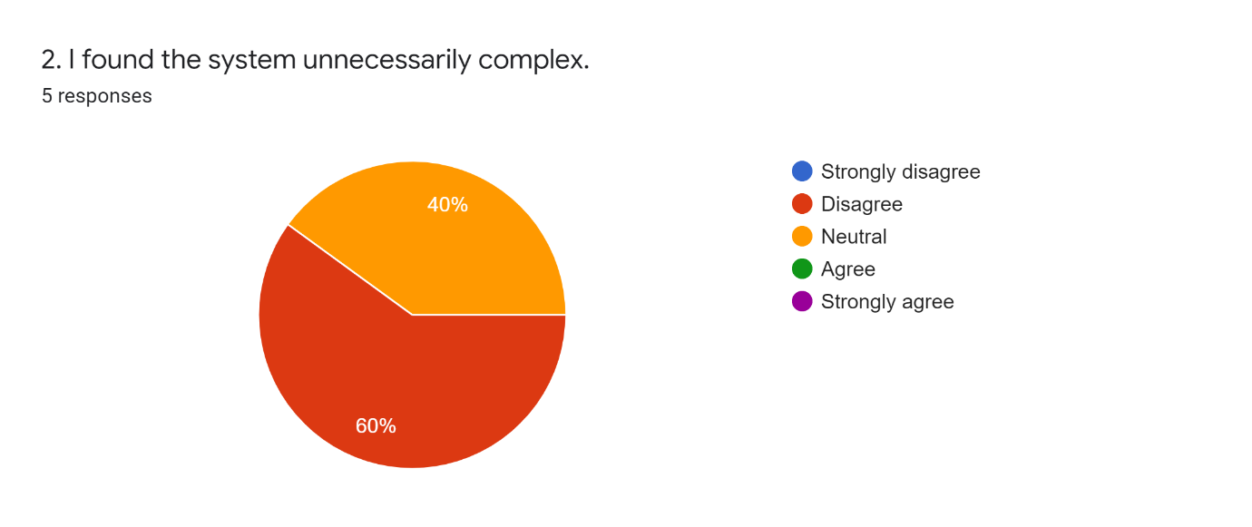

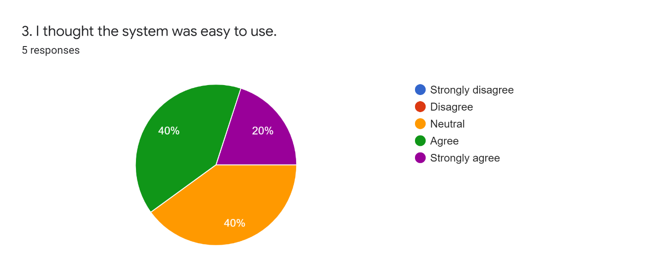

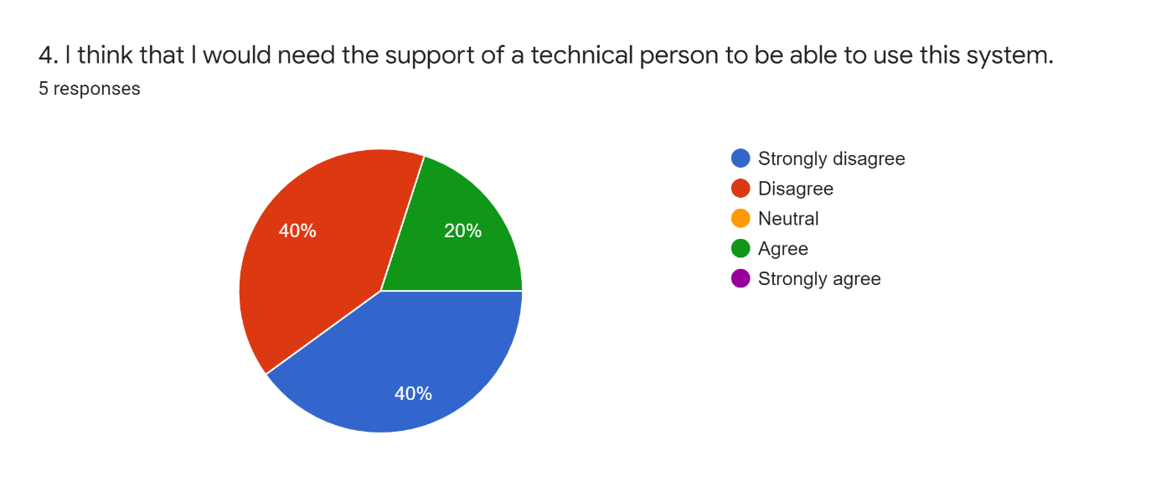



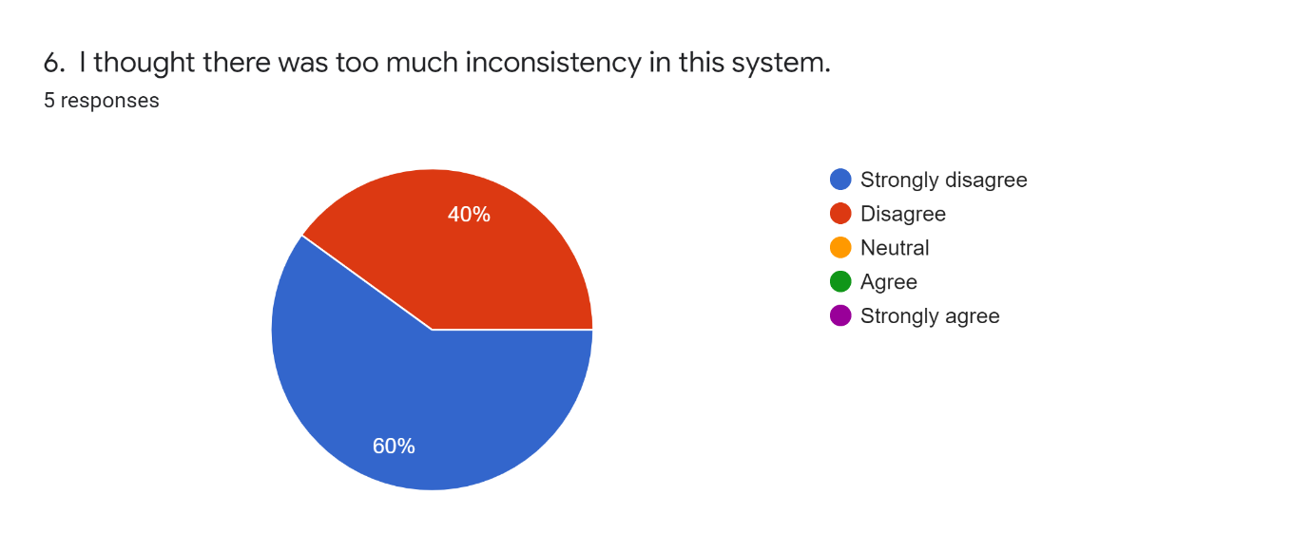

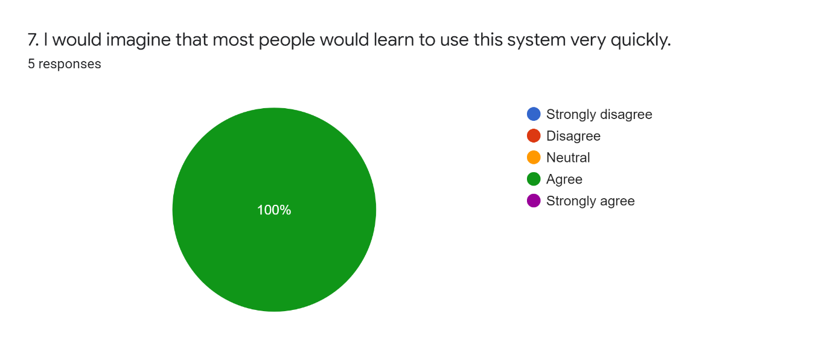

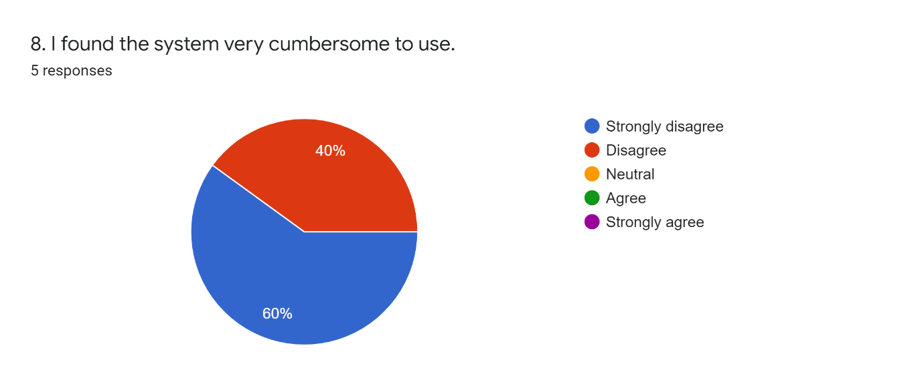



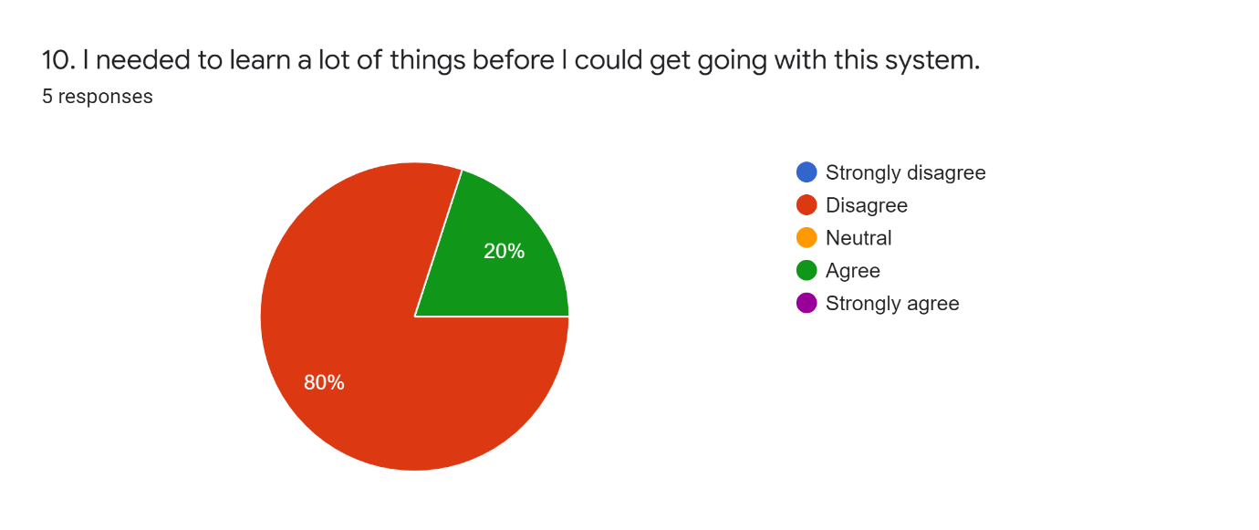

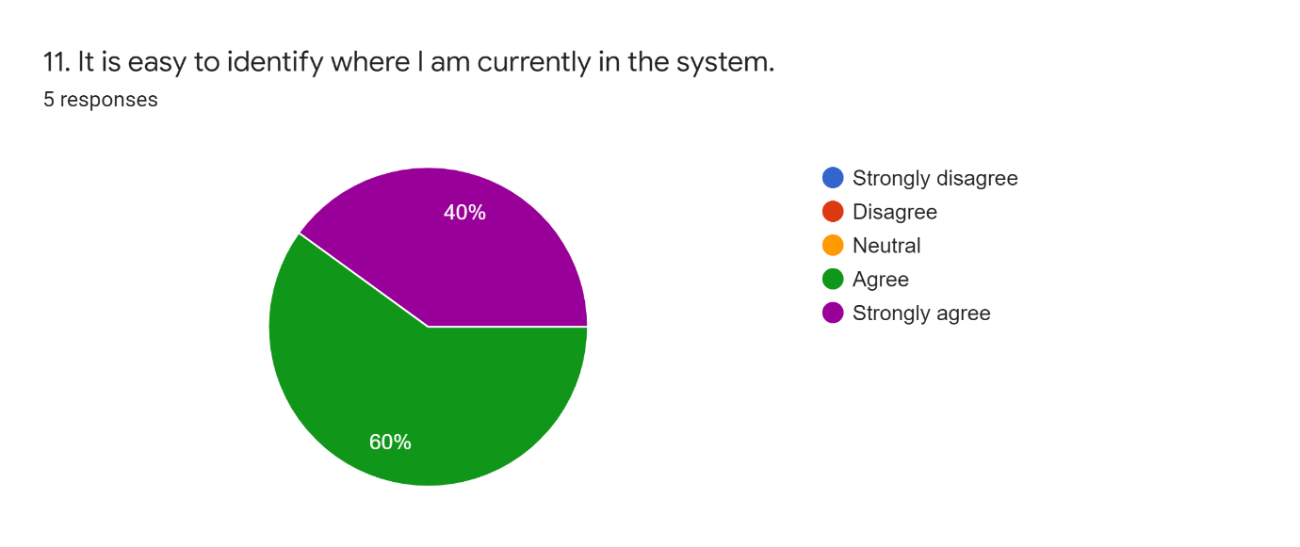

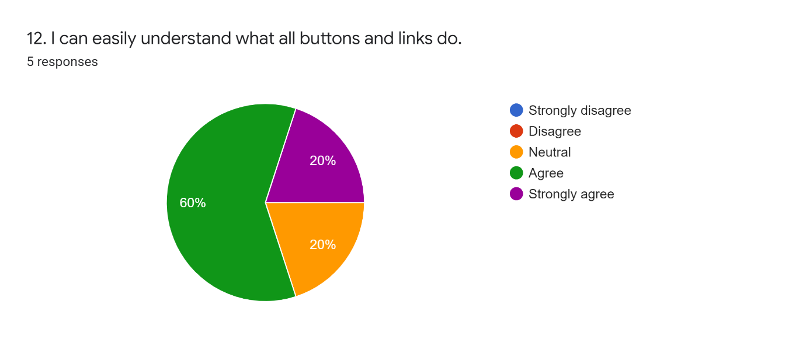

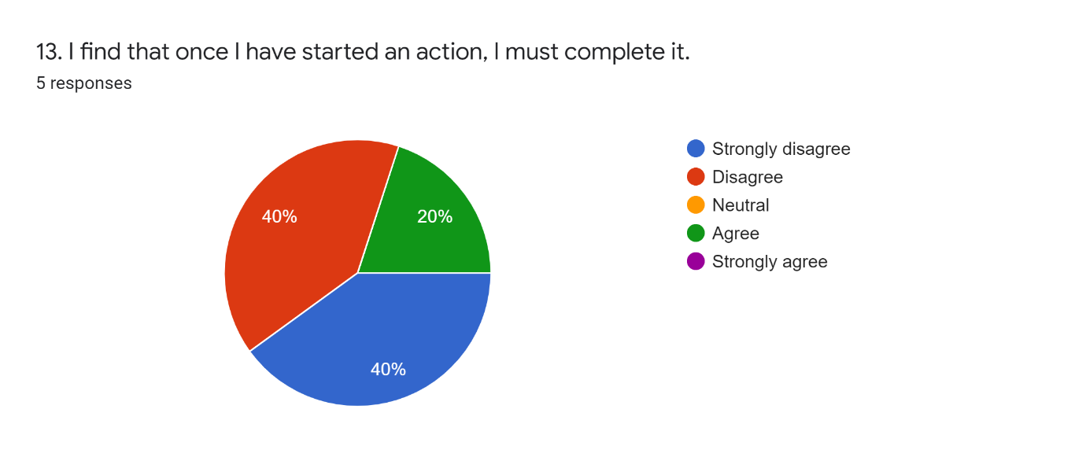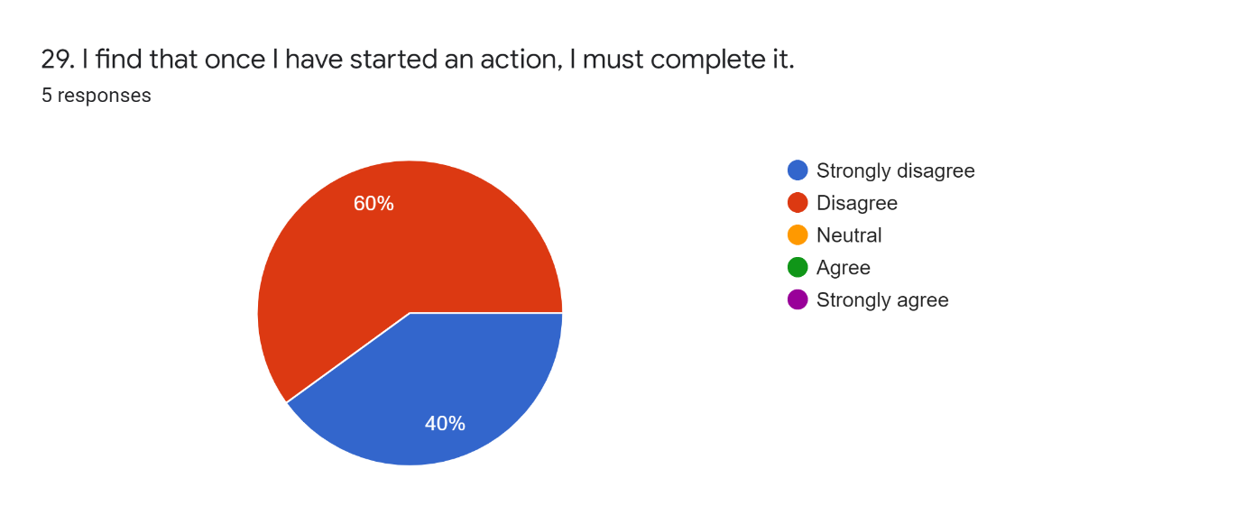

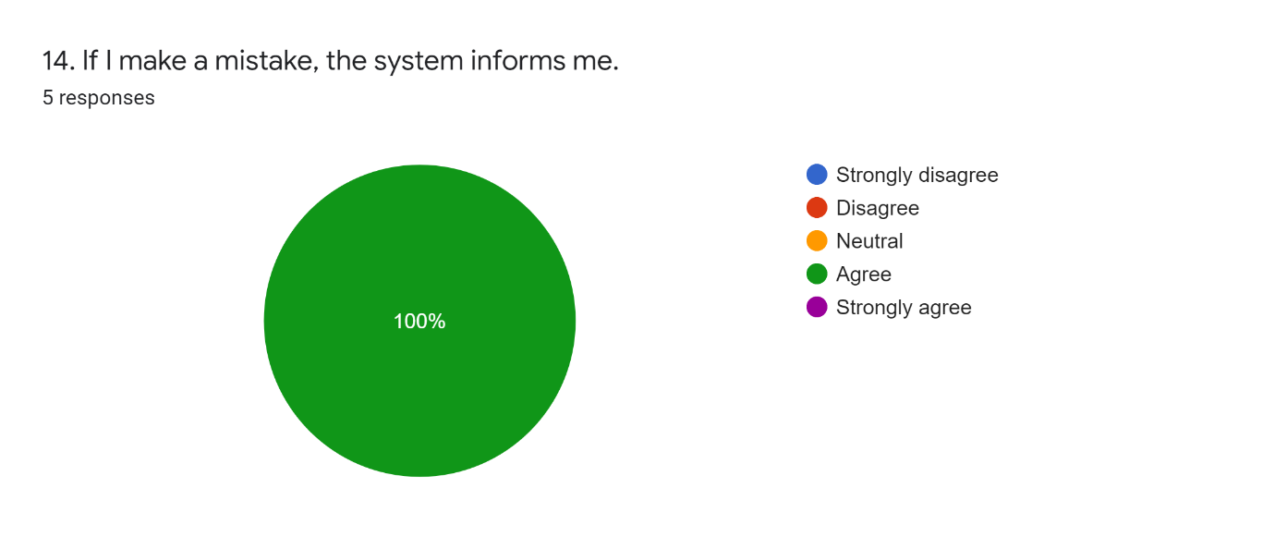

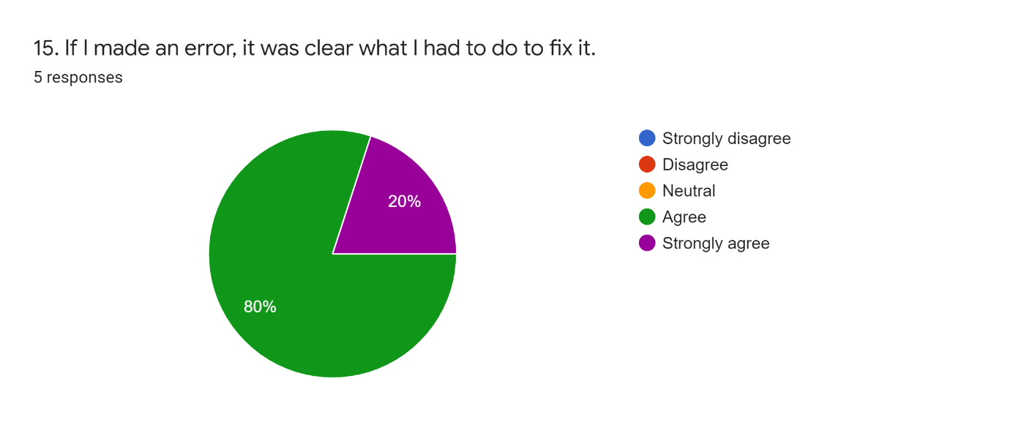



### Mobile Device Usability Questions (Part 2/3)

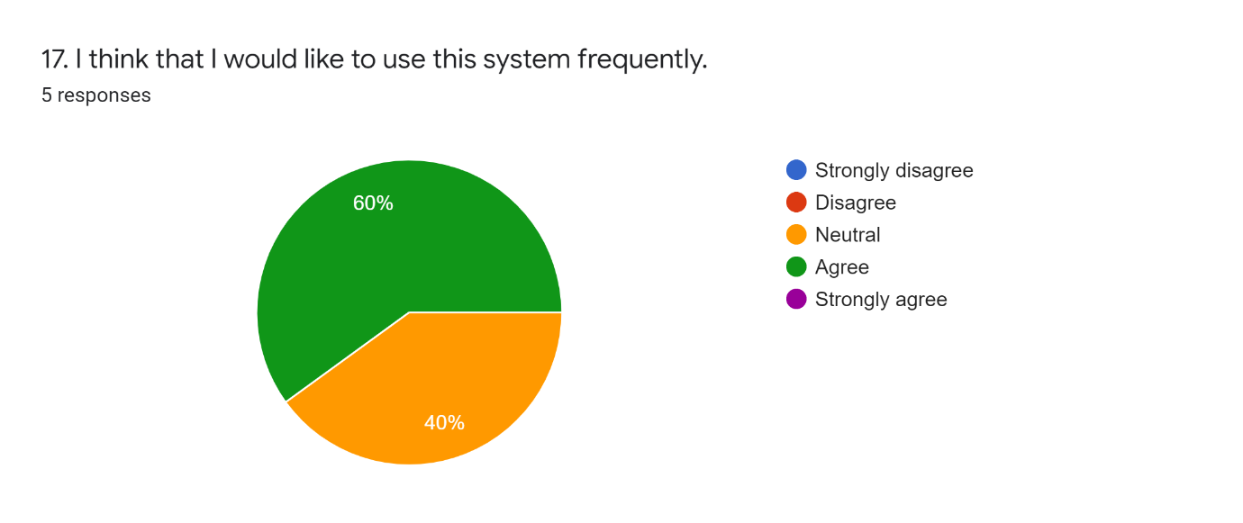

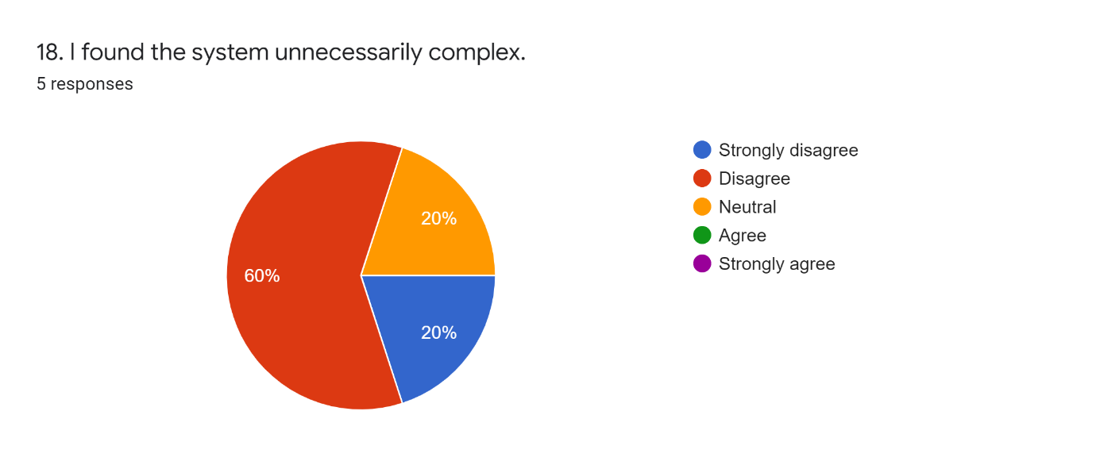

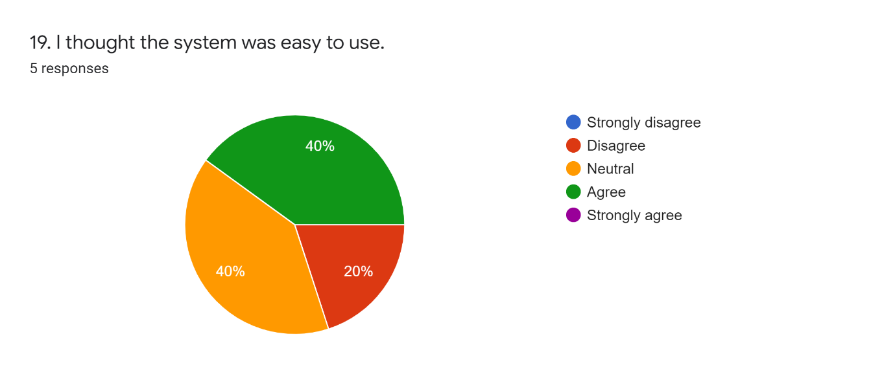

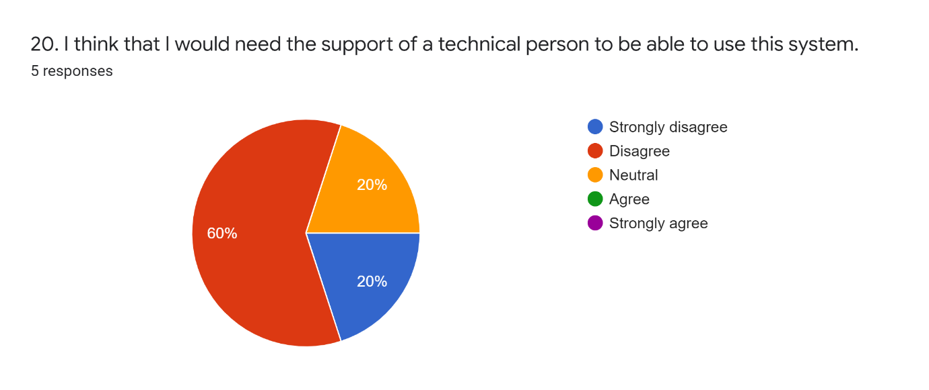



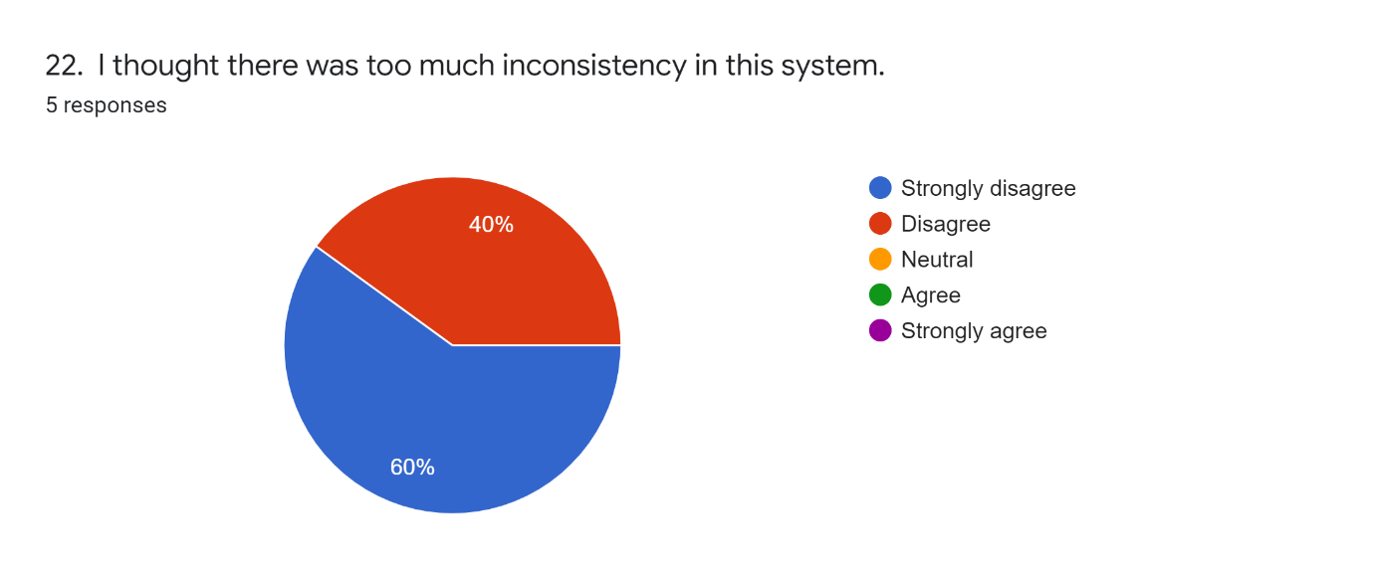

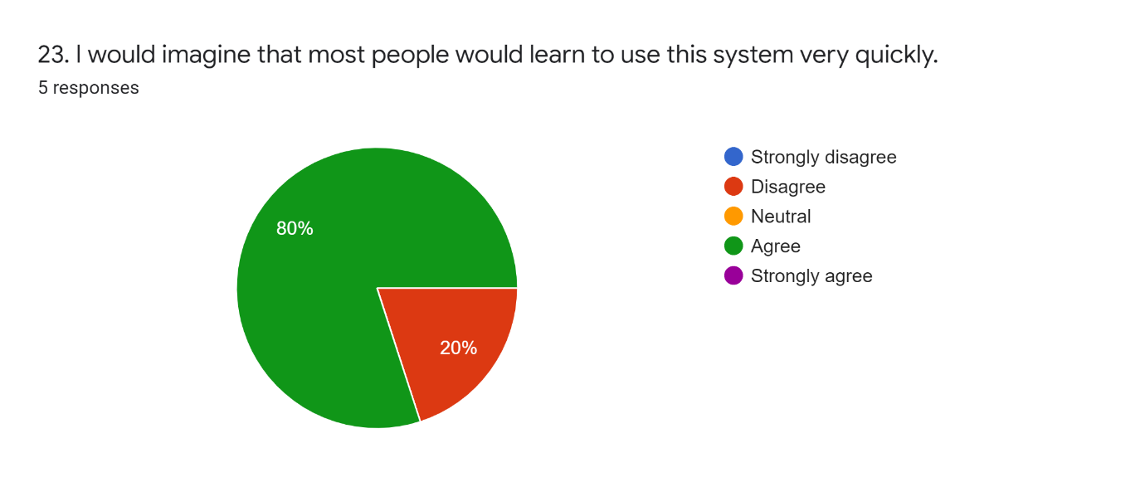

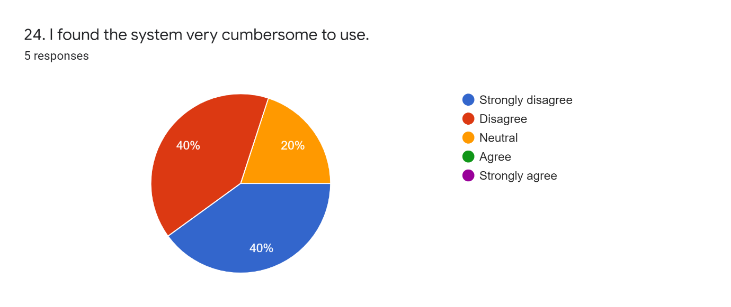



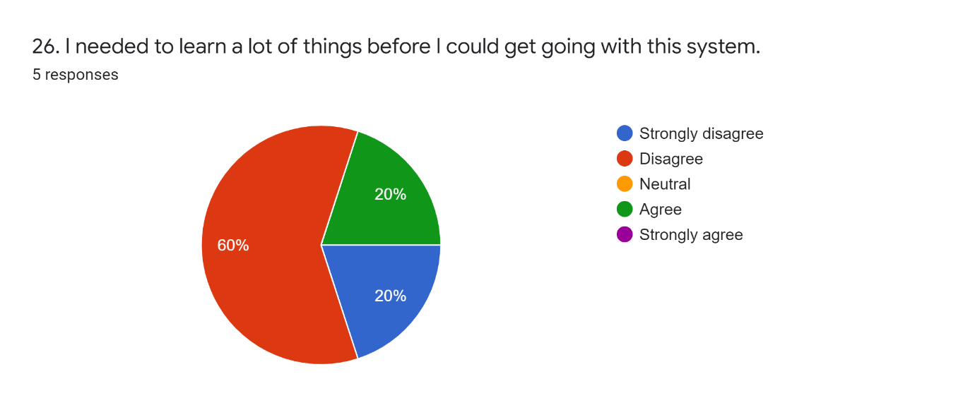

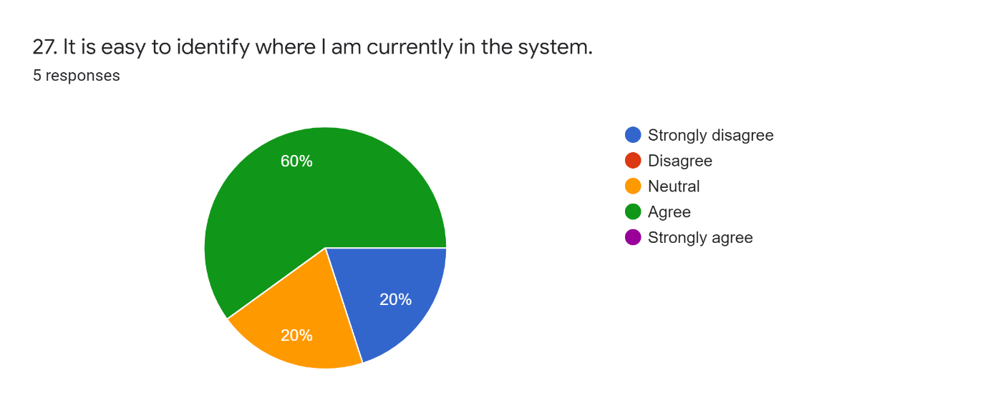





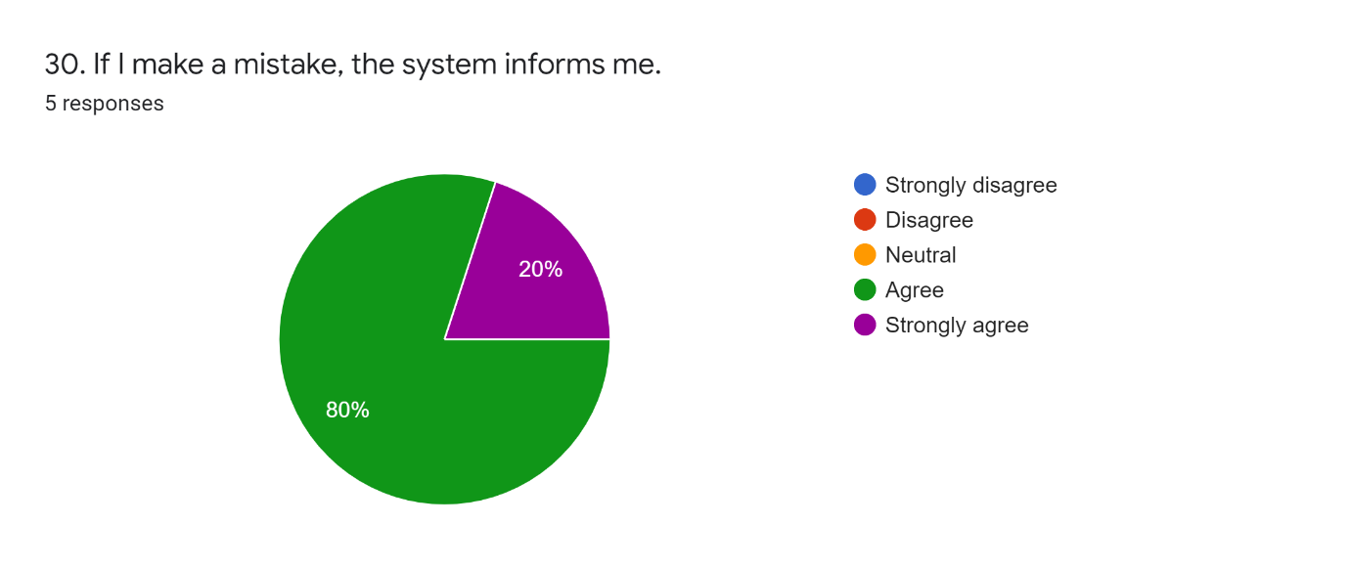

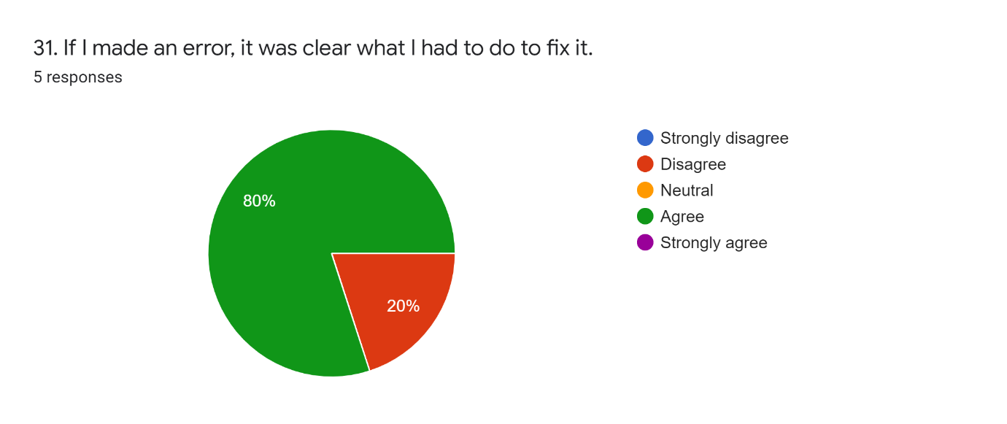



### PC/Laptop and Mobile Devices Usability Questions (Part 3/3)



## Appendix G

This shows tasks and timescales created at the start of my project and the 16.1.1 Gantt Chart shows the final chart after changes were made during the project.

#### Semester 1: 08/10/2021 – 14/01/2022

|  |  |  |  |
| --- | --- | --- | --- |
| Task | Start Date | End Date | Status |
| Create a list of possible features | 08/10/2021 | 21/10/2021 | Completed |
| Create basic project timeline | 08/10/2021 | 21/10/2021 | Completed |
| Research | 22/10/2021 | 26/11/2021 | Completed |
| Read API Documentation and Test Features | 22/10/2021 | 22/10/2021 | Completed |
| Preliminary Research on Similar Projects | 25/10/2021 | 26/10/2021 | Completed |
| Feature Questionnaire | 27/10/2021 | 22/11/2021 | Completed |
| Design and Create Feature Questionnaire | 27/10/2021 | 27/10/2021 | Completed |
| Keep Sending off Questionnaire for Feedback and make changes | 28/10/2021 | 12/11/2021 | Completed |
| Ethics Consent for Question | 15/11/2021 | 15/11/2021 | Completed |
| Send off and Wait for Results (let it run over the weekend) | 16/11/2021 | 19/11/2021 | Completed |
| Analysis Questionnaire Results and Decide Features | 22/11/2021 | 22/11/2021 | Completed |
| Further Research on Similar Projects | 28/10/2021 | 01/11/2021 | Completed |
| Research Spring MVC and how to connect to an API | 25/11/2021 | 26/11/2021 | Completed |
| Interim Report Write-up | 15/11/2021 | 25/11/2021 | Completed |
| Interim Report Deadline | 25/11/2021 | 25/11/2021 |  |
| Create Basic Spring MVC Program | 29/11/2021 | 30/11/2021 | Completed |
| Link Program to Rebrickable API | 01/12/2021 | 01/12/2021 | Completed |
| Add basic set number search feature using Rebrickable API and display the JSON file result | 02/12/2021 | 02/12/2021 | Completed |
| Research how to transform a JSON file into a Java Class | 03/12/2021 | 07/12/2021 | Completed |
| Implement a class that turns a Lego Set JSON result into a class | 08/12/2021 | 10/12/2021 | Completed |
| Implement a class that turns a Lego Piece JSON result into a class | 13/12/2021 | 15/12/2021 | Completed |
| Implement a feature that turns each Lego Piece in the JSON list into an instance of the Lego Piece Class | 16/12/2021 | 17/12/2021 | Completed |
| Add feature to display all pieces in a Lego set with an image | 20/12/2021 | 22/12/2021 | Completed |
| Implement the Check feature to the checklist of pieces in a set | 23/12/2021 | 28/12/2021 | Completed |
| Deadline for a simple search for a Lego Set and checking pieces off a checklist | 29/12/2021 | 29/12/2021 | Completed |
| Add feature to save checklist progress to device storage | 29/12/2021 | 03/01/2022 | Completed |
| Improve search feature so that their text search that displays a possible list of sets with image | 04/01/2022 | 07/01/2022 | Completed |
| Add filter and sort by theme and year made to search feature | 10/01/2022 | 12/01/2022 | Completed |
| Implement a way of sorting a set checklist by piece colour and type | 13/01/2022 | 18/01/2022 | Completed |

Above is the list of tasks that I have completed during semester 1.

#### Semester 2: 17/01/2022 – 09/05/2022

|  |  |  |  |
| --- | --- | --- | --- |
| Task | Begin Date | End Date | Status |
| Implement a way of sorting a set checklist by piece colour and type | 13/01/2022 | 18/01/2022 | Completed |
| Add a parameter to the search feature, to allow users to sort and filter by the number of pieces in a Lego Set | 19/01/2022 | 20/01/2022 | Completed |
| Add search parameter to sort alphabetically by set name | 21/01/2022 | 21/01/2022 | Completed |
| Deadline for all Key Features | 24/01/2022 | 24/01/2022 | Completed |
| Implement a feature to filter a checklist by piece colour | 24/01/2022 | 25/01/2022 | Completed |
| Implement a feature to filter a checklist by piece type | 26/01/2022 | 27/01/2022 | Completed |
| Research and design UI for Website | 28/01/2022 | 04/02/2022 | Completed |
| Implement new website UI to the current system | 07/02/2022 | 11/02/2022 | Completed |
| Deadline for the Website UI to be designed and implemented | 14/02/2022 | 14/02/2022 | Completed |
| Prepare for Interview | 14/02/2022 | 17/02/2022 | Completed |
| Add Brickset API to system | 18/02/2022 | 18/02/2022 | Completed |
| Implement a feature to view and download instructions for a Lego set | 21/02/2022 | 23/02/2022 | Completed |
| Implement a feature to add a link to buy a missing piece from a Lego Set | 24/02/2022 | 25/02/2022 | Completed |
| Create MySQL database | 28/02/2022 | 02/03/2022 | Completed |
| Implement User sign-up and login | 03/03/2022 | 03/03/2022 | Completed |
| Implement 'Sets Owned List' feature | 04/03/2022 | 08/03/2022 | Completed |
| Deadline for all Nice to Have Features | 09/03/2022 | 09/03/2022 | Completed |
| Implement a feature to save checklists in progress to the database | 09/03/2022 | 11/03/2022 | Completed |
| Implement a feature to make setlists and save them to the database | 14/03/2022 | 16/03/2022 | Completed |
| Add the search feature to user’s lists of sets | 17/03/2022 | 21/03/2022 | Completed |
| Design and implement any other optional features that have not yet been completed | 22/03/2022 | 01/04/2022 | Completed |
| Deadline for feature development | 04/04/2022 | 04/04/2022 | Completed |
| Design and run software tests on the system, fixing any bugs found | 04/04/2022 | 08/04/2022 | Completed |
| Deadline for Software Testing | 11/04/2022 | 11/04/2022 | Completed |
| End of Semester 1 | 14/01/2022 | 14/01/2022 | Completed |
| Start of Semester 2 | 17/01/2022 | 17/01/2022 | Completed |
| Interview | 21/02/2022 | 25/02/2022 | Completed |
| Dissertation Write-up | 11/04/2022 | 04/05/2022 | Completed |
| Dissertation Deadline | 05/05/2022 | 05/05/2022 | Completed |
| Software System Deadline | 05/05/2022 | 05/05/2022 | Completed |
| Mini viva preparation | 04/05/2022 | 09/05/2022 | Not Started |
| Mini viva | 09/05/2022 | 09/05/2022 | Not Started |

Above is an outline of the tasks that I planned to complete during semester 2 and the estimated time they would take to complete. As this is only an outline these may change depending on if certain tasks take longer or short than expected.

#### Milestones

|  |  |  |
| --- | --- | --- |
| Milestone | Due date | Status |
| Deadline for a simple search for a Lego Set and checking pieces off a checklist | 29/12/2021 | Completed |
| Deadline for all Key Features | 24/01/2022 | Completed |
| Deadline for the Website UI to be designed and implemented | 14/02/2022 | Completed |
| Deadline for all Nice to Have Features | 09/03/2022 | Completed |
| Design and implement any other optional features that have not yet been completed | 22/03/2022 | Completed |
| Deadline for feature development | 04/04/2022 | Completed |
| Design and run software tests on the system, fixing any bugs found | 04/04/2022 | Completed |
| Deadline for Software Testing | 11/04/2022 | Completed |
| Interview | 21/02/2022 | Completed |
| Dissertation Deadline | 05/05/2022 | Completed |
| Software System Deadline | 05/05/2022 | Completed |
| Mini viva | 09/05/2022 | Not Started |

Above are the ‘milestones’ for my project. These are a mix of predetermined project deadlines and self-imposed deadlines I set to help me monitor my progress and ensure I stayed on track with my project.

#### Initial Gantt Chart

Below are screenshots of my Initial Gantt chart that has my tasks listed above along with the milestones for my project. I have planned to have weekends off to have a break, as well as taking Christmas Eve, Christmas Day, Boxing Day, New Year's Eve and New Year’s Day off. (For the full Gantt chart see drb23/Project/‘Project Timeline.gan’ file in my GitLab repository.)

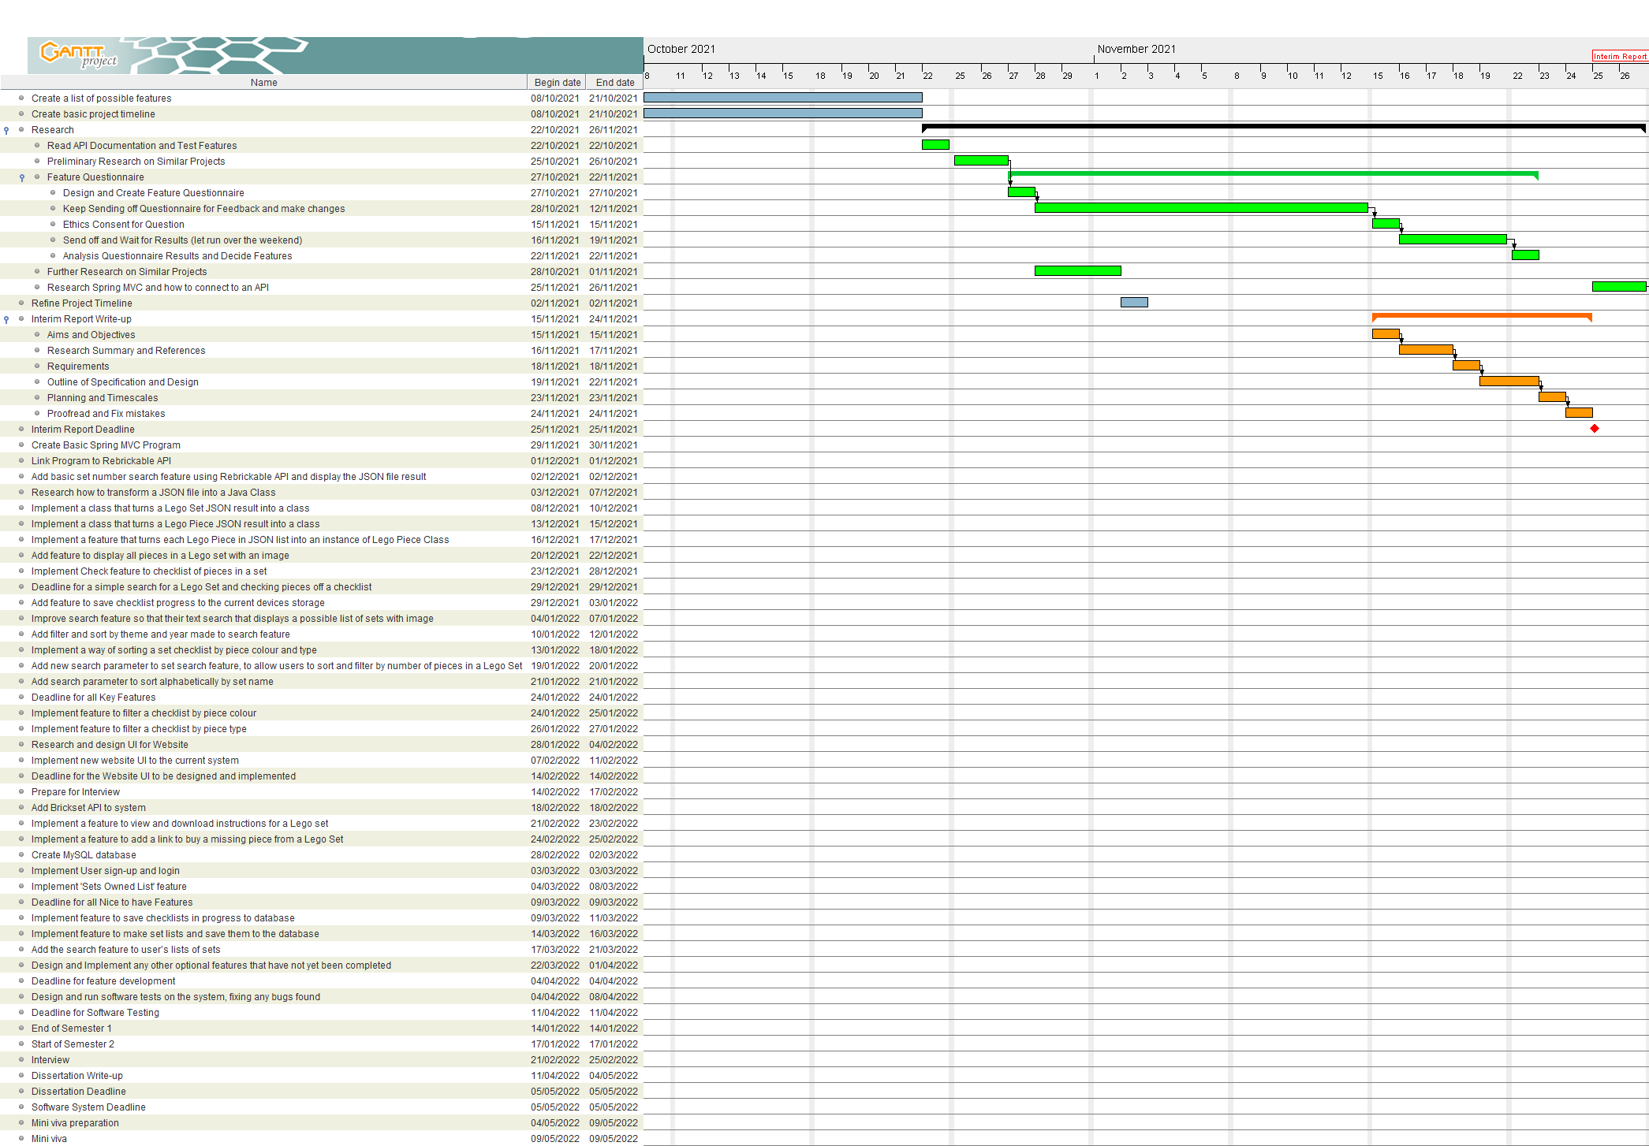

Figure 135 Initial Semester 1 Part 1

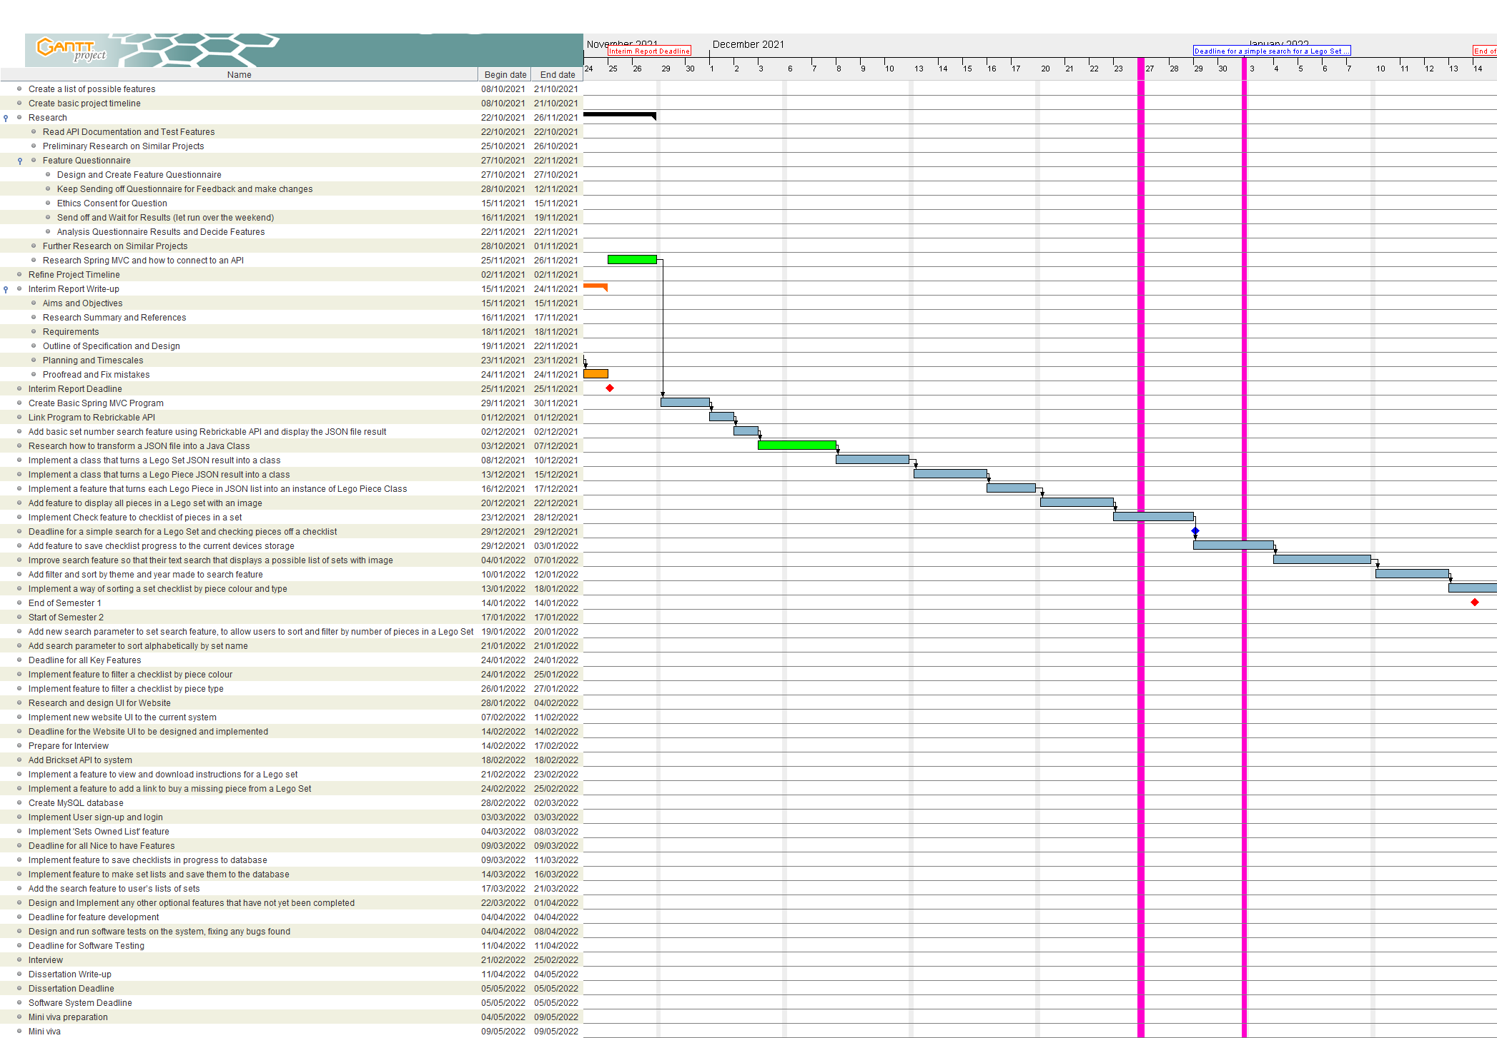

Figure 136 Initial Semester 1 Part 2

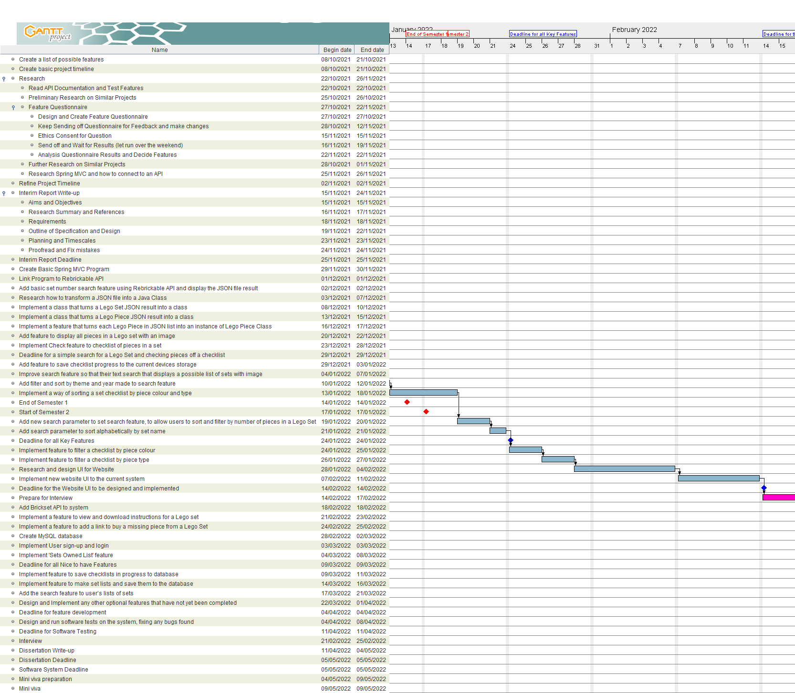

Figure 137 Initial Semester 2 Part 1

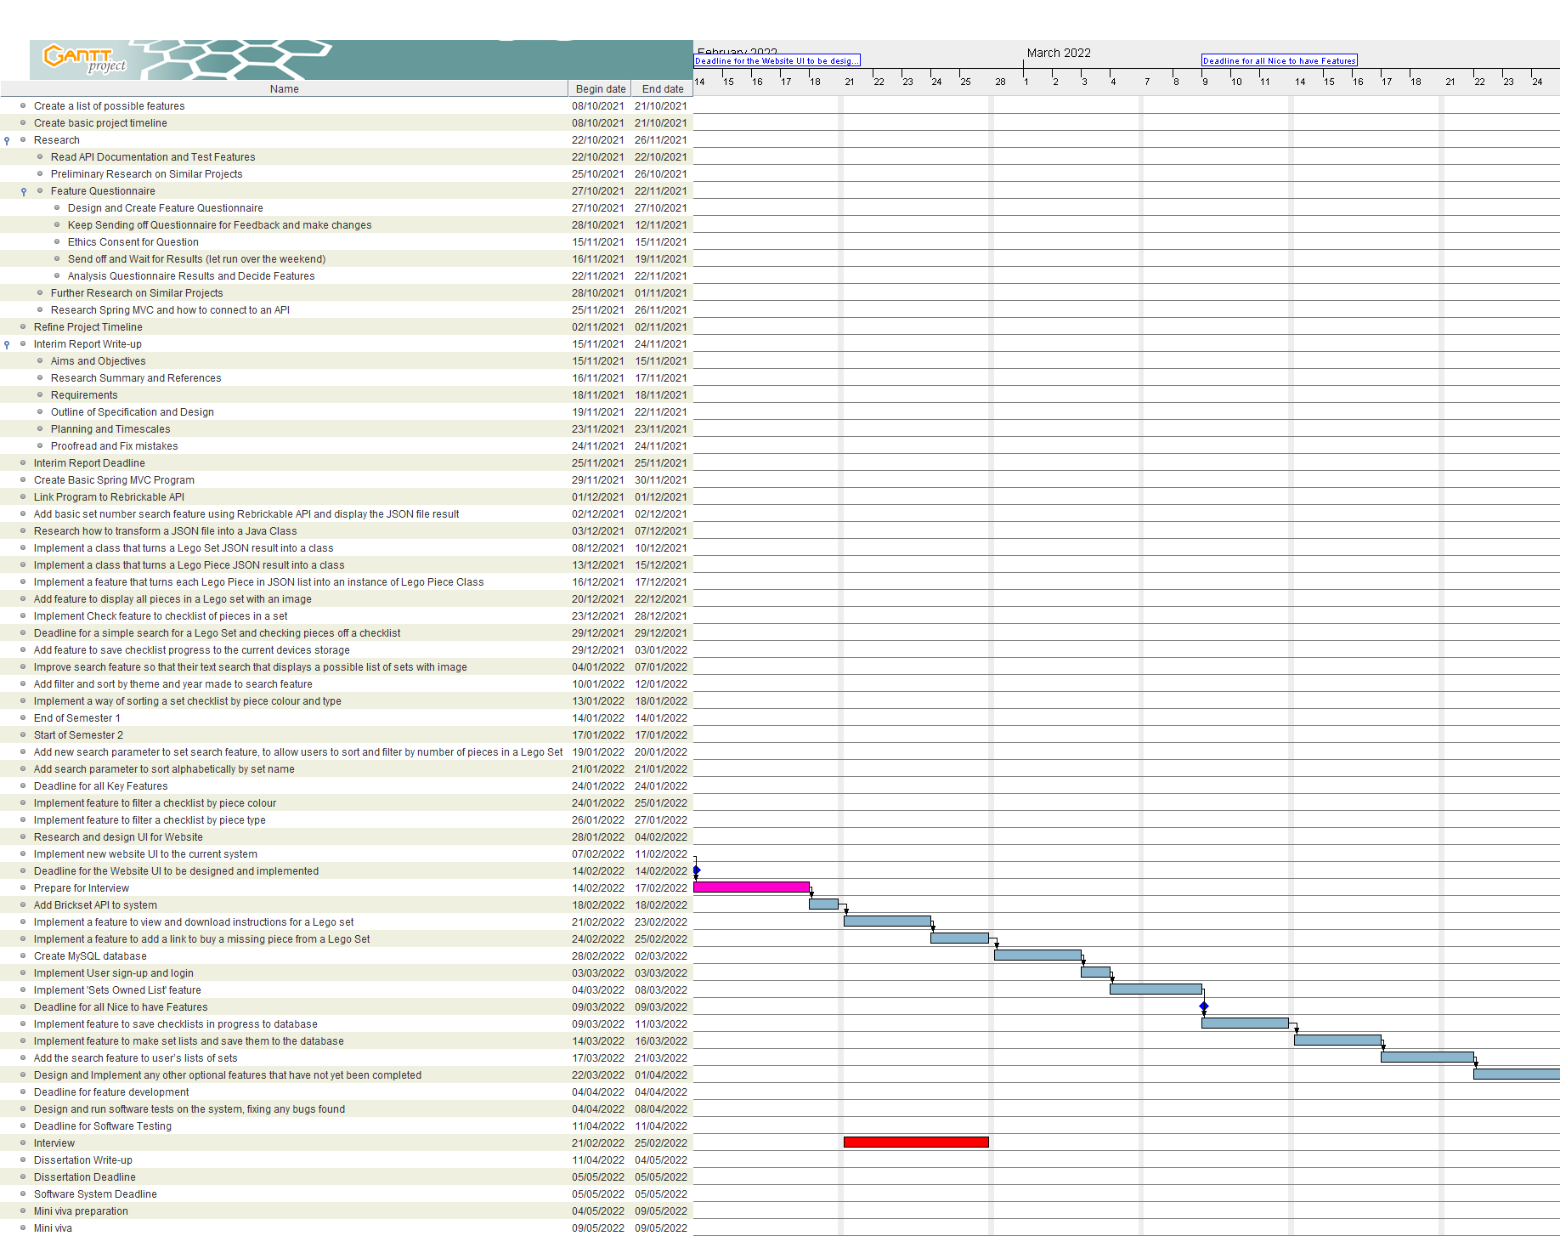

Figure 138 Initial Semester 2 Part 2

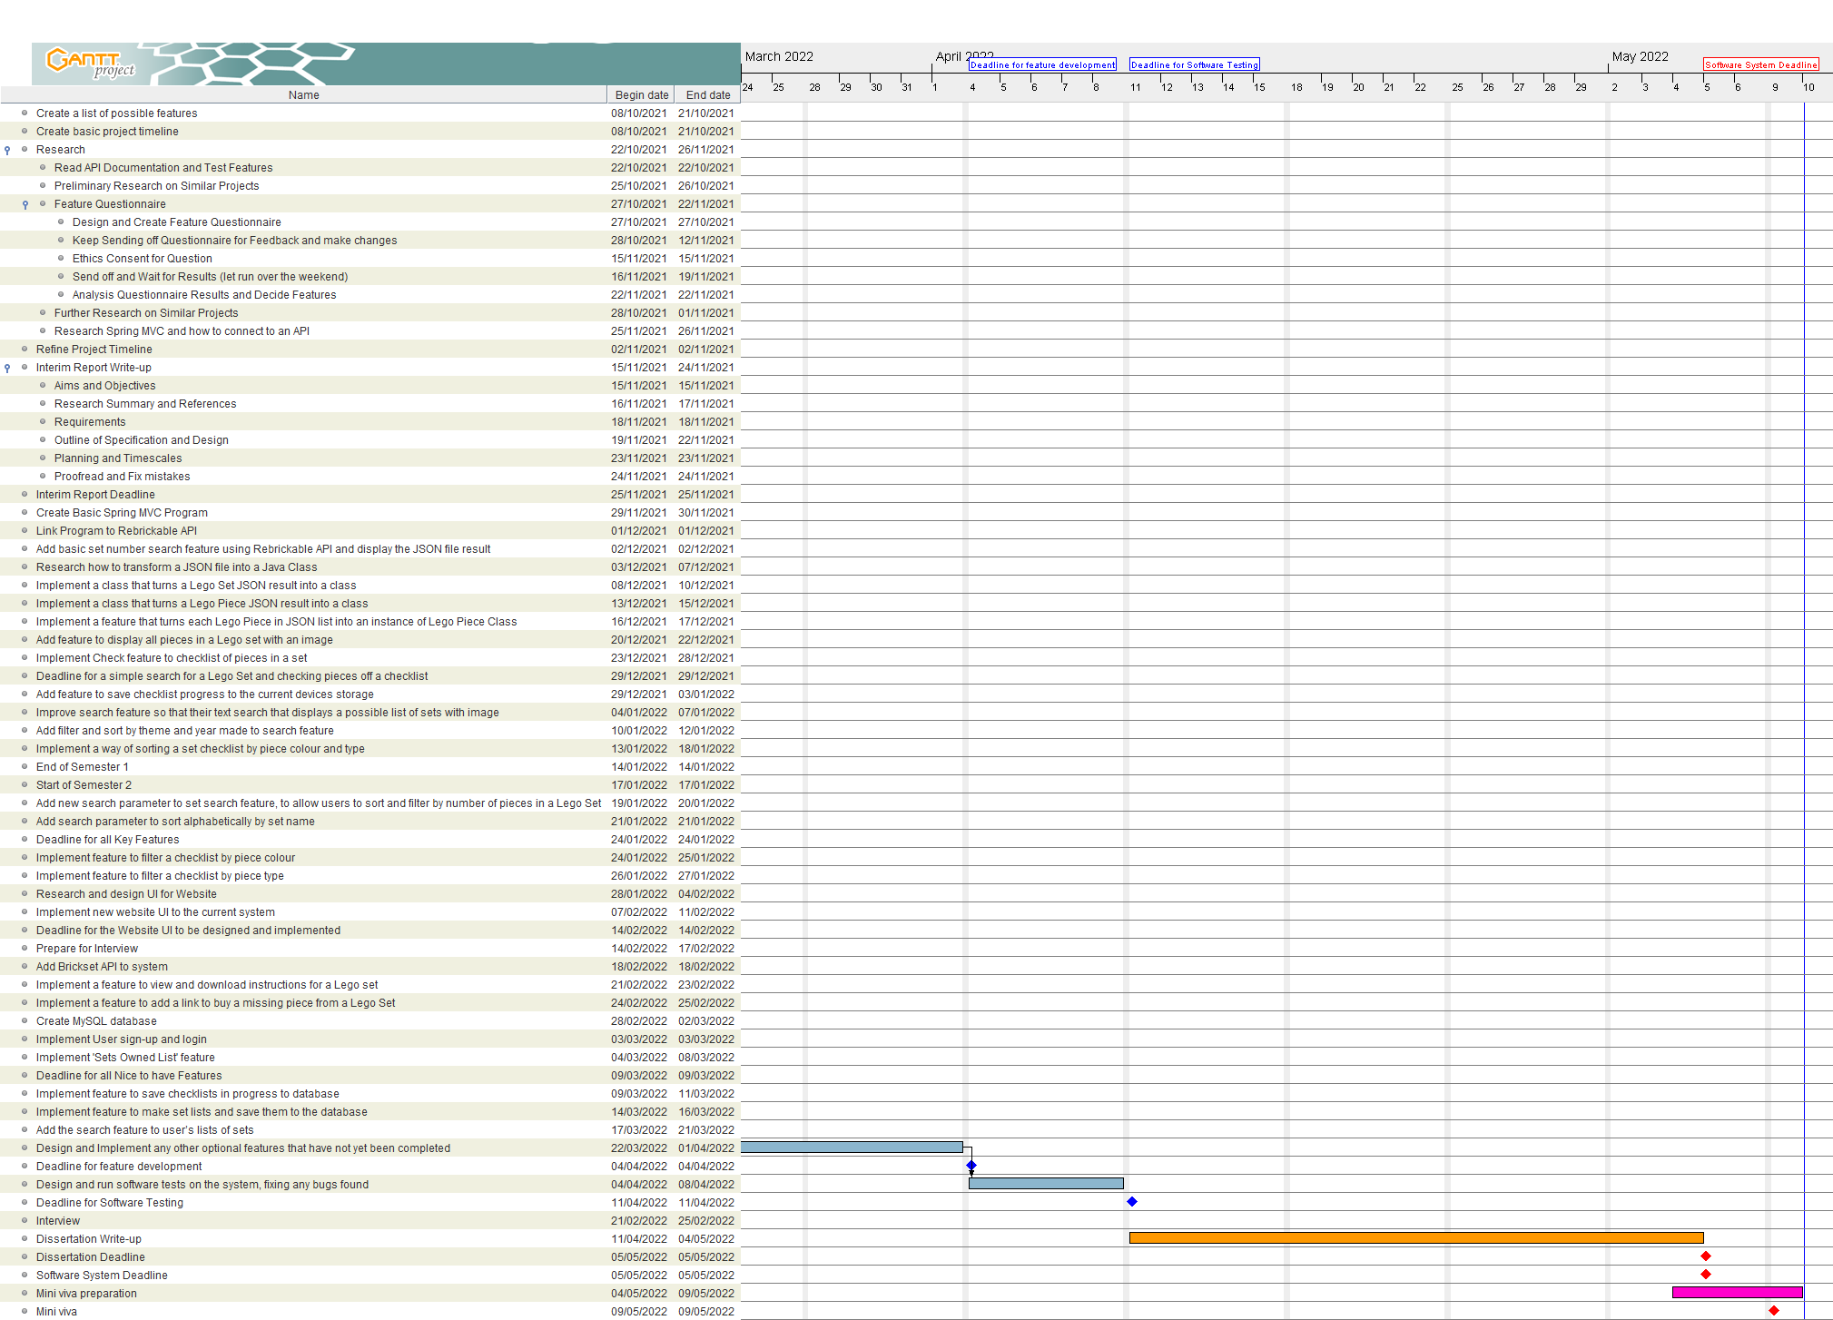

Figure 139: Initial Semester 2 Part 3

#### Gantt Chart

Below are screenshots of my Final Gantt chart that I updated during the project. (For the full Gantt chart see drb23/Project/‘Project Timeline Updated Version.gan’ file in my GitLab repository.)

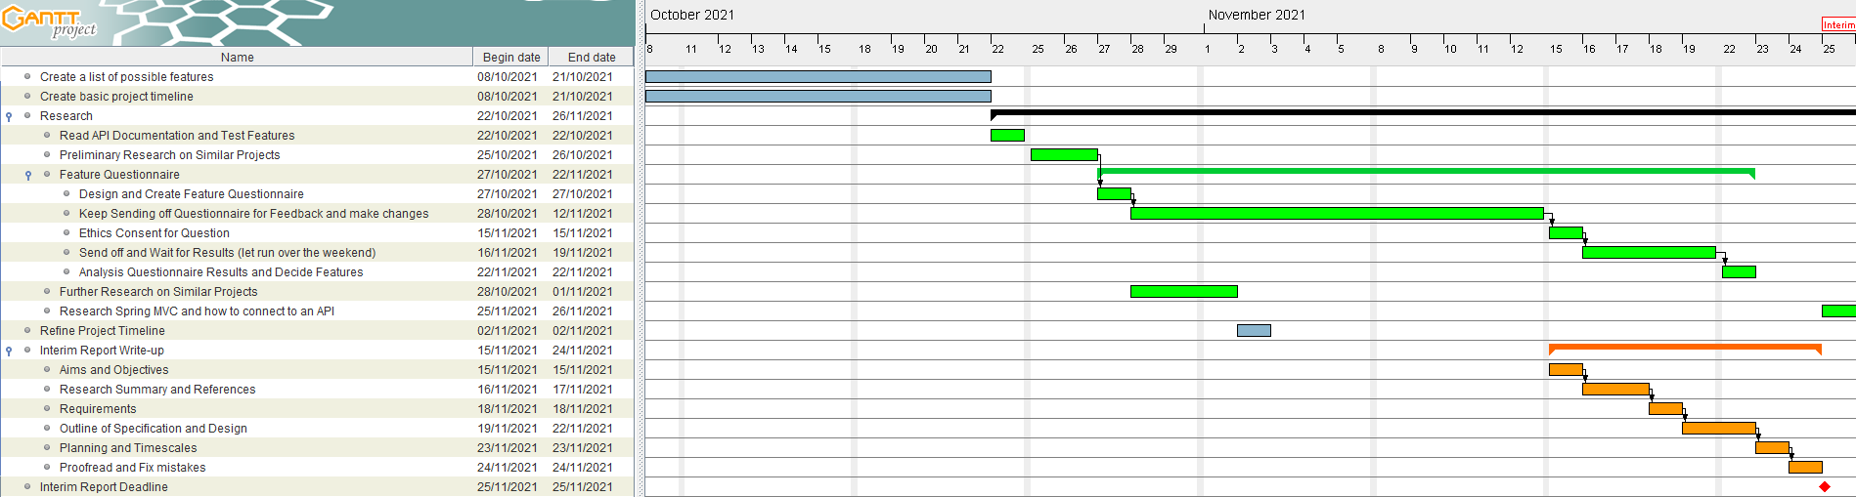

Figure 140 Semester 1 Part 1

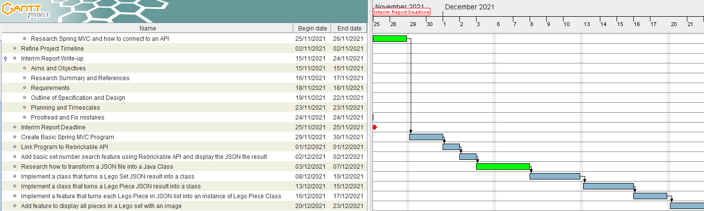

Figure 141 Semester 1 Part 2

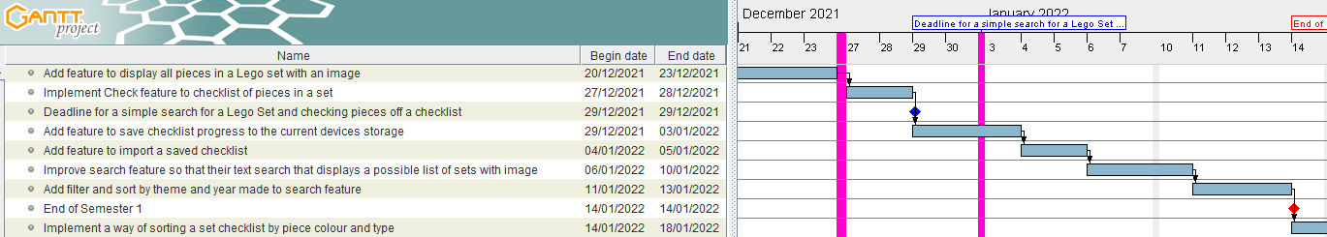

Figure 142 Semester 1 Part 3

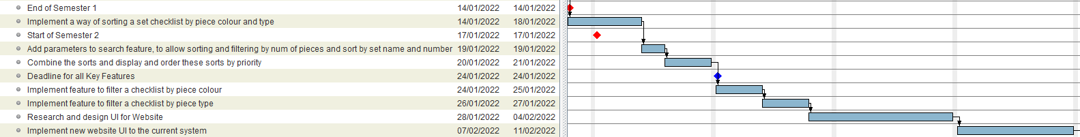

Figure 143 Semester 2 Part 1

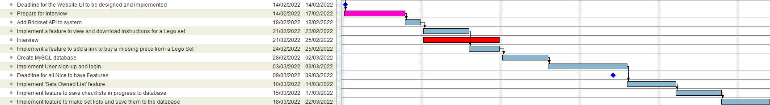

Figure 144 Semester 2 Part 2

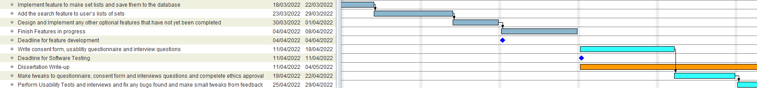

Figure 145 Semester 2 Part 3

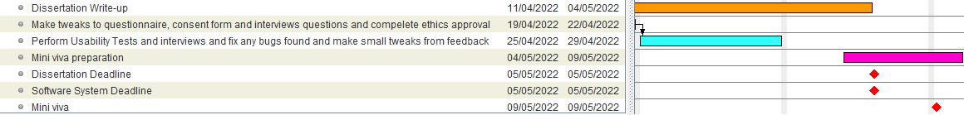

Figure 146 Semester 2 Part 4